The Hof Book Nook

Requirements Specification Document


Version: 1.0

Date: 09/14/22

Team:

Brian Baptista, Christopher Rios, Michael Salomone, Jasmin Varela

Table of Contents
- Preface 1
- Introduction 1
- Glossary 2
- Functional Requirements 2
  - Making and using an Account
  - Selling a Textbook
  - Searching for Textbooks
  - Purchasing a Textbook
  - Additional Functional Requirements
- Non-Functional Requirements 6
  - External Requirements
  - Organizational Requirements
  - Product Requirements
  - User Support
- System Models 7
- System Evolution 9

Preface
This is the first version of the requirements specification document for this project. It is targeted at all stakeholders with or without a technical background. The purpose of this document is to lay out a detailed presentation for a better way for students to buy and sell textbooks. Additionally, this document illustrates the purpose and features of the system, the interfaces of the system, what the system will do, the constraints under which it must operate and how the system will react to external stimuli.

Introduction
The Hof Book Nook is a local textbook exchange platform that enables students to buy and sell textbooks with more simplicity and at a more attractive price, for both the buyer and seller, compared to using the Hofstra Bookstore or any other kind of physical textbook distributor.
In general, both physical and online bookstores with a textbook buyback program buy textbooks from sellers and then resell them to buyers for more than the price they acquired it at. This is both a ‘loss’ for the buyer and seller. There is an opportunity to structure a sweeter deal for both the buyer and seller where they both leave happier; the buyer gets a cheaper price and the seller receives more money for their textbook compared to if they used a textbook buyback program.
The Hof Book Nook is a platform that seeks to structure these deals for the buyer and seller and then connect them with each other through email so they can proceed with a transaction.

Glossary
- AI - Artificial Intelligence
- DB - Database
- ISBN - International Standard Book Number: https://en.wikipedia.org/wiki/ISBN
- pfp - profile picture
- TBN - The Hof Book Nook (aka the system being described in the doc)
- ‘TBN fair price’ - is the competitive pricing edge of TBN, using this price buy and seller get a better deal then using traditional book store system
- 700# - hofstra ID number
- Visitors - People who visit TBN but don’t have a TBN account
- Users - People with a TBN account
- Buyers - Users who intend to buy a book using TBN
- Sellers / Listers - Users who intend to sell a book using TBN, hence they list their book on TBN
- Listing - a user’s offer to sell a book at a given price on TBN

Functional Requirements
- Making and using an Account
User’s will be able to sign-in and sign-up through a login/sign-up page on the app. This will be necessary for students to gain access to the functions of the Hof Book Nook app. To sign-up, students will need to provide their hofstra 700#, their pride email address, and full name. TBN must accept 700# with and without a leading ‘h’ (ex: h703285386 , 703285386). Afterwards, TBN must store and display the 700# in a standardized format. Either strictly with a leading ‘h’ or strictly without it. The information entered by the user will be stored in a database after checked for proper credentials. For example, there cannot be two accounts made that have the same 700# and/or email. The primary restriction for the email is that it must be a hofstra pride email (@pride.hofstra.edu). Passwords and other critical user data will be stored using vetted industry methods of encryption to protect against data breaches. Note that databases often come with vetted methods and technologies that enable developers to securely store passwords. The user can decide to choose their profile picture if they want but a standard profile picture “Identicon” for example https://jdenticon.com/ will be displayed if not. Since TBN is allowing users to upload their own profile pictures, an open source AI will be used to reject inappropriate profile pictures. Additionally, users will remain logged in to the account even when they have exited the app to facilitate ease of use. They will only be logged out if they explicitly choose to logout, or when potentially unsafe behavior is identified where it will force the user to be logged out and potentially request a password change. To log back in to the application they will only have to supply their 700# and password. Users will also be able to update the information of their account such as; password, pfp, and name.
- Selling a Textbook
The Hof Book Nook will utilize a listings database to store information about textbooks available for sale throughout the application. Users will be able to add new textbooks for sale to the database by posting a listing using an ISBN number, the condition of the book, and the price they wish to sell the book. Additionally, they will be able to add an optional description themselves that can include specifications of the book's condition, where they originally bought the textbook, etc. The condition of the book option will be split into three categories. The first is “like new”. This means that the textbook is in the same condition as when it was bought, no annotations, cover damage, etc. The second condition is “slightly used”. This would include some wear and tear to the cover and pages, some annotations, etc. The last category is “acceptable”. If a textbook is acceptable it means that it is still usable but not in the best conditions. This could include: many of the pages having writing on them, the cover or spine is not in optimal conditions, etc. Using an API (application programming interface) more information about the textbook will be added to the description. This includes the title of the textbook, the author of the textbook, and a description. Once the user publishes the listing the information will be stored in the database. Sellers will also have the ability to check an active listing log. This will be accomplished by calling a function that will produce the list of textbook names the user currently has listed from the database. From the same active listing log, the seller will be able to mark their textbook as in negotiations. This will let other users know that the textbook hasn’t been sold yet but there is a chance it will be soon. In addition, sellers can delete a listing which will remove the listing from the database which will in turn remove it from search results for all users.
- Searching for Textbooks
Another main feature of TBN is to search books by ISBN, title, keywords, or author. They will be able to access this function from the home page and search page. If the user chooses to run it from the home page they will then be displayed results in the search page. TBN will need to implement a method of parsing the different inputs and manage them accordingly. To determine which input is sent to the search function, conditional statements can be used to find the textbook. For example, an ISBN is normally 13 digits long and only contains numbers, with this information the function will then search the database looking for listings with that specific ISBN. If the search is not an ISBN, it will check the input search through the title’s stored in the database to determine if the search is a title of a book. Then it will check if the search is associated with a particular author and if nothing returns with a match, a general search through the database will list textbook listings containing the keyword put into the search bar. On the results screen users will be able to sort their results by price or condition. From this same page they will be able to access more information on the textbook. This information will be the one provided by the user and the API. Additionally, if the student views more textbook information the system will register what the last five books they opened and will display it on their home screen.
- Purchasing a Textbook
On the textbook description page users will be able to select “notify seller” if they wish to purchase that book. From there the user will be directed to an email page so that they can express their interest in the textbook to the seller. After this, the seller can contact the individual privately to set up an arrangement to sell the book and set up a payment plan, as payments are not done directly through the site. The seller can also choose to flag the listing as “in negotiations” to let other buyers know the book may be sold momentarily. Once the transaction between the seller and the buyer is complete, the seller will have to remove the book so that no other student believes that it is still available for sale. If the transaction is not completed due to failed negotiations, the seller will also be able to remove the “in negotiations” flag to make sure other buyers can still request to obtain the book.
- Additional Functional Requirements
Additional functional requirements include navigation tabs at the top to switch between pages and scroll bars to view more information. This will simplify the user experience on the application.

Non-Functional Requirements
- External Requirements (Deadlines)
There are additional non-functional requirements that must be taken into consideration while creating this application. The first one that must be the deadline. The project will have to be completed by Thursday, December 1st, 2022. Additionally, check-in deadlines will be set up periodically to ensure that the project is on track.
- Organizational Requirements
To provide simplicity when using the API and the search function for users, ISBN numbers will be limited to ISBN-13 numbers.
- Product Requirements
Another thing that has to be ensured is that the application will be able to be used by multiple users at the same time. Hofstra University has thousands of undergraduate and graduate students who will be able to use the application. This is not including the fact that alumni will also be able to maintain their accounts and sell textbooks from it even after they graduate. If the Hof Book Nook app is unable to support all these users, is functioning at an unusable speed, or has other types of bugs, users will feel less inclined to use the application.
In regards to performance of the application, the app should run without any slow down.
i.e.: It should not take longer than about 2 seconds for any feature of the app to serve the user with its intended function.
- User Support
A final non-functional requirement would be providing users with a help button. From here they will be able to communicate with developers to provide feedback on the application, or give a complaint of a transaction. In the given case that there is a user who provides false information of the condition of the textbook they will receive an email with a warning about misrepresenting information and a list of what the different conditions specifically mean. If three complaints are made of one specific user they will be banned from selling textbooks on the applications. They will still be allowed to purchase textbooks.

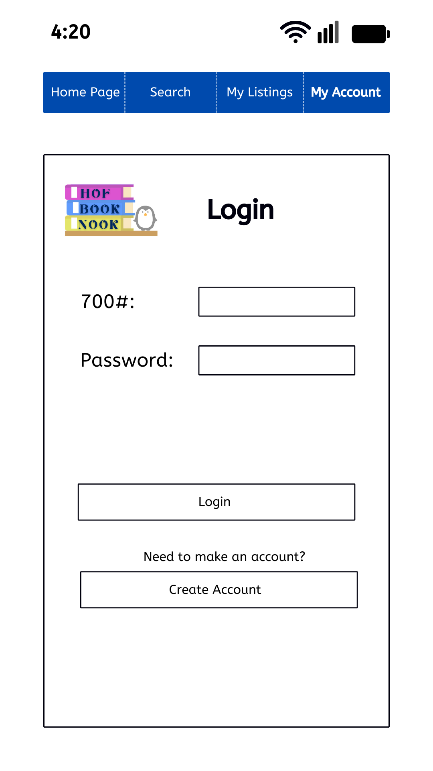
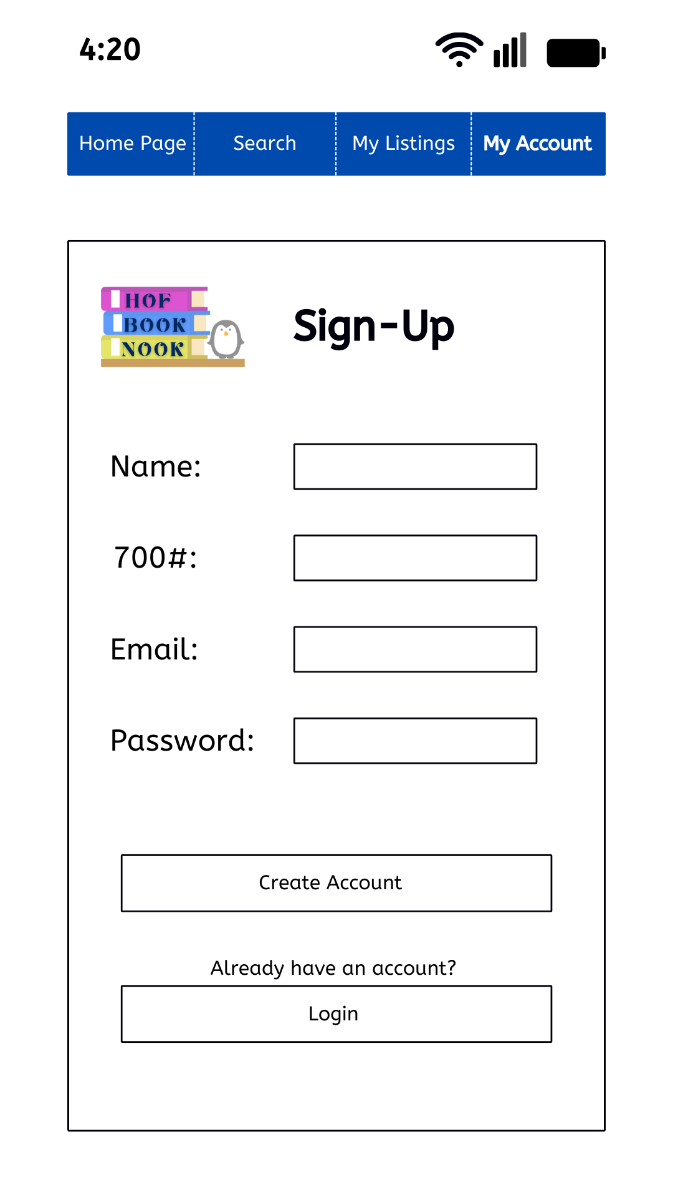
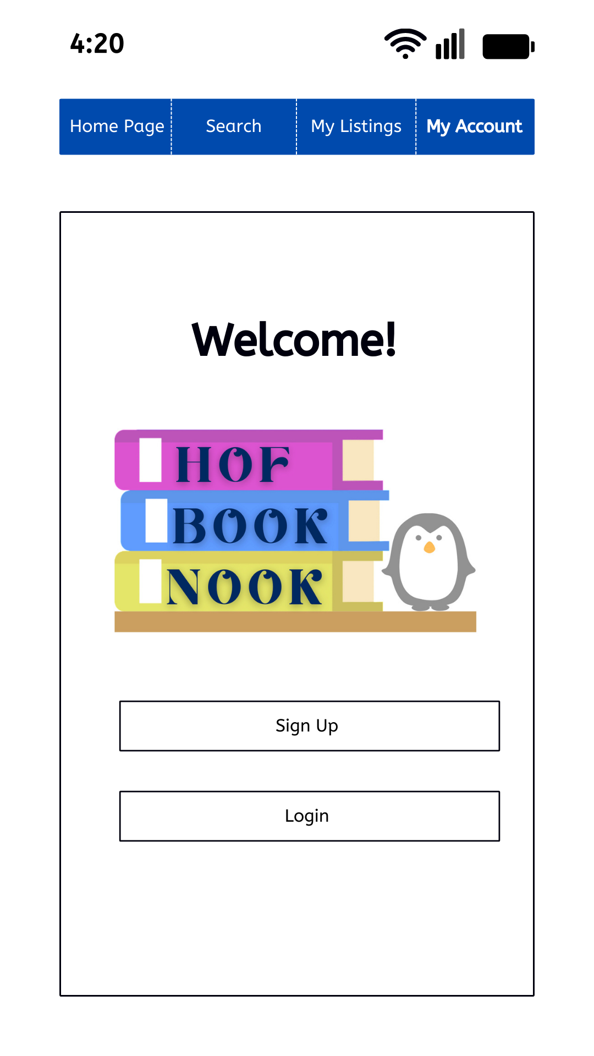
System Models
Figure 1
Figure 2
Figure 3
Figures 1-3 show the start pages for the application. When a user opens their application on their phone they will be prompted to either sign up or login to an account as shown in Figure 1. The login screen is shown in Figure 2 and the sign-up screen is on Figure 3. Both screens would give the user the ability to alternate between them in case you select the wrong button. If the user were to exit the application for an extended period of time before completing the sign-up or login process they will be directed back to Figure 1. Once the user is in their account they will be able to navigate the tabs of ‘home page’, ‘search’, ‘my listings’, and ‘my account’.
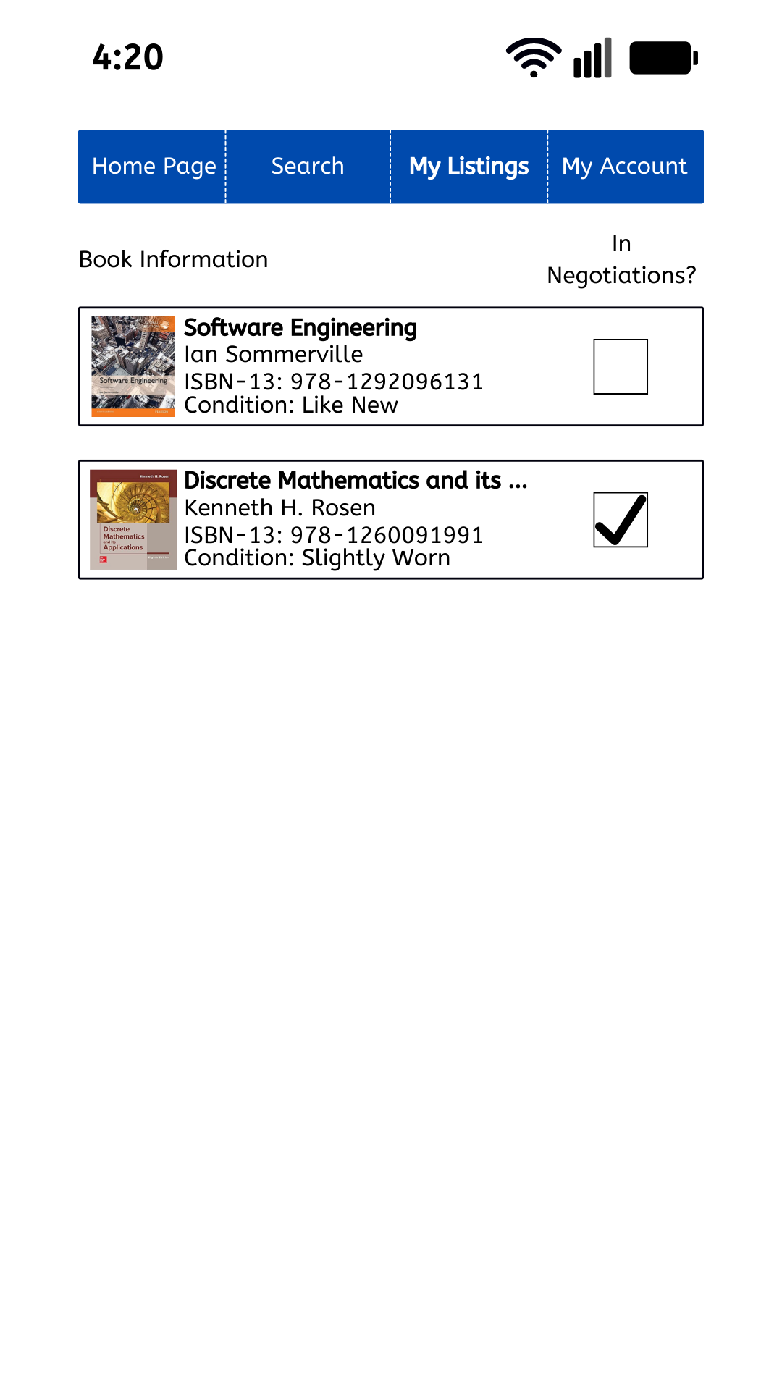
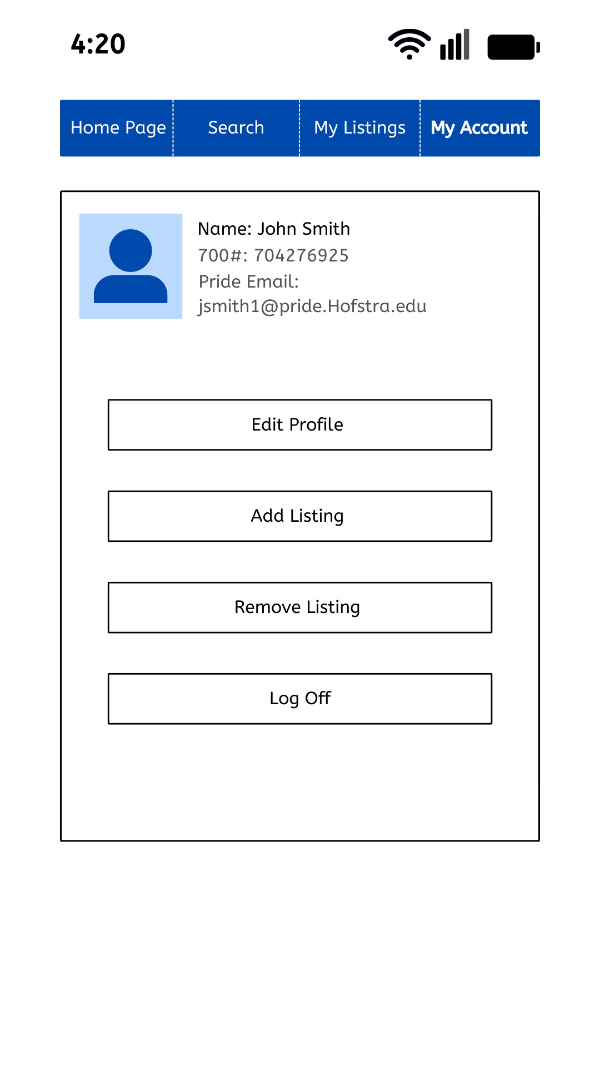
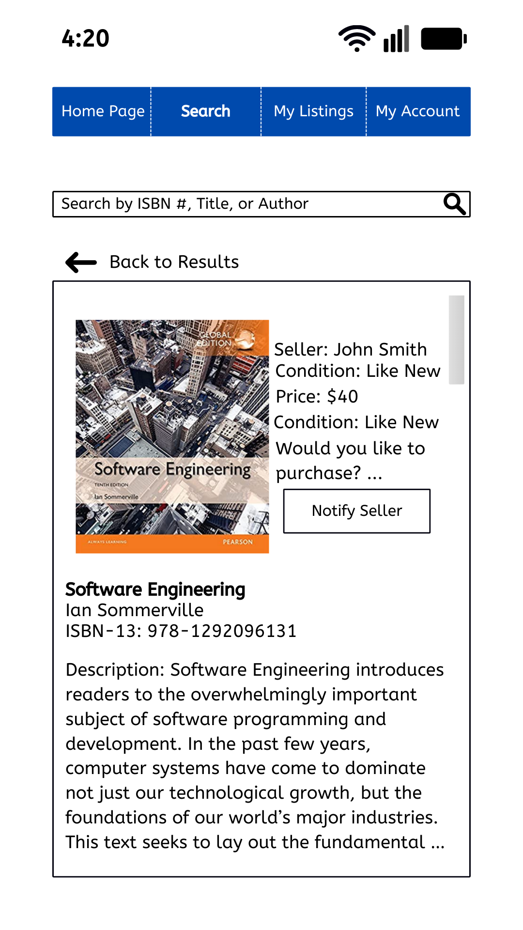
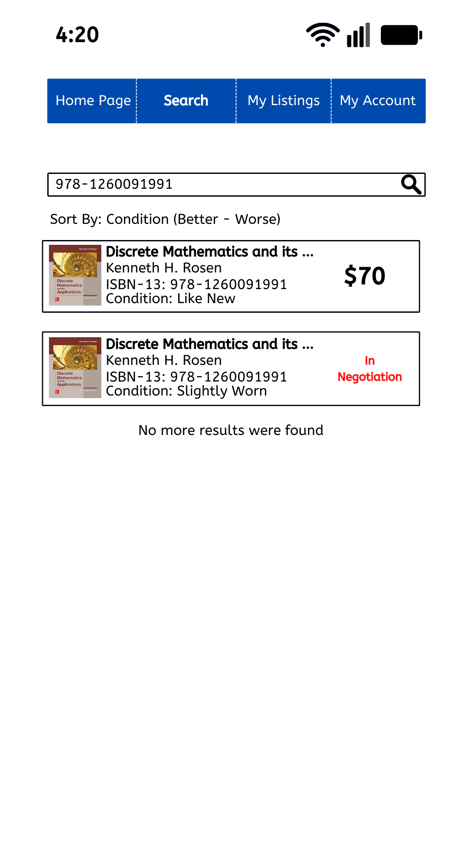

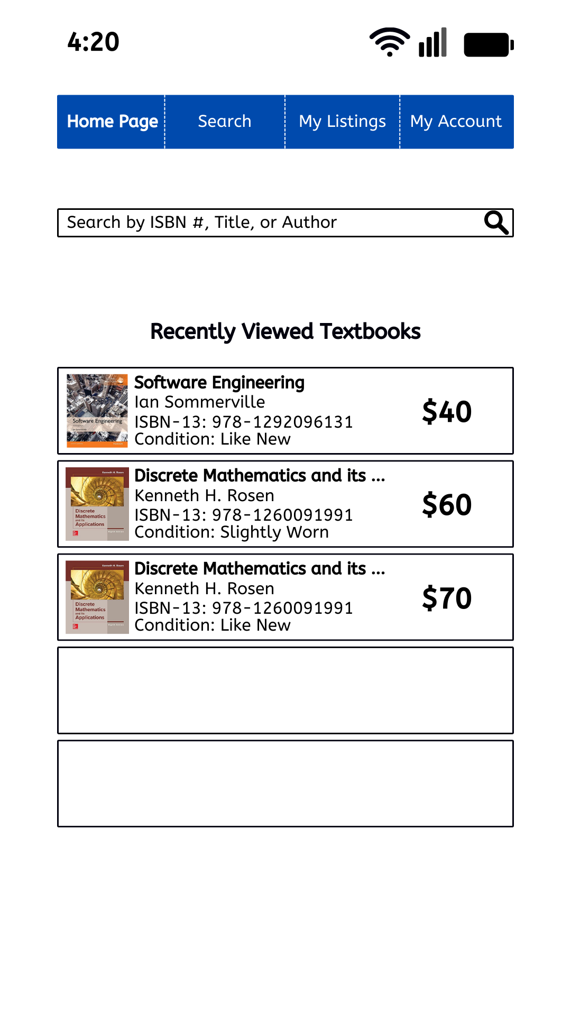
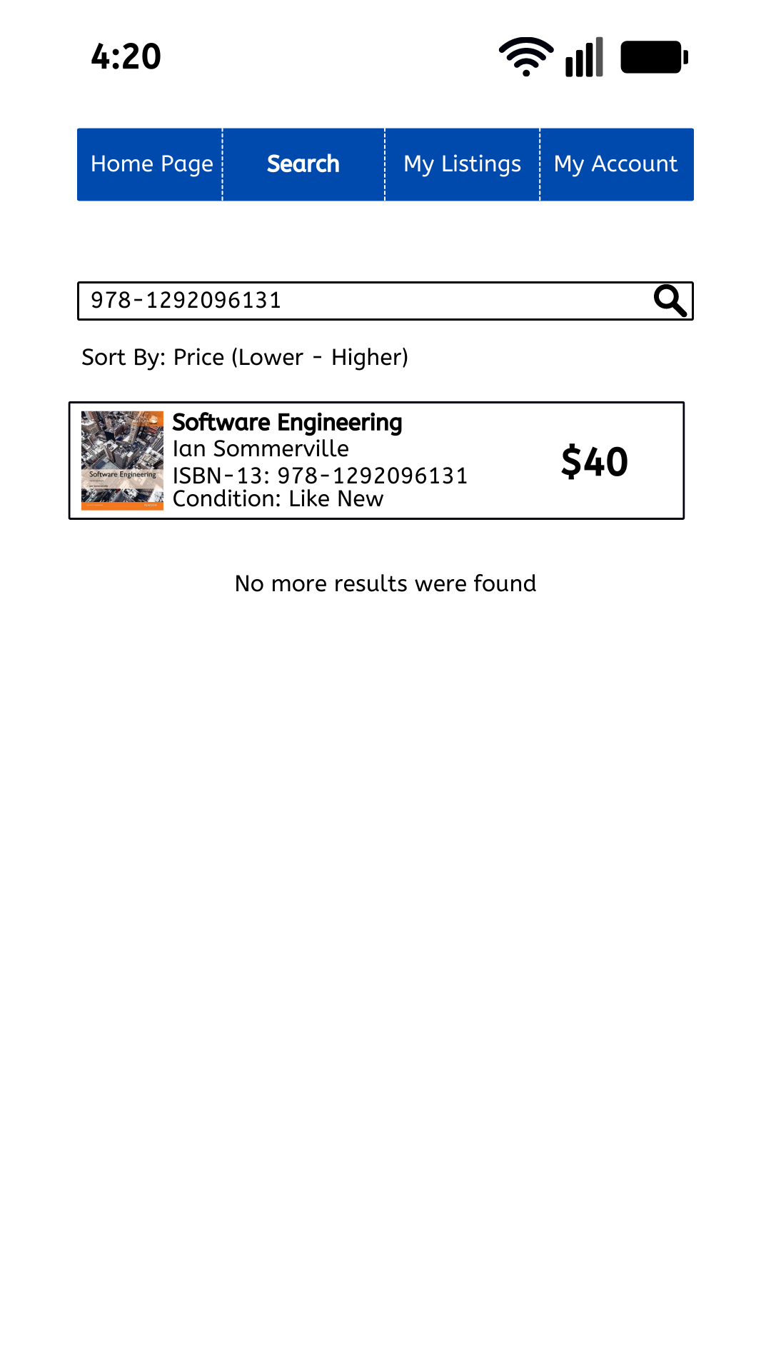
When the user has previously used the application they will be greeted at the home page with a list of their five most recently viewed textbooks as seen in Figure 4. Figures 5-7 show different examples the user will get from their search results. When the user searches for a textbook with a valid ISBN number, author name, or title they will get the results that correspond with that search criteria (Figure 5). Meanwhile if the number they submitted is invalid or there are no textbooks with that search criteria for sale they will get a page that says “no more results were found” (Figure 6). Finally, if they search for a textbook and one of the options is currently in negotiations it will display it in the result information. This way they can come back to check on it at a different time. Once a user selects the textbook they want they will be directed to the product page (Figure 8). From there they will be able to confirm that it is the textbook they are looking for. Additionally if they choose to purchase the textbook then they will be able to press the notify seller button. After pressing the button they will be able to negotiate with the seller off the app. about the textbook purchase.
Figure 9
Figure 10
Figure 8
Figure 4
Figure 5
Figure 6
Figure 7
There are two more pages the user will be able to access on the app. The first being their account page. On this page they will be able to edit their account, add and remove textbooks they have for sale, and finally log out of their account (Figure 9). If the user has textbooks they are selling, they will be able to keep track of them from the “my listings” page (Figure 10). From here they will also be able to add and remove the “in negotiation” tag to their listed books.

System Evolution
The Hof Book Nook is a simple application that provides students with an easier way to buy and sell textbooks. However there are advancements that can be made to the application after the main requirements are completed.
For example, Hof Book Nook allows sellers to input the price that they want to sell their used textbook at. If we were able to provide a way for the user to see what the average price for a book in that condition is being sold on different websites they would be able to decide on a selling price that is competitive with the market rate.
Another advancement that can be made is allowing users to switch between different languages on the app. There are many international students at Hofstra whos first language isn’t English. Although they’d be able to use the application having the ability to switch languages would make the application effortless for them to use.
One more main component of the application is the fact that buyers communicate externally from the app with sellers for the sales of textbooks. If at one point we were able to provide an in-app method to allow communication between the seller and buyer it would simplify the process. Additionally, an in-app method to purchase the books will also be beneficial for simplifying the sale process.
A final evolution for the application that would be beneficial to the application is more on the programmers side. Once a user notes that a book is under negotiations they will be given a time limit to sell the book. Once the time limit is reached their book will be removed from the database and listings. This allows more space in the database for users to upload textbooks and also ensures that the seller is keeping active communication with the buyer over the sale. If they were unable to complete a transaction they can remove the “in negotiations” tag and the timer will stop. If the seller does not remove the tag and is still keeping the book as listed they will have to upload the textbook again.

