1. KissAnime.to

Kissanime is the king of top anime streaming sites. This site has made available a wide variety of anime to its fans. Kissanime has the highest number of fans and rates high in popularity among anime buffs. The site is optimised to consume low-bandwidth and loads fully in almost 10 seconds. The site uploads anime series in a consistent manner in every possible quality similar to that of YouTube from 240p to 1080p optimised for a wide variety of devices.

The site, however, runs using JavaScript, which is missing in mini browsers. **Without registration, you will be able to stream  and watch your favourite episode** but will not be able to download the episodes and participate in community discussion.

* **Read : [Websites To Watch Movies Online](https://www.infogeekers.com/best-free-online-movie-streaming-sites/)**

2. 9Anime.to

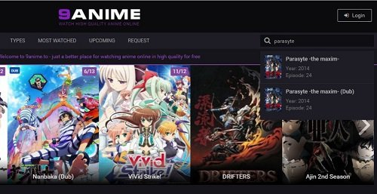

For those who loves to watch dubbed anime or stream anime in English, 9anime is an amazing anime streaming site. High-quality anime site to watch HD anime online for free. Anime is a Japanese art so it’s a good choice to go for dubbed anime or subbed version  in order to enjoy this amazing art. 9anime is an amazing platform for that.

If I get to choose between kissanime or 9anime, I’ll prefer 9anime.to. A way better **anime site than kissanime due to its simple and alluring content**.

3. Chia-anime.tv

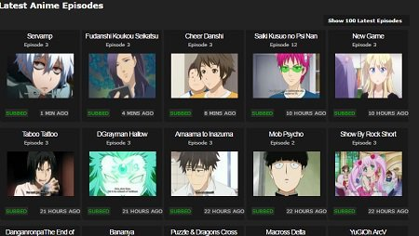

**Chia-anime is another free anime site like Kissanime** that will do wonders for you. The site will let you access all of the popular anime series from all time and the latest ones for free. The site is must visit because of the dedication the site shows; innovation is always the top need in today’s world.

Update frequency of series is very high. The site updates the episodes of the anime 10 times faster than any other site.**The site offers English subbed anime in high quality and can be streamed and easily downloaded with a single click**.

**Note :**Animes are Japanese legacy so they are not generally dubbbed in English. They are only available in subbed version, i.e, English subtitles. Sites claiming Anime dubbed in English only provide subbed version not dubbed one.

4. AnimeSeason.com

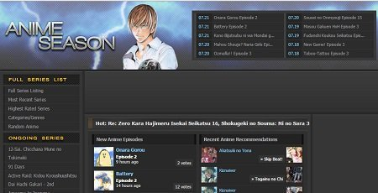

Many users use this site and are a fan of the quality that the site promises. The site is well-polished to provide a quality scrolling experience with simple infrastructure properly organised to please the eyes. The good part is that the site will not force you to watch irritating ads making the experience more reliable and beautiful. ***The site is close to providing ad-free anime streaming***.

The site has embedded video players that let you watch online subbed anime episode with captions and titles on them. The site has no search bar, but the left pane is organised well to locate anything that you would search for. On the left pane, you can quickly locate your favourite show from the category and archive tab.

5. Gogoanime.com

Gogoanime is another great place to watch anime online for free. It let you stream all the anime episodes that are in the Japanese language with English subtitles. What is good than this if you are an anime lover and get the anime with English subtitle. The site has maintained an excellent database which is refreshed from time to time and has a pretty good user interface too.

More than that, the site owners have shown sheer dedication by providing the GoGo Anime app that also streams the anime site on iPhone iPad and Android devices.

6. AnimeFreak.Tv

Plethora of Anime is what I call whenever Animefreak comes to mind. Watch Naruto, Bleach, Death Note and other top anime series here. They have a separate category for latest, popular anime. Browse using genre tab to get precisely what you were looking for. **Not everywhere you get manga to read with the latest anime series on the stock.** Yes, you can easily read manga on their new platform. That’s a great news for manga readers.

7. watch-anime.net

Simple and clean interface and the best website to watch anime online. This site has calm composure as it not looks rushed and messy. The simple design has made it easy to navigate and find anime to watch much easier than ever before. Apart from series, users get to watch anime movies too. Now read the latest manga. Bonus treat for anime lovers.

Top Legal Anime Streaming Sites ( Free & Paid )

1. [Crunchyroll](http://www.crunchyroll.com/)

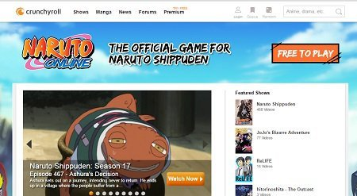

Crunchyroll is a legal anime website that has organised the best of the anime collection and is available in most of the countries. The site has features similar to a premium site. Some anime videos can be accessed for free, and rest of the videos can be viewed after you subscribe to a premium membership with ad-free experience.

If you do not care about the money and want quality legally, go ahead this site is for you. You will have access to all the latest shows, manga discussions and more. **Moreover, if you are a premium user, then you can Simulcast newest episodes as soon as 1 hour after airing in Japan and can have an ad-free experience**.

**Good news:** Site has launched a 14-Day Free Trial of Crunchyroll Premium after that you can Watch unlimited anime from $6.95/month which you can Cancel online anytime. Hurry…!!! Take the benefit now.

2. Daisuki.Net

Daisuki is another **[site to legally stream anime online](https://www.infogeekers.com/anime-streaming-sites-watch-anime-online/)**. Moreover, they put light on what the website is by claiming that DIASUKI is the newest innovation launched by major Japanese anime production companies that have continued to cater anime development. Thus, this site is an official resource that provides everything from the anime that everyone is crazy about to the anime that is rarely known, and the latest anime in the highest quality.

DAISUKI is an official real anime site where *you can watch real, high-quality anime legally with premium membership*! Conclusively, they have quite good anime collection available but you are smart enough to judge that the series can be watched only using the premium membership.

3. Hulu.com

Hulu is mainly known for the high-quality uploads and a wide collection of anime films and anime series. The anime site is unavailable in most countries but has good anime collections. This website with a user-friendly interface that let you watch the latest episode of the anime that you like or follows legally and officially. But, remember there is a restriction to access **Hulu,**the website is not available to the whole world. Hulu can only be found by internet users that live in some parts of Europe and Asia. Still, you can use US VPN and aces the website.

4. Funimation.com



This site is a smart well-run business to challenge the capabilities and provide the best legal anime streaming website.  This site thus holds the official title, and every anime that you are going to watch on this site is Funimation licensed Anime video in dubbed or subbed version. The aspect of business calls for premium membership where the dubbed versions are available to premium users and subbed versions are available to free users.

Again, if you do not bother money, you can use this site. If you like subbed version for free, you can surely visit this site. **This is a site that provides English dubbed Anime.**

**No. 1 anime website -**[**Kissanime.com**](https://kissanime.to/)

Kissanime is a popular website which allows you to enjoy any anime in high quality. This anime website provides lots of anime resources, and you can get the anime in a various formats from 240p to 720p even 1080p. What's more, Kissanime also support HTML５so that you are able to enjoy the popular anime on your mobile phone.

[](http://www.aiseesoft.com/images/anime-websites/kissanime.jpg)

**Top 2 anime website - [Hulu anime](http://www.hulu.com/search?q=anime)**

You must have heard of Hulu when you want to watch TV and movies online. Lulu allows you not only enjoy the TV series and movies, it also enables you to search and find the most popular anime, Korean drama and video games. Want to enjoy Dragon Ball Z on Hulu anime? Just insert the anime name on the search bar to find the best answer.

[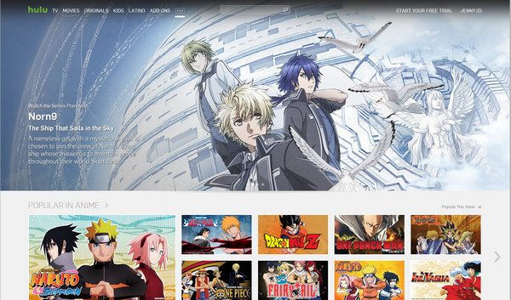](http://www.aiseesoft.com/images/anime-websites/hulu-anime.jpg)

**Top 3 anime website - [Crunchyroll](http://www.crunchyroll.com/)**

Erased is hot on Crunchyroll now! As the most active anime website, crunchyroll provides different solutions to find your best anime. For example, this anime strreaming website makes a clear anime category to make it easier to find your what you want: the simulcasts, latest news, sites news, all-new anime, all-new drama, and forum to discuss the anime with other strangers.

[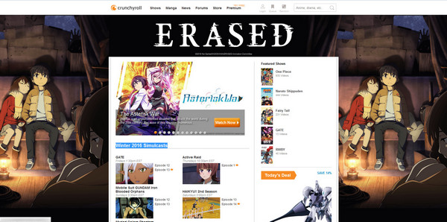](http://www.aiseesoft.com/images/anime-websites/crunchyroll.jpg)

**Top 4 anime website -**[**Anime Heaven**](http://animehaven.org/)

Anime heaven is another free anime site for you to watch anime. You are able to find the favorite Cartoons, Anime Series, Ongoing Series, Movies and select the new shows by rating, Genre and year. It is well compatible with your Windows 7/8/10 and Mac computer. What's more, Anime Heaven has an obvious advantage that it allows users to download the favorite anime to computer with different video quality.

[](http://www.aiseesoft.com/images/anime-websites/anime-heaven.jpg)

**Top 5 anime website -**[**Anime Season**](http://www.animeseason.com/)

Anime Season also has done a good job for providing the anime series for its users. You will get the popular anime with votes from its supporters. In addition, this anime streaming site departs to 4 parts to choose the anime: New Anime Eposodes, Recent Anime Recommendations, Recently Rated Anime and Recently Added Anime. Are you interested in its categories? Go visit this anime website to find your favorite anime.

[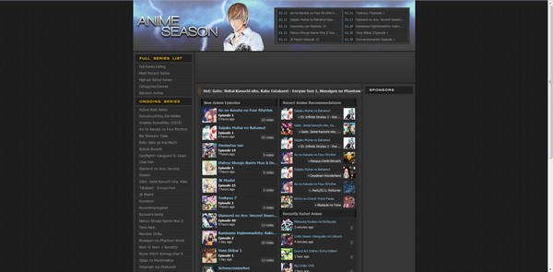](http://www.aiseesoft.com/images/anime-websites/anime-season.jpg)

Are these anime websites good enough to watch anime? If you need more anime websites, you may get the answer from the following table.

## Other anime sites list

|  |  |  |  |
| --- | --- | --- | --- |
| Logo | Top Anime Websites | Download | Details |
| http://www.aiseesoft.com/images/anime-websites/free-movie-linker.jpg | [freemovielinker.com](http://www.freemovielinker.com/) | No | 1.It is much more than an anime website, you can find the popular movies here. 2. The unregistered version only allows you to watch the anime within certain scale. If you want to find more movies and anime series, you need to sign in. |
| http://www.aiseesoft.com/images/anime-websites/soul-anime.jpg | [soul-anime](http://www.soul-anime.cc/) | Yes, you are able to free download the anime with the green Download button. | 1. You are able to watch the whole anime episode with subtitle for free. 2. Support to watch 3000+ Animes series and 50000+anime episode. |
| http://www.aiseesoft.com/images/anime-websites/watch-anime.jpg | [watch-anime.net](http://www.watch-anime.net/) | No | 1.Watch Anime online with English Subbed within high video quality. 2. Choose the anime from its release date. |
| http://www.aiseesoft.com/images/anime-websites/chia-anime.jpg | [chia-anime.tv](http://www.chia-anime.tv/) | No | 1.Frequent rate to update. 2.Play anime with high video quality. 3. Easy to search and choose. |
| http://www.aiseesoft.com/images/anime-websites/anilinkz.jpg | [anilinkz.tv](http://anilinkz.tv/) | No | Watch your favorite anime online in this anime streaming websites with the largest database. |
| http://www.aiseesoft.com/images/anime-websites/gogo-anime.jpg | [gogoanime.com](http://www.gogoanime.com/) | No | 1.The world's largest free anime site as its webpage describes. 2. Watch free series and movies online with English Subtitle. |
| http://www.aiseesoft.com/images/anime-websites/anime-crazy.jpg | [anime crazy](http://animecrazy.eu/) | No | 1.Watch anime online free. 2. Support both English dubbed and subbed anime videos. |
| http://www.aiseesoft.com/images/anime-websites/anime44.jpg | [anime nova](http://www.animenova.org/) | No | 1.Watch online free anime series and movies online with English subtitle. 2. Support playing Korean Drama. |
| http://www.aiseesoft.com/images/anime-websites/naruto.jpg | [narutoget](http://www.watchnaruto.tv/) | No | 1.It aims to provide the Naruto episodes. 2. It is the best and fastest source to free watch Naruto anime online. |
| http://www.aiseesoft.com/images/anime-websites/animefreak.jpg | [animefreak.tv](http://www.animefreak.tv/) | No | 1.It has its own Android app. 2. Watch stream anime and movies online for free. |
| http://www.aiseesoft.com/images/anime-websites/animeultima.jpg | [animeultima](http://www.animeultima.io/) | No | 1.Need to register.  2.Update anime hourly. 3. Free anime website to watch anime with English subtitles and dubs. |
| http://www.aiseesoft.com/images/anime-websites/animehere.jpg | [animehere.com](http://www.animehere.com/) | No | 1.Stream the latest anime online. 2. Watch all the anime for free. |
| http://www.aiseesoft.com/images/anime-websites/anime-show.jpg | [animeshow.com](http://animeshow.tv/) | No | 1.Watch high quality anime series with English subs online. 2. Provide the best anime series: Dragon Ball Super. |
| http://www.aiseesoft.com/images/anime-websites/animeseed.jpg | [anime seed](http://animeseed.com/) | Yes. It will navigate to another link to download the anime. | 1.Watch anime online. 2. Some anime are unable to play due to the copyright. |
| http://www.aiseesoft.com/images/anime-websites/funimation.jpg | [funimation](http://www.funimation.com/) | No | 1. Need to register. 2. Enable users to watch anime and Asian drama episodes. 3. Available to watch anime in English subs and subtitles. |