**Modulation of Transcription Elongation**

**by Herpes Simplex Virus-1**

Submitted by Christine Liao

Supervisor: Prof. Dr. Jochen Bodem

**Results**

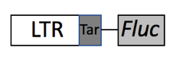

B

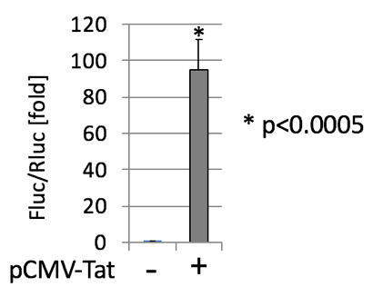

A

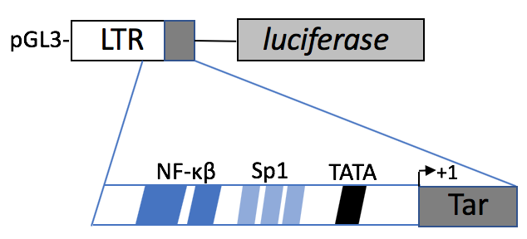

**Figure 1. HIV-1 promoter serves as model to study transcription elongation. A.** HIV1-LTR-Fluc reporter plasmid construct. This viral promoter contains specific sequences recognized by host proteins needed for the initiation of transcription by RNA polymerase II. For example, TATA-binding protein recognizes the TA-rich sequence, TATA box; stimulating protein 1 binds to Sp1 region and enhancers such as nuclear factor kappa-beta protein complex to NF-κβ region. Viral protein Tat binds to TAR (transactivation response element) RNA and stimulates elongation of transcription by increasing processivity of elongating complexes, thus producing full-length transcripts of, in this case, Firefly Luciferase (*Fluc*). **B.** Tat increases transcription driven by HIV1-LTR promoter by almost 100 folds. Hek293T cells were co-transfected with HIV1-LTR reporter plasmid with Cytomegalovirus (CMV)-driven Tat plasmid, then assessed by Dual-Glow Luciferase assay.

48h post transfection

30h post transfection

B

A

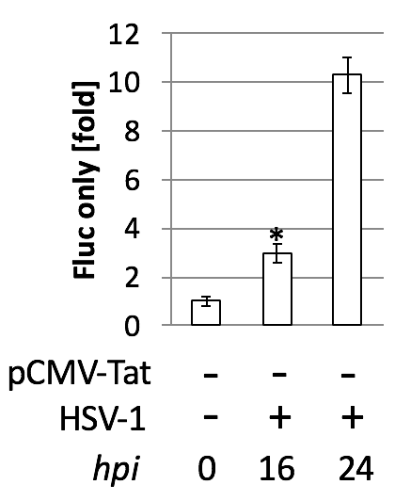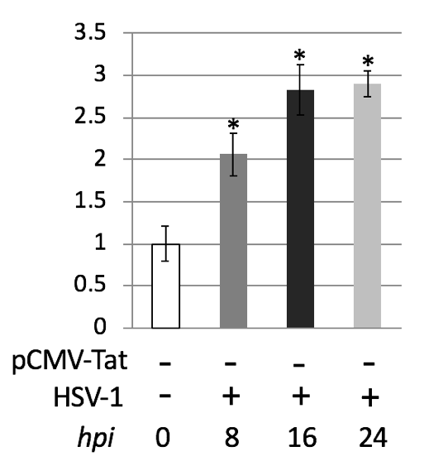



**Figure 2. Two-fold activation of HIV1-LTR promoter by HSV-1 in the absence of Tat.** Hek293T cells were infected with wildtype HSV-1 at MOI 10 for various time points: 8, 16, 24 *hpi* (hours of post infection). The promoter activity is subsequently assessed by Luciferase assay. **A.** After 30h of transfection of HIV1-LTR reporter plasmid, HSV1 significantly increase transcription activity by 2-folds at 8*hpi* and less than 3-folds at 16 and 24*hpi*. **B.** Similarly, after 48h of transfection, there’s a significant increase of promoter activity by 3-fold after 16 hpi but 10-folds for 24 hpi with no statistical significance. T-test performed comparing to the 0 *hpi*,= p<0.0005.

B

A

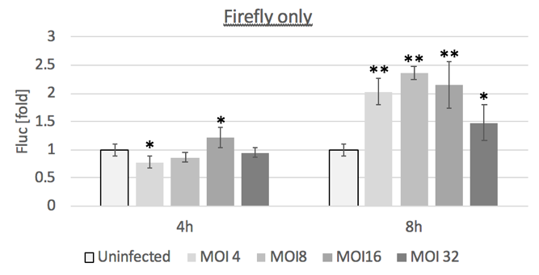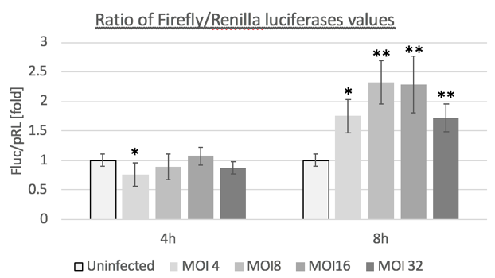

C

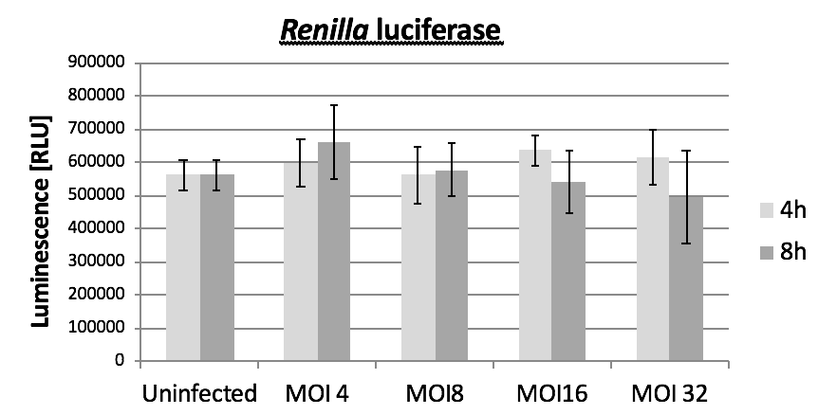

**Figure 3. HSV-1 has no effect on CMV-driven Renilla luciferase plasmid.** Hek293T cells were infected at 4 and 8 hpi with HSV-1 with different MOI’s (4, 8, 16, 32) and compared firefly values to ratio of firefly divided by Renilla. **A.** Only at 8 hpi, two-folds of HIV1-LTR promoter activation by HSV-1 was observed across different MOI’s, as observed in Fig 2. **B.** Again, this two-folds increase of promoter activity is observed for 8 hpi at MOI 8 and 16 when luciferase values are divided to an internal control gene Renilla luciferase. **C.** No significant changes in Renilla values due to HSV-1 MOI. Statistical analyses performed comparing to the uninfected cells, where = p<0.05, =p<0.00001.

B

A

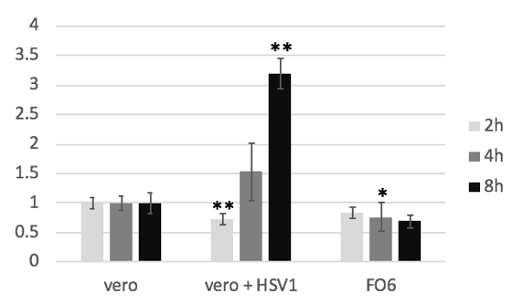

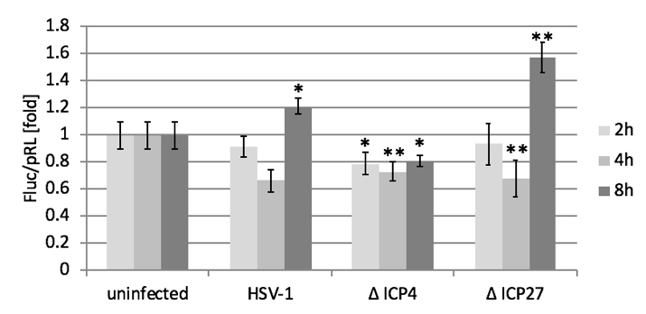

**Figure 4. Screening for HSV-1 infected-cell proteins (ICP) responsible for transcription activation of HIV-1 LTR promoter. A.** After transfection of LTR reporter plasmid,Hek293Twere infected with either wildtype HSV-1, mutant lacking ICP4 or mutant lacking ICP27. HSV-1 mutant lacking ICP27 showed a modest increase of LTR promoter activity by 1.6-fold after 8 *hpi*. Interestingly HSV-1 lacking ICP4 reduced activity of promoter by 20% when compared to control uninfected cells. **B.** Infection ofFO6 cell line overexpressing ICP0, 4, 27 is compared to vero cell line with and without HSV-1. Interestingly, only the control vero cell line showed an increase of 3-fold LTR promoter activity after 8 hpi when compared to noninfected vero cells. Instead the FO6 cells showed a decrease in LTR activity when compared to uninfected vero cells. = p<0.01, =p<0.0005.

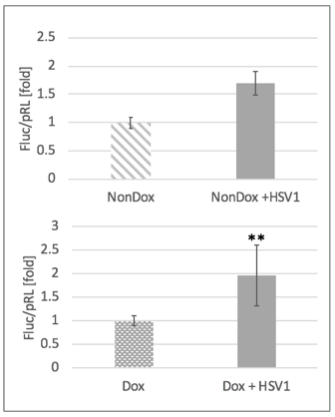

B

A

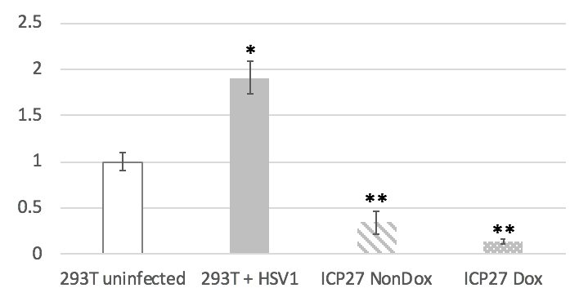

**Figure 5. ICP27 causes reduction of HIV-1 LTR promoter activity**. **A**. Doxycycline-inducible 293T cell line is able to turn ON/OFF overexpression of ICP27, when doxycycline is added (dox) or not (nondox), respectively. Non-induced ICP27-cell line showed a nearly 50% decrease in LTR promoter activity, whereas in dox-induced state, there was a pronounced 90% reduction of LTR promoter activity, assessed by Dual-glow luciferase assay. **B.** Surprisingly, when wildtype HSV-1 was added to the nondox and dox ICP27 cell line, the promoter activity is restored to approximately 2-fold increase compared to non-infected ICP27 cell line.

NEW STUFF below

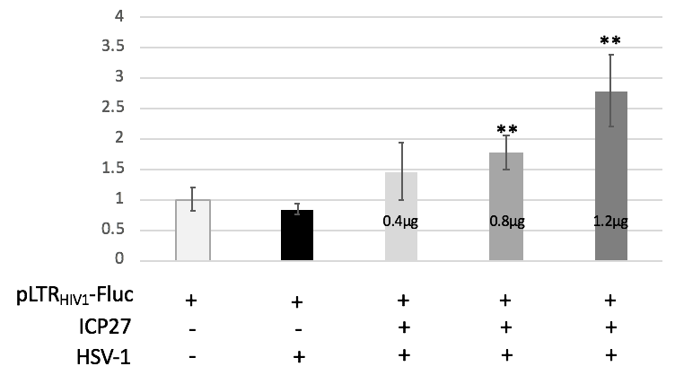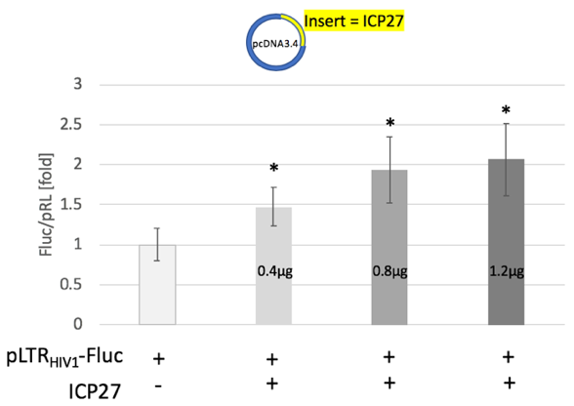

B

A

**Figure 6. High expression of ICP27 by transient transfection, however, increases LTR promoter activity by 2-folds. A.** Hek293T cells were transfected with synthesized pcDNA3.4-ICP27 at various concentrations (400ng, 800ng and 12.µg). Here, consistent data showed that ICP27 was able to increase LTR promoter activity by 2-fold by transfected 800ng of ICP plasmids when compared to non-transfected HEK cells. =p<0.005. **B.** When these ICP27-transfected cells were infected with wildtype HSV-1, the LTR promoter activity didn’t improve much at 800ng, but seems to bring almost another fold-increase at 1.2µg. =p<0.001.

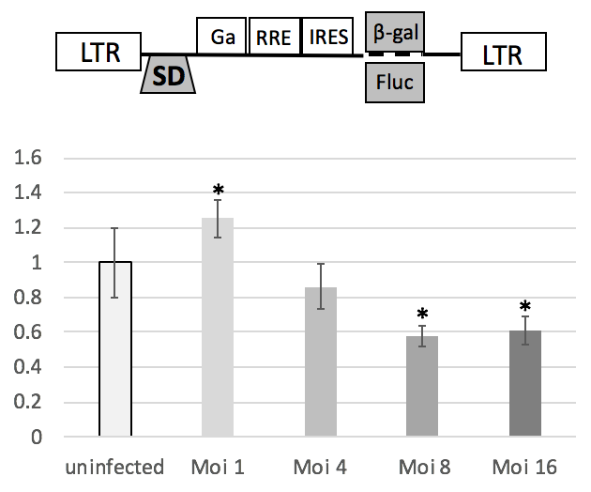

A

* P<0.001

C

B

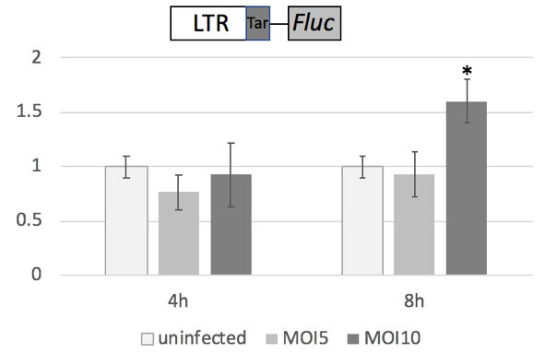

P<0.05

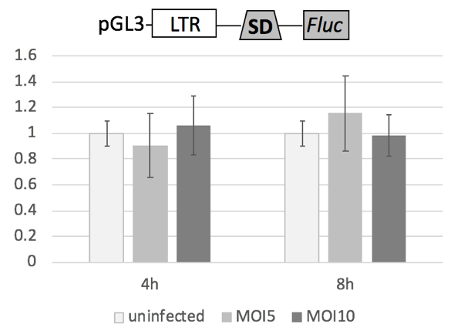

**Figure 7. HSV1 transcription activation is halted by splice donor site within HIV-1 LTR. A.** TZM is a stable cell which contains integrated reporter genes for Firefly luciferase or E coli b-galatosidase, under control of the HIV1-LTR promoter with a splice donor sequence. When TZM cells were infected with wildtype HSV1 at various MOIs, luciferase activity decreased. **B**. When HEK293T cells were transfected with LTR containing a splice donor, which is about 121 bp more after the the LTR in the proviral HIV-1 genome, consistent data showed that no increase of luciferase activity after HSV-1 infection. **C.** HEK 293T showing modest, yet significant increase of luciferase activity by HSV-1.

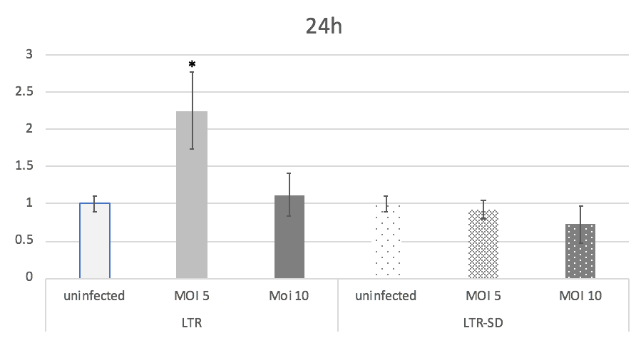

**Figure 7. HSV-1 was not able to activate LTR-SD promoter even after 24h of infection.** Normally, the LTR promoter is activated by between 2 – 10 folds after 24hr of HSV1 infection, usually at a lower MOI. Here, we see no or decrease activity of the promoter in LTR-SD promoter after 24h of HSV-1 infection.

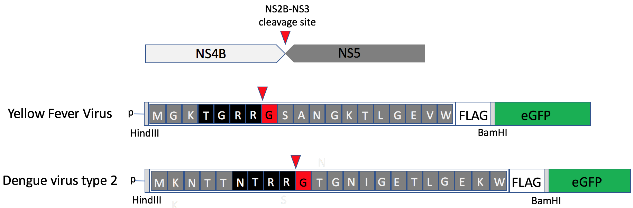

**Figure 8. Glycine myristoylation constructs for Yellow fever virus and Dengue virus type 2.** Oligos containing the cleavage site for NS2B-NS3 protease (TGRR for Yellow fever virus and NTRR for Dengue virus type2), the N-terminus after cleavage site, and a Flag tag was inserted to a pE-GFP-N1 plasmid. Red down arrow represents potential cleavage by NS2B-NS3 protease, exposing glycine residue at the N-terminus. This glycine (G in red) is the signal for myristoylation by host NMT.

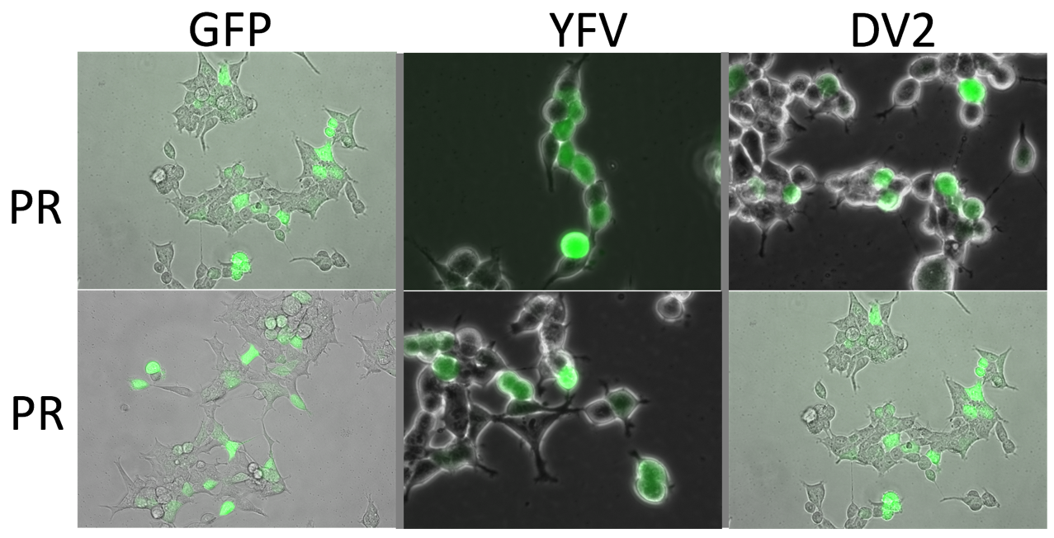

A

IF of GFP here

B

**Figure 9.** No GFP translocation. **A.** Transfection of HEK293t with GFP, YFV and DV2.

**B.** Immunoflourescence of anti-GFP, N-terminus, etc…

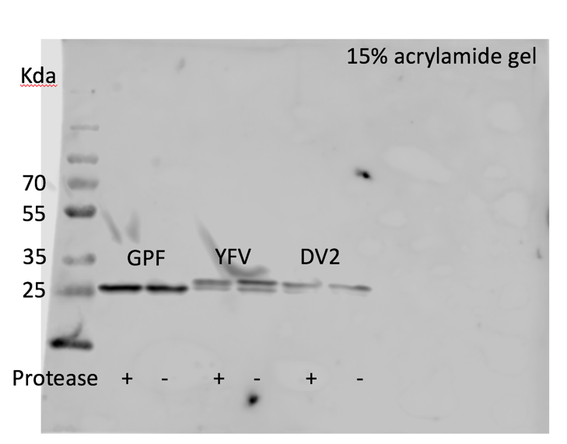

**Figure 10. No cleavage by protease in the cleavage site.**

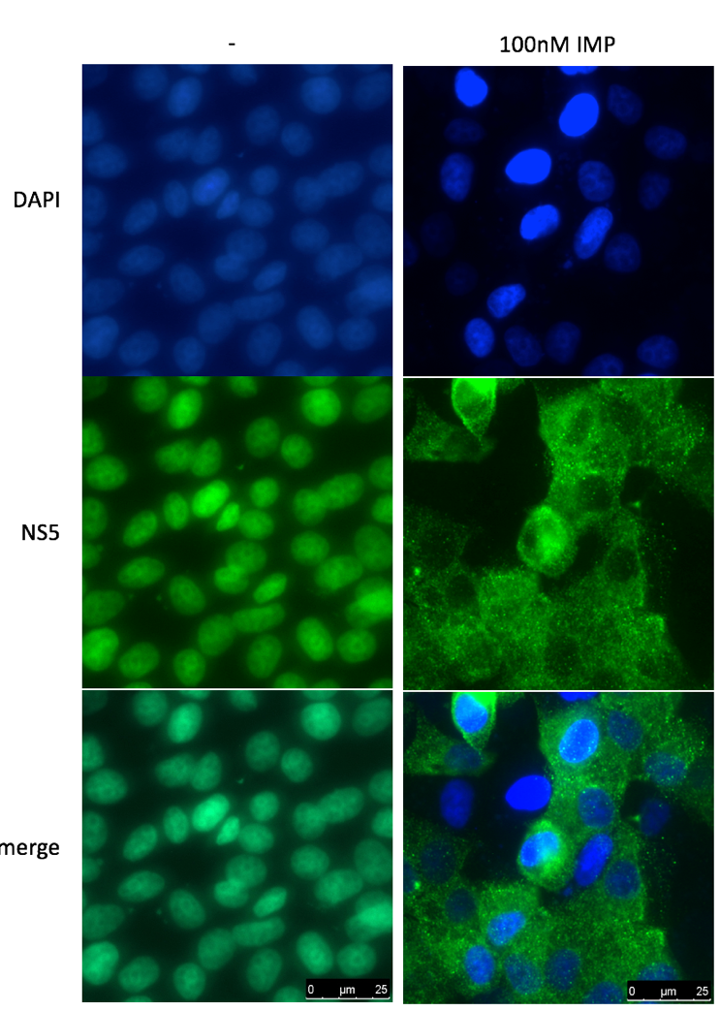

**Figure 11. NS5 translocated from nuclear to cytoplasm in Dengue virus-infected cells treated with IMP-1088.** In fact, the predicted cleavage site of DV2 is not myristoylated, etc…