**Data Warehousing with IBM Cloud Db2 Warehouse**

**INNOVATION:**

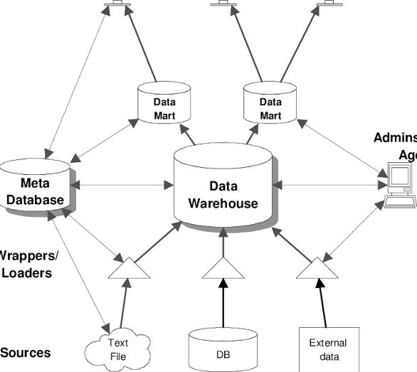

In data warehousing with IBM Cloud DB2 Warehouse involves leveraging its features and capabilities to drive business insights and gain a competitive edge. Here are some innovative approaches and strategies you can consider:

1. Real-time Data Processing: Implement real-time data processing using tools like IBM Event Streams or Apache Kafka. This allows you to ingest and analyze data as it arrives, enabling timely decision-making and instant insights.

2. Machine Learning Integration: Incorporate machine learning models into your data warehouse. Utilize IBM Watson Machine Learning to build predictive models and deploy them within DB2 Warehouse for advanced analytics and AI-driven insights.

3. Data Virtualization: Implement data virtualization techniques to create a unified view of data from various sources without physically moving or duplicating data. This reduces data redundancy and simplifies data access.

4. Data Governance and Security: Strengthen data governance and security practices by using features like encryption, access controls, and auditing provided by IBM Cloud services. Ensure compliance with data regulations such as GDPR or HIPAA.

5. Advanced Analytics: Explore advanced analytics capabilities, including geospatial analytics, time series analysis, and natural language processing. These techniques can uncover valuable insights from your data.

6. Integration with Cloud Services: Integrate DB2 Warehouse with other IBM Cloud services like Watson Studio, IBM Cloud Pak for Data, or Red Hat OpenShift for a comprehensive data and analytics ecosystem.

7. Scalability and Cost Optimization: Continuously monitor and adjust the scalability of your data warehouse to match your evolving needs. Use auto-scaling features to optimize costs while maintaining performance.

8. Data Visualization: Leverage data visualization tools like IBM Cognos Analytics or open-source alternatives like Tableau or Power BI to create interactive dashboards and reports for data exploration and storytelling.

9. Data Catalog and Metadata Management: Implement a data catalog and metadata management system to organize and document your data assets. This enhances data discoverability and understanding.

10. Collaboration and Self-Service Analytics: Promote collaboration and self-service analytics within your organization. Provide user-friendly interfaces for business users and analysts to explore and analyze data without IT dependencies.

11. Hybrid Cloud Integration: If your organization operates in a hybrid cloud environment, integrate on-premises systems with IBM Cloud DB2 Warehouse for seamless data sharing and analysis.

12. Continuous Learning and Training: Invest in training and skill development for your team to stay updated with the latest features and best practices in data warehousing and analytics.

Innovation in data warehousing is an ongoing process, driven by evolving technologies and business needs. It's important to align your data warehousing strategy with your organization's goals and explore how IBM Cloud DB2 Warehouse can help you achieve those objectives through advanced data management and analytics.