Module description
Library: | MPLCCommunication_Addins.lib
Module: | MC_Client_FTP
Author: | Cristian Adamo | Date: | 24.08.2009
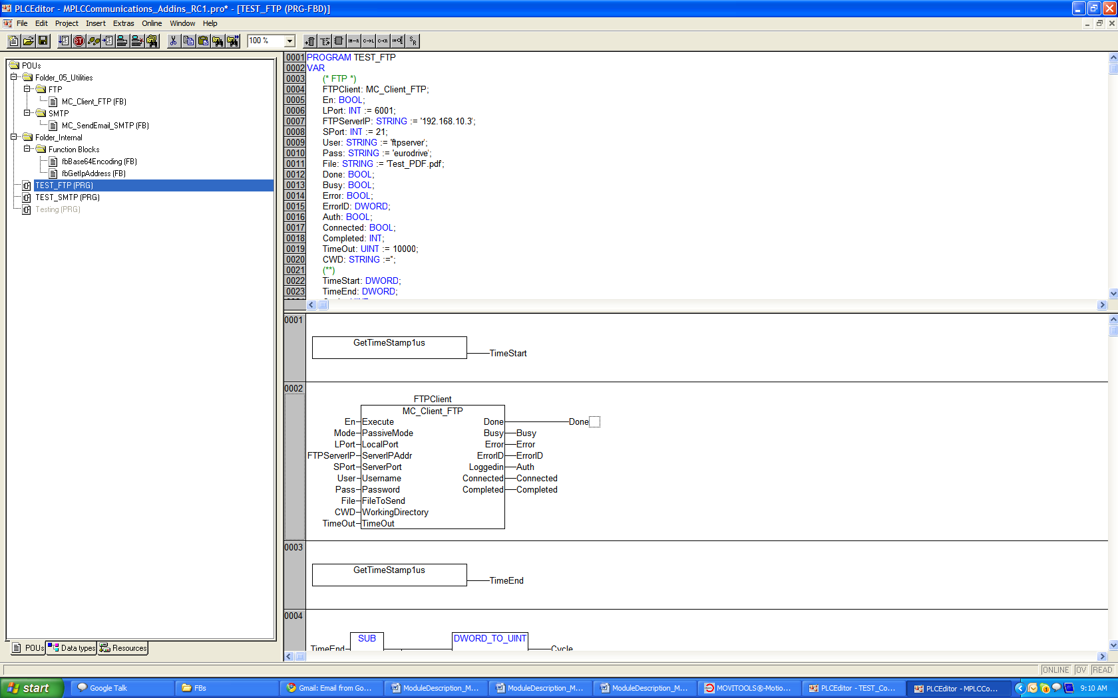

1 - Functional principles of the module:
The MC_Client_FTP allows the MOVI-PLC Advanced to send any type of file through the
File Transfer Protocol using the PassiveMode or ActiveMode.
The difference between those Modes is the following:

Active Mode:
The MC_Client_FTP opens a dynamic port and listens, waiting for a connection from the FTP Server. The MC_Client_FTP sends the follow command to the server:
PORT (192,168,10,10,192,1). The first four numbers (192,168,10,10 ) are the IP address of the server, the next two numbers are used to calculate the port opened. The server calculates the PORT as follows port1*256+port2 = PORT, e.g.: in this case the IP address is 192.168.10.10 and the port is 192 * 256 + 1 = 49153. Therefore, the port where the FTP server should establish the connection is 49153.

Passive Mode:
The FTP server opens a dynamic port and listens, waiting for a connection from the client.
The FTP server sends to the MoviPLC the following data, PASV (192,168,10,15,192,52)
The data order is the same as in Active Mode.

2 - Call of the function block in FBD:

Input Signals

Execute: DataType BOOL
The execution of the Module when it gets a rising edge on this input.
ActiveMode: DataType BOOL
Selecion of transference mode:
TRUE = Passive Mode (Sends the PASV Command),
FALSE = Active Mode (Sends the PORT command)
LocalPort: DataType UINT
Port of the MoviPLC where the server should establish the connection.
ServerIPAddr: DataType STRING(15)
IP address of the FTP Server.
ServerPort: DataType UINT
FTP port on the Server, commonly port number 21
Username: DataType STRING(80)
Username of the FTP account, if there are any.
Password: DataType STRING(80)
Password of the FTP account.
FileToSend: DataType STRING(80)
Name of the file to be sent altogether with the extension.
WorkingDirectory: DataType STRING(245)
Path of the directory where the file will be stored in the FTP server.
TimeOut: DataType UINT
TimeOut for the HeartBeat mode.

Output Signals
Done DataType BOOL
The file was sent successfuly.
Busy: DataType BOOL
The module is working.
Error: DataType BOOL
Error in the module.
ErrorID: DataType DWORD
Error code.
LoggedIn: DataType BOOL
The FTP client is logged In successfuly
Connected: DataType BOOL
The MC_Client_FTP is connected to the FTP server.
Completed: DataType UINT
Information from the current percentual of the sending process.

3 Monitoring the “LifeSigns” of the Module

Heartbeat-Mode
This mode will monitor the ProcessStep of the module. If the process repeats continuously in the same “step”, producing a loop, the Heartbeat-Mode timer will start a count up. When it reaches the TimeOut input value, the module will return a Time out error.

4 - Frameworks

Framework that gets the edges of the Execute input
Positive edge:
Start the Sending process
Negative Edge:
Resets all Outputs and closes all connections including the current opened file.

Framework to Check active errors
If it has active errors, closes all connections including the current opened file.

Main Framework that has the State machine for the sending process
It contains the Heartbeat-Mode, the State machine and the Error Provider Module in order to know which module is failing.

