Module description
Library: | MPLCCommunication_Addins.lib
Module: | MC_SendEmail_SMTP
Author: | Cristian Adamo | Date: | 24.08.2009
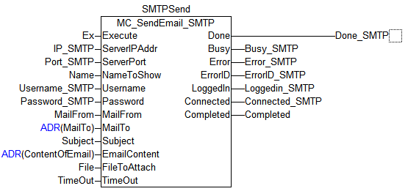

1 - Functional principles of the module:
The MC_SendEmail_SMTP allows the MOVI-PLC Advanced to send an e-mail to any destination with or without any files attached, which can be of any type (extension).

The sending process is based on the RFC 2821(SMTP).The content of it, is sent with MIME extension (RFC in its five parts), which determines the way of showing the content, the encoding type of it, the encoding type of the file and its very content. In this part, it´s defined over MIME as an “application/octet-stream” with Base64 (RFC 3548). This encoding (file content shown in Base64) is made by the fbBase64Encoding module.

2 - Call of the function block in FBD:

Input Signals

Execute: DataType BOOL
The execution of the Module when it gets a rising edge on this input.
ServerIPAddr: DataType STRING(15)
IP address of the SMTP Server.
ServerPort: DataType UINT
SMTP port on the Server, commonly port number 25
NameToShow: DataType STRING(80)
Name that will appear on the E-Mails viewer. E.g. FROM: MoviPLC instead of moviplc@sew-eurodrive.com.
Username: DataType STRING(80)
Username of the SMTP account.
Password: DataType STRING(80)
Password of the SMTP account.
MailFrom: DataType STRING(80)
E-mail address where the e-mail will be sent from.
MailTo: DataType DWORD
memory address of the Recipients variables (ADR)
Email addresses of the recipients where the e-mails will be sent to.To send e-mails to multiple recipients they must be separated with a semicolon.
Subject: DataType STRING(80)
Subject of the e-mail.
EmailContent: DataType DWORD
memory address of the variable who has the e-mail content (ADR)
Content of the e-mail.
FileToSend: DataType STRING(80)
Name of the file to be sent altogether with the extension.
TimeOut: DataType UINT
TimeOut for the HeartBeat mode.

Output Signals
Done DataType BOOL
The e-mail was sent successfuly.
Busy: DataType BOOL
The module is working.
Error: DataType BOOL
Error in the module.
ErrorID: DataType DWORD
Error code.
LoggedIn: DataType BOOL
The SMTP has logged in successfuly
Connected: DataType BOOL
The MC_SendEmail_SMTP is connected to the server.
Completed: DataType UINT
Information from the current percentual of the sending process.

3 Monitoring the “LifeSigns” of the Module

Heartbeat-Mode
This mode will monitor the ProcessStep of the module. If the process repeats continuously in the same “step”, producing a loop, the Heartbeat-Mode timer will start a count up. Once it reaches the TimeOut input value, the module will return a Time out error.

4 - Frameworks

Framework that gets the edges of the Execute input
Positive edge:
Starts the Sending process
Negative Edge:
Resets all Outputs and closes all connections including the current opened file.

Framework to Check if there are any active errors
If it indeed has active errors, closes all connections including the current opened file.

Main Framework that has a State machine for the sending process
It contains the Heartbeat-Mode, the State machine and the Error Provider Module in order to know which module is failing.

