DOCUMENTATION

ASSIGNMENT 2

NUME STUDENT: CRISAN OANA ANDRA
GRUPA: 30421

CONTENTS OF TABLE

1. Objective 3
2. Problem analysis, modelling, scenarios, use cases 3
3. Design 3
4. Implementation 3
5. Results 3
6. Conclusions 3
7. Bibliography 3

Objective
The main objective is to design and implement an application aiming to analyze queuing-based systems by simulating a series of N clients arriving for service, entering Q queues, waiting, being served and finally leaving the queues, and computing the average waiting time, average service time and peak hour. The sub-objectives are the following: analyzing the problem and identifying the requirements, designing the simulation application, implementing the simulation application and testing it.

Problem analysis, modelling, scenarios, use-cases

Problem analysis:

As in a real-life situation, this management system should imitate several clients entering queues (like in a supermarket).
Due to the different queues, clients should be processed independently and simultaneously. The concept is to look at the amount of clients and queues in order to position each client in the most efficient queue at the time.
Different sets of data could be tested through the graphical interface, the user being able to choose the number of queues and clients and the simulation intervals.

Scenarios and use cases:

Primary Actor: user

Use-case diagram:

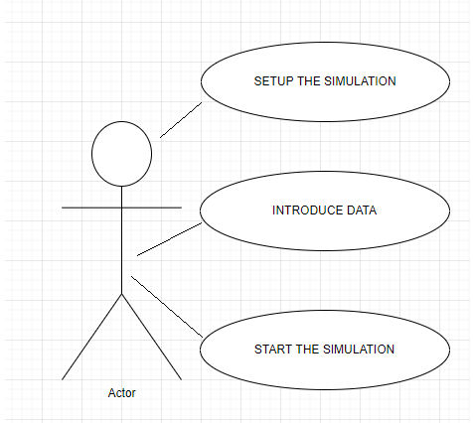

Main Success Scenario:

- The user introduces data such as: number of clients, number of queuees, simulation interval, minimum and maximum arrival time and mininum and maximum service time.
- The user presses the start simulation button for validating the data and starting the simulation.
- The simulation window will appear and the user will be able to see a log of events.

Alternative Sequences:
- Alternative sequences may appear if the input values are not valid. In this case, the user will be informed about the mistake via a message specifying where he/she has done wrong

Design
I chose for my application to have a MVC (Model – View – Controller) architecture which has 4 packages:

- Application: starts the application
- Model: classes which “simulate” the clients and the queues
- Gui(view): classes for the user interface
- BusinessLogic(controller): makes the connection between the classes from the Model and View packages

Package Diagram:

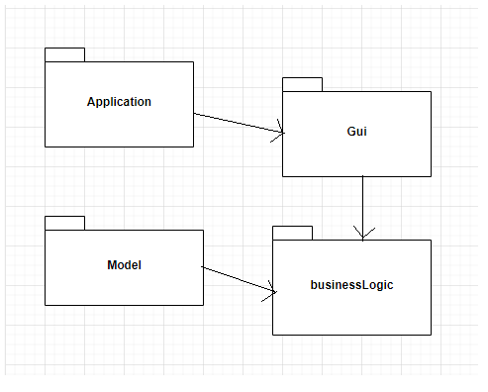

Class Diagram:
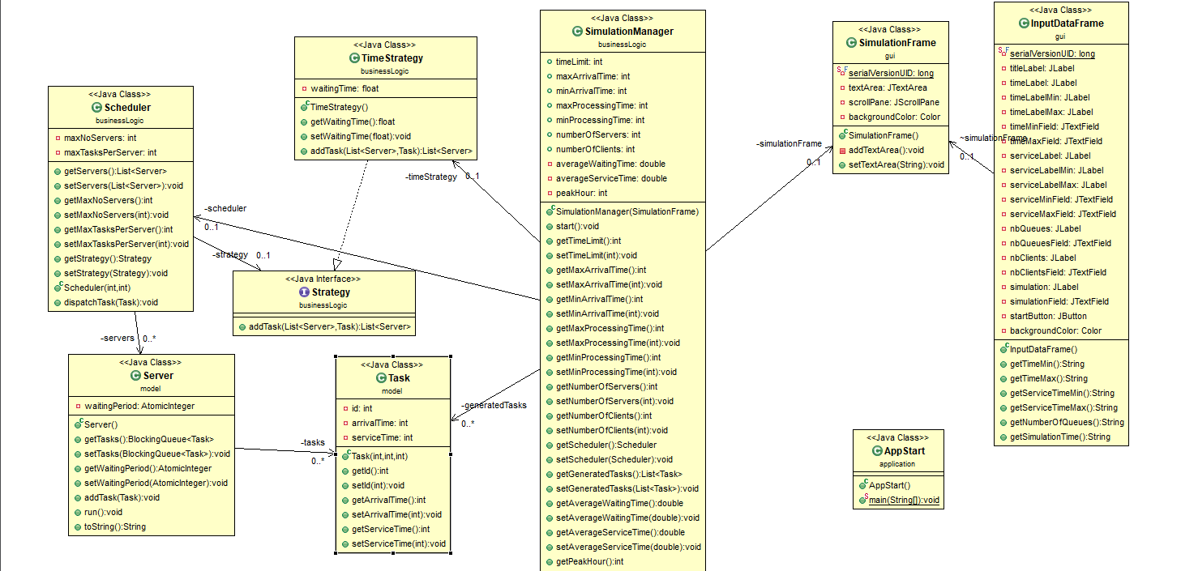

Data Structures:

For the implementation of the application I used the Blocking Queue, ArrayLists and servers and tasks (defined by me). Another special type of used data might be Atomic Integer which has the purpose to minimize threads’ errors.

Implementation
My implementation consists of a MVC architecture, containing 4 packages with the following classes:

Application:

AppStart:

- Contains a method which starts the application by .calling the method run() from the class SimulationManager and starting a thread

Model:

Server:

- This class contains the attributes for the queue and the waiting time
- Apart from the constructor, getters and setters, this class also contains two methods
- One returns a string for the display, while the other one takes care of the generating of the corresponding thread

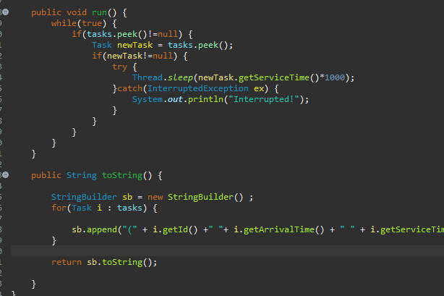

Task:

- Contains the attributes of a client: id, arrival time and service time
- As for the methods, there are only getters, setters and the constructor

businessLogic:
Strategy:

- This class is actually an interface which contains the method responsible for choosing the strategy applied on the queues
- At the moment only time strategy is available

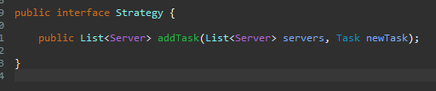

TimeStrategy:

- This class implements Strategy interface
- The method addTask returns a list of tasks ordonated by the total waiting period of the queues

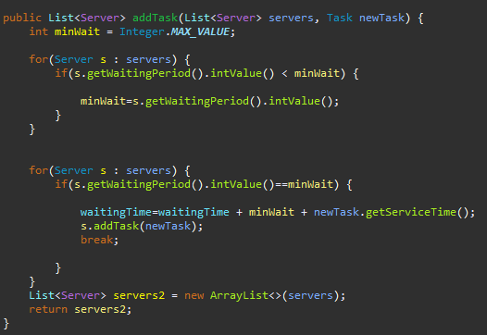

Scheduler:

- This class has the following atributes: a list of servers (queues), the maximum number of servers, the maximum number of tasks per server and the strategy
- Apart from getters and setters, there are the constructor (which starts the thread and creates the list of servers) and the dispatchTask method (which adds a task in relation with the chosen strategy)
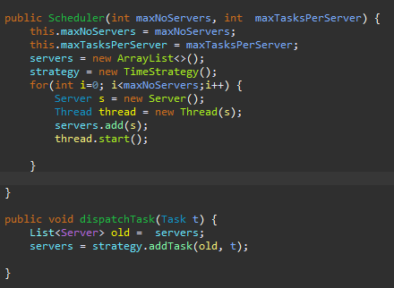

SimulationManager:

- This is the most important class from the application because it makes the connection between the interface and the code
- The method run() is the one that takes the data from the gui and processes it in order to start the simulation
- Here are also computed reports obtained after the simulation and puts them in a text file

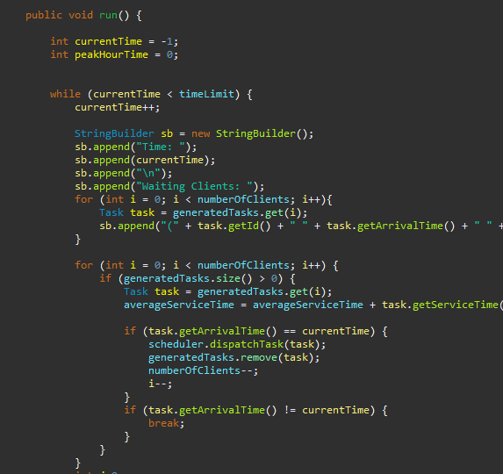

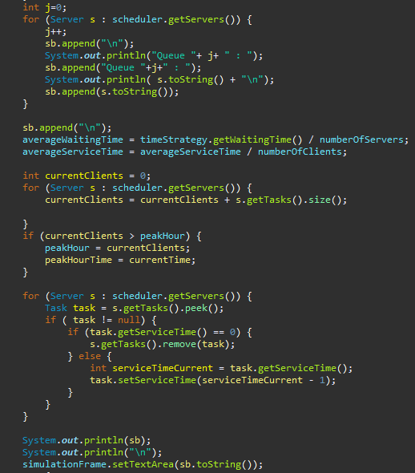
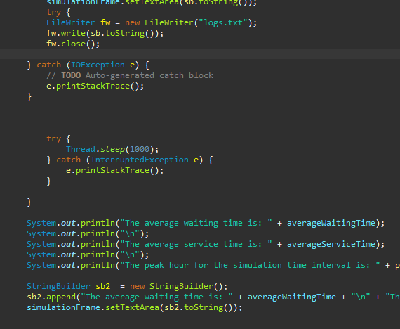

Gui:

InputDataFrame:

- This class contains the elements necessary for the user interface where he/she introduces the data

SimulationFrame:
-
This class contains the elements necessary to implement the results from the simulation

Results
The result of the simulation can be seen in the console, in the graphical interface and in a text file. At the end of the simulation, the user may see some statistics regarding the average waiting time, the average service time and the peak hour.

Sim1:
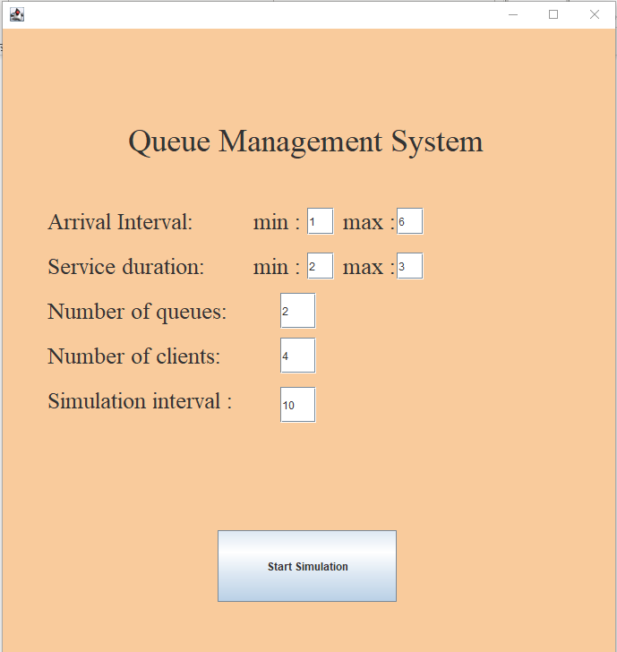

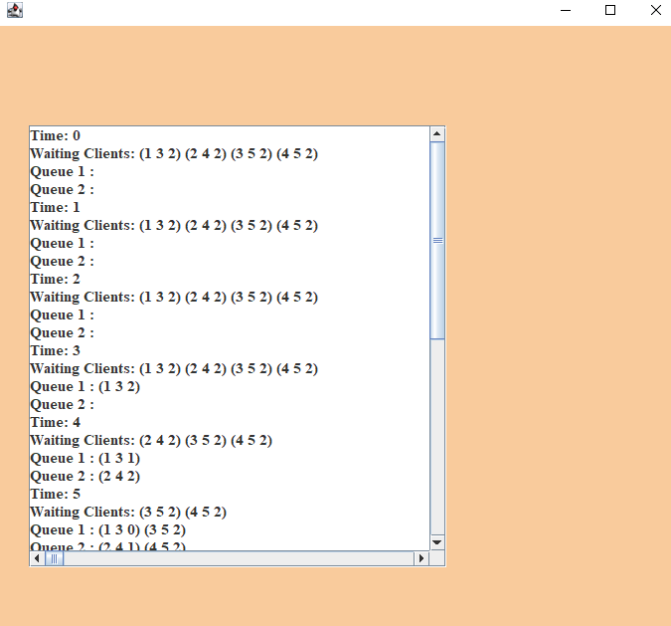

Sim2:

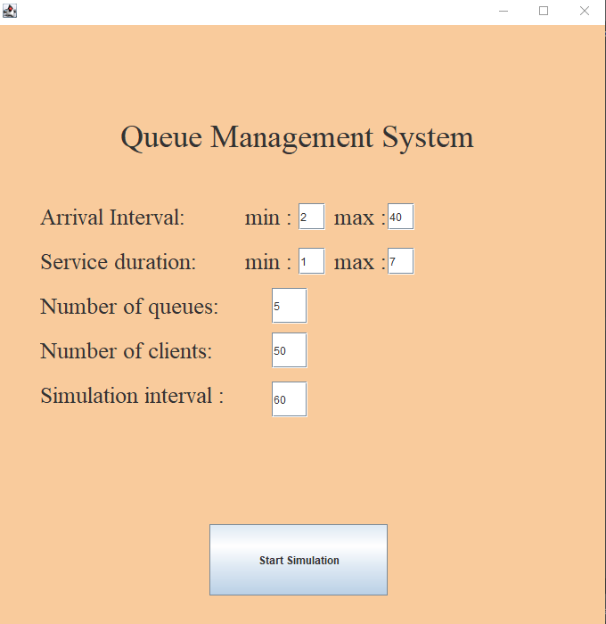

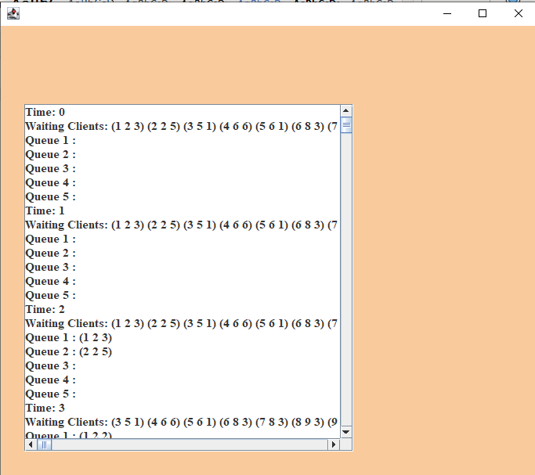
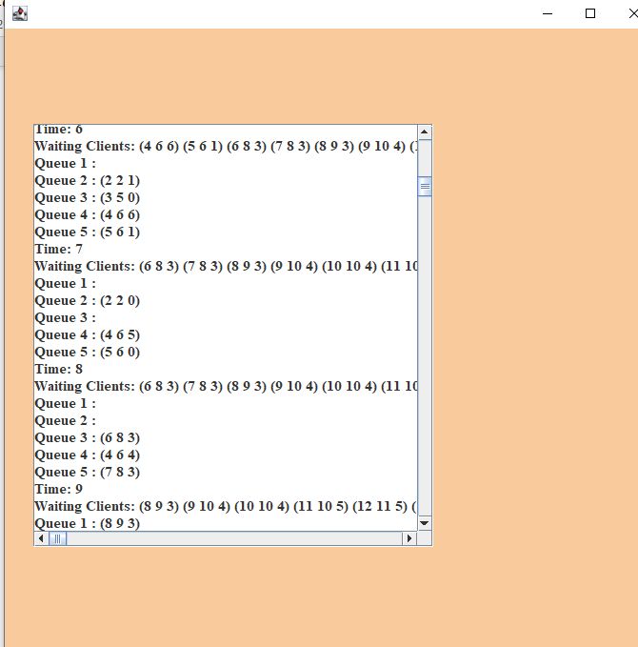

Sim3:
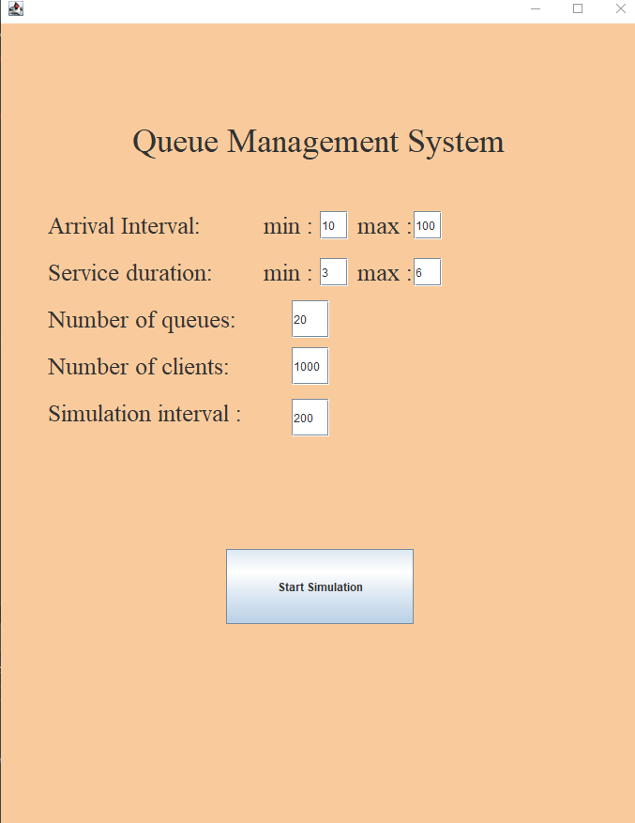

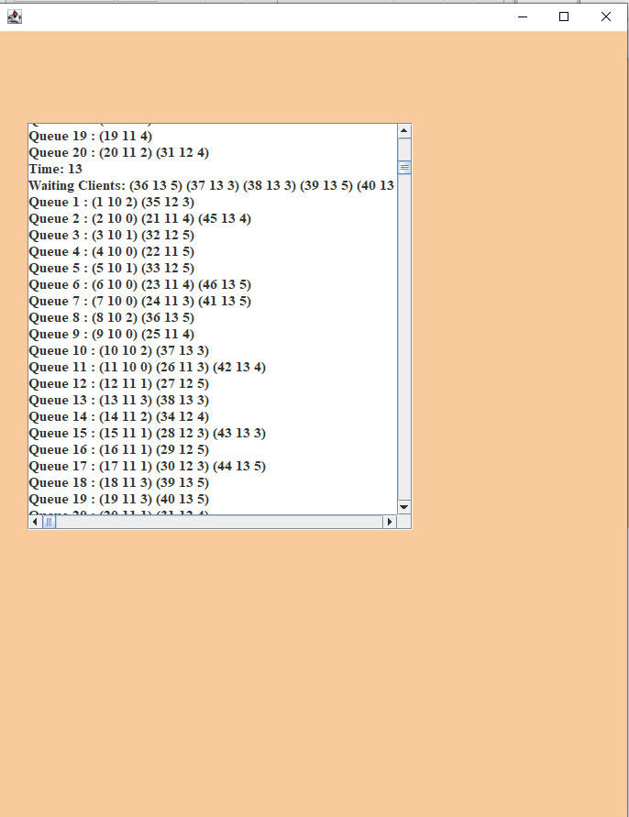

Conclusion
Working with threads can be difficult, especially when you have a lots of them, because they require a huge amount of attention. This project taught me something new and taught me how to create a simulation on my own. These ideas will undoubtedly be implemented in the future.

Bibliography

https://dsrl.eu/courses/pt/
https://docs.oracle.com/javase/7/docs/api/java/util/concurrent/BlockingQueue.html

