1. Introduction (5 marks)
Middlesex University:
- Type of business
- Objective, vision and scope
  - Try to get an updated version of the files below:
  - University Regulations for the Academic Year 2004/2005
  - Equality and Diversity at Middlesex University

Click here for more information about the pyramid below.
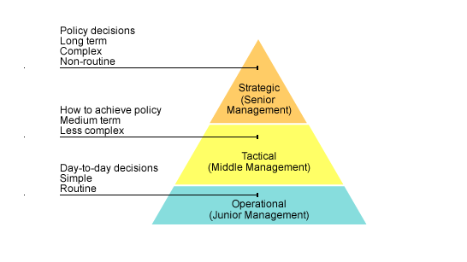

2. Analysis of Operational Systems and Data Sources (20 marks)
What operational system they have in place?
What data is stored?
What are the tables?
How are they connected?
What are the advantages and disadvantages of the current system?
Design an ER diagram from the Marketing department. UML notation!
Include the Determinacy diagram
Design the DFD diagram (extra points!)
Data store (DFD) is an entity on the ER and tables on the database schema
Advantage and disadvantage of having a data warehouse (Slide week 4)

3 - Data mark design
Two subject areas, within the section of the business
Snowflake is normalised! Star schema is not

4 - ETL process
How extract data from operational system?
What do you do with it before storing on the data warehouse?
Implement the prototype of one of the star schema

5 - OLAP.
How to query it?
What would managers be interested at?

6 - Conclusion
What challenges do we have to keep it up and running?
Performance? Amount of data stored. Flexibility to adapt/include/remove different columns.

