­­­­­­



**School of Science and Technology**

**BIS3214**

**Data Warehousing and Business Intelligence**

**Autumn/Winter term**

**2014/2015**

|  |
| --- |
| **Date:** 23rd January 2015 |
| **Supervisor:** Dr. Syed Murad |
| **Campus:** Hendon |
| **Group Members:** |

|  |  |  |  |
| --- | --- | --- | --- |
| Cristiano Cardoso Maia  M00322036 | Jade Van Nelson  M00405270 | Kateryna Vyshnyak  M00330646 | Veeraj Bhura  M0041555 |

Table of Contents

Introduction 3

Middlesex University 3

Types of Management 3

Objectives, Values and Mission 3

Marketing Department 4

Analysis of Operational Systems and Data Sources (20 marks) 4

Entity Relationship Diagram(ERD) description 4

Advantages and Disadvantages to Using a Data Warehouse 8

Data mark design 9

ETL process 9

OLAP 9

Conclusion 9

References 9

# Introduction

## Middlesex University

A University in England with roots back to 1878 who has since build up a reputation in London and international as a providing a high level of higher education from its wealth of experience and strategic operational capabilities. Through strengthening our efficiency by employing highly qualified academics, attracting the best ambitious students and strengthening our research reputation we can capitalise internationally on becoming an excellent international tertiary education establishment.

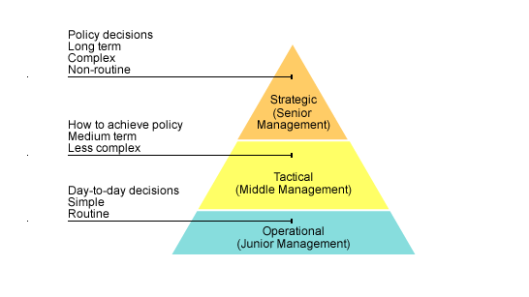

Figure - Reference http://www.bbc.co.uk/bitesize/higher/business_management/business_enterprise/decision_making_business/revision/1/

## Types of Management

The Government Business Reference Model shown above illustrates the three levels of control that the university runs with. All major decisions that has to be made as far as what the university needs to achieve long-term and how they need to achieve it are made at the Strategic level (Senior Management). On the same level you will find job titles such as dean, chancellor, vice chancellor and many other high-ranking job titles as they have the power and knowledge that it takes to make complex decisions.

All the decisions made by the Senior Management team will be passed to the Tactical level of management (Middle Management). This action is important to make sure the whole University is aligned with the same objectives and aims. Middle management staff (such as the head of department) will be responsible to develop a plan to implement the direction given to the managers in the operational bracket.

Finally, the Operational level (junior management) is responsible to implement the overall goal. This level is where professors, librarians and other university staff that deals directly with the students, will take the instructions from the above two management teams. With the training and experience provided by Middlesex they will be able to implement the strategies to turn the strategic plans in reality. They will also be responsible do report their progress directly to the Middle management team.

## Objectives, Values and Mission

Our Objectives are to attract students that are determined to succeed and support these students with the correct support and insure student satisfaction by developing policies to maximise their performance. We strive to enhance graduate level employability in an effort to improve our university rankings. We have strategies and policy to organise our schools to enhance excellence.

“Our vision is to become a leading University of choice, recognised internationally for excellence in all that we do.”

## Marketing Department

Middlesex University Marketing department is based at the Middlesex University London campus. The department specialises and focuses on each of the five schools across three different campuses universally. The department receive funding for our advertising projects from the relevant departments. The marketing department managers will detail projects and allocate tasks accordingly. This will be inline with equity and diversity strategic strategy ([Equality and Diversity at Middlesex University](https://www.mdx.ac.uk/__data/assets/pdf_file/0009/58707/Equality-and-Diversity-Strategy-2013.pdf)), University regulations ([University Regulations for the Academic Year 2004/2005](http://www.web.mdx.ac.uk/regulations/archive/regs0405/STS.HTM)) and decision-making and discussions held at middle management meetings. There after the relevant departments would handle the assignments and would also manage the suppliers and supplies to the project via task ID and project ID. Middlesex University will not consider all staff to be participating in one project each staff member will be assigned to a specific project and task in that project.

The projects are based on the development of current marketing tools available. E-commerce and online marketing trends are generating popularity and there for more funding is spend on online marketing thus to insure that the marketing department achieves its aims and goals. These projects are the same projects from the departments of each school and the content is made available in the means of online marketing and various other outlets depending on the projects.

The list of local and international suppliers the suppliers contracts are available either locally, nationally or internationally. The supplier catalogs and the supplier contracts are saved in the contracts database. A specific enquiry regarding contracts and agreements with the relevant suppliers will be approved by the marketing department and will be inline with the university's framework, mission or scope, the suppliers can provide anything that will physically assist the projects needs.

Permanent MDX staff will not be considered for these projects as they are the “clients”.

Overall the objectives of the marketing department is to attract students that work hard and willing to go the extra mile to reach success in their studies.

The marketing department is important for the whole University as it influences the direct correlation between the success rate and the rates of new students attending the University. The marketing department is one of the most important business departments of most any company but especially so in this case as the University renders a services namely education.

# Analysis of Operational Systems and Data Sources

## Entity Relationship Diagram(ERD) description

In introduction to the following report we will be covering various topics, thus starting with the link between the advantages and disadvantages of operational databases to data warehouses. We will also cover the how the marketing department has developed its own operational database in correlations with a ERD.

The different projects allow the University to meet its objectives by planning events and managing these events. These projects have cost and they are directly related to the project thus a budget is set by each department as to how much would be spend.

The values are met by taking into consideration the long-term effects these projects will have on staff members, attendees and the different attractions held at these events that could generate positive publicity in line with the values of the university.

The mission is to attract the highest amount of high calibre students and by having different projects like open days, digital and social media events, career events and more traditional events at university like research projects the marketing fulfil its mission.

The ERD that we have displayed below shows all the different entities and their attributes. This will allow us to show relationships across all the entities and compose a data mart that will display relevant information so that Middlesex University at the strategic level can make informed choices in how the budget should be used. The ERD will also show the university a cornucopia of other information like what suppliers are used at certain events and what the turnout of the event was. The ERD is vital to the success and longevity of the database and the data mart as if any relationships are missing or any entities have been missed this could result in the error in running queries and retrieving accurate results.

At every event each member of staff plays a crucial role like events management, relations officer from marketing would be there to insure that everything goes according to plan. The member of staff is picked for each event by a few criteria; these criteria are their expertise as to the role that they are required to fill.

After events and during the course of the year all staff members that are part of the Middlesex University marketing department or are part of an event that the marketing department has held need to be paid for their work.

To keep a track of all the task and how they were accomplished in the past will help us to understand perhaps how to overcome current difficulties but also will be beneficial to justify our expenditure. How we have managed the task indirectly relates to our budget and therefore we could justify requesting more budget for projects as we have x y and z amount of task that was not completed with other projects and therefore we perhaps under performed as a marketing department

Different venues can be held in different countries thus the university fulfils its mission of attracting international attention as well as focusing on the international students who represent a large amount of the university target audience.

Each project would occur at a venue and to organise the events would have different sessions booked in by booking therefore being able to ascertain the correct amount of space allocated. This takes care of the logistical matters like seating plan, amounts expected to be catered for and falls under general event management.

**Van/Veraj**: Update the entities and relationship according to the new ERD. Double check if the paragraphs above are updated as well.

1. **Role - Staff**

Each member of staff in the department have a specific role to play.

1. **Staff- Tasks - Projects**

A project can have 0 (in case the tasks hasn't be assigned yet) or many tasks but a specific task can only be related to one project. An extra table called Task History is responsible to keep track of all the tasks from any project even if it has been archived. Along with the keeping track of the staff that was part of the task.

1. **Address - Venue - Booking-Session**

The marketing department has a list addresses of venues names and locations. These venues are booked by bookings, each session is part of an event.

1. **Attendee list - Sessions**

For every session there is an attendee list so that the number of attendees can be recorded for later analysis.

1. **Events - Projects**

An event can have 0 (if the event is online) or many to many projects. Events are optional for each Project but one event can only be related to one Project at time.

1. **Task-Project**

There is a one to many relationship between Projetcs and Tasks as each project has to be part of Projects. At the begining of each Project there will be no task thus 0 as minimum but as time progresses there will be many task to one project.

1. **SupplierRep - Supplier - Projects**

A SupplierRep works for a SupplierCompany.There is a one to many relationship but a there has to be a supply company though there does not have to be a Rep as some supplies are done with out SupplierRep.Each project has to have a to be supplied and these supplies can be from many different suppliers thus there is one to many relation between SuppliersRep and Projects(This resolve the many to many problem).Theres is how ever a 0 to one relationship as there does not have to be supplies to a project as some projects might not need supplies.

1. **BudgetCodes - Department**

There can be 0 or many budget codes belonging to a specific department 1.

1. **BudgetCodes- Projects**

There can be 0 or many budget codes belonging to a specific project 1.

1. **Expense sheets - Budget Codes**

There can be 0 or many budget codes belonging to a expense sheet 1.

**Cristiano**: mention the external data sources!

Unistats like external stats on the university

How many student where registered per year from different data marts.

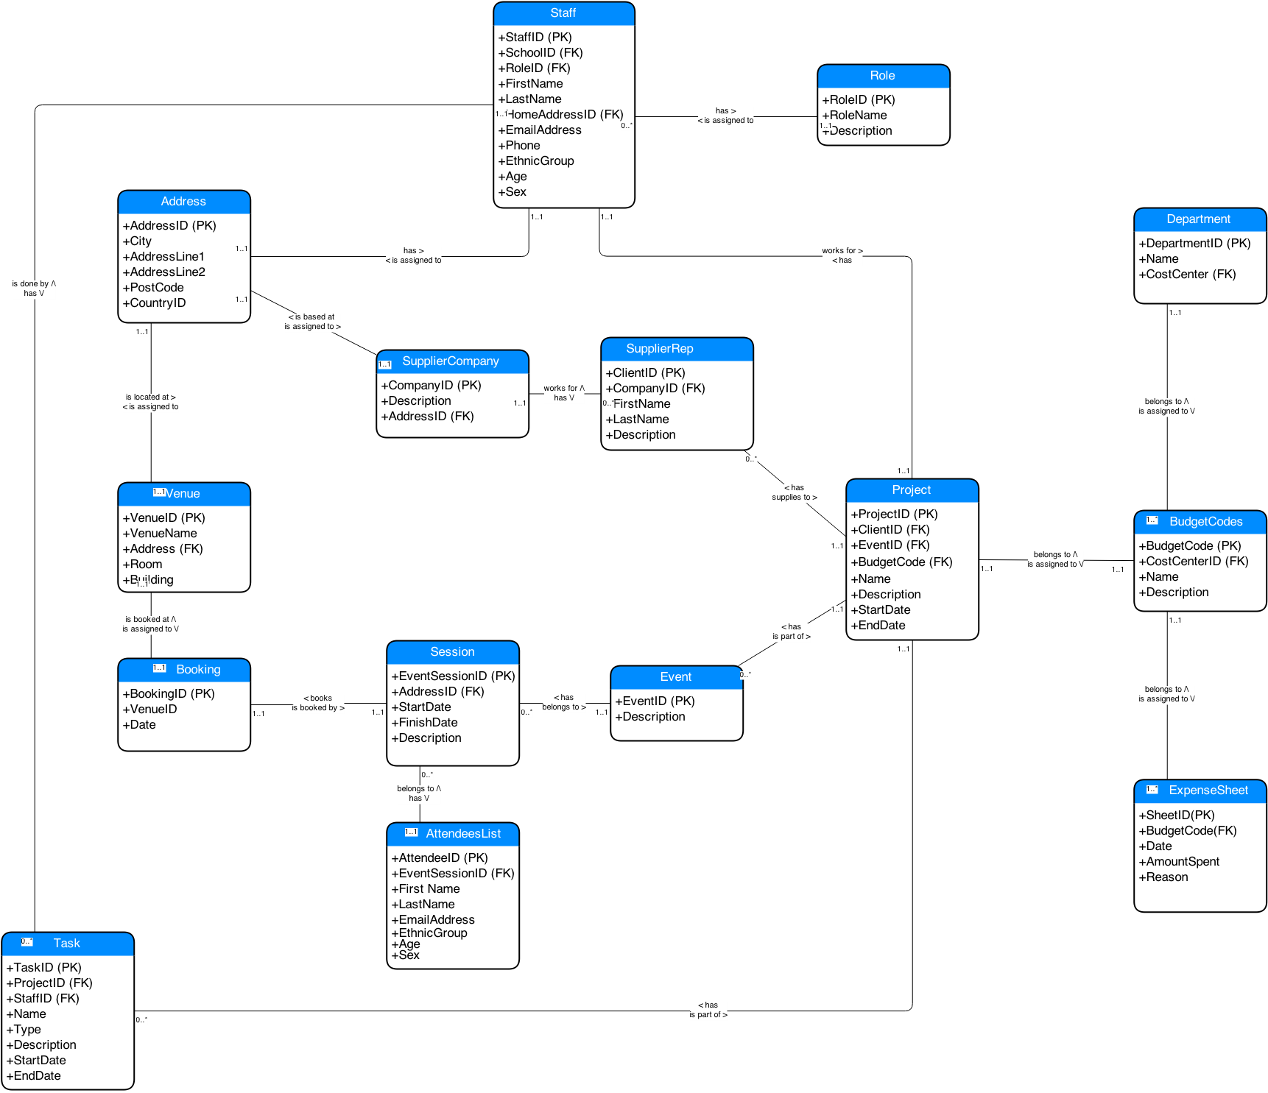

## Advantages and Disadvantages to Using a Data Warehouse

Operational database is designed to process and manage dynamic flow of real-time data. It allows access to the archived data and permits data modification of this data such as deletion, adding or updating. The significant difference between operational and warehouse systems are that operational system designed to assist with transaction process whereas data warehousing oriented for online analytical process (OLAP) (Exforsys). Therefore usage of data is optimized for different purposes, see Table 1 below.

|  |  |
| --- | --- |
| **Operational Database** | **Data Warehouse** |
| Provides process-oriented or process-driven analysis only around defined processes of the business and its tasks. | Provides subject-oriented analysis with main focus on the business area where company requires strategic decisions. The collected information is concise about particular issue and collected from more then one operational sources. The data analysis produce information about short-range strategies its assessment and evaluations. |
| Dealing with current data and this data updated on the regular basis. | Dealing with historical data and this data rarely changed. Data warehouse stores information as non-volatile and read only format. This data is loaded on the regular basis and growing constantly. |
| System optimized for fast data uploading but small content at the time. | System optimized for fast data retrieval and large content at the time. |
| Data is specific to application performance; therefore it is non-integrated or partially integrated causing data redundancy. | Controlling data redundancy problems within DBSM integration layer. |
| Doesn’t require expert level of computing skills to navigate system. | Requires advance computing knowledge to navigate system. |
| Supporting high-volume transaction performance with minimum rear reporting. | Supporting high-volume analytical transactions with maximum reporting that promptly used for making strategic decisions. |

Table Operational system VS data warehouse (Rensselaer).

Data Warehouse is computerised system for storing information. This information helps organisation to analyse historical patterns and make important business decisions. The advantage of having large repository of information that it helps to solve number of problems, increase company profitability while and reduce cost to access this historical data within external sources. Furthermore, the data is consistent, relevant, structured and combined from various locations into one centralised location. This data centralisation helps to find multiple solutions than where data analysed separately. Data Warehouse allows storing already retrieved data within operational level that improves turn around time of data reporting and analysis (Power).

The advantage of having data warehouse in marketing is that the data is static and provides a "single version" of the truth about enterprise activities. To understand better its customers – students, future prospects on the marketplace and event’s opportunities to attract more students – customers, researchers and funds.

However there are a number of disadvantages that need to be addressed. Firstly, data warehouse is very expensive to maintain, as data itself must be normalised, loaded and extracted. Moreover, company have to train their users, otherwise it could lead to the security problems while conducting any queries via online access. Secondly, there is always a chance that new transaction system may not be compatible with the currently used systems. There are also a numerous ways of storing information in the data warehouse and applying one set of rules might not be beneficial if in the future company decides to change the way it conducts business (Exforsys).

# Data mark design

http://www.peopleinaid.org/pool/files/hhr/HHRAfrica2014/HHRAfrica-KimberleyRyan-HRmetrics-UchennaBassey.pdf

* The identification of two subject areas, identified during 2, which would be of benefit to the managers your organisation.
* The design of the star schemas associated with both subjects area identified in 3.1
* A discussion of the granularity of dimension and fact tables
* The extension of one of the star schemas into a snowflake schema.

Two subject areas, within the section of the business

Snowflake is normalised! Star schema is not

Add content here

# ETL process

How extract data from operational system?

What do you do with it before storing on the data warehouse?

Implement the prototype of one of the star schema

# OLAP

How to query it?

What would managers be interested at?

# Conclusion

What challenges do we have to keep it up and running?

Performance? Amount of data stored. Flexibility to adapt/include/remove different columns.

# References

Exforsys, Advantages and Disadvantages to Using a Data Warehouse | IT Training and Consulting – Exforsys. Available at: http://www.exforsys.com/tutorials/data-warehousing/advantages-and-disadvantages-to-using-a-data-warehouse.html [Accessed November 14, 2014].

Power, D., Ask Dan! about DSS - What are advantages and disadvantages of data warehouses? Available at: http://dssresources.com/faq/index.php?action=artikel&id=180 [Accessed November 14, 2014].

Rensselaer, Operational Systems vs. Data Warehousing. Available at: http://www.rpi.edu/datawarehouse/dw-about-cmp.html [Accessed November 25, 2014].