**Questions structure:**

English question

OLAP Type

Query

Summary

**Business question:** What is the average budget per departments for all event types and how can we compare this to the amounts spent for that department?

**Olap type:** Roll-Up

**Query (average budget):**

SELECT D.D_NAME AS DEPARTMENT,

AVG(B.TOTAL) AS "AVERAGE BUDGET SPENT",

SUM(B.TOTAL) AS "BUDGET TOTAL SPENT",

COUNT(B.DEPARTMENT) AS "PROJECTS COMPLETED"

FROM DEPARTMENT_D D, BUDGET B

WHERE B.DEPARTMENT = D.D_NAME

GROUP BY ROLLUP(D.D_NAME)

ORDER BY D.D_NAME;

**Result:**

DEPARTMENT AVERAGE BUDGET SPENT BUDGET TOTAL SPENT PROJECTS COMPLETED

-------------------- -------------------- ------------------ ------------------

Arts 1000 1000 1

Business 277.5 1110 4

Health Education 400 1200 3

Law 2125 10625 5

Media 3875 7750 2

Science Technology 4375 17500 4

**Summary:**

The query and the result matches and therefore we can see the budget average of each department.The intelligence come from being able to calculate the total spend and compare it to the average budget therefore being able to match the correct pattern of spending on each department.

We have compared the average budget for each department and have found that *Health Education* on average spends 400 pounds per event and a total of 1200 was spend on the three events they had.

We compared this to Arts that had only one event with a average spend of 1000 and therefore can draw the conclusion that Health and Education has spend their budget more sensibly.

Comparing

1. What is the total amount spend on per project for all departments.
2. What amount of projects have been completed since the beginning.
3. What were the under budget projects and how much money was left from each?

-----------------------------------------------------------------------------------------------

**Business question:** What amount of projects have been completed since the beginning.

**Olap type:**

**Query ():**

**Result:**

**Summary:**

-----------------------------------------------------------------------------------------------

**Business question:**

**Olap type:**

**Query ():**

**Result:**

**Summary:**

-----------------------------------------------------------------------------------------------

**Business question:**

**Olap type:**

**Query ():**

**Result:**

**Summary:**

OLAP

# ROLL UP: summarize data

SELECT S.product_id, St.city, SUM(S.sales_amt)

INTO City_sales

FROM Sales S, Store St

WHERE St.store_id=S.store_id

GROUP BY S.product_id, St.city

SELECT T.product_id, St.State, SUM(T.sales_amt)

FROM City_sales T, Store St

WHERE St.city=T.City

GROUP BY T.product_id, St.State

# **DRILL DOWN: reverse of roll-up**

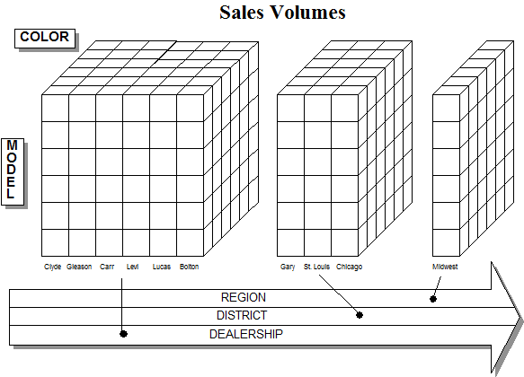

SELECT department_id event_id,

FROM Budget

GROUP BY department_id,event_id;

SELECT S.product_id, S.store_id, SUM(S.sales_amt)

FROM Sales S

GROUP BY S.store_id, S. product_id

SELECT S.product_id, St.state, SUM(S.sales_amt)

FROM Sales S, Store St

WHERE St.store_id=S.store_id

GROUP BY S.product_id, St.state

SELECT S.product_id, St.city, SUM(S.sales_amt)

FROM Sales S, Store St

WHERE St.store_id=S.store_id

GROUP BY S.product_id, St.city

# PIVOTING: reorient the cube, visualization, 3D to series of 2D planes

Pivoting on product & time corresponds to grouping on prod_id & quarter & aggregating over store_id

SELECT S.product_id, T.quarter, SUM(S.sales_amt)

FROM Sales S, Time T

WHERE T.time_id=S.time_id

GROUP BY S.product_id, T.quarter

# **Slicing: Slice and dice: project and select**

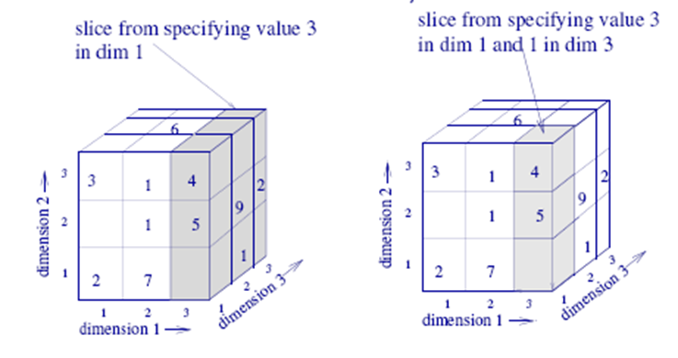

When we use WHERE to specify a particular value for an axis, we are performing a SLICE

Slicing in the time dimension: choosing sales only in week 12, then pivoting to product_id (aggregating over store_id)

SELECT S.product_id, SUM(S.sales_amt)

FROM Sales S, Time T

WHERE T.time_id=S.time_id & T.week=12

GROUP BY S.product_id

# Dicing: When we use GROUP BY to specify part of an hierarchy, we are performing a range selection called a DICE

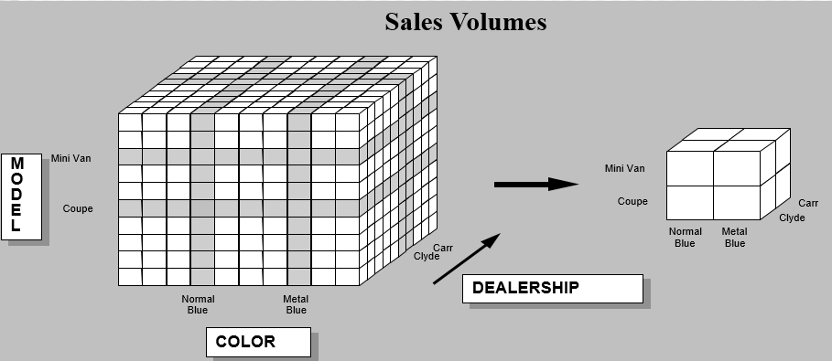

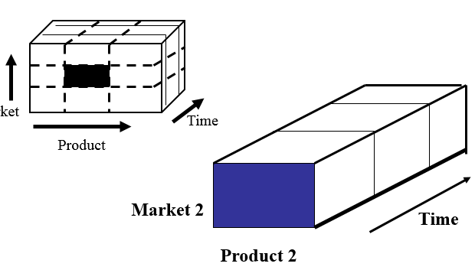

Dicing Sales in the time dimension: total sales for each product in each quarater

The end user selects the desired positions along each dimension

The data is scoped down to a subset grouping

When we use GROUP BY to specify part of an hierarchy, we are performing a range selection called a DICE

Dicing Sales in the time dimension: total sales for each product in each qurater

SELECT S.product_id, T.quarter, SUM(S.sales_amt)

FROM Sales S, Time T

WHERE T.time_id=S.time_id

GROUP BY T.quarter, S.product_id