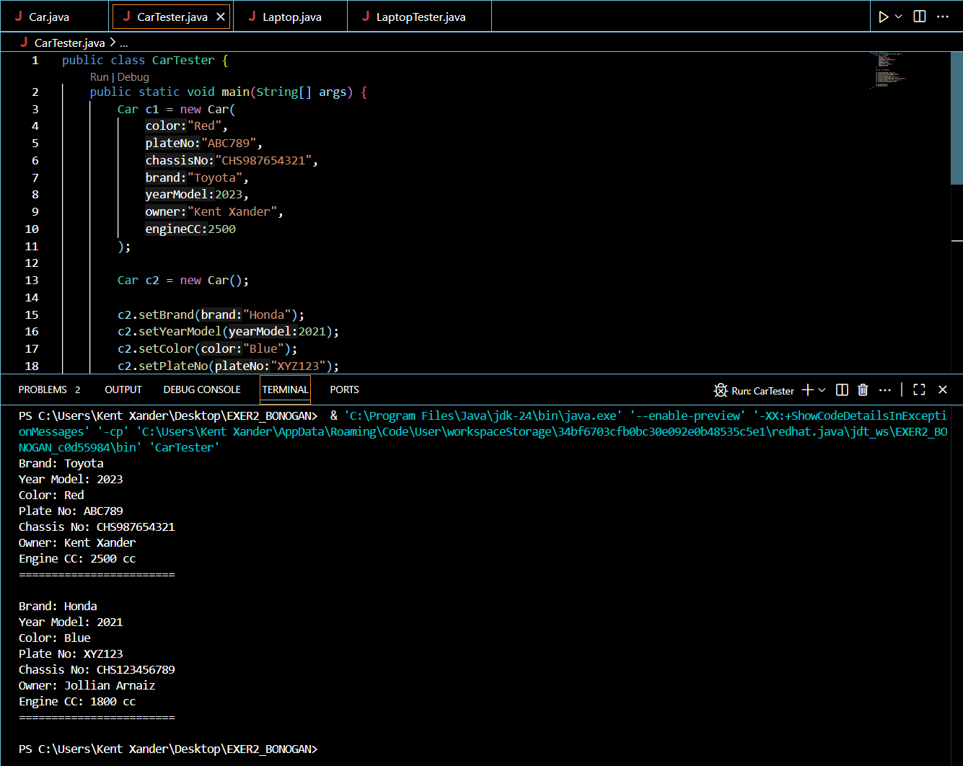OUTPUT OF CarTester.java

OUTPUT OF LaptoTester.java

