- Install Python package
- Installing Flask
- Install MySQL database
- Create a database. The database creation file is fingerprint.sql
- Configure the set.conf file in the database config file
The red lines are the database username, database password, and database server.
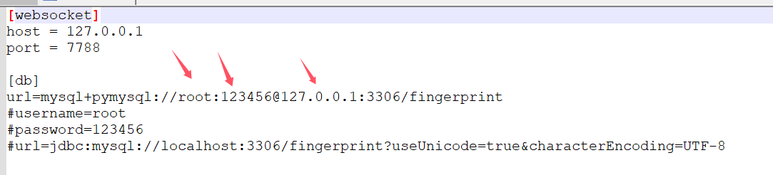
- websocket configuration
host 127.0.0.1 default configuration
Port The port of the websocket service
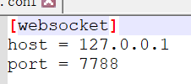

- Run SDK
Run py.bat to start the project
Note: py.bat file settings
host=192.168.0.174 is the IP address of the debugging computer or server
port=7788 The port where Flask runs
python.exe -m flask run --host=192.168.0.174 --port=7788
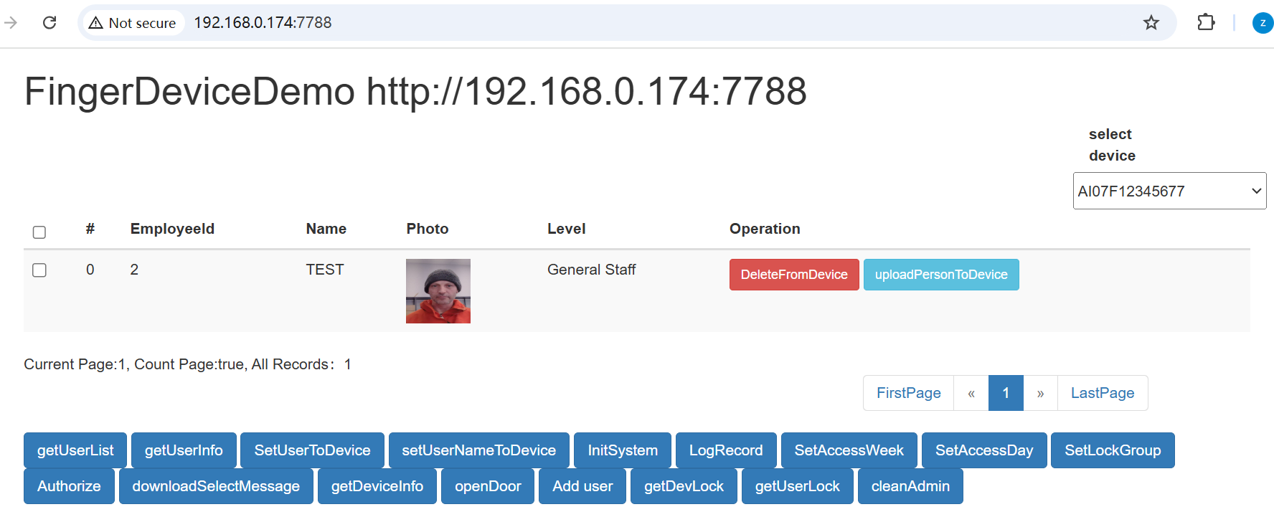

7、If you cannot run the SDK, please run the python.bat file that comes with the SDK to check whether the problem is solved.
8、Device menu settings
1、MENU--Comm set-Ethernet--DHCP(yes)
2、MENU--Comm set--server--server req(yes)
3、MENU--Comm set--server--server ip(PC IP or server ip)
4、MENU--Comm set--server--serPortNO(7788)

