Predicting the Improvement of NBA players

Cristina M

July 19,2020

1. Introduction

Our company decided to provide free coffee to all employees working at our Distribution Center. The goal is to find locations that provide coffee and are in close proximity to the Distribution Center. Based on the selection, the stakeholders with sign agreements with the respective venues.

2. Data acquisition and cleaning

2.1 Data used in this project is a list of Distribution centers with the name and address.

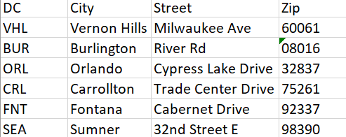

2.2 Mapped all locations

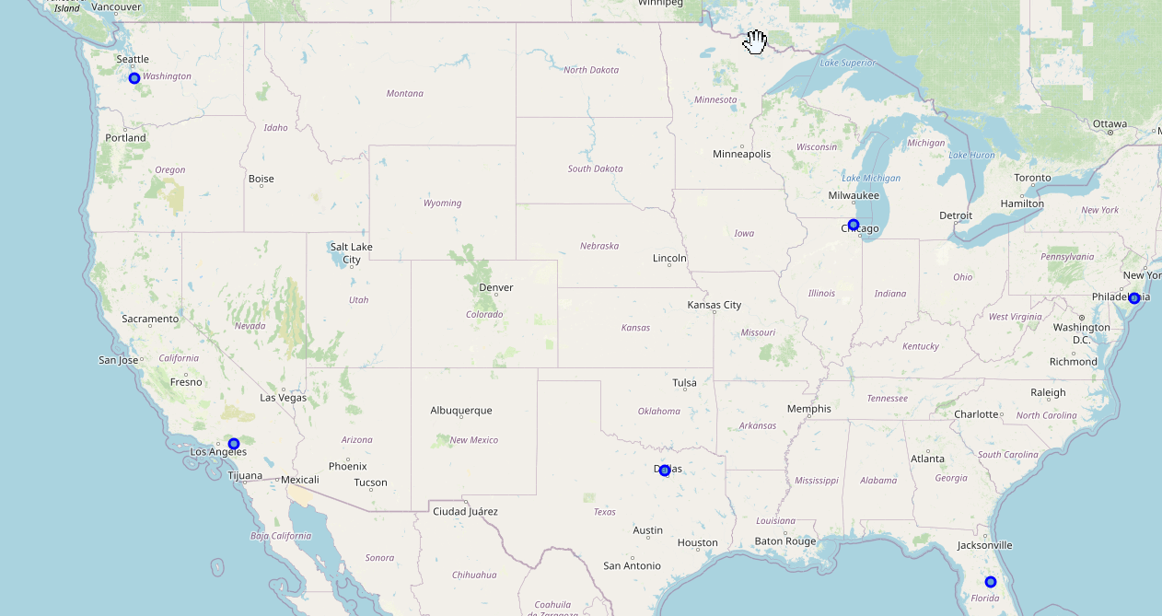

2.2 Data cleaning – there is no need for data cleaning on the input data

2.3 Used Geocoder to get latitude and longitude

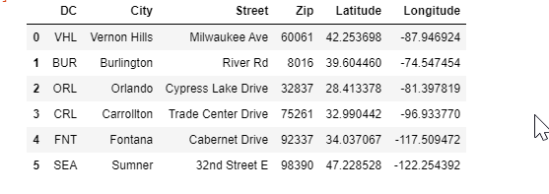

2.4 Used Foursquare data to get a list of venues and clean categories of venues that are not selling coffee, and merged with original dataset – see before and after merge

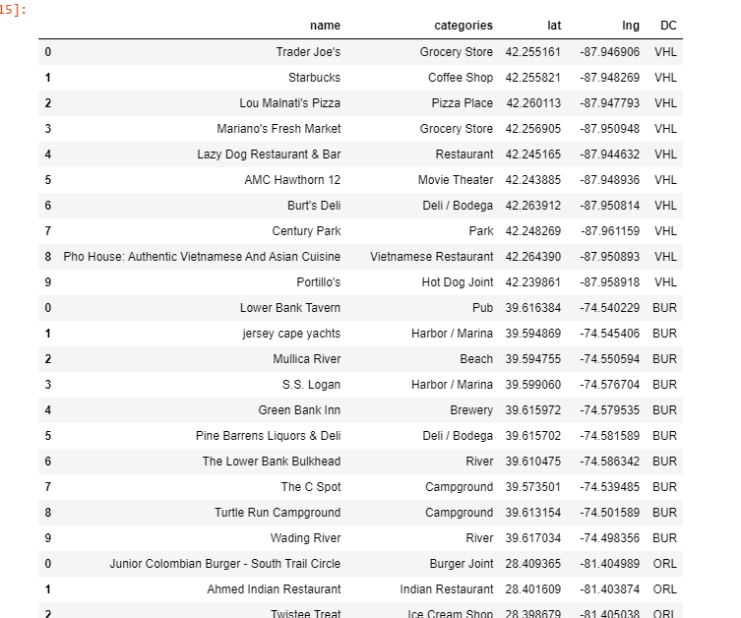

After merge:

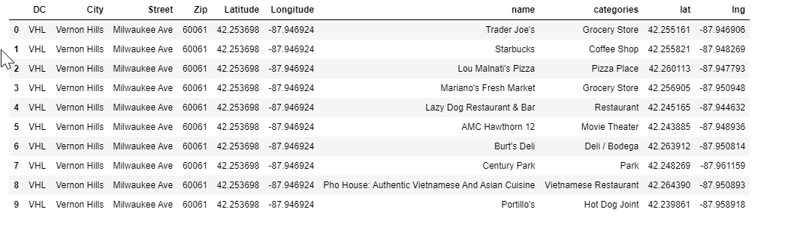

3. Exploratory Data Analysis

3.1 Extracted a list of unique categories

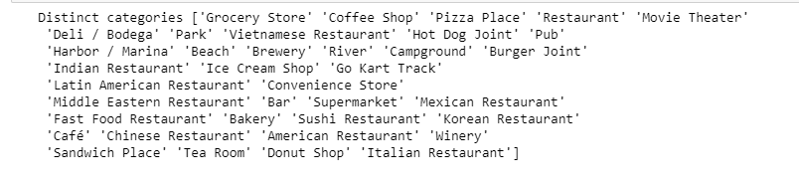

3.2 Filtered out venues that will not sell just coffee

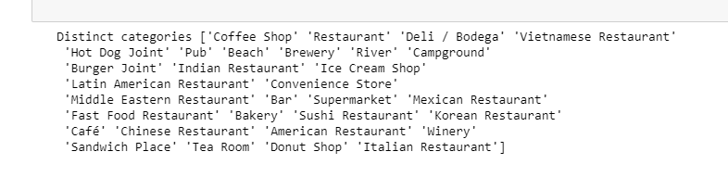

3.3 Calculate distance between each DC and the venues

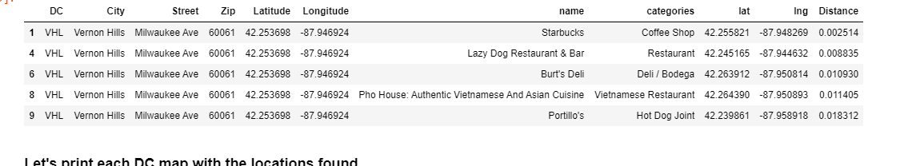

3.4 Print each DC (blue circle) surrounded by the potential venues (red circle)

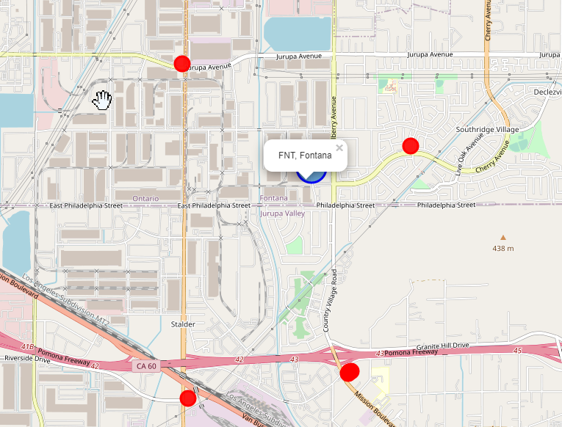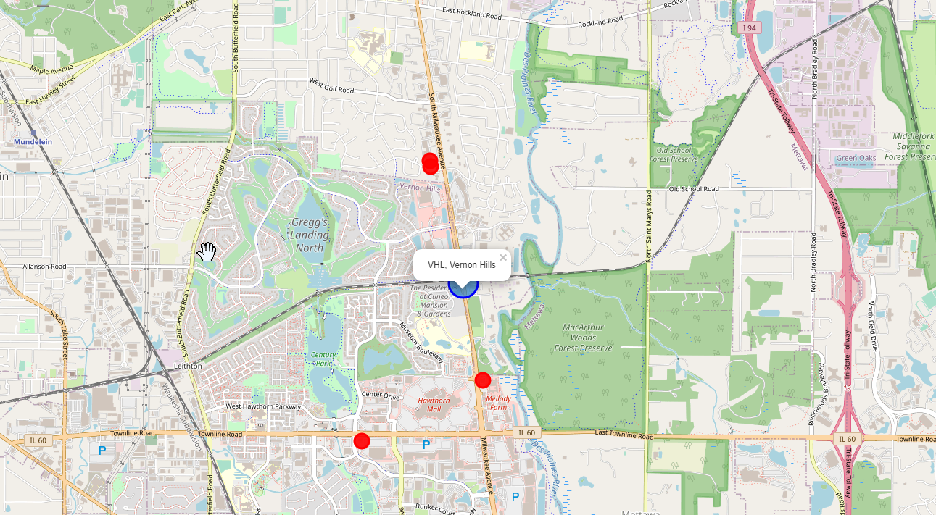

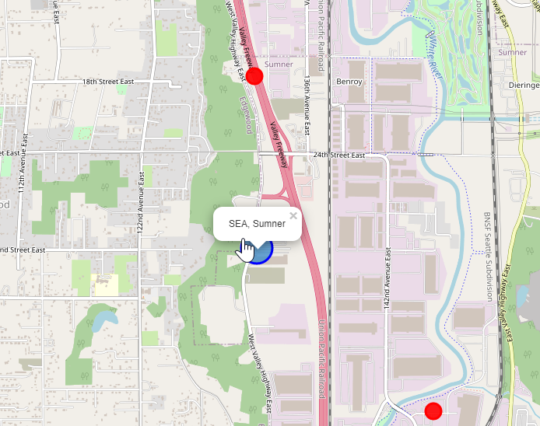

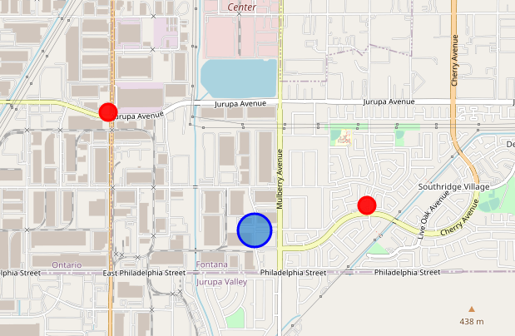

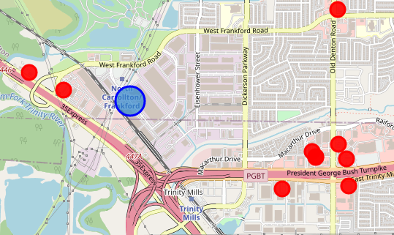

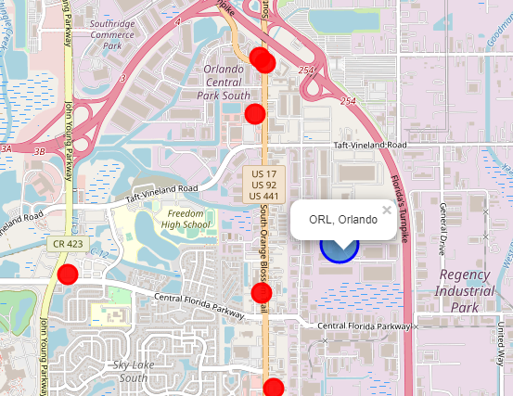

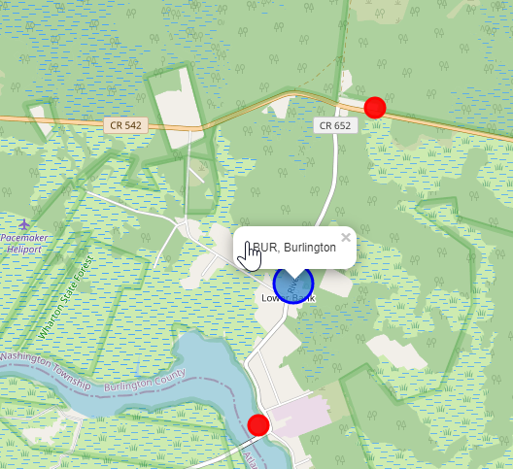

4. Conclusion

Based on the visuals, the stakeholders are able to select the appropriate venue.

5. Future enhancement

Upgrade Foursquare and retrieve ratings for each location