**Crishel B. Ponce**

**BSCS3-B1**

**SAMPLE DATA MODEL & ANALYSIS**

Data model:

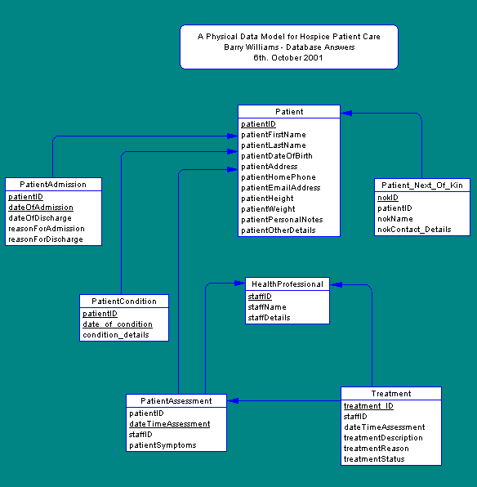<https://fordnox.github.io/databaseanswers/data_models/hospice_patient_care/index.htm>

This is a Conceptual Data Model for a Hospice Care System. It helps manage patient information, medical conditions, treatments, staff details to make care easier and more organized.

**Original Scope & Key Components**

**Patient Management**

* Store patient personal information (name, contact details, address, date of birth).
* Record physical attributes (height, weight) and additional notes.

**Admission & Discharge Management**

* Track admission and discharge dates.
* Document reasons for admission and discharge.

**Condition Tracking**

* Monitor patient conditions with details and dates.

**Health Professional Management**

* Maintain staff details (names and roles).

**Assessment Tracking**

* Record assessments, including symptoms, assessment times, and assigned staff.

**Treatment Management**

* Document treatments with descriptions, reasons, statuses, and responsible staff.

**Original System:**

* 7+ interconnected tables.
* Focus on patient-centric data management.
* Detailed tracking of admissions, conditions, assessments, and treatments.
* Integration of staff and next-of-kin information.

**MINIMIZED SCOPE – ESSENTIAL FEATURES ONLY**

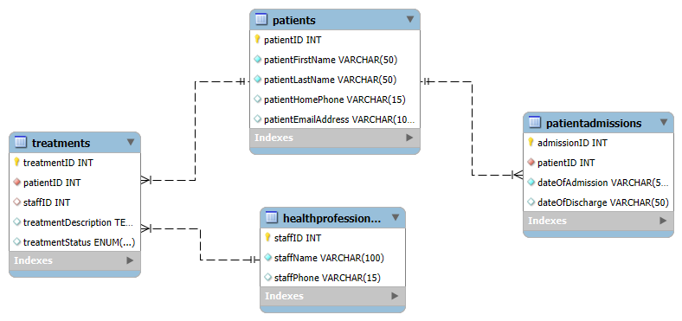

1. **Patients (Simplified)**

* patientID
* patientFirstName
* patientLastName
* patientHomePhone
* patientEmailAddress

2. **Health Professionals (Simplified)**

* staffID
* staffName
* staffPhone

3. **Patient Admissions**

* patientID (FK)
* dateOfAdmission
* dateOfDischarge

4. **Treatments**

* treatmentID
* patientID (FK)
* staffID (FK)
* treatmentDescription
* treatmentStatus

**Simplified System:**

* 4 core tables
* Direct relationships
* Basic patient info
* Basic admission and treatment tracking
* Simple staff management

**Example User Stories (Simplified)**

1. **As a Patient**

* "I want to view my admission and discharge dates."
* "I want to see my treatment history."

1. **As a Health Professional**

* "I want to view my patients' personal details.
* "I want to update the treatment status of a patient."

1. **As a Receptionist**

* "I want to add a new patient to the system."
* "I want to track the admission and discharge dates of patients."