**Worksheet – 2**

**Name : Crishtina K.C.**

**Student ID : 23085130**

**Cyber Security And Digital Forensics  
  
Github link:** [**https://github.com/crishtina01/cpp_Worksheet**](https://github.com/crishtina01/cpp_Worksheet)

**Task 1: Basic student grading system prototype using classes and objects. [30 Marks]**

Write a program that manages a simple student grade calculator with the following requirements. Create a Student class that has:

1. Student name (string)
2. Three subject marks (integers)
3. A basic member function to calculate average

The program should:

1. Accept student details (name and marks) from user input
2. Calculate and display:
   1. Total marks
   2. Average marks
   3. Grade (A for ≥90%, B for ≥80%, C for ≥70%, D for ≥60%, F for <60%)
3. Display a message if any mark is below 0 or above 100

**#include <iostream>**

**#include <string>**

**using namespace std;**

**class Student**

**{**

**private:**

**string name;**

**int marks[3];**

**public:**

**void inputData()**

**{**

**cout << "Enter student's name: ";**

**cin >> name;**

**for (int i = 0; i < 3; i++)**

**{**

**cout << "Enter marks for subject " << i + 1 << ": ";**

**cin >> marks[i];**

**while (marks[i] < 0 || marks[i] > 100)**

**{**

**cout << "Input Invalid! Marks must be between 0 and 100. Re-enter: ";**

**cin >> marks[i];**

**}**

**}**

**}**

**int calculate_Total()**

**{**

**return marks[0] + marks[1] + marks[2];**

**}**

**double calculate_Average()**

**{**

**return static_cast<double>(calculate_Total()) / 3;**

**}**

**char calculate_Grade()**

**{**

**double average = calculate_Average();**

**if (average >= 90)**

**return 'A';**

**else if (average >= 80)**

**return 'B';**

**else if (average >= 70)**

**return 'C';**

**else if (average >= 60)**

**return 'D';**

**else**

**return 'F';**

**}**

**void displayResults()**

**{**

**cout << "\n----- Student Report -----" << endl;**

**cout << "Student Name: " << name << endl;**

**cout << "Total Marks: " << calculate_Total() << " / 300" << endl;**

**cout << "Average Marks: " << calculate_Average() << "%" << endl;**

**cout << "Grade: " << calculate_Grade() << endl;**

**}**

**};**

**void StudentGradingsystem()**

**{**

**Student s1;**

**s1.inputData();**

**s1.displayResults();**

**}**

**int main()**

**{**

**StudentGradingsystem();**

**return 0;**

**}**

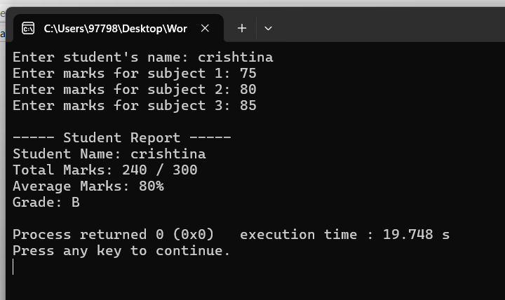

**Task 2: Programming assignments: All questions are mandatory**

1. **Write a program with a class Circle having:**
   1. **Private member: radius (float)**
   2. **A constructor to initialize radius**
   3. **A friend function compareTwoCircles that takes two Circle objects and prints which circle has the larger area**

**#include <iostream>**

**#include <cmath>**

**using namespace std;**

**class Circle;**

**void compareTwoCircles(Circle &c1, Circle &c2);**

**class Circle**

**{**

**private:**

**float radius;**

**public:**

**Circle(float r)**

**{**

**radius = r;**

**}**

**float area()**

**{**

**return 3.14 * radius * radius;**

**}**

**friend void compareTwoCircles(Circle &c1, Circle &c2);**

**};**

**void compareTwoCircles(Circle &c1, Circle &c2)**

**{**

**float area1 = c1.area();**

**float area2 = c2.area();**

**cout << "Area of Circle 1: " << area1 << endl;**

**cout << "Area of Circle 2: " << area2 << endl;**

**if (area1 > area2)**

**{**

**cout << "Circle 1 has the larger area." << endl;**

**}**

**else if (area1 < area2)**

**{**

**cout << "Circle 2 has the larger area." << endl;**

**}**

**else**

**{**

**cout << "Both circles have the same area." << endl;**

**}**

**}**

**int main()**

**{**

**float r1, r2;**

**cout << "Enter radius of Circle 1: ";**

**cin >> r1;**

**cout << "Enter radius of Circle 2: ";**

**cin >> r2;**

**Circle circle1(r1);**

**Circle circle2(r2);**

**compareTwoCircles(circle1, circle2);**

**return 0;**

**}**

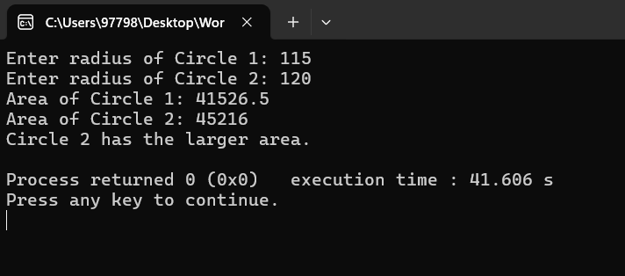

1. **Create a program with these overloaded functions named findMax:**
   1. **One that finds maximum between two integers**
   2. **One that finds maximum between two floating-point numbers**
   3. **One that finds maximum among three integers**

**One that finds maximum between an integer and a float**

**#include <iostream>**

**using namespace std;**

**class Max_Finder**

**{**

**public:**

**int findMax(int a, int b)**

**{**

**return (a > b) ? a : b;**

**}**

**float findMax(float a, float b)**

**{**

**return (a > b) ? a : b;**

**}**

**int findMax(int a, int b, int c)**

**{**

**return (a > b) ? ((a > c) ? a : c) : ((b > c) ? b : c);**

**}**

**float findMax(int a, float b)**

**{**

**return (a > b) ? a : b;**

**}**

**};**

**int main()**

**{**

**Max_Finder max_Finder;**

**int int1, int2, int3;**

**float float1, float2;**

**cout << "Enter two integers: ";**

**cin >> int1 >> int2;**

**cout << "Enter two floating-point numbers: ";**

**cin >> float1 >> float2;**

**cout << "Enter three integers: ";**

**cin >> int1 >> int2 >> int3;**

**cout << "Maximum between two integers: " << max_Finder.findMax(int1, int2) << endl;**

**cout << "Maximum between two floating-point numbers: " << max_Finder.findMax(float1, float2) << endl;**

**cout << "Maximum among three integers: " << max_Finder.findMax(int1, int2, int3) << endl;**

**cout << "Maximum between an integer and a float: " << max_Finder.findMax(int1, float1) << endl;**

**return 0;**

**}**

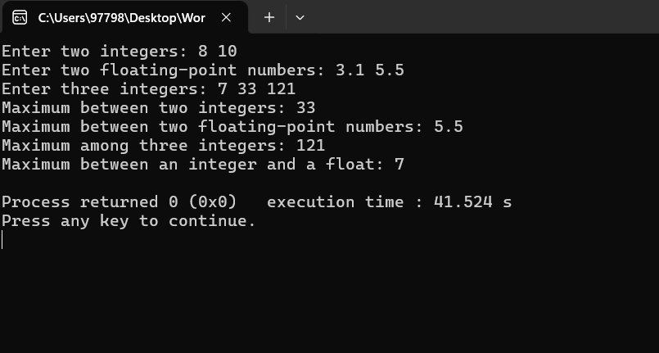

**Task 3: Basics of File Handling**

**Write a program that reads the titles of 10 books (use an array of 150 characters) and writes them in a binary file selected by the user. The program should read a title and display a message to indicate if it is contained in the file or not.**

**#include <iostream>**

**#include <fstream>**

**#include <cstring>**

**using namespace std;**

**const int MAX_TITLE_LENGTH = 150;**

**const int NUM_BOOKS = 10;**

**void writeBooksToFile(const string& filename, const string books[])**

**{**

**ofstream outFile(filename, ios::binary);**

**if (!outFile)**

**{**

**cout << "Error opening your file for writing." << endl;**

**return;**

**}**

**for (int i = 0; i < NUM_BOOKS; i++)**

**{**

**int length = books[i].length();**

**outFile.write(reinterpret_cast<char*>(&length), sizeof(length));**

**outFile.write(books[i].c_str(), length);**

**}**

**outFile.close();**

**}**

**bool searchBookInFile(const string& filename, const string& title)**

**{**

**ifstream inFile(filename, ios::binary);**

**if (!inFile)**

**{**

**cout << "Error opening your file for reading." << endl;**

**return false;**

**}**

**bool found = false;**

**int length;**

**char buffer[MAX_TITLE_LENGTH];**

**while (inFile.read(reinterpret_cast<char*>(&length), sizeof(length)))**

**{**

**inFile.read(buffer, length);**

**buffer[length] = '\0'; // Null terminate the string**

**if (title == buffer)**

**{**

**found = true;**

**break;**

**}**

**}**

**inFile.close();**

**return found;**

**}**

**int main()**

**{**

**string books[NUM_BOOKS];**

**cout << "Enter 10 book titles: " << endl;**

**for (int i = 0; i < NUM_BOOKS; i++) {**

**cout << "Book " << i + 1 << ": ";**

**getline(cin, books[i]);**

**}**

**string filename = "books.dat";**

**writeBooksToFile(filename, books);**

**string searchTitle;**

**cout << "\nEnter the book title to search for: ";**

**getline(cin, searchTitle);**

**if (searchBookInFile(filename, searchTitle))**

**{**

**cout << "The book \"" << searchTitle << "\" is in the file." << endl;**

**}**

**else**

**{**

**cout << "The book \"" << searchTitle << "\" is not in the file." << endl;**

**}**

**return 0;**

**}**

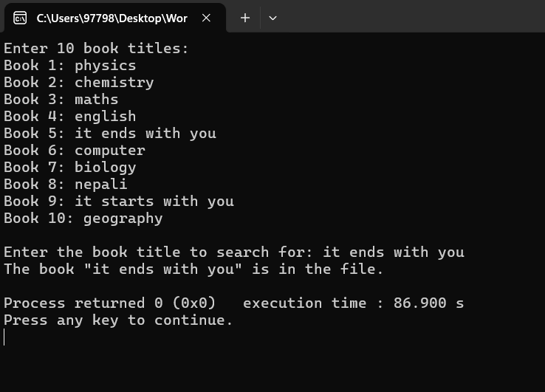

**Create a program that:**

1. **Reads student records (roll, name, marks) from a text file**
2. **Throws an exception if marks are not between 0 and 100**
3. **Allows adding new records with proper validation**
4. **Saves modified records back to file**

**#include <iostream>**

**#include <fstream>**

**#include <string>**

**#include <vector>**

**#include <stdexcept>**

**using namespace std;**

**class Student**

**{**

**private:**

**int roll;**

**string name;**

**int marks;**

**public:**

**Student(int r, const string& n, int m) : roll(r), name(n), marks(m)**

**{}**

**int getRoll() const**

**{**

**return roll;**

**}**

**string getName() const**

**{**

**return name;**

**}**

**int getMarks() const**

**{**

**return marks;**

**}**

**static void validateMarks(int marks)**

**{**

**if (marks < 0 || marks > 100)**

**{**

**throw out_of_range("Marks must be between 0 and 100.");**

**}**

**}**

**void display() const**

**{**

**cout << "Roll Number: " << roll << ", Name: " << name << ", Marks: " << marks << endl;**

**}**

**};**

**class StudentManager**

**{**

**private:**

**vector<Student> students;**

**string filename;**

**public:**

**StudentManager(const string& file) : filename(file)**

**{**

**readStudentRecords();**

**}**

**void readStudentRecords()**

**{**

**ifstream file(filename);**

**if (!file)**

**{**

**cout << "Error opening your file for reading." << endl;**

**return;**

**}**

**int roll, marks;**

**string name;**

**while (file >> roll)**

**{**

**file.ignore();**

**getline(file, name);**

**file >> marks;**

**file.ignore();**

**students.push_back(Student(roll, name, marks));**

**}**

**file.close();**

**}**

**void addStudentRecord()**

**{**

**int roll, marks;**

**string name;**

**cout << "Enter student roll number: ";**

**cin >> roll;**

**cin.ignore();**

**cout << "Enter student name: ";**

**getline(cin, name);**

**cout << "Enter student marks: ";**

**cin >> marks;**

**try**

**{**

**Student::validateMarks(marks);**

**students.push_back(Student(roll, name, marks));**

**cout << "Successfully added new students record!" << endl;**

**}**

**catch (const out_of_range& e)**

**{**

**cout << "Error: " << e.what() << endl;**

**}**

**}**

**void displayStudentRecords() const**

**{**

**if (students.empty())**

**{**

**cout << "No records available." << endl;**

**return;**

**}**

**cout << "\nStudent Records:\n";**

**for (const auto& student : students)**

**{**

**student.display();**

**}**

**}**

**void saveStudentRecords() const**

**{**

**ofstream file(filename);**

**if (!file)**

**{**

**cout << "Error opening your file for writing." << endl;**

**return;**

**}**

**for (const auto& student : students)**

**{**

**file << student.getRoll() << endl;**

**file << student.getName() << endl;**

**file << student.getMarks() << endl;**

**}**

**file.close();**

**}**

**};**

**int main()**

**{**

**string filename = "students.txt";**

**StudentManager manager(filename);**

**int choice;**

**bool running = true;**

**while (running)**

**{**

**cout << "\nMenu:\n";**

**cout << "1. Show student records\n";**

**cout << "2. Add new student record\n";**

**cout << "3. Exit\n";**

**cout << "Enter your choice (1-3): ";**

**cin >> choice;**

**switch (choice)**

**{**

**case 1:**

**manager.displayStudentRecords();**

**break;**

**case 2:**

**manager.addStudentRecord();**

**break;**

**case 3:**

**manager.saveStudentRecords();**

**cout << "Exiting program...\n";**

**running = false;**

**break;**

**default:**

**cout << "Invalid choice, please try again.\n";**

**break;**

**}**

**}**

**return 0;**

**}**

