# Plots

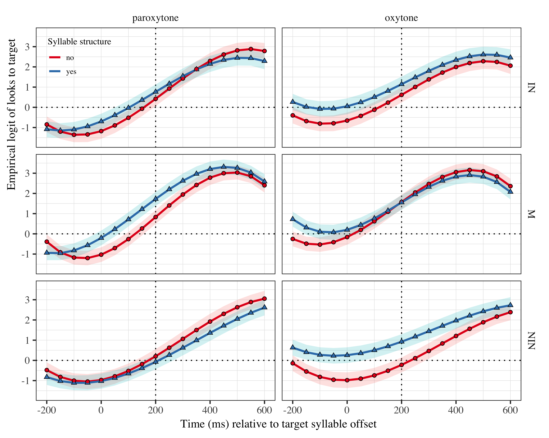

Figure 1: Growth curve estimates of target fixations as a function of lexical stress and syllable structure for each group during the analysis window. Symbols and lines represent model estimates, and the transparent ribbons represents ±SE. Empirical logit values on y-axis correspond to proportions of 0.12, 0.50, 0.88, and 0.98. The horizontal dotted line represents the 50% probability of fixating on the target. The vertical dotted line indicates 200 ms after the offset of the target syllable.

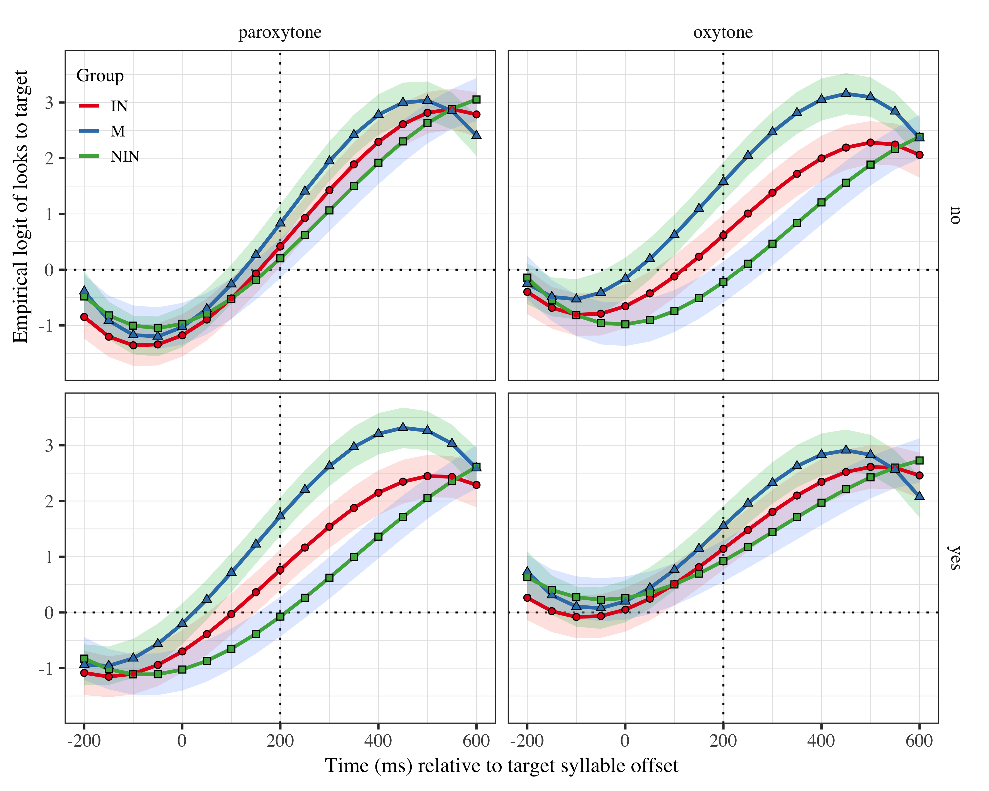

Figure 2: Growth curve estimates of target fixations as a function of lexical stress and syllable structure for each group during the analysis window. Symbols and lines represent model estimates, and the transparent ribbons represents ±SE. Empirical logit values on y-axis correspond to proportions of 0.12, 0.50, 0.88, and 0.98. The horizontal dotted line represents the 50% probability of fixating on the target. The vertical dotted line indicates 200 ms after the offset of the target syllable.

|  |  |  |
| --- | --- | --- |
|  | CV | CVC |
| Paroxytone | PApa *(potato)* | CARne *(meat)* |
| Oxytone | paPÁ *(dad)* | carNÉ *(ID)* |

# Tables

## Model estimates at target syllable offset

| Group | Lexical stress | Syllable structure | Probability | LB | UB |
| --- | --- | --- | --- | --- | --- |
| IN | paroxytone | no | 0.604 | 0.515 | 0.686 |
|  | oxytone |  | 0.650 | 0.560 | 0.729 |
|  | paroxytone | yes | 0.683 | 0.599 | 0.756 |
|  | oxytone |  | 0.758 | 0.683 | 0.820 |
| M | paroxytone | no | 0.697 | 0.620 | 0.764 |
|  | oxytone |  | 0.829 | 0.772 | 0.874 |
|  | paroxytone | yes | 0.849 | 0.799 | 0.888 |
|  | oxytone |  | 0.825 | 0.768 | 0.871 |
| NIN | paroxytone | no | 0.551 | 0.462 | 0.636 |
|  | oxytone |  | 0.445 | 0.356 | 0.537 |
|  | paroxytone | yes | 0.481 | 0.394 | 0.570 |
|  | oxytone |  | 0.716 | 0.635 | 0.785 |

*Table 1*: Model estimates for probability of target fixations ±SE at 200 ms after the target syllable offset.

## Fixed effects

|  |  |  |  |  |
| --- | --- | --- | --- | --- |
| Parameter | Estimate | SE | *t* | *p* |
| Intercept (γ00) | 1.291 | 0.189 | 6.834 | < .001 |
| Time1 (γ10) | 5.433 | 0.565 | 9.620 | < .001 |
| Time2 (γ20) | −0.483 | 0.318 | −1.520 | .129 |
| Time3 (γ30) | −1.928 | 0.244 | −7.906 | < .001 |
| Syllable structure (γ01) | −0.151 | 0.108 | −1.401 | .161 |
| Lexical stress (γ11) | −0.148 | 0.118 | −1.253 | .210 |
| Group NIN (γ21) | −0.694 | 0.246 | −2.820 | .005 |
| Group IN (γ31) | −0.478 | 0.252 | −1.900 | .057 |
| Time1 × Syllable structure (γ02) | 0.364 | 0.290 | 1.255 | .210 |
| Time2 × Syllable structure (γ12) | 0.243 | 0.217 | 1.122 | .262 |
| Time3 × Syllable structure (γ22) | −0.175 | 0.152 | −1.153 | .249 |
| Time1 × Lexical stress (γ32) | 0.798 | 0.290 | 2.747 | .006 |
| Time2 × Lexical stress (γ03) | −0.016 | 0.217 | −0.076 | .940 |
| Time3 × Lexical stress (γ13) | −0.048 | 0.152 | −0.317 | .751 |
| Syllable structure × Lexical stress (γ23) | −0.094 | 0.098 | −0.961 | .337 |
| Time1 × Group NIN (γ33) | −0.840 | 0.741 | −1.133 | .257 |
| Time1 × Group IN (γ04) | −0.252 | 0.758 | −0.332 | .740 |
| Time2 × Group NIN (γ14) | 1.911 | 0.382 | 5.006 | < .001 |
| Time2 × Group IN (γ24) | 0.764 | 0.390 | 1.959 | .050 |
| Time3 × Group NIN (γ34) | 1.107 | 0.327 | 3.382 | < .001 |
| Time3 × Group IN (γ05) | 0.606 | 0.334 | 1.812 | .070 |
| Time1 × Syllable structure × Lexical stress (γ15) | −0.404 | 0.320 | −1.262 | .207 |
| Time2 × Syllable structure × Lexical stress (γ25) | 0.498 | 0.255 | 1.950 | .051 |
| Time3 × Syllable structure × Lexical stress (γ35) | −0.199 | 0.203 | −0.981 | .327 |
| Syllable structure × Lexical stress × Group NIN (γ06) | 0.406 | 0.063 | 6.456 | < .001 |
| Syllable structure × Lexical stress × Group IN (γ16) | 0.206 | 0.064 | 3.217 | .001 |
| Time1 × Syllable structure × Lexical stress × Group NIN (γ26) | 0.352 | 0.259 | 1.359 | .174 |
| Time1 × Syllable structure × Lexical stress × Group IN (γ36) | 0.477 | 0.264 | 1.806 | .071 |
| Time2 × Syllable structure × Lexical stress × Group NIN (γ07) | −0.661 | 0.258 | −2.557 | .011 |
| Time2 × Syllable structure × Lexical stress × Group IN (γ17) | −0.251 | 0.264 | −0.951 | .342 |
| Time3 × Syllable structure × Lexical stress × Group NIN (γ27) | 0.151 | 0.258 | 0.583 | .560 |
| Time3 × Syllable structure × Lexical stress × Group IN (γ37) | 0.135 | 0.264 | 0.512 | .609 |

Appendix 1: Growth curve model fixed effects

## 

|  |  |  |  |  |
| --- | --- | --- | --- | --- |
| Parameter | Estimate | SE | *t* | *p* |
| Intercept (γ00) | 1.291 | 0.189 | 6.834 | < .001 |
| Time1 (γ10) | 5.433 | 0.565 | 9.620 | < .001 |
| Time3 (γ30) | −1.928 | 0.244 | −7.906 | < .001 |
| Group NIN (γ21) | −0.694 | 0.246 | −2.820 | .005 |
| Time1 × Lexical stress (γ32) | 0.798 | 0.290 | 2.747 | .006 |
| Time2 × Group NIN (γ14) | 1.911 | 0.382 | 5.006 | < .001 |
| Time2 × Group IN (γ24) | 0.764 | 0.390 | 1.959 | .050 |
| Syllable structure × Lexical stress × Group NIN (γ06) | 0.406 | 0.063 | 6.456 | < .001 |
| Syllable structure × Lexical stress × Group IN (γ16) | 0.206 | 0.064 | 3.217 | .001 |
| Time2 × Syllable structure × Lexical stress × Group NIN (γ07) | −0.661 | 0.258 | −2.557 | .011 |

## - Group NIN (γ21): NIN were significantly worse? Slower? -For monolinguals, a change from Paroxytone to Oxytone increased the probability of prediction - Syllable structure × Lexical stress × Group NIN, Syllable structure × Lexical stress × Group IN For IN and NIN, changing from paroxytone to Oxytone + CV to CVC increased the probability of prediction - Time2 × Group NIN; Time2 × Group IN; Time2 × Syllable structure × Lexical stress × Group NIN What does it mean in Time 2? (second order polynomial, for both group and interaction?)

|  |  |  |  |  |
| --- | --- | --- | --- | --- |
| Parameter | Estimate | SE | *t* | *p* |
| IN - NIN (γ08) | −0.216 | 0.264 | −0.819 | .413 |
| Time1 × IN - NIN (γ18) | −0.588 | 0.795 | −0.740 | .459 |
| Time2 × IN - NIN (γ28) | 1.147 | 0.409 | 2.804 | .005 |
| Time3 × IN - NIN (γ38) | 0.501 | 0.351 | 1.429 | .153 |
| Syllable structure × Lexical stress × IN - NIN (γ09) | 0.199 | 0.067 | 2.966 | .003 |
| Time1 × Syllable structure × Lexical stress × IN - NIN (γ19) | −0.125 | 0.277 | −0.452 | .651 |
| Time2 × Syllable structure × Lexical stress × IN - NIN (γ29) | −0.410 | 0.277 | −1.482 | .138 |
| Time3 × Syllable structure × Lexical stress × IN - NIN (γ39) | 0.016 | 0.277 | 0.057 | .954 |

- Time2 × IN – NIN: Interpreters predicted more than non-interpreters  
- Not sure about this one “Syllable structure × Lexical stress × IN - NIN (γ09)”, the changes in both variables were greater for interpreters?

## Random effects

|  |  |  |  |  |  |  |  |  |  |
| --- | --- | --- | --- | --- | --- | --- | --- | --- | --- |
| Group | Parameter | Variance | SD | Correlations |  |  |  |  |  |
| Participant | Intercept | 0.873 | 0.934 | 1.00 |  |  |  |  |  |
|  | Syllable structure | 0.260 | 0.510 | −.10 | 1.00 |  |  |  |  |
|  | Lexical stress | 0.444 | 0.666 | −.26 | −.04 | 1.00 |  |  |  |
|  | Time1 | 6.931 | 2.633 | .26 | −.04 | .00 | 1.00 |  |  |
|  | Time2 | 1.169 | 1.081 | −.31 | −.11 | .17 | −.14 | 1.00 |  |
|  | Time3 | 0.589 | 0.767 | −.30 | .12 | −.04 | −.84 | .05 | 1.00 |
| Item | Intercept | 0.250 | 0.500 | 1.00 |  |  |  |  |  |
|  | Time1 | 2.324 | 1.525 | −.23 |  |  | 1.00 |  |  |
|  | Time2 | 1.128 | 1.062 | −.75 |  |  | .04 | 1.00 |  |
|  | Time3 | 0.365 | 0.604 | .11 |  |  | −.98 | .16 | 1.00 |
| Residual |  | 14.780 | 3.844 |  |  |  |  |  |  |

Appendix 2: Growth curve model random effects