Eq. 1

<https://www.perplexity.ai/search/take-the-following-manuscript-YC2IUABYSCK7Aimaa.BvJQ>

Δ*G*fold=Δ*H*fold−*T*Δ*S*micro+*kT*ln(2)⋅*Ifold*

Eq. 2

<https://www.perplexity.ai/search/give-an-opinion-on-the-attache-_FDq.Iu5Qu2tjQHYVrX.Ww>

\frac{dE_{\text{total}}}{dt} = \underbrace{\eta \cdot P_{\text{env}}(t)}_*{\text{Energy input}} - \underbrace{\left[ W*{\text{work}}(t) + Q_{\text{diss}}(t) \right]}_*{\text{Energy output}} + \underbrace{\alpha \cdot Q*{\text{rec}}(t)}_{\text{Waste heat recovery}}

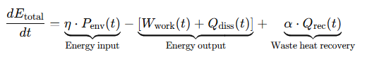

Variables eq 2:

\( E_{\text{total}}(t) \)

\( P_{\text{env}}(t) \)

\( \eta \)

\( W_{\text{work}}(t) \)

\( Q_{\text{diss}}(t) \)

\( Q_{\text{rec}}(t) \)

\( \alpha \)

Copy latex from P search

Render it in <https://www.quicklatex.com/>

Other tools  
<https://markdowntohtml.com/>