SELECT * FROM employees_data;
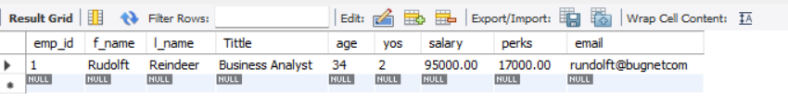
SELECT f_name, l_name, Tittle, age, yos, salary, perks, email FROM employees_data;
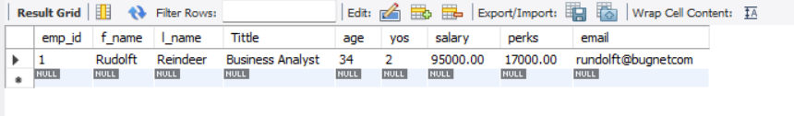
SELECT f_name, email FROM employees_data;
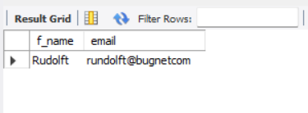
SELECT salary, perks, yos FROM employees_data;
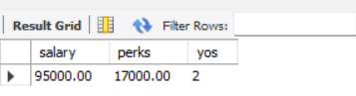
SELECT COUNT(*) FROM employees_data;
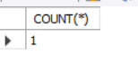

SELECT salary, l_name FROM employees_data;
