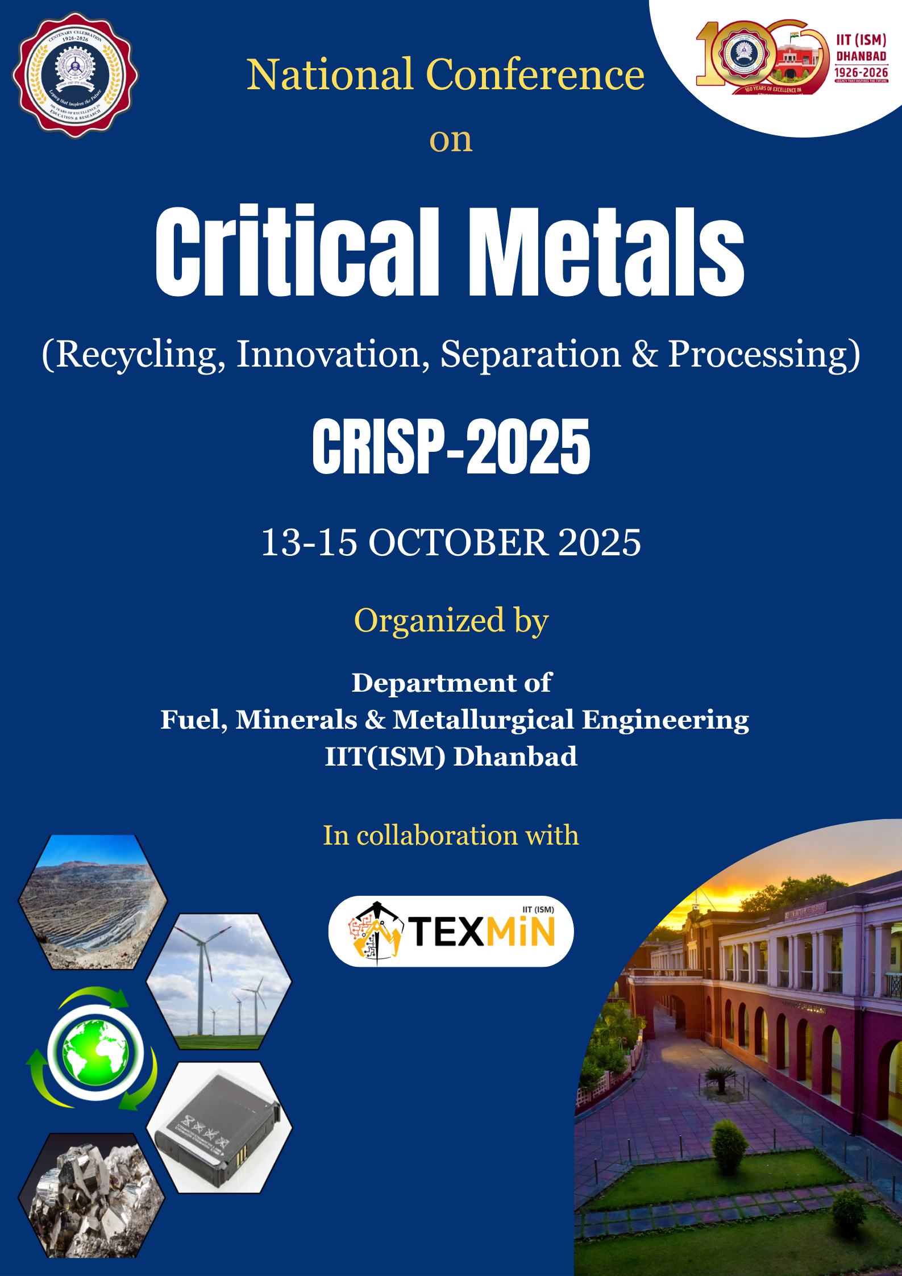

**About the conference**

The accelerating global transition towards clean energy, digitalization, and advanced manufacturing has intensified the demand for critical metals - lithium, cobalt, rare earth elements, nickel, and more. These elements power the future: from EVs and wind turbines to aerospace and electronics. India, recognizing the strategic importance of these resources, has launched the National Critical Minerals Mission to enhance domestic exploration, forge global partnerships, and build sustainable, resilient supply chains. Global efforts toward resource security, responsible mining, and innovation in recycling underscore the urgency for collaborative platforms that address the full lifecycle of critical metals. As part of the **100 years celebrations of the IIT(ISM) Dhanbad**, a national conference on **Critical Metals: Recycling, Innovation, Separation and Processing (CRISP-2025)** has been envisioned as a landmark event that brings together leading researchers, scientist, academician, industry professionals, policymakers, and sustainability experts. The conference will explore cutting-edge advancements in extraction, recycling, separation, and lifecycle management of critical metals. Special emphasis will be placed on emerging technologies and sustainable practices that align with national priorities and global sustainability goals.

**Theme of the conference**

* Identification, exploration and characterization of critical minerals
* Beneficiation of critical minerals
* Critical metals extraction from primary & secondary resources
* Advanced separation and purification techniques
* Value addition and alloy development
* Role of AI and automation in critical metals exploration and extraction
* Environmental impact and lifecycle analysis
* National policy and regulatory framework on critical metals
* Future trends and opportunities in critical metals

### **Who Should Attend?**

* Researchers and Academicians
* Mining, Mineral and Metallurgical Engineers
* Scientists and Sustainability Experts
* Industry Professionals and E-waste recyclers
* Policy Makers
* Students and Young Researchers

**Venue: IIT (ISM) Dhanbad, Jharkhand-826004, India**

**About IIT(ISM), Dhanbad**

The Indian Institute of Technology (Indian School of Mines), Dhanbad, established in 1926, is a premier institution renowned for excellence in mining, minerals, and energy research. Strategically located in India's resource-rich region, IIT(ISM) has evolved into a multidisciplinary centre of innovation spanning engineering, sciences, management, and humanities. With a strong emphasis on sustainable mining, mineral processing, energy transition technologies, and advanced materials, the institute plays a pivotal role in addressing national and global challenges in critical metals and resources management. Ranked 20th globally and 1st nationally in Mineral and Mining Engineering (QS World Rankings 2025), and 15th in Engineering (NIRF 2024), IIT(ISM) Dhanbad stands at the forefront of research, technology development, and industry collaboration. Its dynamic academic and industrial ecosystem makes it an ideal venue for hosting CRISP-2025, a conference dedicated to advancing innovation, sustainability, and resilience in the critical metals sector.



**About the Department of Fuel Minerals and Metallurgical Engineering**

Established in 1976, the Department of Fuel Minerals and Metallurgical Engineering (FMME) at IIT(ISM) Dhanbad has been a leader in addressing challenges across mineral processing, fuel technology, and resource management. In response to emerging research and industry trends, the department expanded its academic and research horizons by incorporating Metallurgical Engineering in 2019. Today, it offers a comprehensive B.Tech program in Mineral and Metallurgical Engineering, along with M.Tech specializations in Fuel Engineering, Mineral Engineering, and Metallurgical Engineering, and a vibrant Ph.D. program. Equipped with state-of-the-art laboratories and advanced research infrastructure, the department conducts cutting-edge research in mineral processing, extractive metallurgy, process modelling, critical metal extraction, sustainable metallurgy, materials processing, additive manufacturing, fuel pyrolysis and combustion. Strong collaborations with premier R&D organizations and industries enhance its industry interface and research relevance. With 22 dedicated faculty members and a focus on interdisciplinary innovation, the department plays a crucial role in advancing sustainable resource utilization and critical metal technologies, aligning with national priorities and global industrial needs.

**List of Key Speakers**

|  |  |  |
| --- | --- | --- |
| Deependra Singh, Chairman and Managing Director of IREL (India) Limited  **Dr. D. Singh**  Ex-Chairman and Managing Director, IREL(India) Limited | NFAPT | Home  **Dr. Raghvendra Tewari**  Director, Materials Group  BARC | **Shri Anuttam Mishra**  Director Technical  IREL(India) Limited |
| Business Potentials of E-Waste Management in India Through Sustainability  Lens (Online MDP) - Amrita Vishwa Vidyapeetham  **Shri R. Saravanabhavan**  Deputy Advisor, NITI Aayog | **C:\Users\Aarti\Downloads\AA.jpg**  **Dr. Alok Awasthi**  Head, Materials Processing & Corrosion Engg. Division, BARC | kksingh.met | Indian Institute of Technology (BHU)  **Dr. Kamalesh Kumar Singh**  (Professor, Department of Metallurgical Engg., IIT(BHU) |
| Anand Rao KACHAM | Head, Mineral Beneficiation Section & Scientific Officer  / H | B. Tech (Chemical Engineering), M. Tech (Computer Science), Doctor of  Philosopy | Bhabha Atomic Research Centre, Mumbai |  **Dr. K. Anand Rao**  Head, Mineral Processing Division, BARC | CSIR-NML  **Dr. S. K. Sahu**  Senior Prinicpal Scientist  CSIR-NML, Jamshedpur | **C:\Users\Aarti\Downloads\IMG-20200218-WA0007.jpg**  **Dr.T.Sreenivas**  Former Head, Mineral Division, BARC Hyderabad |
|  | सीएसआईआर-केंद्रीय विद्युतरसायन अनुसंधान संस्थ  **Dr. C. Naveen Kumar**  Head, Electroplating & Electrometallurgy Division  CSIR-CECRI, Karaikudi |  |

**Call for Abstract:**

CRISP-2025 invites abstract from scientist, faculty, researchers, students and industry professionals. The submission of abstract should be align with the theme of the conference. The abstract can be sent to [crisp2025@iitism.ac.in](mailto:crisp2025@iitism.ac.in). Abstracts must be written in text form and up to 250 words in length. The abstract template can be downloaded from the conference website. **Last date of abstract submission is 15th August, 2025.** The acceptance of abstract for oral or poster presentation will notified later.

**Registration Details:**

For offline participants, registration fee includes access to all lectures, registration kit, breakfast, lunch, and dinner. For online participants, registration fee includes access to all lectures. Participation certificate will be given for both offline and online participants.

|  |  |  |
| --- | --- | --- |
| **Participants** | **Offline Participation**  **Amount (INR)**  **(Inclusive of 18% GST)** | **Online Participation**  **Amount (INR)**  **(Inclusive of 18% GST)** |
| Industry Professionals | 12000/- | 7000/- |
| Faculty & Scientist | 8000/- | 4000/- |
| Post Docs | 7000/- | 3500/- |
| Students & Research Scholars | 3500/- | 2000/- |

Registration fee is to be paid to the below account through net banking or UPI. After the payment is successful, please register yourself on the conference website **(https://people.iitism.ac.in/~crisp2025/)** and upload the payment receipt using the same link.

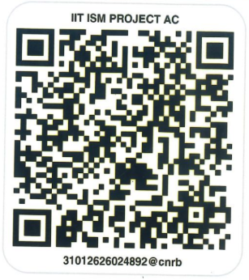

**Name:** IIT(ISM) SPECIAL FUND

**A/C no:** 0986101024892

**IFSC:** CNRB0000986

**Bank Name:** Canara Bank

**Branch:** Saraidhela Branch

**Net Banking**

**UPI**

**Last Date for Registration: 5th September 2025**

**Important Dates**

|  |  |
| --- | --- |
| **Abstract Submission start date** | **1st June, 2025** |
| **Abstract Submission Ends** | **15th August, 2025** |
| **Abstract Acceptance Notification** | **30th August, 2025** |
| **Last date of registration** | **5th September, 2025** |

**Accommodation**

Based on the availability, efforts shall be made to accommodate the participants inside the IIT(ISM) campus based on first-come, first-served. Arrangements can be made to provide institute guest houses (for delegates) and hostels/shared accommodation (for students) on request and payment basis. Besides the campus, there are many hotels available in Dhanbad, which participants can book.

**Sponsorship Details**

**Diamond**

**Sponsorship Amount: INR 3 Lakhs**

* Complimentary registration for 3 participants
* One stall for exhibition
* Name & logo on conference website, booklet, banners, participant certificate
* Inside full page for message in conference booklet

**Platinum**

**Sponsorship Amount: INR 5 lakhs**

* Complimentary registration for 5 participants
* One stall for exhibition
* Name & logo on conference website, booklet, banners, participant certificate
* Inside full page for message in conference booklet

**Gold**

**Sponsorship Amount: INR 2 lakhs**

* Complimentary registration for 2 participants
* One stall for exhibition
* Name & logo on conference website, booklet, banners, participant certificate
* Inside half page for message in conference booklet

**Silver**

**Sponsorship Amount: INR 1 Lakh**

* Complimentary registration for 1 participant
* One stall for exhibition
* Name & logo on conference website, booklet, and banners
* Name and logo in conference booklet-sponsors list

**Bronze**

**Sponsorship Amount: INR 0.5 Lakh**

* Complimentary registration for 1 participant
* One stand for poster
* Name & logo on conference website, booklet, and banners
* Name and logo in conference booklet-sponsors list

**Organizing Committee**

|  |  |
| --- | --- |
| **Patron** | Prof. Sukumar Mishra, Director, IIT(ISM) Dhanbad |
| **Co-Patron** | Prof. Dheeraj Kumar, Co-Patron, Deputy Director, IIT(ISM) Dhanbad |
| **Chairperson** | Prof. Shravan Kumar, HOD, FMME Department, IIT(ISM) Dhanbad |
| **Advisor** | Dr. D. K. Singh, Visiting Professor, IT(ISM) Dhanbad |
| **Convenors** | Prof. Aarti Kumari, FMME, IIT(ISM) Dhanbad  Prof. Vishnu Teja Mantripragada, FMME, IIT(ISM) Dhanbad |
| **Core Committee** | Prof. Shatrughan Soren, FMME  Prof. B. K. Nandi, FMME  Prof. Shalini Gautam, FMME  Prof. Madhumanti Bhattacharyya, FMME  Prof. Kesavan Ravi, FMME  Prof. Rahul MR, FMME  Prof. Raj Kumar Dishwar, FMME  Prof. Avanish Kumar, FMME  Prof. Kasturi Sala, FMME  Prof. Vivek Kumar Sahu, FMME  Prof. Rajasekhar Reddy Busigari, FMME  Prof. Pankaj Kumar Jain, FMME  Prof. Anand Anupam, FMME  Prof. Subhendu Mishra, FMME  Prof. Gaurav Jha, FMME  Prof. Shubhi Gupta, FMME  Prof. Nitesh Kumar Sahu, FMME |
| **National**  **Advisory Committee** | Dr. D. Singh, IREL  Dr. Anuttam Mishra, IREL  Dr. K. Ramesha, CSIR-CECRI  Dr. R. Tewari, BARC  Shri R. Saravanabhavan, NITI Aayog  Dr. Sandip Ghosh Chowdhury, CSIR-NML, Jamshedpur  Dr. Rajiv Shekhar, IIT Kanpur  Dr. Alok Awasthi, BARC  Dr.T.Sreenivas, BARC Hyderabad  Dr. K. K. Singh, IIT(BHU)  Dr. K. Anand Rao, BARC Hyderabad  Dr C. Naveen Kumar, CSIR-CECRI, Karaikudi  Dr. S. K. Sahu, CSIR-NML, Jamshedpur  Prof. Nikkam Suresh, IIT(ISM) Dhanbad  Prof. S. Bhattacharya, IIT(ISM), Dhanbad  Prof. Sagar Pal, IIT(ISM), Dhanbad  Prof. M. K. Singh, IIT(ISM), Dhanbad  Prof. Sarat Kumar Das, IIT(ISM), Dhanbad  Prof. Amit Rai Dixit, IIT(ISM), Dhanbad  Prof. Alok Kumar Das, IIT(ISM), Dhanbad  Prof. S. K. Gupta, IIT(ISM), Dhanbad  Prof. R. M. Bhattacharjee, IIT(ISM), Dhanbad  Prof. Rajni Singh, IIT(ISM), Dhanbad  Prof. Sahendra Singh, IIT(ISM), Dhanbad  Prof Shushanta Sarangi, IIT(ISM), Dhanbad  Dr Devi Prasad Mishra, IIT(ISM), Dhanbad  Prof. Aditya Kumar, IIT(ISM), Dhanbad  Prof. Alok Sinha, IIT(ISM), Dhanbad  Prof Somnath Chattopadhyaya, IIT(ISM), Dhanbad |

For any information:

**Website:** <https://people.iitism.ac.in/~crisp2025/>

**Email to:** [crisp2025@iitism.ac.in](mailto:crisp2025@iitism.ac.in)

**Convenors: Dr. Aarti Kumari (9304603155)**

**Dr. Vishnu Teja (8754510216)**