SOUTHERN CROSS UNIVERSITY
ASSIGNMENT COVER SHEET
For use with online submission of assignments

Please complete all of the following details and then make this sheet the first page of each file of your assignment – do not send it as a separate document.

Your assignments must be submitted as either Word documents, text documents with .rtf extension or as .pdf documents. If you wish to submit in any other file format please discuss this with your lecturer well before the assignment submission date.

Student Name: | Crispin Andrade
Student ID No.: | 22204240
Unit Name: | Web Development 2
Unit Code: | CSC10217
Tutor’s name: | Dr. Bill Smart
Assignment No.: | 2
Assignment Title: | Assignment 2 - Major
Due date: | 14/09/2015
Date submitted: | 14/09/2015

Declaration: I have read and understand the Rules Relating to Awards (Rule 3 Section 18 – Academic Misconduct Including Plagiarism) as contained in the SCU Policy Library. I understand the penalties that apply for plagiarism and agree to be bound by these rules. The work I am submitting electronically is entirely my own work.
Signed:  (please type your name) | Crispin Andrade
Date: | 14/09/2015

Contents

Concept Map 3
CSS Plan 4
CSS Layout 7
Structure Chart 8
Navigation 9
Testing Plan 10
Story Board 10
Index.php 11
techzone.php 12
ApacheIIS.php 13
CMS.php 14
join.php 15
moviezone.php 16
contact.php 17

Concept Map
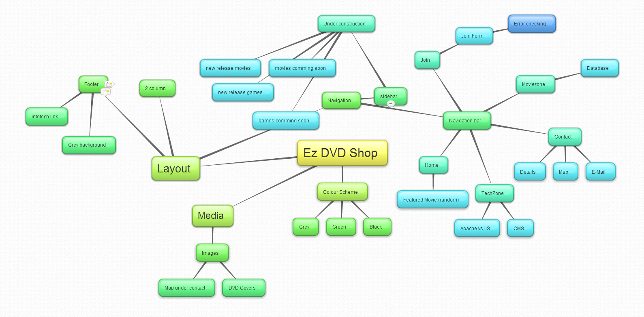

CSS Plan
styles.css | Font Family Text | Colour/Special Characteristics | Size | Align
#container | As body | - width:1024px  - margin to the left set to auto  - margin to the right set to auto
#page | As body | - Width:1024px  - Floats to the left  - Margin-left = 0 pixels  - Margin-top = 10pixels  - Padding-top = 10pixels  - Padding-bottom = 20 pixels  - Box-shadow 25 pixels bottom and 5 pixels right
#nav | As body | - height: 30px;  - padding-top:5px;  - font-size: 20px;  - font-weight: bold;  - text-align: center;  - text-shadow: 2px 2px 2px #666666;  - background-color: #cccccc;  - text-decoration:none; | 200% | Centre
#nav a | As body | - text-decoration:none;  - color:#111111; (grey)
#nav a:hover | As body | - color:#00CC00 (green)
#nav li | As body | - margin:0;  - padding:10px;  - list-style:none;  - display:inline;
#nav ul | As body | height:auto;  margin:0;  padding:0; |  | Centre
#banner | As body | - height:40px;  - text-align:left |  | Centre
#banner h1 | As body | - color:#00CC00;  - margin:10px; |  | Centre
.subTitle | As body | - color:#00CC00; (green)  - text-decoration:none;
.description | As body | - color:#50505F; (grey)  - width: 500px;  - padding: 2px;  - font-size: 16px;  - text-align: left;
.title | As body | - font-size:22px;  - color:#50505F; (grey)  - padding-left:10px;  - padding-right:10px;  - margin-bottom:10px; |  | Centre
form | As body | - width:450px;  - height:850px;  - font-size: 14px;  - font-weight: bold;  - color: #50505F;  - text-decoration: none;  - border-radius: 10px;  - padding-left:40px;  - border: 1px solid #999;  - box-shadow: 0px 0px 8px rgba(0, 0, 0, 0.3); |  | Centre
input | As body | - width:375px;  - display:block;  - height: 18px;  - padding:0px 6px;  - margin-bottom:10px;  - box-shadow: 0px 0px 0px rgba(0, 0, 0, 0.3); |  | Centre
select | As body | - width:375px;  - display:block;  - height: 25px;  - padding:0px 0px;  - margin-bottom:10px;  - box-shadow: 0px 0px 0px rgba(0, 0, 0, 0.3);
input[type=radio] | As body | - width:20px;  - display:inline
input[type=checkbox] | As body | - width:20px;  - display:inline;
input[type=submit] | As body | - margin-top:30px;  - display:inline;  - width:100px;  - right:20px;  - bottom:20px;  - font-weight:bold;  - background:#CCCCCC; (grey)  - color:#111111; (black)  - height:25px;  - border-radius: 10px;  - border: 1p solid #999;
input[type=submit]:hover | As body | - background:#009900;  - color:#CCCCCC; (grey)
input[type=reset] | As body | - display:inline;  - width:100px;  - right:20px;  - bottom:20px;  - font-weight:bold;  - background:#CCCCCC;  - color:#111111;  - height:25px;  - border-radius: 10px;  - border: 1p solid #999;
input[type=reset]:hover | As body | - background:#009900;  - color:#CCCCCC;
#sidebar | As body | - color:#50505F;  - width:200px;  - padding:5px 15px;  - font-size: 16px;  - font-weight: bold;  - text-align: left;  - text-decoration:none;  - float:left;
#sidebar a | As body | - text-decoration:none;  - color:#727288; (light grey)
#sidebar a:hover | As body | - text-decoration:underline;
#sidebar li | As body | - margin:0;  - padding:3px;  - list-style:none;  - display:table;
#sidebar ul | As body | - height:auto;  - margin:0;  - padding:0;
#column2 | As body | - margin-left:20px;  - padding-left:210px;  - padding-right:10px;
#footer | As body | - clear:both;  - text-align:center;  - background-color:#cccccc;

CSS Layout

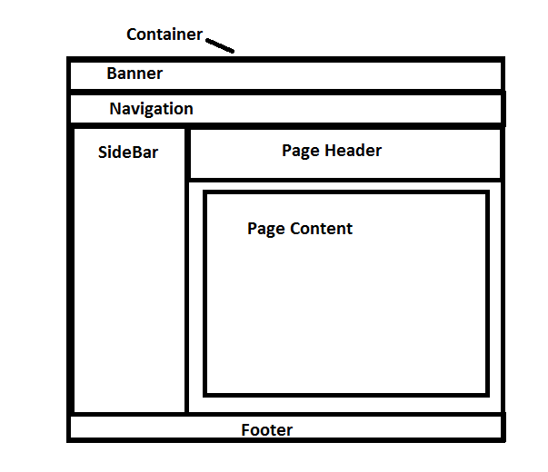

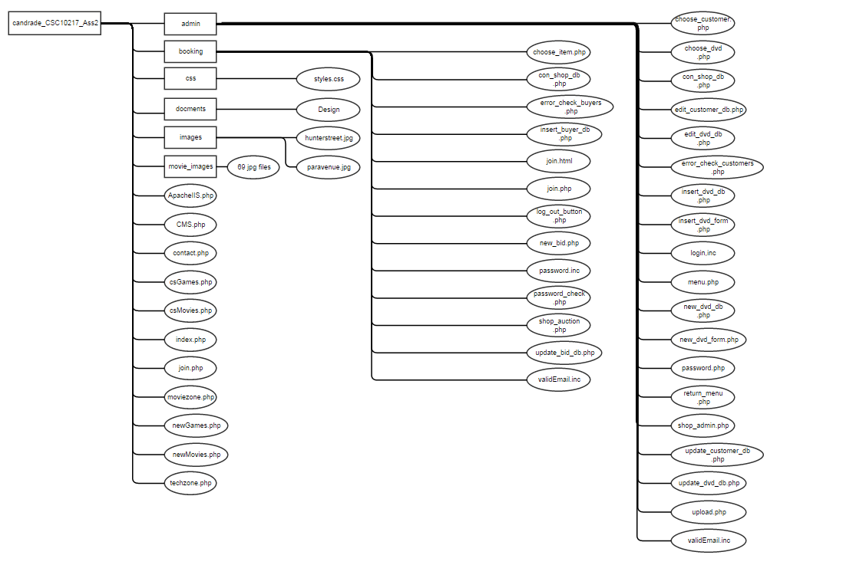
Structure Chart

Navigation
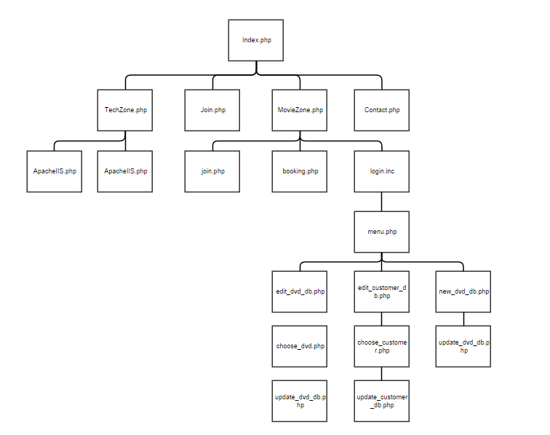

Testing Plan

Validation:
- CSS validated by using CSS Level 3
Display of pages on different browser sizes
- 800 x 600 pixels
- 1024 x 768 pixels
- 1280 x 800 pixels
- 1280 x 1024 pixels
- 1366 x 768 pixels
- 1920 x 1080 pixels
Same webpage on different browsers
- Internet Explorer
- Mozilla Firefox
- Google Chrome
- Safari
- Opera
Hyperlinks/Media links
- Internal links
- External links
Working media
- Images

Story Board
Title: | Index.php | Screen ID: | 1.0 | Date: | 14/09/2015
ELEMENTS:
GRAPHICS: No images present

TEXT: Landing page for the site

AUDIO/VIDEO: No audio or video present.

NOTES: The divisions shown in the CSS layout are within a wrapper that is within a container. The Header contains the Logo and site banner, Navigation Bar gives us access to linked pages, Page Header informs users what this page is about, Sidebar contains sites that are under construction, Footer contains a link to the site.

Description: | My Resume details
Content: | Featured new release
Interactions:
Media Creation:
Navigation: | The navigation bar links to all 3 main pages. Home (index.php), TechZone (techzone.php), Join (join.php), MovieZone (moviezone.php), Contact (contect.php  The Header links to the site itself (http://infotech.scu.edu.au/~candra10)

Title: | techzone.html | Screen ID: | 1.2 | Date: | 14/09/2015
ELEMENTS:
GRAPHICS: No images present

TEXT: Site that contains information about I.T related questions

AUDIO/VIDEO: No audio or video present.

NOTES: The divisions shown in the CSS layout are within a wrapper that is within a container. The Header contains the Logo and site banner, Navigation Bar gives us access to linked pages, Page Header informs users what this page is about, Sidebar contains sites that are under construction, Footer contains a link to the site.

Description: | My Resume details
Content: | Information about various I.T questions
Interactions:
Media Creation:
Navigation: | The navigation bar links to all 3 main pages. Home (index.php), TechZone (techzone.php), Join (join.php), MovieZone (moviezone.php), Contact (contect.php  The Header links to the site itself (http://infotech.scu.edu.au/~candra10)

Title: | ApacheIIS.html | Screen ID: | 1.2.1 | Date: | 14/09/2015
ELEMENTS:
GRAPHICS: No images present

TEXT: Information about Apache vs IIS

AUDIO/VIDEO: No audio or video present.

NOTES: The divisions shown in the CSS layout are within a wrapper that is within a container. The Header contains the Logo and site banner, Navigation Bar gives us access to linked pages, Page Header informs users what this page is about, Sidebar contains sites that are under construction, Footer contains a link to the site.

Description: | My Resume details
Content: | Apache vs IIS
Interactions:
Media Creation:
Navigation: | The navigation bar links to all 3 main pages. Home (index.php), TechZone (techzone.php), Join (join.php), MovieZone (moviezone.php), Contact (contect.php  The Header links to the site itself (http://infotech.scu.edu.au/~candra10)

Title: | CMS.html | Screen ID: | 1.2.2 | Date: | 14/09/2015

ELEMENTS:
GRAPHICS: No images present

TEXT: Contains information about CMS

AUDIO/VIDEO: No audio or video present.

NOTES: The divisions shown in the CSS layout are within a wrapper that is within a container. The Header contains the Logo and site banner, Navigation Bar gives us access to linked pages, Page Header informs users what this page is about, Sidebar contains sites that are under construction, Footer contains a link to the site.

Description: | My Resume details
Content: | Information about “What content management system does your business need”
Interactions:
Media Creation:
Navigation: | The navigation bar links to all 3 main pages. Home (index.php), TechZone (techzone.php), Join (join.php), MovieZone (moviezone.php), Contact (contect.php  The Header links to the site itself (http://infotech.scu.edu.au/~candra10)

Title: | join.php | Screen ID: | 1.3 | Date: | 14/09/2015

ELEMENTS:
GRAPHICS: No images present

TEXT: join page

AUDIO/VIDEO: No audio or video present.
NOTES: The divisions shown in the CSS layout are within a wrapper that is within a container. The Header contains the Logo and site banner, Navigation Bar gives us access to linked pages, Page Header informs users what this page is about, Sidebar contains sites that are under construction, Footer contains a link to the site.

Description: | My Resume details
Content: | Details to fill for the customer
Interactions:
Media Creation:
Navigation: | The navigation bar links to all 3 main pages. Home (index.php), TechZone (techzone.php), Join (join.php), MovieZone (moviezone.php), Contact (contect.php  The Header links to the site itself (http://infotech.scu.edu.au/~candra10)

Title: | moviezone.php | Screen ID: | 1.4 | Date: | 14/09/2015

ELEMENTS:
GRAPHICS: No images present

TEXT: moviezone page
Movie related page

AUDIO/VIDEO: No audio or video present.

NOTES: The divisions shown in the CSS layout are within a wrapper that is within a container. The Header contains the Logo and site banner, Navigation Bar gives us access to linked pages, Page Header informs users what this page is about, Sidebar contains sites that are under construction, Footer contains a link to the site.

Description: | My Resume details
Content: | Contains join, booking and admin links
Interactions:
Media Creation:
Navigation: | The navigation bar links to all 3 main pages. Home (index.php), TechZone (techzone.php), Join (join.php), MovieZone (moviezone.php), Contact (contect.php  The Header links to the site itself (http://infotech.scu.edu.au/~candra10)

Title: | contact.php | Screen ID: | 1.5 | Date: | 14/09/2015
ELEMENTS:
GRAPHICS: Images of the locations of the shops

TEXT: Contact details about the shop

AUDIO/VIDEO: No audio or video present.

NOTES: The divisions shown in the CSS layout are within a wrapper that is within a container. The Header contains the Logo and site banner, Navigation Bar gives us access to linked pages, Page Header informs users what this page is about, Sidebar contains sites that are under construction, Footer contains a link to the site.

Description: | My Resume details
Content: | Contact details about the shop with images to the shop, trading hours, email
Interactions:
Media Creation:
Navigation: | The navigation bar links to all 3 main pages. Home (index.php), TechZone (techzone.php), Join (join.php), MovieZone (moviezone.php), Contact (contect.php  The Header links to the site itself (http://infotech.scu.edu.au/~candra10)

