Supplementary Table 1—Biochemical PFS multivariable analysis
Variable | HR (95% CI) | p val
BRCA2mut/SPOPmut (vs BRCA2mut/SPOPwt) | 0.16 (0.05-0.47) | 0.001
Histology: Other (vs Adenocarcinoma) | 2.07 (0.19-22.72) | 0.551
Histology: Small Cell (vs Adenocarcinoma) | 0 (0-Inf) | 0.996
Gleason Sum: 9-10 (vs 6-8) | 0.79 (0.5-1.25) | 0.310
Gleason Sum: Unknown (vs 6-8) | 0.56 (0.18-1.77) | 0.323
Prior Taxane | 1.44 (0.87-2.38) | 0.156
Prior ARPI | 1.65 (0.65-4.14) | 0.289
Age | 1.01 (0.98-1.05) | 0.386
M stage: M1a (vs M0) | 0.37 (0.09-1.47) | 0.157
M stage: M1b (vs M0) | 0.85 (0.28-2.62) | 0.781
M stage: M1c (vs M0) | 0.69 (0.17-2.86) | 0.610
Baseline PSA | 1 (1-1) | NA
BRCA2 Somatic only (versus Germline) | 1.15 (0.65-2.05) | 0.631
BRCA2 Homozygous Deletion (vs other alteration type) | 0.7 (0.32-1.51) | 0.074
BRCA2 Alteration Unknown (versus Monoallelic) | 0.91 (0.36-2.28) | 0.833
BRCA2 Alteration Biallelic (versus Monoallelic) | 0.7 (0.36-1.37) | 0.301
TP53 unknown (versus wild type) | NA | NA
TP53 mutated (versus wild type) | 1.51 (0.76-2.99) | 0.241
PTEN unknown (versus wild type) | NA | NA
PTEN mutated (versus wild type) | 1.08 (0.5-2.33) | 0.852
RB1 unknown (versus wild type) | NA | NA
RB1 mutated (versus wild type) | 1.99 (0.77-5.15) | 0.155
ATM unknown (versus wild type) | 0.56 (0.22-1.4) | 0.213
ATM mutated (versus wild type) | 0.4 (0.14-1.18) | 0.098
AR unknown (versus wild type) | 0.59 (0.18-1.93) | 0.387
AR mutated (versus wild type) | 0.83 (0.31-2.24) | 0.713
TMPRSS2 fusion unknown (versus wild type) | 0.57 (0.17-1.87) | 0.350
TMPRSS2 fusion present (versus wild type) | 1.02 (0.46-2.25) | 0.960

Supplementary Table 2—Clinical/Radiographic PFS multivariable analysis
Variable | HR (95% CI) | p val
BRCA2mut/SPOPmut (vs BRCA2mut/SPOPwt) | 0.28 (0.1-0.81) | 0.019
Histology: Other (vs Adenocarcinoma) | 3.04 (0.27-34.74) | 0.370
Histology: Small Cell (vs Adenocarcinoma) | 0 (0-Inf) | 0.996
Gleason Sum: 9-10 (vs 6-8) | 0.91 (0.56-1.5) | 0.716
Gleason Sum: Unknown (vs 6-8) | 0.66 (0.2-2.15) | 0.492
Prior Taxane | 1.24 (0.75-2.05) | 0.408
Prior ARPI | 1.62 (0.62-4.25) | 0.323
Age | 1.02 (0.99-1.06) | 0.178
M stage: M1a (vs M0) | 0.46 (0.12-1.84) | 0.275
M stage: M1b (vs M0) | 1.05 (0.34-3.23) | 0.935
M stage: M1c (vs M0) | 0.88 (0.21-3.7) | 0.857
Baseline PSA | 1 (1-1) | NA
BRCA2 Somatic only (versus Germline) | 1.29 (0.71-2.33) | 0.405
BRCA2 Homozygous Deletion (vs other alteration type) | 0.68 (0.32-1.46) | 0.324
BRCA2 Alteration Unknown (versus Monoallelic) | 0.84 (0.31-2.27) | 0.732
BRCA2 Alteration Biallelic (versus Monoallelic) | 0.72 (0.36-1.41) | 0.332
TP53 unknown (versus wild type) | NA | NA
TP53 mutated (versus wild type) | 0.7 (0.34-1.45) | 0.337
PTEN unknown (versus wild type) | NA | NA
PTEN mutated (versus wild type) | 1.09 (0.49-2.43) | 0.835
RB1 unknown (versus wild type) | NA | NA
RB1 mutated (versus wild type) | 2.73 (0.99-7.56) | 0.053
ATM unknown (versus wild type) | 0.79 (0.31-2.04) | 0.630
ATM mutated (versus wild type) | 0.37 (0.11-1.22) | 0.102
AR unknown (versus wild type) | 0.56 (0.17-1.85) | 0.339
AR mutated (versus wild type) | 1.43 (0.57-3.61) | 0.450
TMPRSS2 fusion unknown (versus wild type) | 0.47 (0.12-1.78) | 0.266
TMPRSS2 fusion present (versus wild type) | 1.23 (0.54-2.78) | 0.620

Supplementary Table 3—OS multivariable analysis
Variable | HR (95% CI) | p val
BRCA2mut/SPOPmut (vs BRCA2mut/SPOPwt) | 0.19 (0.05-0.69) | 0.012
Histology: Other (vs Adenocarcinoma) | 2.85 (0.23-35.17) | 0.415
Histology: Small Cell (vs Adenocarcinoma) | 2.15 (0.19-24.57) | 0.538
Gleason Sum: 9-10 (vs 6-8) | 1.04 (0.62-1.76) | 0.870
Gleason Sum: Unknown (vs 6-8) | 1.13 (0.34-3.75) | 0.846
Prior Taxane | 1.83 (1.06-3.16) | 0.031
Prior ARPI | 1.4 (0.45-4.33) | 0.562
Age | 1 (0.97-1.04) | 0.944
M stage: M1a (vs M0) | 0.81 (0.08-7.73) | 0.852
M stage: M1b (vs M0) | 3.04 (0.39-23.6) | 0.288
M stage: M1c (vs M0) | 1.61 (0.14-18.5) | 0.701
Baseline PSA | 1 (1-1) | NA
BRCA2 Somatic only (versus Germline) | 1.16 (0.65-2.1) | 0.614
BRCA2 Homozygous Deletion (vs other alteration type) | 0.35 (0.14-0.84) | 0.019
BRCA2 Alteration Unknown (versus Monoallelic) | 0.5 (0.18-1.42) | 0.195
BRCA2 Alteration Biallelic (versus Monoallelic) | 1.2 (0.59-2.47) | 0.612
TP53 unknown (versus wild type) | NA | NA
TP53 mutated (versus wild type) | 2.86 (1.42-5.77) | 0.003
PTEN unknown (versus wild type) | NA | NA
PTEN mutated (versus wild type) | 1.78 (0.77-4.1) | 0.177
RB1 unknown (versus wild type) | NA | NA
RB1 mutated (versus wild type) | 2.59 (0.9-7.46) | 0.079
ATM unknown (versus wild type) | 0.47 (0.19-1.18) | 0.106
ATM mutated (versus wild type) | 0.42 (0.11-1.56) | 0.194
AR unknown (versus wild type) | 0.69 (0.18-2.61) | 0.586
AR mutated (versus wild type) | 0.53 (0.2-1.43) | 0.210
TMPRSS2 fusion unknown (versus wild type) | 0.5 (0.13-1.91) | 0.313
TMPRSS2 fusion present (versus wild type) | 0.54 (0.21-1.42) | 0.213

Supplementary Table 6—COSMIC Signature Prediction by Linear Model

Signature | estimate | p value
SBS3 | 0.309 | 0.0029
ID83C | -2.715 | 0.0145
ID83D | 0.853 | 0.0169
ID83A | -13.162 | 0.0202
ID83K | 0.521 | 0.0235
ID83O | -1.041 | 0.0263
ID83E | 0.703 | 0.0333
ID83R | -20.543 | 0.0341
ID83Q | -3.584 | 0.0409
ID83H | -1.359 | 0.0444
ID83P | -2.017 | 0.0447
SBSU2 | -0.066 | 0.047
SBS19 | -0.039 | 0.0674
ID83B | -6.666 | 0.0685
ID83J | -0.839 | 0.0931
SBS2 | -0.059 | 0.108
ID83G | -0.457 | 0.1669
ID83N | -0.301 | 0.1693
SBS5 | -0.017 | 0.1871
SBS8 | -0.043 | 0.1909
DBS78B | -0.022 | 0.2162
DBS78C | 0.021 | 0.2615
SBS14 | 0.028 | 0.2886
ID83L | -0.24 | 0.373
DBS78E | 0.016 | 0.3755
SBS7 | -0.028 | 0.3873
SBSR2 | -0.011 | 0.3968
SBS6 | -0.108 | 0.398
Signature | estimate | p value
DBS78H | -0.013 | 0.4401
SBS1A | 0.168 | 0.4578
ID83I | 0.172 | 0.4805
DBS78G | 0.014 | 0.5003
DBS78I | -0.009 | 0.5978
ID83M | 0.108 | 0.6427
SBS21 | -0.019 | 0.6631
DBS78F | -0.008 | 0.6645
ID83F | 0.094 | 0.6646
SBS10 | -0.009 | 0.6653
SBS15 | -0.045 | 0.7164
SBS12 | -0.004 | 0.7589
SBS17 | 0.004 | 0.8219
SBSU1 | -0.009 | 0.8222
SBSR1 | 0.007 | 0.824
DBS78K | -0.004 | 0.8335
SBS1B | 0.017 | 0.8337
SBS11 | 0.005 | 0.8386
SBS13 | -0.006 | 0.8411
SBS16 | 0.003 | 0.8642
SBS20 | 0.006 | 0.8669
SBS9 | 0.002 | 0.8768
DBS78A | 0.002 | 0.897
SBS18 | 0.003 | 0.9192
DBS78D | -0.001 | 0.9304
SBS4 | -0.006 | 0.9437
DBS78J | 0 | 0.9897

Supplementary Figure 1—Mosaic plot

Supplementary Figure 2—Outcomes in patients not treated with PARP inhibitors from a separate cohort
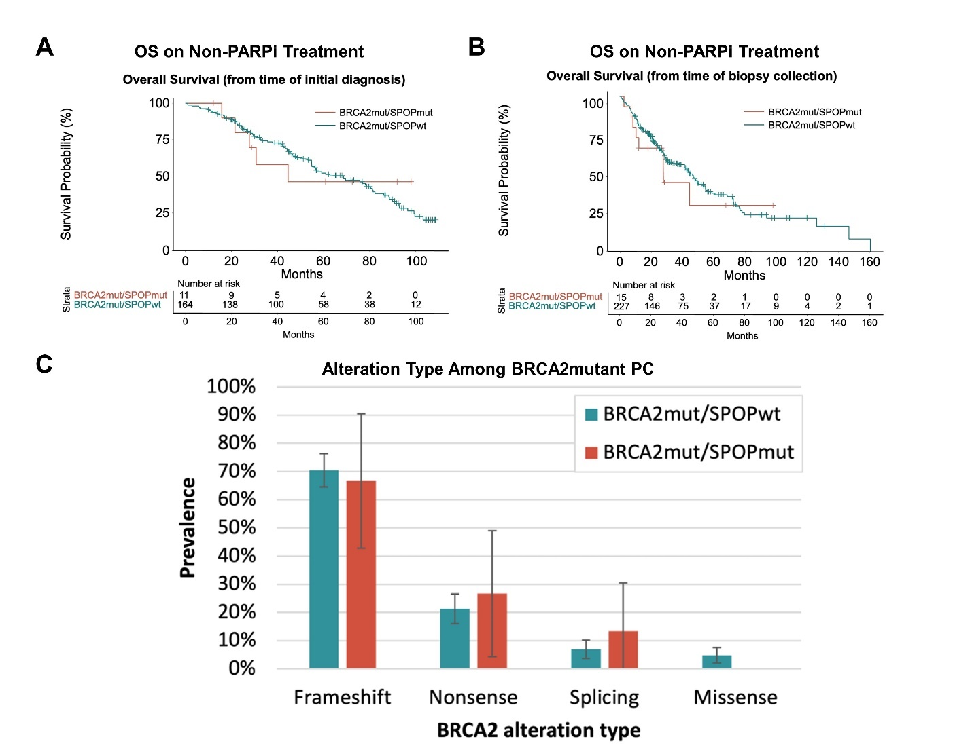

Supplementary Figure 3—COSMIC SBS3 scores in large prostate cancer cohort

Supplementary Figure 4—SPOP Mutation Interaction SBS3 Prediction

