10.2.2020

https://www.youtube.com/watch?v=F9IVtKa8C7Q

LCD -> Arduino

1. GND -> Power GND

2. VCC -> Power 5V

3. SDA -> A4

4. SCL -> A5

Software

* Install library from here <https://bitbucket.org/fmalpartida/new-liquidcrystal/downloads/>
* #include <LiquidCrystal_I2C.h>Demo
* Write demo programme

LiquidCrystal_I2C lcd(0x27, 2, 1, 0, 4, 5, 6, 7, 3, POSITIVE);

void setup() {

lcd.begin(20,4);

lcd.setCursor(3,0);

lcd.print("Hello world!”);

lcd.setCursor(8,1);

lcd.print("***");

lcd.setCursor(0,2);

lcd.print("This is a demo text");

lcd.setCursor(8,3);

lcd.print("***");

}

void loop() {

// put your main code here, to run repeatedly:

}

**Membrance Switch Module**

<https://playground.arduino.cc/Code/Keypad/#Download>

* Download and include keypad.h

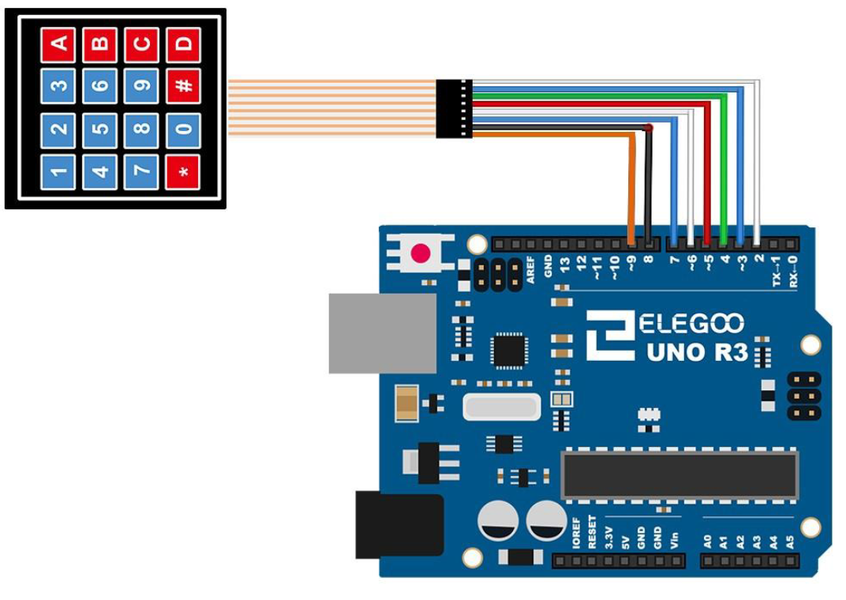

#include <Keypad.h>

const byte ROWS = 4; //four rows

const byte COLS = 4; //four columns

//define the cymbols on the buttons of the keypads

char hexaKeys[ROWS][COLS] = {

{'1','2','3','A'},

{'4','5','6','B'},

{'7','8','9','C'},

{'*','0','#','D'}

};

byte rowPins[ROWS] = {9, 8, 7, 6}; //connect to the row pinouts of the keypad

byte colPins[COLS] = {5, 4, 3, 2}; //connect to the column pinouts of the keypad

//initialize an instance of class NewKeypad

Keypad customKeypad = Keypad( makeKeymap(hexaKeys), rowPins, colPins, ROWS, COLS);

void setup(){

Serial.begin(9600);

}

void loop(){

char customKey = customKeypad.getKey();

if (customKey){

Serial.println(customKey);

}

}