Nova Retraining & Evaluation Report
Local retrain on broadened dataset (nova-counseling-v2) + first real detection-accuracy evaluation

Summary
- Model retrained locally (RTX PRO 4000 Blackwell, 24GB VRAM) on a broadened dataset - 23,037 examples across 7 sources, up from 9,825 in the original counseling-only run.
- First run with a real 80/10/10 train/validation/test split - validation loss was tracked live during training, not just training loss.
- First real, measured accuracy/precision/recall/F1 numbers for the emotion, stress-type, and crisis detection system, against a labeled test set.
- Two items remain open and are marked clearly below rather than assumed: (1) app-level crisis-pathway verification, (2) scaling the labeled detection test set beyond the current small starter set.

1. Training Data
Source | Examples | Type
CounselChat | 2,508 | Real counselor Q&A
Amod (Mental Health Counseling Conversations) | 3,364 | Real counselor Q&A
ESConv | 10,171 | Real crowdsourced support dialogue
MentalChat16K | 3,953 | Synthetic counseling dialogue
Dolly-15k (context-free subset) | 1,411 | General instruction-following
Career Guidance QA | 1,620 | Real career/job-role Q&A
Hand-authored scope/disambiguation set | 10 | Written for this project

- Total: 23,037 examples -> split 80/10/10 -> 18,429 train / 2,303 val / 2,305 test (fixed seed = 3407, reproducible).
- Why broader than v1: the original run used counseling-only data; this run adds general instruction data (Dolly) so the model doesn't over-specialize into only counseling-style phrasing, plus career-guidance data, plus hand-written examples directly targeting a scope/disambiguation issue found during testing (see Section 4).

2. Training Configuration
- Base model: Llama 3.2, 3B parameters, Instruct
- Method: LoRA (rank=16, alpha=16) via Unsloth + TRL SFTTrainer
- Epochs: 3
- Precision: native bf16 (Blackwell GPU supports this directly - the original Colab run needed an fp16 workaround since the T4 GPU used then could not do bf16)
- Hardware: local RTX PRO 4000 Blackwell, 24GB VRAM (vs. Colab's free T4, 15GB)
- Batch size: 4 per device x 4 gradient accumulation steps
- Final train_loss: 0.9546
- Final eval_loss (validation): 0.9107

3. Validation Loss During Training
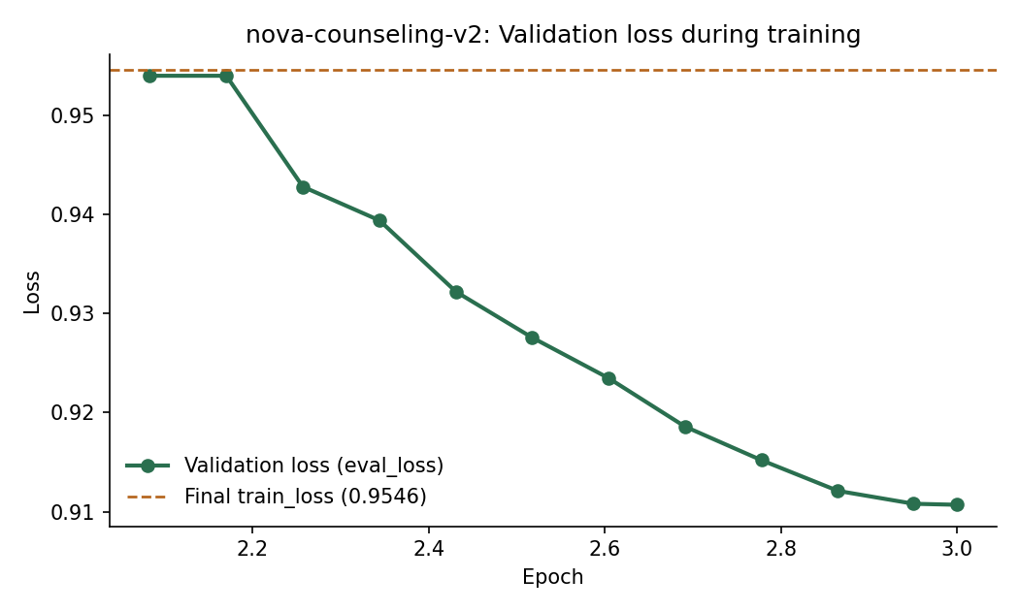
Figure 1 - Validation loss, epochs 2.08-3.0 (earlier portion of the log was not available for this chart). Steady decrease throughout with no upturn - a healthy training run, no visible overfitting.

4. Qualitative Spot-Checks
- Scope/disambiguation fix: confirmed working. The Korean query "성적을 어떻게 향상시킬 수 있을까요?" ("how can I improve my grades") now correctly discusses academic grades - the earlier version of this model had misinterpreted 성적 as a different, inappropriate meaning and produced an off-topic response. That specific failure mode did not recur across repeated testing.
- Korean fluency: grammar remains rough/repetitive in Korean output. Expected and not addressed by this retrain - none of the added datasets were Korean-language; this run targeted topic-correctness, not fluency.
- Career/scholarship question: produced reasonable general guidance when tested directly against the model. Note this test bypassed the app's RAG layer, so it reflects the base model's general knowledge only, not university-specific retrieved information.

Crisis-message test result is NOT a valid safety check and should not be read as one. Testing a crisis-worded message directly against the raw model (bypassing the application) produced a mediocre, dismissive-sounding reply. This is EXPECTED - crisis-pattern messages are deliberately excluded from training data, and the application's actual safety mechanism (inference.py's rule-based crisis check) is designed to intercept these messages before they ever reach the model, returning a fixed, human-reviewed response instead. That app-level pathway has not yet been re-confirmed against this new model as of this report and is an open item - see Section 6.

5. Detection Evaluation (Emotion / Stress-Type / Crisis)
This evaluates inference.py's rule-based classification layer - a separate system from the LLM above - against a labeled test set with human-assigned ground truth. Run on a starter set of 24 examples (see limitations below).

Overall accuracy
Task | Accuracy
Emotion detection | 0.71
Stress-type detection | 0.71
Crisis detection | 1.00

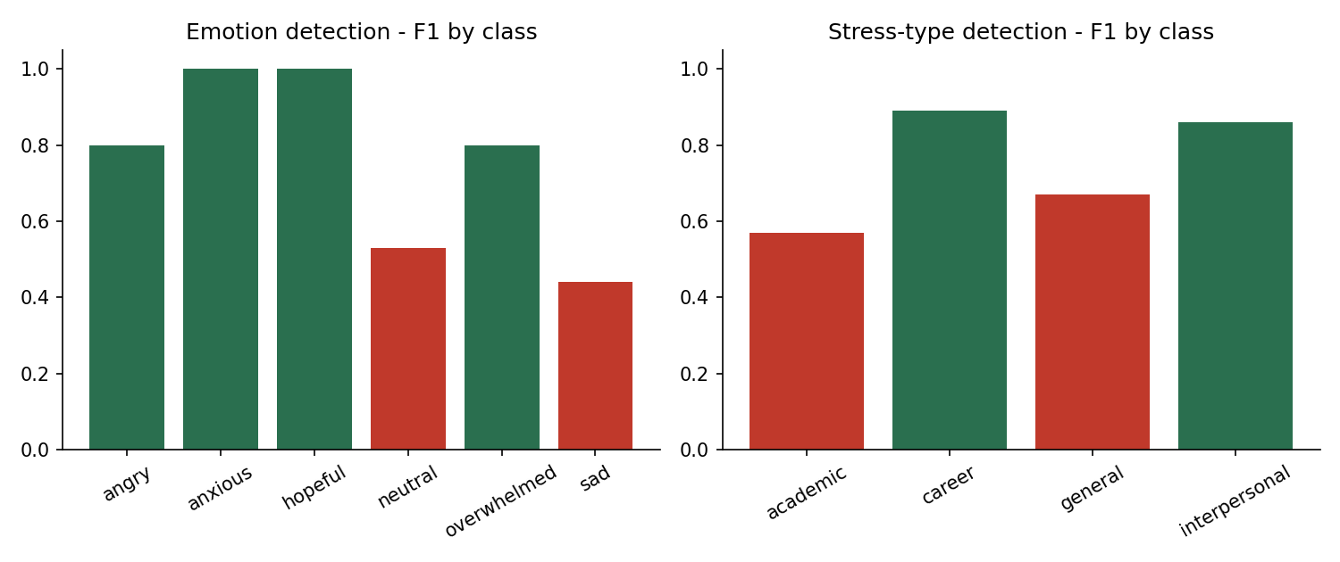
Figure 2 - Per-class F1 scores. Red bars mark classes below 0.70 F1.

Crisis detection detail
Class | Precision | Recall | F1
not_crisis | 1.00 | 1.00 | 1.00
crisis | 1.00 | 1.00 | 1.00

- Crisis recall = 1.00 on this set. Recall is the metric that matters most for this class specifically, since a missed real crisis message is far more costly than a false alarm.

Real errors surfaced (useful findings, not just a score)
- "burnt out from this semester" and "group project" were not recognized as academic stress - the keyword list matches "exam/grade/assignment/deadline/class/course" but not "semester" or "project".
- "chemistry final" was not recognized as academic - "final" is not currently in the academic keyword list, only "exam" is.
- Crisis-worded messages were consistently classified as emotion="neutral" rather than "sad" - the emotion detector's keyword list does not have strong coverage for despair-type language, since it was designed as a general mood classifier, separate from crisis detection.
- A family conflict message ("huge fight with my family") was not recognized as "angry" - "fight" is not in the angry keyword list.

Limitations of this evaluation (important for the paper)
- n=24 is a small starter set, sufficient to prove the evaluation methodology works end-to-end, not sufficient alone for a publishable claim.
- The 3 crisis examples were written with knowledge of inference.py's own regex patterns, so 1.00 recall here demonstrates the mechanism works as designed, not that it generalizes to crisis language phrased differently than the patterns anticipate. A larger, independently-sourced crisis-language test set is needed before this number is reported as a general result.
- Next step: expand this labeled set substantially (target: 150-300+ examples, ideally with multiple independent human raters and inter-rater agreement reported) before including these numbers in the paper's evaluation section.

6. Reinforcement Learning (Strategy Selection) - Status
- Implementation: confirmed complete. strategy_selector.py (LinUCB contextual bandit), integration into chatbot_engine.py, StrategyLog persistence in chatbot_service.py, the /feedback endpoint, and bandit warm-start at app startup are all built and verified working - including a direct test confirming crisis messages never reach the RL component.
- Not yet done: frontend thumbs-up/down UI. Without it, no real student feedback reaches the bandit yet, so it has not begun learning in production. This is the next concrete step for the RL component specifically.
- Strategy-selection accuracy/precision/recall/F1 (vs. human-preferred strategy): not yet measured - requires both the feedback UI (to generate real usage) and a human-labeled preferred-strategy set, neither of which exist yet.

7. Open Items
- Re-verify the crisis-response pathway against the app itself (not the raw model) with the new nova-counseling-v2 model loaded - pending confirmation.
- Expand the labeled detection test set from 24 to 150-300+ examples for a publishable evaluation number.
- Build the frontend feedback UI so the RL component can begin learning from real usage.
- Once feedback exists, build the human-preferred-strategy labeled set and measure RL strategy-selection accuracy/precision/recall/F1.

Conclusion
- The retrain succeeded: broader, more diverse training data, a real validation split showing healthy (non-overfit) learning, and a confirmed fix for the scope/disambiguation issue found in the previous model version.
- The detection layer now has a first real, honestly-reported accuracy measurement (0.71 emotion, 0.71 stress-type, 1.00 crisis-on-starter-set) with specific, actionable gaps identified rather than a black-box score.
- Two verifications remain open before these results should be treated as final for a paper: app-level crisis-pathway confirmation, and a larger detection test set.

