AgriSync: An Integrated AI Framework for Leaf Disease Detection, Soil Classification, and Crop Recommendation
First Author#1, Second Author*2, Third Author#3
#First-Third Department, First-Third University, Address Including Country Name
1first.author@first-third.edu, 3third.author@first-third.edu
*Second Company Address Including Country Name
2second.author@second.com
Abstract- Farmers routinely lose a significant share of their harvest to undiagnosed plant diseases, poorly understood soils, and crop choices driven by habit rather than field conditions; however, existing digital agriculture tools usually address only one of these decisions in isolation. This paper introduces AgriSync, a web-based decision-support framework that unifies three agricultural prediction services: leaf disease detection, soil type classification, and crop recommendation. The leaf and soil modules use a training-free approach in which ImageNet-pretrained EfficientNetB0 embeddings are matched against class prototypes by cosine similarity, while the crop recommendation module uses a Random Forest trained on soil nutrients (N, P, K), pH, temperature, humidity, and rainfall. The system is built on a FastAPI backend and a React frontend. Experimental evaluation on held-out data shows 99.55% crop recommendation accuracy, 80.9% top-3 soil accuracy, and inference latency below 150 ms on an ordinary CPU.
Keywords— Precision Agriculture, Plant Disease Detection, Soil Classification, Crop Recommendation, EfficientNet, Random Forest, FastAPI.

I. INTRODUCTION
Agriculture remains the primary source of livelihood for a large share of the population in developing economies, and India alone loses an estimated 35 percent of its annual crop yield to plant diseases [2]. Farmers must routinely make three interlinked decisions: identifying whether a crop is diseased, understanding the soil they are working with, and choosing which crop to sow in the coming season. Advances in deep learning and machine learning have shown strong potential for supporting each of these decisions from photographs and simple field measurements [6], [7].
In practice, however, these decisions are still made largely through intuition, inherited practice, or occasional visits from extension officers. Laboratory soil testing and expert plant pathology are expensive and slow to reach rural areas. Furthermore, a single misjudged decision, such as sowing a water-intensive crop in a low-rainfall season, can cause losses that persist across an entire year.
Prior research has produced accurate models for individual tasks, notably convolutional neural networks for leaf disease classification [1] and machine-learning classifiers for crop selection [8]. However, most of these solutions remain standalone research prototypes trained on controlled laboratory images and are rarely delivered to farmers as a usable application. Models trained on laboratory images also degrade sharply on real field photographs with cluttered backgrounds [2].
This paper presents AgriSync, an open-source, web-based agricultural decision-support platform that combines image-based and data-driven predictions behind a single, simple interface. The primary contributions of this work are fourfold:
(1) Unified Agricultural Prediction Platform: Integrating leaf disease detection, soil type classification, and crop recommendation into one FastAPI service consumed by a responsive React dashboard.
(2) Training-Free Image Recognition: Using ImageNet-pretrained EfficientNetB0 embeddings with cosine-similarity prototype matching, so that new disease or soil classes can be added by supplying a few reference images instead of retraining a network.
(3) Data-Driven Crop Recommendation: Introducing a Random Forest classifier that recommends the most suitable of 22 crops from soil nutrients, pH, and local climate, returning the top three options with confidence scores.
(4) Transparent Empirical Evaluation: Measuring top-1 accuracy, top-3 accuracy, macro F1-score, and inference latency for all three modules on data that was not used to build or train the models.
II. RELATED WORK
AgriSync builds on two established lines of agricultural artificial intelligence research: image-based crop health assessment and data-driven soil and crop management.
A. Deep Learning for Plant Disease Detection
Mohanty et al. [1] trained deep convolutional networks on 54,306 laboratory leaf images and reached 99.35 percent accuracy. However, Singh et al. [2] showed that such models generalize poorly to field photographs and released PlantDoc, a 27-class in-the-wild dataset on which a fine-tuned VGG16 reached only 29.73 percent accuracy on uncropped images. Kamilaris and Prenafeta-Boldu [6] likewise identified realistic training data as a recurring limitation.
B. Soil Classification and Crop Recommendation Systems
Liakos et al. [7] reviewed machine-learning applications in crop, water, and soil management and highlighted ensemble methods for tabular agronomic data. Doshi et al. [8] proposed AgroConsultant, which recommends crops from location, season, soil, temperature, and rainfall, reporting 90.43 percent accuracy with a Random Forest [5]. However, most existing systems treat soil identification and crop selection as separate tools and do not combine them with visual disease diagnosis in a single farmer-facing application.
III. SYSTEM ARCHITECTURE AND PREDICTION WORKFLOW
AgriSync is engineered as a modular client-server application featuring a responsive web interface, a lightweight REST backend, and a local model store that requires no external cloud services.
A. High-Level System Architecture
The system architecture is structured into three distinct operational tiers to ensure separation of concerns and fast response: Presentation Layer: The client-side tier is a React and Tailwind CSS single-page application with three tool pages. Farmers upload a leaf photograph, upload a soil photograph, or enter seven field readings, and immediately view the prediction, its confidence, and practical guidance. API and Validation Layer: A FastAPI backend exposes the /predict, /predict-soil, and /predict-crop endpoints. It stores uploads temporarily, validates inputs (colour checks for images and range checks for field readings), and routes each request to the appropriate predictor. Model and Knowledge Layer: This tier holds the EfficientNetB0 feature extractor, precomputed class-prototype indexes for 27 leaf classes and 4 soil classes, the trained Random Forest model, and curated treatment and soil-care knowledge, all loaded lazily on first use.
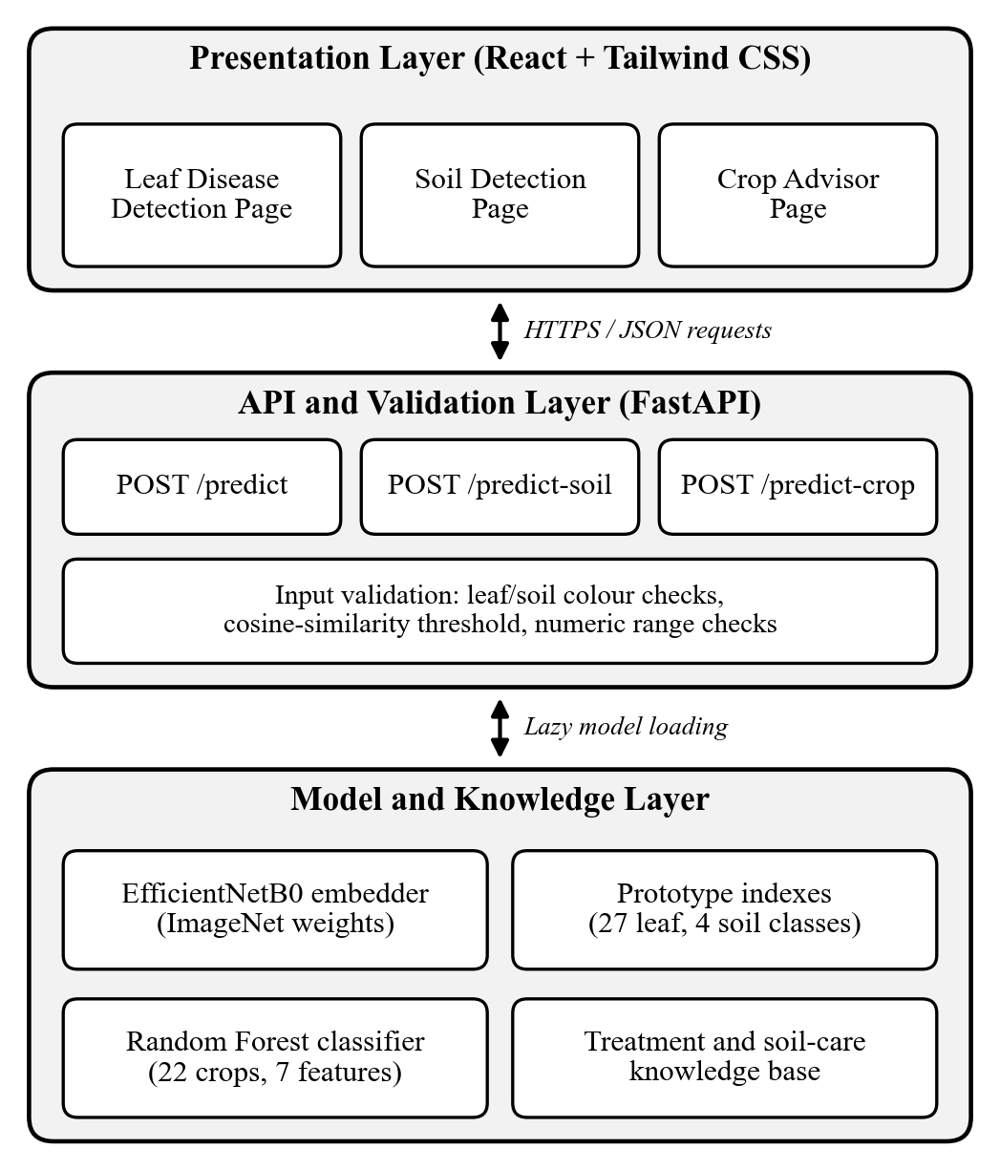
Fig. 1. High-level three-tier system architecture of AgriSync showing the Presentation, FastAPI API and Validation, and Model and Knowledge layers.
B. Prediction Modules and Workflow
The prediction workflow distributes responsibilities across three independent modules, each of which can be invoked separately from the dashboard: Leaf Disease Detection Module: An uploaded leaf image is resized to 224 x 224 pixels and passed through EfficientNetB0 [3], pretrained on ImageNet [4], to produce an L2-normalised 1,280-dimensional embedding. The embedding is compared by cosine similarity with the mean prototype of each of the 27 PlantDoc classes, and the three closest matches are returned with a healthy or diseased status and treatment advice. Soil Classification Module: The same embedder is applied to soil photographs and matched against prototypes for Alluvial, Black, Clay, and Red soil. The response includes soil notes, care tips, and crops typically suited to that soil. Crop Recommendation Module: The farmer enters nitrogen, phosphorus, and potassium levels, soil pH, temperature, humidity, and rainfall, and a Random Forest returns the most suitable crop together with two alternatives and their class probabilities. Inputs with very low similarity or out-of-range values are rejected with a clear message rather than a misleading prediction.
IV. IMPLEMENTATION DETAILS
The implementation emphasizes simplicity, low hardware requirements, and reproducibility, so that the complete platform runs on an ordinary laptop CPU.
A. Backend Design and Model Storage
The backend uses Python's FastAPI framework with Pydantic request validation and lazy model loading, so TensorFlow is loaded only when an image endpoint is first called. Prototype indexes are stored as compact NumPy archives and the crop model is serialised with joblib, giving a total model footprint below 23 MB including the shared EfficientNetB0 weights.
B. Feature Extraction and Model Training
Because the image modules are training-free, a new disease or soil class only requires a few labelled reference images; prototypes are averaged from eight leaf images and ten soil images per class. The crop model was trained on a public dataset of 2,200 samples covering 22 crops with seven numeric features, using a stratified 80/20 split and 200 trees. Training takes under one second on a CPU, with rainfall, humidity, and potassium as the most important features.
V. EXPERIMENTAL EVALUATION
To evaluate the accuracy, responsiveness, and practicality of AgriSync, each module was tested on data that was not used to build its prototypes or train its model, using a consumer laptop CPU without GPU acceleration.
A. Evaluation Metrics and Methodology
The evaluation framework measures three primary performance dimensions: (1) Top-1 and Top-3 Accuracy, the percentage of samples whose true class is the first prediction or among the first three; (2) Macro F1-Score, the unweighted mean F1-score across classes, which accounts for class imbalance; and (3) Inference Latency, the average time of a single end-to-end prediction including image decoding and validation. Leaf disease detection was evaluated on 2,316 held-out PlantDoc images, soil classification on 1,170 held-out soil images, and crop recommendation on a 440-sample stratified test split.
Prediction Module | Top-1 / Top-3 Accuracy | Avg. Inference Latency
Leaf Disease Detection (27 classes) | 28.6% / 52.9% | 128 ms
Soil Classification (4 classes) | 46.3% / 80.9% | 86 ms
Crop Recommendation (22 crops) | 99.6% / 100.0% | 33 ms
TABLE I. QUANTITATIVE PERFORMANCE METRICS OF THE THREE AGRISYNC PREDICTION MODULES.
B. Empirical Results and Discussion
Experimental results show that the crop recommendation module achieves 99.55% top-1 accuracy with a macro F1-score of 0.996. The soil module reaches 46.3% top-1 and 80.9% top-3 accuracy, while the leaf module achieves 28.6% top-1 and 52.9% top-3 accuracy across 27 field-condition classes, comparable to the 29.73 percent of a fine-tuned VGG16 on uncropped PlantDoc images [2] despite requiring no training. All modules respond in under 150 ms on a CPU, and the image results are best presented to farmers as ranked suggestions.
VI. CONCLUSION
This paper introduced AgriSync, an integrated agricultural decision-support framework that brings leaf disease detection, soil classification, and crop recommendation together in a single web application. By combining training-free EfficientNetB0 prototype matching with a Random Forest crop recommender behind a lightweight FastAPI backend, the system delivers fast and easily extensible predictions on ordinary hardware. The crop recommender proved highly accurate, while the image modules provide useful ranked suggestions. Future work will fine-tune the image modules on larger field datasets, add leaf localisation, and connect live weather data to the crop recommender.
ACKNOWLEDGMENT
The authors gratefully acknowledge the creators of the PlantDoc and Crop Recommendation datasets, and the open-source communities behind TensorFlow, scikit-learn, FastAPI, and React, whose tools and data made this research platform possible.
REFERENCES
[1] S. P. Mohanty, D. P. Hughes, and M. Salathe, "Using deep learning for image-based plant disease detection," Front. Plant Sci., vol. 7, Art. no. 1419, Sept. 2016.
[2] D. Singh, N. Jain, P. Jain, P. Kayal, S. Kumawat, and N. Batra, "PlantDoc: A dataset for visual plant disease detection," in Proc. 7th ACM IKDD CoDS and 25th COMAD, Hyderabad, India, 2020, pp. 249-253.
[3] M. Tan and Q. Le, "EfficientNet: Rethinking model scaling for convolutional neural networks," in Proc. 36th Int. Conf. Mach. Learn. (ICML), PMLR vol. 97, 2019, pp. 6105-6114.
[4] J. Deng, W. Dong, R. Socher, L.-J. Li, K. Li, and L. Fei-Fei, "ImageNet: A large-scale hierarchical image database," in Proc. IEEE Conf. Comput. Vis. Pattern Recognit. (CVPR), 2009, pp. 248-255.
[5] L. Breiman, "Random forests," Mach. Learn., vol. 45, no. 1, pp. 5-32, Oct. 2001.
[6] A. Kamilaris and F. X. Prenafeta-Boldu, "Deep learning in agriculture: A survey," Comput. Electron. Agric., vol. 147, pp. 70-90, Apr. 2018.
[7] K. G. Liakos, P. Busato, D. Moshou, S. Pearson, and D. Bochtis, "Machine learning in agriculture: A review," Sensors, vol. 18, no. 8, Art. no. 2674, Aug. 2018.
[8] Z. Doshi, S. Nadkarni, R. Agrawal, and N. Shah, "AgroConsultant: Intelligent crop recommendation system using machine learning algorithms," in Proc. 4th Int. Conf. Comput. Commun. Control Autom. (ICCUBEA), Pune, India, 2018.

