Cristalina Nguyen, Amelia Jay

Dr. Andrew Forney

Artificial Intelligence

11/19/2018

Homework 3 Report

1. 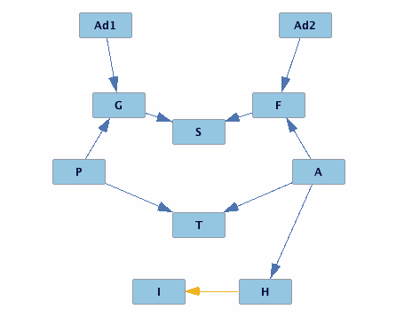
2. PC Structure Learning Algorithm
   1. The algorithm creates a model given some set of data. It detects classes of models that make the same conditional independence claims about some variable. It starts with a complete undirected graph with edges between all nodes, and says that if two variables X and Y are independent of each other given another variable Z, remove the edge between X and Y. It also tries to orient undirected edges consistent with the ones that are already oriented, and it does this recursively until there are no edges left that can be oriented
3. When an edge between two variables can be redirected without affecting those conditional independence claims, it leaves it empty and we can decide what to do with it. As long as a move to redirect does not mess with the claim, it can be directed however the person sees fit.
4. We do not believe that this practice should be considered ethical if the data was collected via social media. Considering the person whose data is being collected most likely does not know, just because their information is online and available, if they did not consent to their information being used to sway them through advertisements, that is not fair. Also, considering there is no template for what political party a person is considering their views on certain topics, you can never be certain that using the information you collected will be successful. Targeting political advertising where ads are curated based on perceived group is less invasive and somewhat more ethical. If you are choosing what to display to someone based on their perceived group, you are not collected large amounts of data and deriving conclusions from such data.