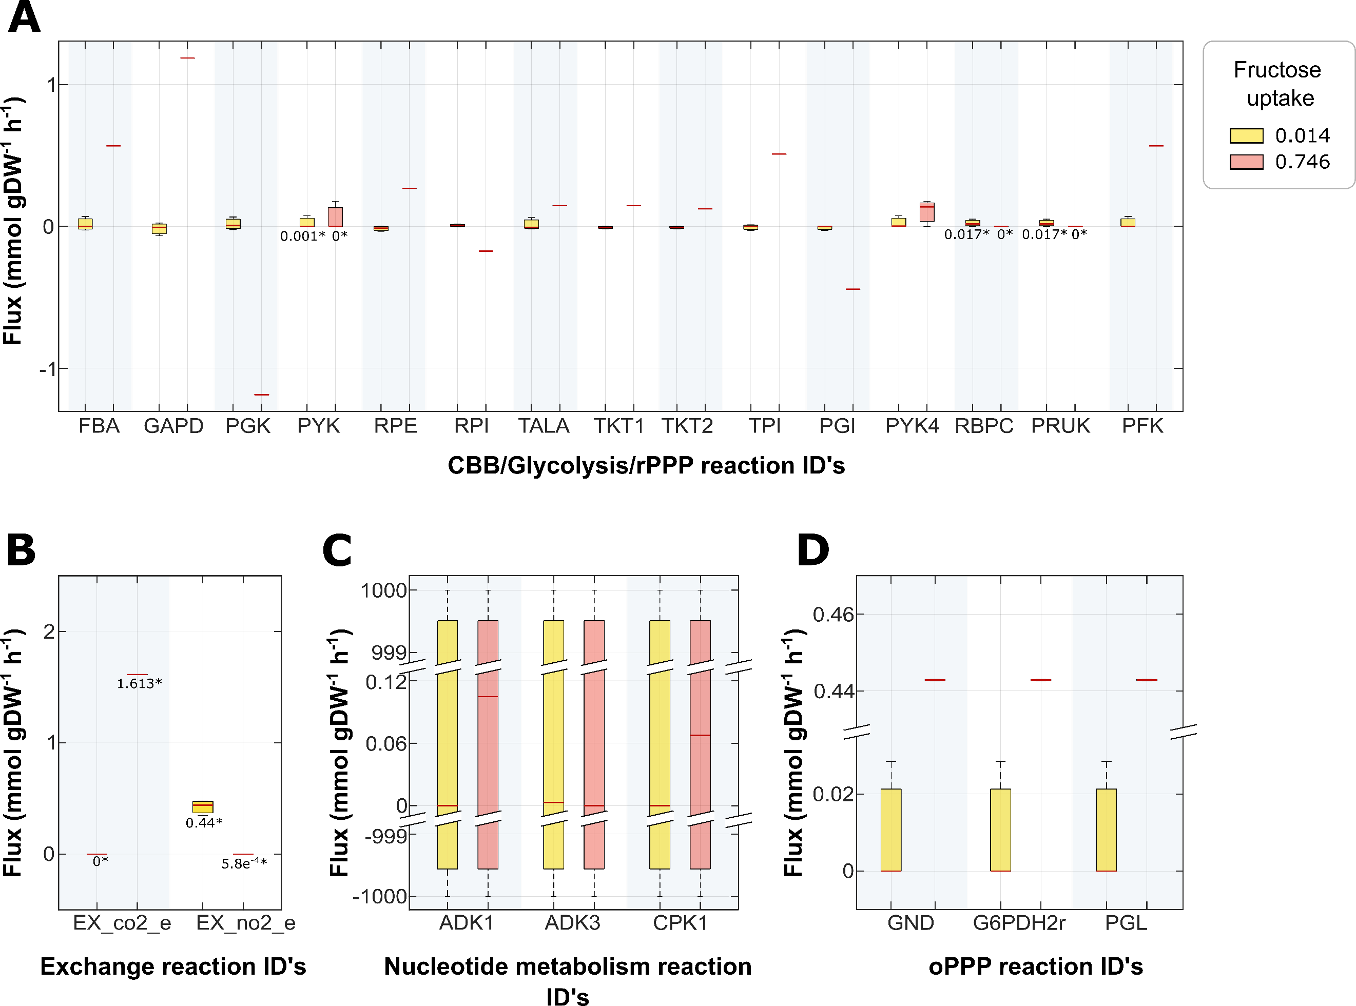**Figure S1.** A) Flux prediction change of CBB cycle, glycolysis, rPPP reactions when fructose uptake is 0.014 (low concentration) or 0.746 (high concentration) mmol/gDW/h (ammonium uptake rate setting on 0.5 mmol/gDW/h ). B) Flux prediction change of exchange reactions when fructose uptake is 0.014 or 0.746 mmol/gDW/h (ammonium uptake rate setting on 0.5 mmol/gDW/h ). C) Flux prediction change of nucleotide metabolism reactions when fructose uptake is 0.014 or 0.746 mmol/gDW/h (ammonium uptake rate setting on 0.5 mmol/gDW/h. D) Flux prediction change of oPPP reactions when fructose uptake is 0.014 or 0.746 mmol/gDW/h (ammonium uptake rate setting on 0.5 mmol/gDW/h)

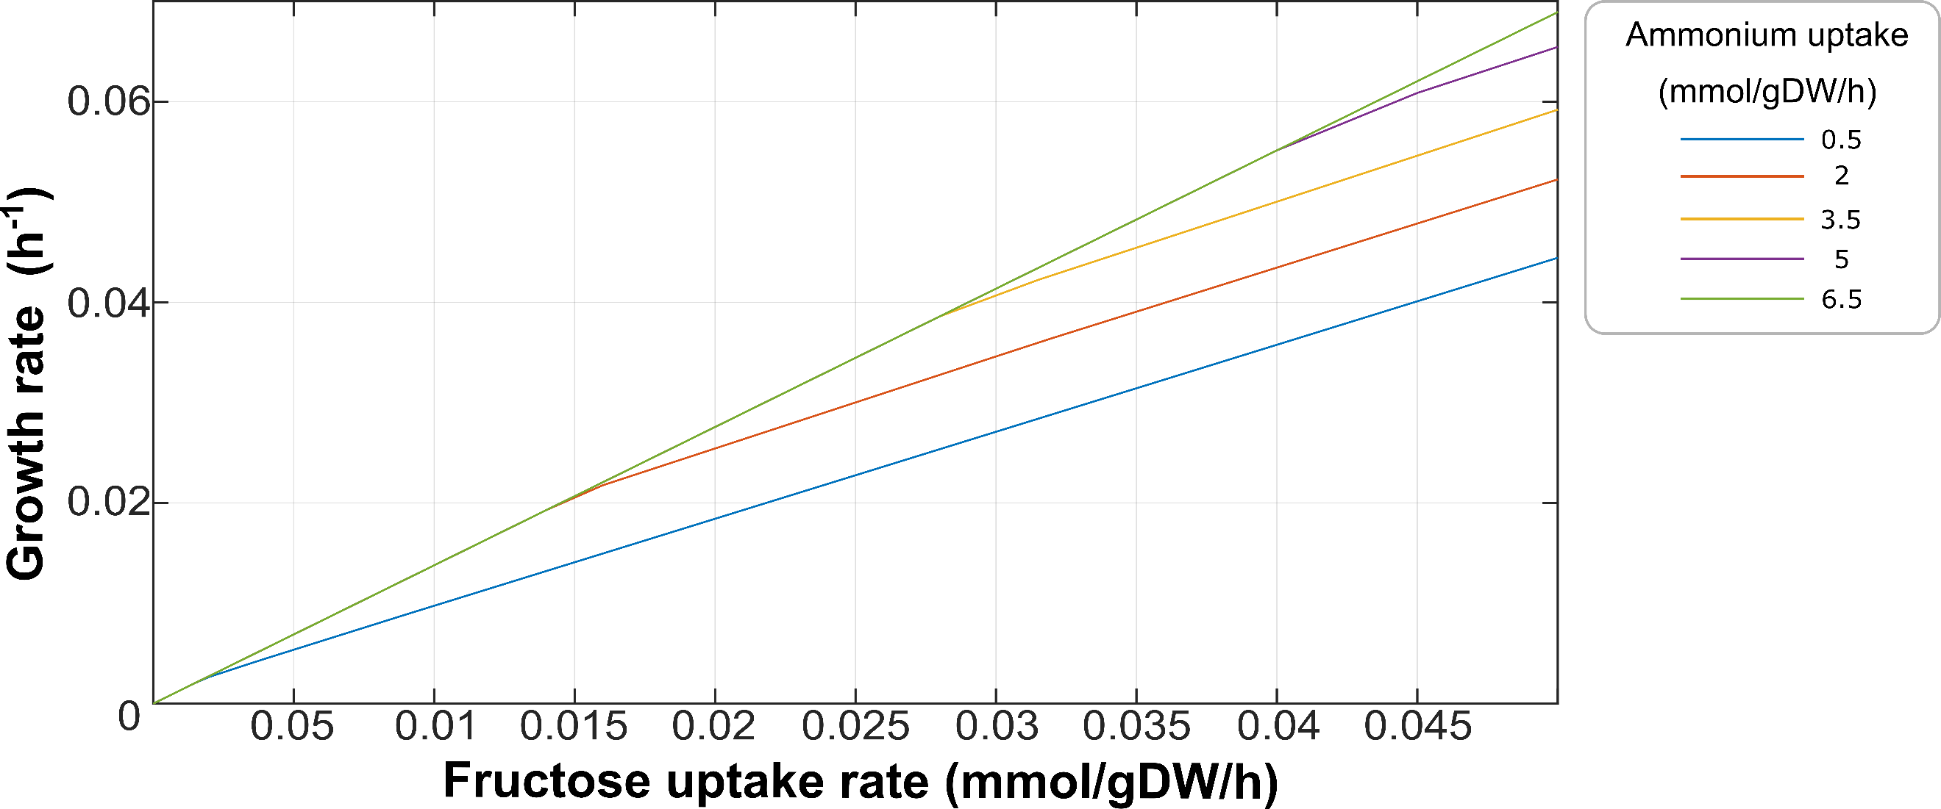

**Fig. S2.** *N. europaea*growth rates under different uptake fluxes of ammonium and fructose