Ministerul Educației al Republicii Moldova

Universitatea Tehnică a Moldovei

Facultatea Calculatoare,Informatică și Microelectronică

Laboratory work nr.4

REPORT

At Embedded systems

“Pulse Width Modulation”

st. gr. FAF-141: Cristea Victor

Verified by: Andrei Bragarenco

Chişinău 2016

Goal of the work:

* Implement keyboard control with USART and Virtual Terminal
* Implement PWM
* Implement HBridge
* Create basic 2wd car using elements from previous point.

Condition

Write a C program and schematics for 2WD car using **Universal asynchronous receiver/transmitter**, **h-bridge, pulse width modulation**. Use keyboard as control for wheels. Car should be able to steer,increase velocity, decrease velocity,stop or free wheeling.

Theory

### Motor speed control

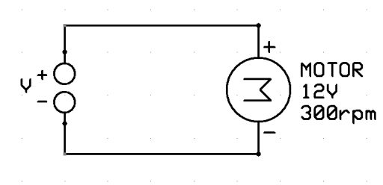

The motor is rated 12V/300rpm. This means that (assuming ideal conditions) the motor will run at 300 rpm only when 12V DC is supplied to it. If we apply 6V, the motor will run at only 150 rpm.

**Motor driver (L293D)**

First, to allow the motor to run clockwise and counterclockwise it is needed a motor drive. In this project was used the L293D motor drive which implements the H-Bridge circuit. L293D is a typical Motor driver or Motor Driver integrated circuit which is used to drive direct current on either direction. It is a 16-pin IC which can control a set of two DC motors simultaneously in any direction.

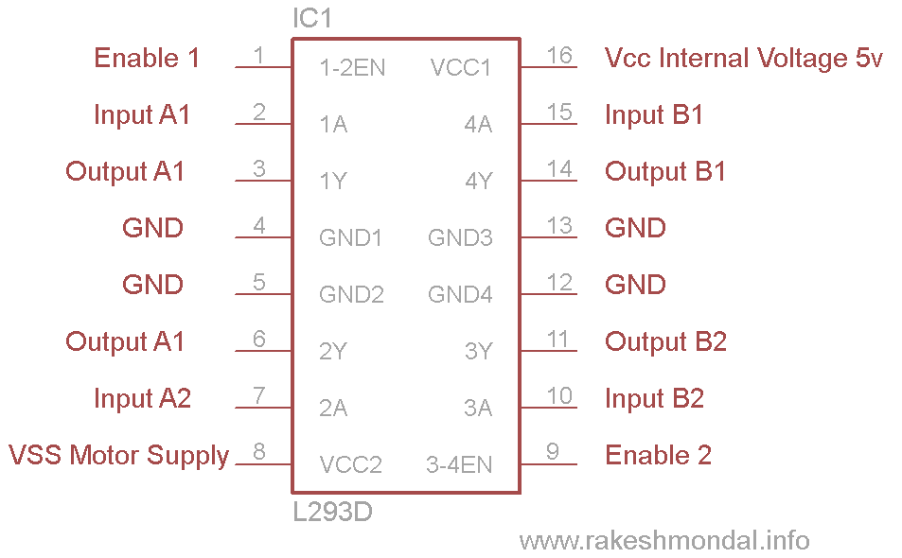

**[Pulse width modulation](http://en.wikipedia.org/wiki/Pulse-width_modulation) (PWM**) is a fancy term for describing a type of digital signal.Pulse width modulation is used in a variety of applications including sophisticated control circuitry. A common way to use them is to control dimming of  [RGB LEDs](https://www.sparkfun.com/products/105) or to control the direction of a  [servo motor.](https://www.sparkfun.com/products/9064) We can accomplish a range of results in both applications because pulse width modulation allows us to vary how much time the signal is high in an analog fashion. While the signal can only be high (usually 5V) or low (ground) at any time, we can change the proportion of time the signal is high compared to when it is low over a consistent time interval.

### PWM Generation

The simplest way to generate a PWM signal is by comparing the a predetermined waveform with a fixed voltage level.

 It has three **compare output modes** of operation:

* **Inverted Mode –** In this mode, if the waveform value is greater than the compare level, then the output is set high, or else the output is low. This is represented in figure A above.
* **Non-Inverted Mode –** In this mode, the output is high whenever the compare level is greater than the waveform level and low otherwise. This is represented in figure B above.
* **Toggle Mode –** In this mode, the output toggles whenever there is a compare match. If the output is high, it becomes low, and vice-versa.

### The Duty Cycle of a PWM

[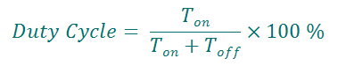](https://i1.wp.com/maxembedded.files.wordpress.com/2011/08/duty-cycle.png)

**H-Bridge**

An *H bridge* is an  [electronic circuit](https://en.wikipedia.org/wiki/Electronic_circuit) that enables a voltage to be applied across a load in either direction. These circuits are often used in  [robotics](https://en.wikipedia.org/wiki/Robotics) and other applications to allow DC

motors to run forwards or backwards. Most DC-to-AC converters  [(power inverters)](https://en.wikipedia.org/wiki/Power_inverter), most  [AC/AC converters,](https://en.wikipedia.org/wiki/AC/AC_converter) the DC-to-DC  [push–pull converter,](https://en.wikipedia.org/wiki/Push%E2%80%93pull_converter) most  [motor controllers,](https://en.wikipedia.org/wiki/Motor_controller) and many other kinds of  [power electronics](https://en.wikipedia.org/wiki/Power_electronics) use H bridges. In particular, a  [bipolar stepper motor](https://en.wikipedia.org/wiki/Stepper_motor#Bipolar_motor) is almost invariably driven by a motor controller containing two H bridges.

The H-bridge arrangement is generally used to reverse the polarity/direction of the motor, but can also be used to 'brake' the motor, where the motor comes to a sudden stop, as the motor's terminals are shorted, or to let the motor 'free run' to a stop, as the motor is effectively disconnected from the circuit. The following table summarises operation, with S1-S4 corresponding to the diagram above.

H bridges are available as  [integrated circuits,](https://en.wikipedia.org/wiki/Integrated_circuits) or can be built from  [discrete components](https://en.wikipedia.org/wiki/Discrete_components).

The term *H bridge* is derived from the typical graphical representation of such a circuit. An H bridge is built with four switches (solid-state or mechanical). When the switches S1 and S4 (according to the first figure) are closed (and S2 and S3 are open) a positive voltage will be applied across the motor. By opening S1 and S4 switches and closing S2 and S3 switches, this voltage is reversed, allowing reverse operation of the motor.

Using the nomenclature above, the switches S1 and S2 should never be closed at the same time, as this would cause a short circuit on the input voltage source. The same applies to the switches S3 and S4. This condition is known as shoot-through.

|  |  |  |  |  |  |  |  |  |  |  |  |  |  |  |  |
| --- | --- | --- | --- | --- | --- | --- | --- | --- | --- | --- | --- | --- | --- | --- | --- |
|  | S1 |  |  | S2 |  |  | S3 |  |  | S4 |  |  | Result |  |  |
|  |  |  |  |  |  |  |  |  |  |  |
|  |  |  |  |  |  |  |  |  |  |  |  |  |  |  |  |
|  | 1 |  |  | 0 |  |  | 0 |  |  | 1 |  |  | Motor moves right |  |  |
|  |  |  |  |  |  |  |  |  |  |  |  |  |  |  |  |
|  | 0 |  |  | 1 |  |  | 1 |  |  | 0 |  |  | Motor moves left |  |  |
|  |  |  |  |  |  |  |  |  |  |  |
|  |  |  |  |  |  |  |  |  |  |  |
|  |  |  |  |  |  |  |  |  |  |  |  |  |  |  |  |
|  | 0 |  |  | 0 |  |  | 0 |  |  | 0 |  |  | Motor coasts |  |  |
|  |  |  |  |  |  |  |  |  |  |  |
|  |  |  |  |  |  |  |  |  |  |  |  |  |  |  |  |
|  | |  |  | |  |  | |  |  | |  |  |  | |  |
|  | 0 |  |  | 1 |  |  | 0 |  |  | 1 |  |  | Motor brakes |  |  |
|  |  |  |  |  |  |  |  |  |  |  |  |  |  |  |  |
|  | |  |  | |  |  | |  |  | |  |  |  | |  |
|  | 1 |  |  | 0 |  |  | 1 |  |  | 0 |  |  | Motor brakes |  |  |
|  |  |  |  |  |  |  |  |  |  |  |  |  |  |  |  |
|  | |  |  | |  |  | |  |  | |  |  |  | |  |
|  | 1 |  |  | 1 |  |  | 0 |  |  | 0 |  |  | Short circuit |  |  |
|  |  |  |  |  |  |  |  |  |  |  |  |  |  |  |  |
|  | |  |  | |  |  | |  |  | |  |  |  | |  |
|  | 0 |  |  | 0 |  |  | 1 |  |  | 1 |  |  | Short circuit |  |  |
|  |  |  |  |  |  |  |  |  |  |  |  |  |  |  |  |
|  | |  |  | |  |  | |  |  | |  |  |  | |  |
|  | 1 |  |  | 1 |  |  | 1 |  |  | 1 |  |  | Short circuit |  |  |
|  |  |  |  |  |  |  |  |  |  |  |  |  |  |  |  |
|  |  |  |  |  |  |  |  |  |  |  |  |  |  |  |  |



Solving

1. Environment setup by creating the following files: main.c, car_2wd.c, motor.c, pwm.c, gpio.c ,hbridge.c, uart_stdio.c ,car_2wd.h, motor.h, pwm.h., hbridge.h,uart_stdio.h,
2. UART driver initializes serial IO for UART and it used as keyboard controller.

void uart_stdio_Init(void);

int uart_PutChar(char c, *FILE* *stream);

char uart_ReadChar();

1. Car_2w driver has a descriptor which is composed from two DC motor and methods to control de car from the keyboard

int motor_left[] = {2, 3};

int motor_right[] = {7, 8};

void setup() {

for(int i = 0; i < 2; i++){

pinMode(motor_left[i], OUTPUT);

pinMode(motor_right[i], OUTPUT);

}

}

void loop() {

delay(50);

drive_forward(); // Change this line to other methods like drive_backward, turn_left, turn_right to test the rotation of wheels

}

void drive_forward() {

digitalWrite(motor_left[0], HIGH);

digitalWrite(motor_left[1], LOW);

digitalWrite(motor_right[0], HIGH);

digitalWrite(motor_right[1], LOW);

}

void drive_backward() {

digitalWrite(motor_left[0], LOW);

digitalWrite(motor_left[1], HIGH);

digitalWrite(motor_right[0], LOW);

digitalWrite(motor_right[1], HIGH);

}

void turn_left() {

digitalWrite(motor_left[0], LOW);

digitalWrite(motor_left[1], HIGH);

digitalWrite(motor_right[0], HIGH);

digitalWrite(motor_right[1], LOW);

}

void turn_right() {

digitalWrite(motor_left[0], HIGH);

digitalWrite(motor_left[1], LOW);

digitalWrite(motor_right[0], LOW);

digitalWrite(motor_right[1], HIGH);

}

void motor_stop(){

digitalWrite(motor_left[0], LOW);

digitalWrite(motor_left[1], LOW);

digitalWrite(motor_right[0], LOW);

digitalWrite(motor_right[1], LOW);

}

1. Hbridge driver

HBridge* HBRIDGE_create(GPIO *en,GPIO *in1,GPIO *in2);

void HBRIDGE_init(HBridge *descriptor);

void HBRIDGE_enable(HBridge descriptor);

void HBRIDGE_disable(HBridge *descriptor);

void HBRIDGE_set_operation(HBridge *descriptor,HBridge_Operation operation);

5. Motor Driver

Motor* MOTOR_create(HBridge *descriptor,void (*pwm)(*uint8_t*)); void MOTOR_start(Motor *descriptor);

void MOTOR_stop(Motor *descriptor);

void MOTOR_set_direction(Motor *descriptor,Motor_Direction direction);

void MOTOR_set_speed(Motor *descriptor,*uint8_t* speed);

void MOTOR_reset_speed(Motor *descriptor);

void MOTOR_brake(Motor *descriptor);

6. PWM driver

Sets first 8bit timer for PWM with phase void pwm_0_set(*uint8_t* time_on);

Sets second 8bit timer for PWM with phase void pwm_2_set(*uint8_t* time_on);

7. Building the solution and importing the .elf resulting file in Proteus

### Schematics

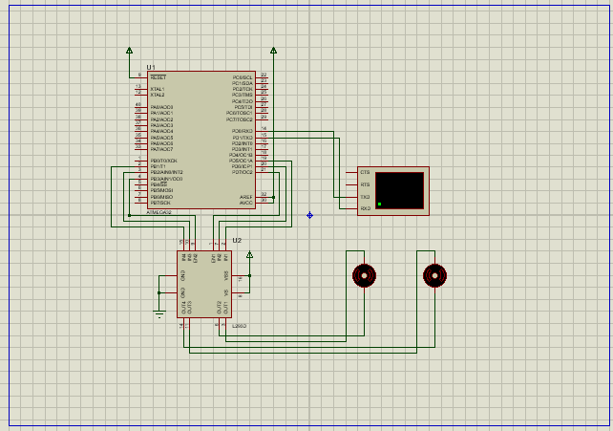

Conclusion

In this laboratory work has been learnt the principles of how a DC motor interfaces with

ATmega32. The interesting part was controlling the motor’s rotation direction and its speed. The first thing was accomplished using H-Bridge circuit from the motor driver L293D, and the second thing – using PWM

This laboratory work gave us a basic concepts about Timers, PWM and how to control a motor. PWM allows us easily to control “how much voltage to provide to motor”. In this laboratory work I used 8bit timers to control PWM.

I had set both timer to work on 256 PRESCALER, because it allowed me a CYCLE to be (For 1mhz frequency)

I used L293D as dual bridge for controlling wheels and pwm connected to HBridge Enable to control it’s speed.

Appendix

**main.c**

#include <avr/io.h> #include <avr/delay.h>

#include <drivers/hbridge.h> #include "drivers/uart_stdio.h" #include "drivers/pwm.h" #include "gpio.h"

#include "drivers/motor.h" #include "drivers/car_2wd.h"

Car *car;

void create(){

HBridge *leftHBridge = HBRIDGE_create( GPIO_create(&DDRB,&PORTB,&PINB,3), GPIO_create(&DDRB,&PORTB,&PINB,2), GPIO_create(&DDRB,&PORTB,&PINB,1)

);

Motor *leftMotor = MOTOR_create(leftHBridge,&pwm_0_set);

HBridge *rightHBridge = HBRIDGE_create( GPIO_create(&DDRD,&PORTD,&PIND,7), GPIO_create(&DDRD,&PORTD,&PIND,5), GPIO_create(&DDRD,&PORTD,&PIND,6)

);

Motor *rightMotor = MOTOR_create(rightHBridge,&pwm_2_set);

car = CAR_create(leftMotor,rightMotor);

}

int main() { uart_stdio_Init();

char key; create();

while(1){

*printf*("\nEnter command:");key = *getchar*();

switch(key){ case 'a' :

CAR_left(car); break;

case 'w': CAR_forward(car); break;

case 'd': CAR_right(car); break;

case 's': CAR_backward(car); break;

case 'p': CAR_start(car); break;

case 'l': CAR_stop(car); break;

}

}

return 0;

}

**gpio.c**

#include "gpio.h" #include <stdlib.h> #include "utils.h"

GPIO* GPIO_create(*uint8_t* volatile *ddr,*uint8_t* volatile *port,*uint8_t* volatile *pin,*uint8_t* id){

GPIO *descriptor = malloc(sizeof(GPIO)); descriptor->ddr = ddr;

descriptor->port = port; descriptor->pin = pin; descriptor->id = id;

return descriptor;

}

void GPIO_set_mode(GPIO *descriptor,GPIO_Mode mode){ switch(mode){

case GPIO_MODE_INPUT: bit_set_0(descriptor->ddr,descriptor->id); bit_set_1(descriptor->port,descriptor->id); break;

case GPIO_MODE_OUTPUT: bit_set_1(descriptor->ddr,descriptor->id); break;

}

}

void GPIO_write(GPIO *descriptor,GPIO_Value value){ if(value == GPIO_LOW){

bit_set_0(descriptor->port,descriptor->id); } else {

bit_set_1(descriptor->port,descriptor->id);

}

}

GPIO_Value GPIO_read(GPIO *descriptor){

*uint8_t* value= (*descriptor->pin) & (1 << descriptor->id);

return value == 0 ? GPIO_LOW : GPIO_HIGH;

}

**Hbridge.c**

#include <drivers/hbridge.h> #include "utils.h"

#include <stdlib.h>

HBridge* HBRIDGE_create(GPIO *en,GPIO *in1,GPIO *in2){ HBridge *descriptor = malloc(sizeof(HBridge)); descriptor->en = en;

descriptor->in1 = in1; descriptor->in2 = in2;

return descriptor;

}

void HBRIDGE_init(HBridge *descriptor){ GPIO_set_mode(descriptor->en,GPIO_MODE_OUTPUT); GPIO_set_mode(descriptor->in1,GPIO_MODE_OUTPUT); GPIO_set_mode(descriptor->in2,GPIO_MODE_OUTPUT);

}

void HBRIDGE_enable(HBridge *descriptor){ GPIO_write(descriptor->en,GPIO_HIGH);

}

void HBRIDGE_disable(HBridge *descriptor){ GPIO_write(descriptor->en,GPIO_LOW);

}

void HBRIDGE_set_operation(HBridge *descriptor,HBridge_Operation operation){ *uint8_t* in1= 0;

*uint8_t* in2= 0;switch(operation){

case HBRIDGE_OPERATION_LEFT: in1 = 1;

break;

case HBRIDGE_OPERATION_RIGHT: in2 = 1;

break;

case HBRIDGE_OPERATION_BREAK: in1 = 1;

in2 = 1; break;

}

GPIO_write(descriptor->in1,in1 ? GPIO_HIGH : GPIO_LOW); GPIO_write(descriptor->in2,in2 ? GPIO_HIGH : GPIO_LOW);

}

**pwm.c**

#include <avr/io.h> #include "drivers/pwm.h" #include "utils.h"

void pwm_0_set(*uint8_t* time_on){

* set timer0 for fast pwm bit_set_1(&TCCR0,WGM00); bit_set_1(&TCCR0,WGM01);
* set clear on compare match and set on top bit_set_1(&TCCR0,COM01);
* set prescaler 256

bit_set_1(&TCCR0,CS02);

bit_set_1(&DDRB,PB3);

* set compare value OCR0 = time_on;
* reset counter TCNT0 = 0;

}

void pwm_2_set(*uint8_t* time_on){

* set timer2 for fast pwm bit_set_1(&TCCR2,WGM20); bit_set_1(&TCCR2,WGM21);
* set clear on compare match and set on top bit_set_1(&TCCR2,COM21);
* set prescaler 256

bit_set_1(&TCCR2,CS21); bit_set_1(&TCCR2,CS22);

bit_set_1(&DDRD,PD7);

* set compare value OCR2 = time_on;
* reset counter TCNT2 = 0;

}

**uart_stdio.c**

#include "drivers/uart_stdio.h"

*FILE* uart_output= *FDEV_SETUP_STREAM*(uart_PutChar, *NULL*, *_FDEV_SETUP_WRITE*); *FILE* uart_input= *FDEV_SETUP_STREAM*(*NULL*,uart_ReadChar, *_FDEV_SETUP_READ*);

void uart_stdio_Init(void)

{

*stdout* = &uart_output; *stdin* = &uart_input;

|  |  |  |  |
| --- | --- | --- | --- |
| #if *F_CPU* | < 2000000UL && defined(U2X) | |  |
| UCSRA = | _BV(U2X); | /* improve baud rate error by using 2x clk */ | |
| UBRRL = (*F_CPU* / (8UL * UART_BAUD)) | | | - 1; |
| #else |  |  |  |

UBRRL = (*F_CPU* / (16UL * UART_BAUD)) - 1; #endif

UCSRB = _BV(TXEN) | _BV(RXEN); /* tx/rx enable */

}

int uart_PutChar(char c, *FILE* *stream)

{

if (c == '\n')

uart_PutChar('\r', stream);

while (~UCSRA & (1 << UDRE)); UDR = c;

return 0;

}

char uart_ReadChar()

{

//Wait untill a data is available while(!(UCSRA & (1<<RXC)))

{

//Do nothing

}

//Now USART has got data from host //and is available is buffer

return UDR;

}

**motor.c**

#include "motor.h" #include <stdlib.h> #define MAX_PWM_VALUE 255

Motor* MOTOR_create(HBridge *hbridge,void (*pwm)(*uint8_t*)){ Motor *descriptor = malloc(sizeof(Motor)); descriptor->hbridge = hbridge;

descriptor->speed = 0; descriptor->pwm = pwm;

HBRIDGE_init(hbridge);

return descriptor;

}

void MOTOR_start(Motor *descriptor){ MOTOR_reset_speed(descriptor);

}

void MOTOR_stop(Motor *descriptor){ descriptor->pwm(0);

}

void MOTOR_set_direction(Motor *descriptor,Motor_Direction direction){ switch(direction){

case MOTOR_DIRECTION_LEFT: HBRIDGE_set_operation(descriptor->hbridge,HBRIDGE_OPERATION_LEFT); break;

case MOTOR_DIRECTION_RIGHT: HBRIDGE_set_operation(descriptor->hbridge,HBRIDGE_OPERATION_RIGHT); break;

}

MOTOR_reset_speed(descriptor);

}

void MOTOR_brake(Motor *descriptor){ HBRIDGE_set_operation(descriptor->hbridge,HBRIDGE_OPERATION_BREAK); descriptor->pwm(MAX_PWM_VALUE);

}

void MOTOR_set_speed(Motor *descriptor,*uint8_t* speed){ if(speed < 0)

speed = 0; if(speed > 100)

speed = 100; descriptor->speed = speed; MOTOR_reset_speed(descriptor);

}

void MOTOR_reset_speed(Motor *descriptor){

*uint8_t* convertedSpeed=descriptor->speed*MAX_PWM_VALUE/100;descriptor->pwm(convertedSpeed);

}

**car_2wd.c**

#include "drivers/car_2wd.h" #include <stdlib.h>

Car* CAR_create(Motor *leftMotor,Motor *rightMotor){ Car *descriptor = malloc(sizeof(Car)); descriptor->leftMotor = leftMotor; descriptor->rightMotor = rightMotor;

return descriptor;

}

void CAR_start(Car *descriptor){ MOTOR_start(descriptor->leftMotor); MOTOR_start(descriptor->rightMotor);

}

void CAR_stop(Car *descriptor){ MOTOR_stop(descriptor->leftMotor); MOTOR_stop(descriptor->rightMotor);

}

void CAR_left(Car *descriptor){ MOTOR_set_speed(descriptor->leftMotor,descriptor->leftMotor->speed-1); MOTOR_set_speed(descriptor->rightMotor,descriptor->rightMotor->speed+1);

}

void CAR_right(Car *descriptor){ MOTOR_set_speed(descriptor->rightMotor,descriptor->rightMotor->speed-1); MOTOR_set_speed(descriptor->leftMotor,descriptor->leftMotor->speed+1);

}

void CAR_forward(Car *descriptor){ CAR_calibrate_speed(descriptor,1);

MOTOR_set_direction(descriptor->leftMotor,MOTOR_DIRECTION_RIGHT); MOTOR_set_direction(descriptor->rightMotor,MOTOR_DIRECTION_RIGHT);

}

void CAR_backward(Car *descriptor){ CAR_calibrate_speed(descriptor,1);

MOTOR_set_direction(descriptor->leftMotor,MOTOR_DIRECTION_LEFT); MOTOR_set_direction(descriptor->rightMotor,MOTOR_DIRECTION_LEFT);

}

void CAR_brake(Car *descriptor){ MOTOR_brake(descriptor->leftMotor); MOTOR_brake(descriptor->rightMotor);

}

void CAR_calibrate_speed(Car *descriptor,*uint8_t* increment){

int new_speed = (descriptor->leftMotor->speed + descriptor->rightMotor->speed) / 2 + increment;

MOTOR_set_speed(descriptor->leftMotor,new_speed);

MOTOR_set_speed(descriptor->rightMotor,new_speed);

}