MINISTERUL EDUCAŢIEI REPUBLICII MOLDOVA

**UNIVERSITATEA TEHNICĂ A MOLDOVEI Facultatea „Calculatoare, Informatică şi**

**Microelectronică”**

FILIERA ANGLOFONĂ

**RAPORT**

**Operational Systems**

**Creating an operational system and functions to it**

**A efectuat:**

st. gr. FAF-141 (l. engleză) Cristea Victor

**A verificat:**

lector. sup. Balan Mihaela

Chișinău 2016

**Task**: Create an operational system with a bootloader which loads a kernel with several functions bellow:

1. Calculator
2. Draw Moldova’s flag
3. String inversor
4. Clr screen
5. ASCII printer
6. String verification for palindrom
7. String inversor
8. HELP
9. Exit

**Work flow**:

**What is a Bootloader?**

A bootloader is a special program that is executed each time a bootable device is initialized by the computer during its power on or reset that will load the kernel image into the memory. This application is very close to hardware and to the architecture of the CPU. All x86 PCs boot in Real Mode. In this mode you have only 16-bit instructions. Our bootloader runs in Real Mode and our bootloader is a 16-bit program.

**How this works?**

When you switch on the PC the BIOS want to boot up an OS which must be found somewhere in hard disks, floppy disk, CDs, etc. The order in which BIOS searches an OS is user configurable. Next the BIOS reads the first 512 byte sector of the bootable disk. Usually a sector is 512 bytes in size. This is known as the Master Boot Record (MBR). BIOS simply loads the contents of the MBR into memory location “0x7c00” and jumps to that location to start executing whatever code is in the MBR. Our bootloader should be 512 bytes in size as well.

In computing, the kernel is a computer program that manages input/output requests from software, and translates them into data processing instructions for the central processing unit and other electronic components of a computer. The kernel is a fundamental part of a modern computer's operating system.

The boot process is:

* Turn on your PC and BIOS executes
* The BIOS seeks the MBR in boot order which is user configurable.
* The BIOS loads a 512 byte boot sector into memory location “0x7c00” from the specified media and begins executing it.
* Those 512 bytes then go on to load the OS itself or a more complex bootloader.

# BIOS Interrupts

These interrupts help OS and application invoke the facilities of the BIOS. This is loaded before the bootloader and it is very helpful in communicating with the I/O. Since we don’t have OS level interrupts this is the only option that would be helpful.

For example to print a character to the screen using BIOS interrupt calls.

mov ah, 0x0e *; function number = 0Eh : Display Character*

mov al, 'O' *; AL = code of character to display*

int 0x10 *; call INT 10h, BIOS video service*

This is a simple boot loader written in AT&T syntax.

.code16

.section .text

.global main

main:

/*

Disk description table, to make it a valid floppy

FAT12 file system format

*/

jmp _start

.byte 144 #NOP

.ascii "OsandaOS" #OEMLabel

.word 512 #BytesPerSector

.byte 1 #SectorsPerCluster

.word 1 #ReservedForBoot

.byte 2 #NumberOfFats

.word 224 #RootDirEntries (224 * 32 = 7168 = 14 sectors to read)

.word 2880 #LogicalSectors

.byte 0xf0 #MediumByte

.word 9 #SectorsPerFat

.word 18 #SectorsPerTrack

.word 2 #Sides

.long 0 #HiddenSectors

.byte 0 #LargeSectors

.byte 0 #DriveNo

.byte 0x29 #Signature (41 for Floppy)

.long 0x12345678 #VolumeID

.ascii "My First OS" #VolumeLabel

.ascii "FAT12 " #FileSystem

_start:

movw **$**0, %ax

movw %ax, %ss

movw %ax, %ds

movw %ax, %es

movw **$**string, %si

loop:

movb **$**0xe, %ah

movb (%si), %al

cmpb **$**0, %al

je done

int **$**0x10

addw **$**1, %si

jmp loop

done:

jmp done #infinite loop

string:

.ascii "Welcome to my First OS :)"

.byte 0

.fill 0x1fe - (. - main) ,1,0 #Pad remainder of boot sector with 0s

.word 0xaa55 #The standard PC boot signature

Assemble the file using binary as the format.

*nasm -f bin -o myfirst.bin myfirst.nasm*

If you use the file utility you will see that it’s a legit 1.4MB floppy Disk and a 32-bit boot sector.

After that convert the binary file to floppy image.

*dd status=noxfer conv=notrunc if= lmyfirst.bin of=fmyfirst.flp*

You can also convert the binary file to an ISO using tools such as UltraISO, etc. You may burn and try in your PC instead of emulating.  
Use Qemu to test our newly created bootloader

*qemu-system-i386 -fda myfirst.flp*

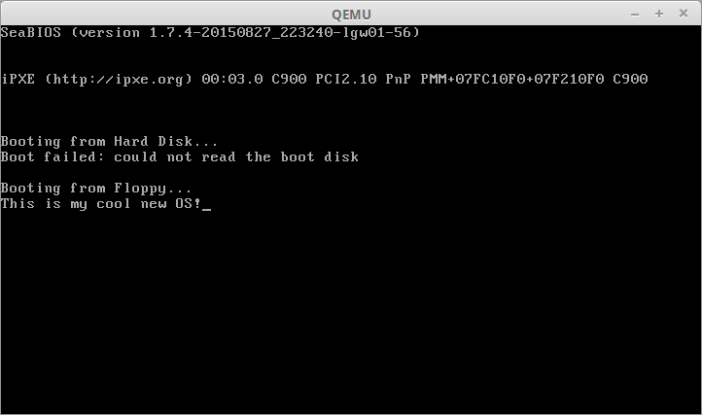

***Kernel***

The **kernel** (also called **nucleus**) is a [computer program](https://en.wikipedia.org/wiki/Computer_program) that constitutes the central core of a computer's [operating system](https://en.wikipedia.org/wiki/Operating_system). It has complete control over everything that occurs in the system.[[1]](https://en.wikipedia.org/wiki/Kernel_(operating_system)#cite_note-Linfo-1) As such, it is the first program loaded on startup, and then manages the remainder of the startup, as well as [input/output](https://en.wikipedia.org/wiki/Input/output) requests from [software](https://en.wikipedia.org/wiki/Software), translating them into [data processing](https://en.wikipedia.org/wiki/Data_processing) instructions for the [central processing unit](https://en.wikipedia.org/wiki/Central_processing_unit). It is also responsible for managing memory, and for managing and communicating with computing [peripherals](https://en.wikipedia.org/wiki/Peripheral), like printers, speakers, etc. The kernel is a fundamental part of a modern computer's [operating system](https://en.wikipedia.org/wiki/Operating_system).

[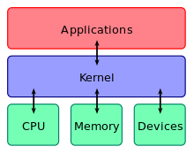](https://en.wikipedia.org/wiki/File:Kernel_Layout.svg)

A kernel connects the [application software](https://en.wikipedia.org/wiki/Application_software) to the hardware of a computer.

The critical code of the kernel is usually loaded into a *protected area* of memory, which prevents it from being overwritten by other, less frequently used parts of the operating system or by [applications](https://en.wikipedia.org/wiki/Application_software). The kernel performs its tasks, such as executing processes and handling interrupts, in [*kernel space*](https://en.wikipedia.org/wiki/Kernel_space), whereas everything a user normally does, such as writing text in a text editor or running programs in a GUI (graphical user interface), is done in [*user space*](https://en.wikipedia.org/wiki/User_space). This separation prevents user data and kernel data from interfering with each other and thereby diminishing performance or causing the system to become unstable (and possibly crashing).[[1]](https://en.wikipedia.org/wiki/Kernel_(operating_system)#cite_note-Linfo-1)

When a [*process*](https://en.wikipedia.org/wiki/Process_(computing)) makes requests of the kernel, the request is called a [system call](https://en.wikipedia.org/wiki/System_call). Various kernel designs differ in how they manage system calls and [resources](https://en.wikipedia.org/wiki/Resource_(computer_science)). For example, a [monolithic kernel](https://en.wikipedia.org/wiki/Monolithic_kernel) executes all the operating system [instructions](https://en.wikipedia.org/wiki/Instruction_set) in the same [address space](https://en.wikipedia.org/wiki/Address_space) in order to improve the performance[ of the system. A [microkernel](https://en.wikipedia.org/wiki/Microkernel) runs most of the operating system's [background processes](https://en.wikipedia.org/wiki/Background_process) in user space,[[3]](https://en.wikipedia.org/wiki/Kernel_(operating_system)#cite_note-3) allowing a more [modular](https://en.wikipedia.org/wiki/Modular_programming) design of the kernel which makes it easier to maintain.[[4]](https://en.wikipedia.org/wiki/Kernel_(operating_system)#cite_note-mono-micro-4)

The kernel's [interface](https://en.wikipedia.org/wiki/Application_programming_interface) is a [low-level](https://en.wikipedia.org/wiki/High-_and_low-level) [abstraction layer](https://en.wikipedia.org/wiki/Abstraction_layer).

Bootloader is loaded, and I can go to kernel.

Now I can use my functions through Qemu Terminal:

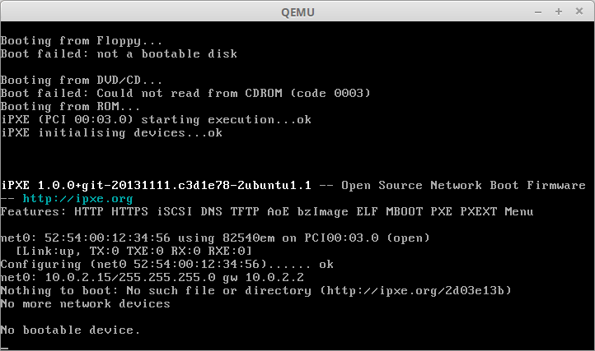

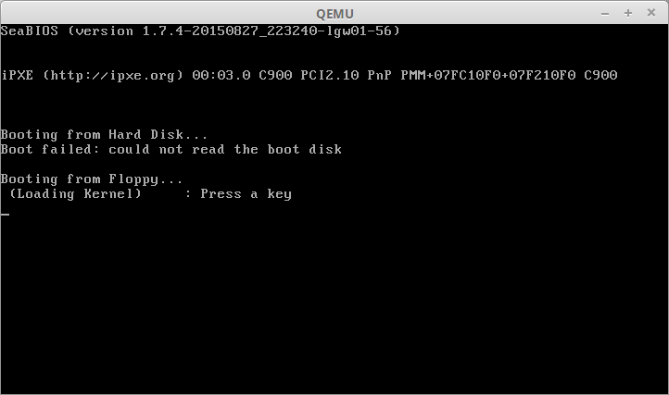

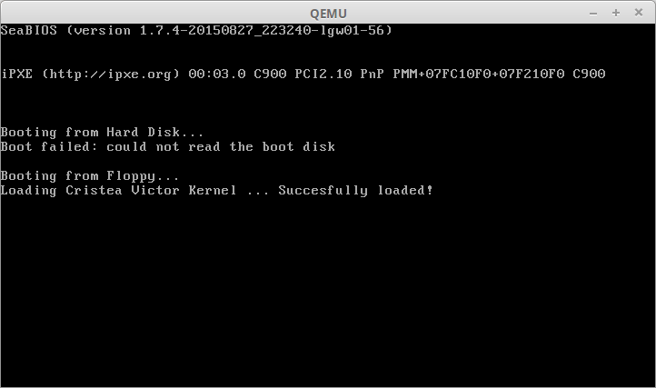

So here I have a Virtual disk image for launching through Virtualbox or Vmware and FLP for launching through QEMU.

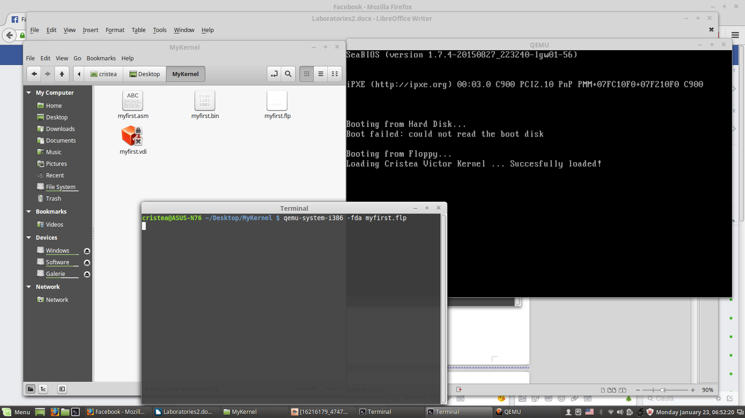

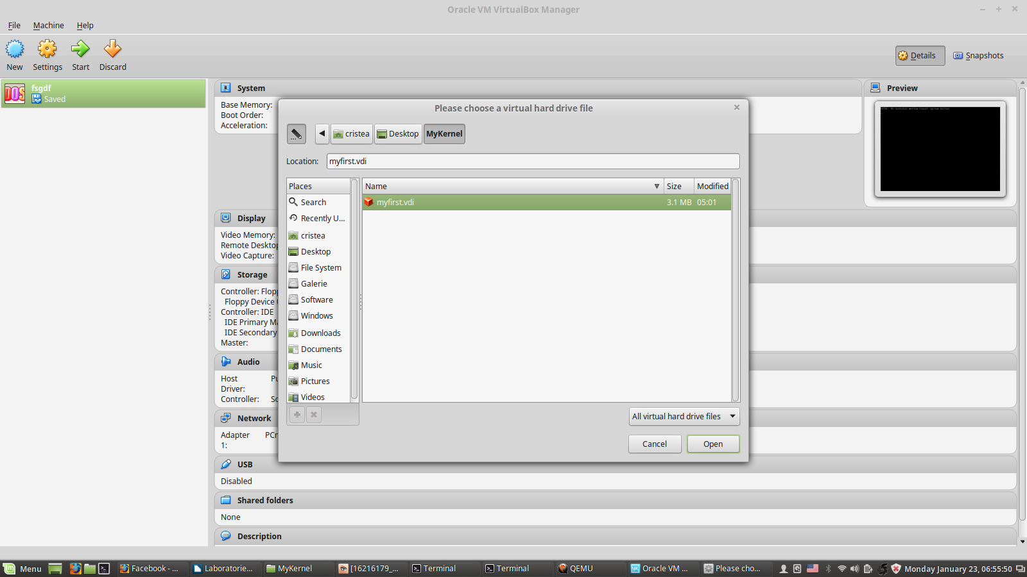

**Where we have booted the system**

**At the references you’ll get github location of the project**

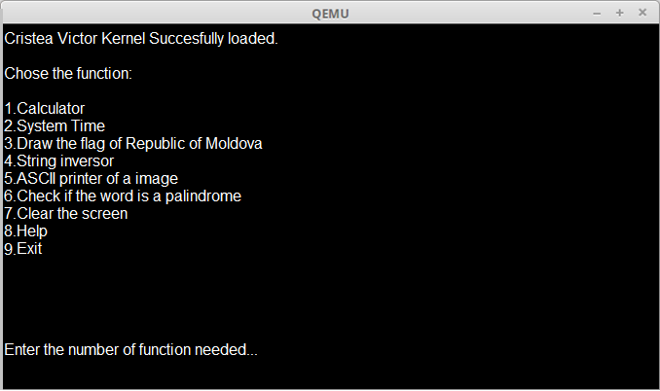

Sequence of code for Main function which loads the screen above:

Main:

mov si, WaitInputMessage call Writeline

xor ax, ax

int 16h ; wait for keypress

; set destination segment mov ax, 7E0h

mov es, ax xor bx, bx

ReadFromFloppy:

mov ah, 2 ; read sectors

mov al, 3 ; number of sectors to read mov ch, 0 ; track number

mov cl, 2 ; sector number (kernel is in the second sector)

mov dh, 0 ; head number mov dl, 0 ; drive number int 13h ; call BIOS

jc ReadFromFloppy ; Error, so try again

; check data integrity mov al, byte [es:0h] cmp al, 0B8h

je LoadKernel

; print error message and halt system mov si, ErrorMessage

call Writeline

cli hl

**Appendix for Calculator**

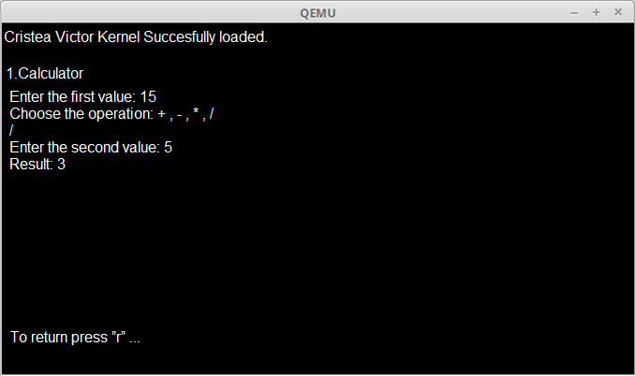

|  |
| --- |
| .date |
|  | operation1: .word 0 |
|  | operand1: .word 0 |
|  | operand2: .word 0 |
|  | operation2: .word 0 |
|  | operand3: .word 0 |
|  | priority: .word 0 |
|  |  |
|  | msg1: .asciiz "\nEnter the first valuer: " |
|  |  |
|  | msg3: .asciiz "Choose the operation:+,-,*,/: " |
|  | msg4: .asciiz "Enter the second value: " |
|  |
|  |
|  | msg7: .asciiz "Result: " |
|  |  |
|  |  |
|  | .text |
|  | .globl main |
|  |  |
|  | main: |
|  | #get 1st operation |
|  | li $v0, 4 #system call for print str |
|  | la $a0,msg1 #addr of string to print |
|  | syscall |
|  |  |
|  | li $v0, 5 #read 1st operand |
|  | syscall |
|  | sw $v0, operand1 |
|  |  |
|  |  |
|  | #get 1st operand |
|  | li $v0, 4 |
|  | la $a0, msg2 |
|  | syscall |
|  |  |
|  | li $v0, 5 #read 1st operation |
|  | syscall |
|  | sw $v0, operation1 |
|  |
|  | #get 2nd operand |
|  | li $v0, 4 |
|  | la $a0, msg3 |
|  | syscall |
|  |  |
|  | li $v0, 5 |
|  | syscall |
|  | sw $v0, operand2 |
|  |  |
|  | #get 2nd operation |
|  | li $v0, 4 |
|  | la $a0, msg4 |
|  | syscall |
|  |  |
|  | li $v0, 5 |
|  | syscall |
|  | sw $v0, operation2 |
|  |  |
|  | #get 3rd operand |
|  | li $v0, 4 |
|  | la $a0, msg5 |
|  | syscall |
|  |  |
|  | li $v0, 5 |
|  | syscall |
|  | sw $v0, operand3 |
|  |  |
|  | #get operation priority |
|  | li $v0, 4 |
|  | la $a0, msg6 |
|  | syscall |
|  |  |
|  | li $v0, 5 |
|  | syscall |
|  | sw $v0, priority |
|  |  |
|  |  |
|  | #put operations and operands into $t0-$t5 |
|  | lw $t0, operation1 |
|  | lw $t1, operand1 |
|  | lw $t2, operand2 |
|  | lw $t3, operation2 |
|  | lw $t4, operand3 |
|  | lw $t5, priority |
|  |  |
|  |  |
|  | #determine which priority to use |
|  |  |
|  |  |
|  | #default operation priority |
|  | beq $t5, 0, default |
|  |  |
|  | #1st operation priority |
|  | beq $t5, 1, first |
|  |  |
|  | #2nd operation priority |
|  | beq $t5, 2, second |
|  |  |
|  |  |
|  |  |
|  | li $v0, 10 # system call code for exit = 10 |
|  | syscall |
|  |  |
|  | default: |
|  | beq $t0, 3, first |
|  | beq $t0, 4, first |
|  | beq $t3, 3, second |
|  | beq $t3, 4, second |
|  |  |
|  |  |
|  | first: |
|  |  |
|  | #perform operation1 on operand1 and operand2 |
|  | #set priority to 1 for default operations |
|  | li $t5, 1 |
|  | move $a0, $t1 |
|  | move $a1, $t2 |
|  | beq $t0, 1, addit1 |
|  | beq $t0, 2, subtr1 |
|  | beq $t0, 3, multi1 |
|  | beq $t0, 4, divis1 |
|  | first2: |
|  | #perform operation2 on result and operand3 |
|  | #place operand in $a1 |
|  | move $a1, $t4 |
|  |  |
|  | beq $t3, 1, addit2 |
|  | beq $t3, 2, subtr2 |
|  | beq $t3, 3, multi2 |
|  | beq $t3, 4, divis2 |
|  |  |
|  | j Exit |
|  |  |
|  |  |
|  |  |
|  | second: #perform operation2 on operan2 and operand3 |
|  | #set priority to 2 for default operations |
|  | li $t5, 2 |
|  | move $a0, $t2 |
|  | move $a1, $t4 |
|  | beq $t3, 1, addit2 |
|  | beq $t3, 2, subtr2 |
|  | beq $t3, 3, multi2 |
|  | beq $t3, 4, divis2 |
|  | second2: |
|  | #perform operation 1 on operand1 and result |
|  | move $a1, $a0 #puts result into $a1 |
|  | move $a3, $a0 #saves result in case it's lost on 2nd pass |
|  | move $a0, $t1 |
|  | beq $t0, 1, addit1 |
|  | beq $t0, 2, subtr1 |
|  | beq $t0, 3, multi1 |
|  | beq $t0, 4, divis1 |
|  |  |
|  | move $a0, $a3 #retains result |
|  | j Exit |
|  |  |
|  |  |
|  | addit1: |
|  | #place the operands in $a0 and $a1 |
|  | #reset operation |
|  | li $t0, 0 |
|  | jal addition |
|  |  |
|  |
|  |
|  | addit2: |
|  | #place the operands in $a0 and $a1 |
|  | #reset operation |
|  | li $t3, 0 |
|  |  |
|  | jal addition |
|  |
|  |
|  | subtr1: #place the operands in $a0 and $a1 |
|  | #reset operation |
|  | li $t0, 0 |
|  |  |
|  | jal subtraction |
|  |  |
|  |  |
|  | subtr2: #place the operands in $a0 and $a1 |
|  | #reset operation |
|  | li $t3, 0 |
|  |  |
|  | jal subtraction |
|  |  |
|  |  |
|  | multi1: #place the operands in $a0 and $a1 |
|  | #reset operation |
|  | li $t0, 0 |
|  |  |
|  | jal multiplication |
|  |  |
|  |  |
|  | multi2: #place the operands in $a0 and $a1 |
|  | #reset operation |
|  | li $t3, 0 |
|  |  |
|  | jal multiplication |
|  |  |
|  |  |
|  | divis1: #place the operands in $a0 and $a1 |
|  | #reset operation |
|  | li $t0, 0 |
|  |  |
|  | jal division |
|  |  |
|  |  |
|  | divis2: #place the operands in $a0 and $a1 |
|  | #reset operation |
|  | li $t3, 0 |
|  |  |
|  | jal division |
|  |  |
|  |  |
|  | addition: |
|  | #take the operands perform addition |
|  | add $a0, $a0, $a1 |
|  |  |
|  | beq $t5, 1, Jumpfirst |
|  | beq $t5, 2, Jumpsecond |
|  |  |
|  |  |
|  | subtraction: #take the operands perform subtraction |
|  | sub $a0, $a0, $a1 |
|  |  |
|  |  |
|  | beq $t5, 1, Jumpfirst |
|  | beq $t5, 2, Jumpsecond |
|  |  |
|  |  |
|  | multiplication: #take the operands perform multiplication |
|  | mult $a0, $a1 |
|  | mflo $a0 |
|  |  |
|  | beq $t5, 1, Jumpfirst |
|  | beq $t5, 2, Jumpsecond |
|  |  |
|  |  |
|  | division: #take the operands perform division |
|  | div $a0, $a0, $a1 |
|  |  |
|  | beq $t5, 1, Jumpfirst |
|  | beq $t5, 2, Jumpsecond |
|  |  |
|  |  |
|  | Jumpfirst: |
|  | j first2 |
|  |  |
|  |  |
|  | Jumpsecond: |
|  | j second2 |
|  |  |
|  |  |
|  | Exit: ##prints result |
|  | move $v1, $a0 |
|  | li $v0, 4 |
|  | la $a0, msg7 |
|  | syscall |
|  | li $v0, 1 |
|  | move $a0, $v1 |
|  | syscall |
|  |  |
|  | #jumps back to main |
|  | j main |

**Appendix for System Time**

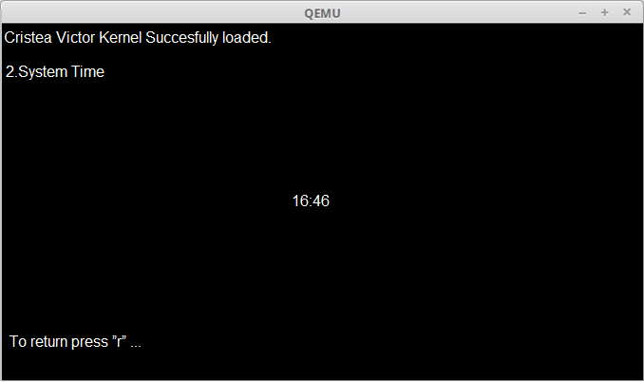

.MODEL SMALL

.STACK 100H

.DATA

PROMPT DB 'Current System Time is : $'

TIME DB '00:00:00$' ; time format hr:min:sec

.CODE

MAIN PROC

MOV AX, @DATA ; initialize DS

MOV DS, AX

LEA BX, TIME ; BX=offset address of string TIME

CALL GET_TIME ; call the procedure GET_TIME

LEA DX, PROMPT ; DX=offset address of string PROMPT

MOV AH, 09H ; print the string PROMPT

INT 21H

LEA DX, TIME ; DX=offset address of string TIME

MOV AH, 09H ; print the string TIME

INT 21H

MOV AH, 4CH ; return control to DOS

INT 21H

MAIN ENDP

;**************************************************************************;

;------------------------------ GET_TIME --------------------------------;

GET_TIME PROC

; this procedure will get the current system time

; input : BX=offset address of the string TIME

; output : BX=current time

PUSH AX ; PUSH AX onto the STACK

PUSH CX ; PUSH CX onto the STACK

MOV AH, 2CH ; get the current system time

INT 21H

MOV AL, CH ; set AL=CH , CH=hours

CALL CONVERT ; call the procedure CONVERT

MOV [BX], AX ; set [BX]=hr , [BX] is pointing to hr

; in the string TIME

MOV AL, CL ; set AL=CL , CL=minutes

CALL CONVERT ; call the procedure CONVERT

MOV [BX+3], AX ; set [BX+3]=min , [BX] is pointing to min

; in the string TIME

MOV AL, DH ; set AL=DH , DH=seconds

CALL CONVERT ; call the procedure CONVERT

MOV [BX+6], AX ; set [BX+6]=min , [BX] is pointing to sec

; in the string TIME

POP CX ; POP a value from STACK into CX

POP AX ; POP a value from STACK into AX

RET ; return control to the calling procedure

GET_TIME ENDP ; end of procedure GET_TIME

;------------------------------- CONVERT ------------------------------;

CONVERT PROC

; this procedure will convert the given binary code into ASCII code

; input : AL=binary code

; output : AX=ASCII code

PUSH DX ; PUSH DX onto the STACK

MOV AH, 0 ; set AH=0

MOV DL, 10 ; set DL=10

DIV DL ; set AX=AX/DL

OR AX, 3030H ; convert the binary code in AX into ASCII

POP DX ; POP a value from STACK into DX

RET ; return control to the calling procedure

CONVERT ENDP ; end of procedure CONVERT

END MAIN

**Appendix for Drawing**

DrawImage:

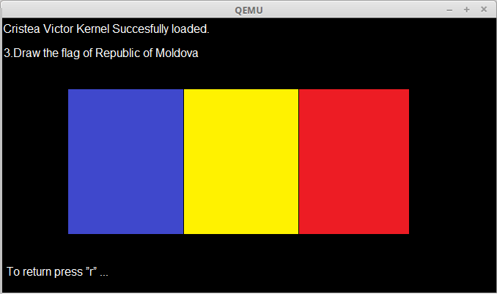

cmp word [ID], "BM"

je DrawBMP

ret

DrawBMP:

cmp word [Depth], 24

je DrawBMP24

cmp word [Depth], 32

je DrawBMP32

ret

DrawBMP24:

pushad

mov [.X], eax

mov [.Y], ebx

mov [.x], eax

mov [.y], ebx

xor edx, edx

mov [.align], edx

mov ebx, 4

mov eax, [Width]

div ebx

cmp edx, 0

je .skip

mov dword [.align], 1

xor edx, edx

mov eax, [Width]

inc eax

div ebx

cmp edx, 0

je .skip

mov dword [.align], 2

xor edx, edx

mov eax, [Width]

add eax, 2

div ebx

cmp edx, 0

je .skip

mov dword [.align], 3

.skip:

mov esi, BMP

add esi, [Offset]

mov [.pointer], esi

mov ebx, [Height]

add [.y], ebx

.drawLine:

mov esi, [.pointer]

mov al, [esi]

mov [.color], al

mov al, [esi + 1]

mov [.color + 1], al

mov al, [esi + 2]

mov [.color + 2], al

add dword [.pointer], 3

mov esi, .params

call DrawPixel

inc dword [.x]

mov ebx, [Width]

add ebx, [.X]

cmp [.x], ebx

jne .drawLine

mov ebx, [.X]

mov [.x], ebx

dec dword [.y]

mov ebx, [.pointer]

add ebx, [.align]

mov [.pointer], ebx

mov ebx, [.Y]

cmp [.y], ebx

je .done

jmp short .drawLine

.done:

mov dword [.y], 0

popad

ret

.X dd 0

.Y dd 0

.align dd 0

.pointer dd 0

.params:

.color dd 0

.x dd 0

.y dd 0

DrawBMP32:

pushad

mov [.X], eax

mov [.Y], ebx

mov [.x], eax

mov [.y], ebx

mov esi, BMP

add esi, [Offset]

mov [.pointer], esi

mov ebx, [Height]

add [.y], ebx

.drawLine:

mov esi, [.pointer]

mov eax, [esi]

mov [.color], eax

add dword [.pointer], 4

mov esi, .params

call DrawPixel

inc dword [.x]

mov ebx, [Width]

add ebx, [.X]

cmp [.x], ebx

jne .drawLine

mov ebx, [.X]

mov [.x], ebx

dec dword [.y]

mov ebx, [.Y]

cmp [.y], ebx

je .done

jmp short .drawLine

.done:

mov dword [.y], 0

popad

ret

.X dd 0

.Y dd 0

.pointer dd 0

.params:

.color dd 0

.x dd 0

.y dd 0

**Appendix for string inversor**

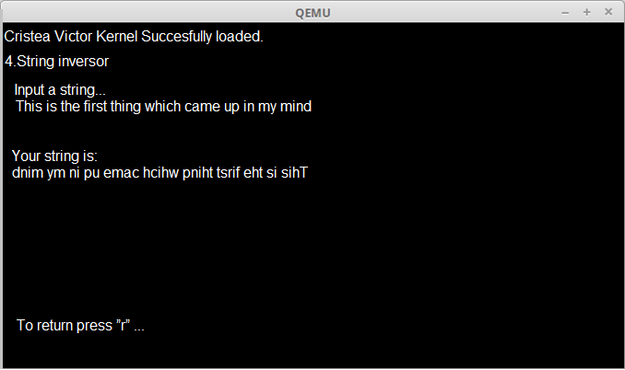

DATA SEGMENT

STR1 DB "ENTER YOUR STRING HERE ->$"

STR2 DB "YOUR STRING IS ->$"

STR3 DB "REVERSE STRING IS ->$"

INSTR1 DB 20 DUP("$")

RSTR DB 20 DUP("$")

NEWLINE DB 10,13,"$"

N DB ?

S DB ?

DATA ENDS

CODE SEGMENT

ASSUME DS:DATA,CS:CODE

START:

MOV AX,DATA

MOV DS,AX

LEA SI,INSTR1

;GET STRING

MOV AH,09H

LEA DX,STR1

INT 21H

MOV AH,0AH

MOV DX,SI

INT 21H

MOV AH,09H

LEA DX,NEWLINE

INT 21H

;PRINT THE STRING

MOV AH,09H

LEA DX,STR2

INT 21H

MOV AH,09H

LEA DX,INSTR1+2

INT 21H

MOV AH,09H

LEA DX,NEWLINE

INT 21H

;PRINT THE REVERSE OF THE STRING

MOV AH,09H

LEA DX,STR3

INT 21H

MOV CL,INSTR1+1

ADD CL,1

ADD SI,2

L1:

INC SI

CMP BYTE PTR[SI],"$"

JNE L1

DEC SI

LEA DI,RSTR

L2:MOV AL,BYTE PTR[SI]

MOV BYTE PTR[DI],AL

DEC SI

INC DI

LOOP L2

MOV AH,09H

LEA DX,NEWLINE

INT 21H

MOV AH,09H

LEA DX,RSTR

INT 21H

MOV AH,09H

LEA DX,NEWLINE

INT 21H

MOV AH,4CH

INT 21H

CODE ENDS

END START

**Appendix for Palindrome**

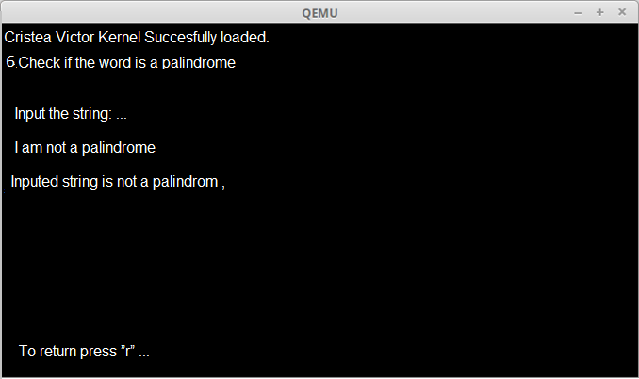; this sample checks if string is a palindrome or not.

; palindrome is a text that can be read backwards

; and give the same meaning as if it was read forward.

; for example: "abba" is polindrome.

; note: this program is case sensitive, "abba" is not "abba".

name "pali"

org 100h

jmp start

m1:

s db 'able was ere ere saw elba'

s_size = $ - m1

db 0Dh,0Ah,'$'

start:

; first let's print it:

mov ah, 9

mov dx, offset s

int 21h

lea di, s

mov si, di

add si, s_size

dec si ; point to last char!

mov cx, s_size

cmp cx, 1

je is_palindrome ; single char is always palindrome!

shr cx, 1 ; divide by 2!

next_char:

mov al, [di]

mov bl, [si]

cmp al, bl

jne not_palindrome

inc di

dec si

loop next_char

is_palindrome:

; the string is "palindrome!"

mov ah, 9

mov dx, offset msg1

int 21h

jmp stop

not_palindrome:

; the string is "not palindrome!"

mov ah, 9

mov dx, offset msg2

int 21h

stop:

; wait for any key press:

mov ah, 0

int 16h

ret

msg1 db " this is palindrome!$"

msg2 db " this is not a palindrome!$"

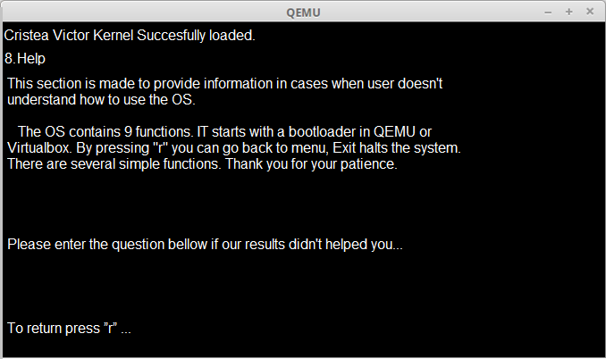**Function HELP**

**Conclusion**: In this laboratory works I have understood how to create an operating system, elaborating a menu for control through command Help. Writing code in assembly, then compiling with nasm, then converting and finally start on a virtual machine QEMU.It was difficult to start with but after couple of hours of reading it was real to obtain a result.

REFFERENCES

<https://osandamalith.com/2015/10/26/writing-a-bootloader/>

http://mikeos.sourceforge.net/write-your-own-os.html

https://github.com/cristeav49/SOMIPP