MINIKUBE

MINIKUBE INSTALLATION

INSATALL MINIKUBE FOR UBUNTU X86 :

curl -LO https://storage.googleapis.com/minikube/releases/latest/minikube-linux-amd64
sudo install minikube-linux-amd64 /usr/local/bin/minikube

Start your cluster :
minikube start
Minikube Dashboard :
minikube dashboard
Get available pods :
kubectl get pods
Delete pods :
kubectl delete pods web
Get pod information :
kubectl get pod -o wide

Interact with pod :
kubectl exec -it web-6d9cb7df59-lpmdw(pod name) -- /bin/bash
How to add(scale) replicas

Deploy applications :

Create a sample deployment and expose it on port 8080:
kubectl create deployment hello-minikube --image=kicbase/echo-server:1.0
kubectl expose deployment hello-minikube --type=NodePort –port=8080

It may take a moment, but your deployment will soon show up when you run:
kubectl get services hello-minikube

The easiest way to access this service is to let minikube launch a web browser for you:
minikube service hello-minikube

Alternatively, use kubectl to forward the port:
kubectl port-forward service/hello-minikube 7080:8080

Your application is now available at http://localhost:7080/.

Manage your cluster :
Pause Kubernetes without impacting deployed applications:
minikube pause
Unpause a paused instance:
minikube unpause
Halt the cluster:
minikube stop
Change the default memory limit (requires a restart):
minikube config set memory 9001
Browse the catalog of easily installed Kubernetes services:
minikube addons list
Create a second cluster running an older Kubernetes release:
minikube start -p aged --kubernetes-version=v1.16.1
Delete all of the minikube clusters:
minikube delete –all

How to create pod using own docker image :
Steps:
1) create docker imager using dockerfile
2) build docker image (docker buid -t (any name for image)
3) create yaml file to create pod
apiVersion: apps/v1
kind: Deployment
metadata:
name: web
spec:
replicas: 1
selector:
matchLabels:
app: web
template:
metadata:
labels:
app: web
spec:
containers:
- name: your-container
image: udhaya24/css:latest

4) create yaml file to create pod :
kubectl create -f (yaml file name)
5) If any changes made in created pod use apply to apply changes :
kubectl apply -f (yaml file name)

6) port forwarding to show out put of this pod :
kubectl port-forward web-6d9cb7df59-lpmdw(pod name) 8087(local host port):80
Create service instead of port forwarding:
create service.yaml
apiVersion: v1
kind: Service
metadata:
name: web-service
spec:
selector:
app: web
ports:
- protocol: TCP
port: 80
targetPort: 80
nodePort: 30080
type: NodePort
if you want run this service you have give http://ip address:port
(example : http://http://192.168.49.2(nodeport ip):30080(node port given in service yaml file))
How to find node port ip :
minikube ip
Apply service:
kubectl apply -f service.ymal

output :
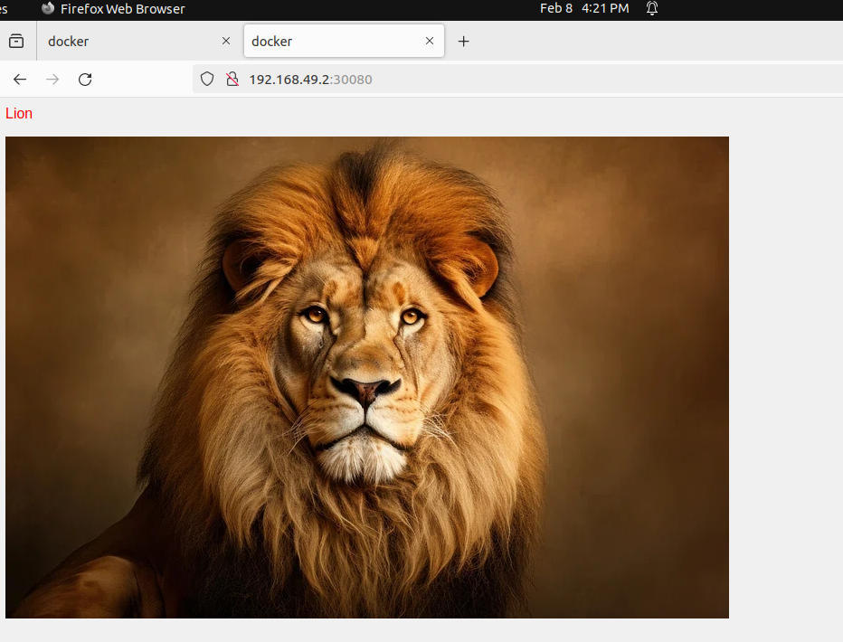

output using service

create ingress for domain name :
Using ingress we can provide domain name instead of ip address (Ex: http://web.com)
apiVersion: networking.k8s.io/v1
kind: Ingress
metadata:
name: web-ingress
spec:
rules:
- host: web.com
http:
paths:
- path: /
pathType: Prefix
backend:
service:
name: web-service
port:
number: 80

Apply ingress :
Kubectl apply -f ingress.yaml

output :
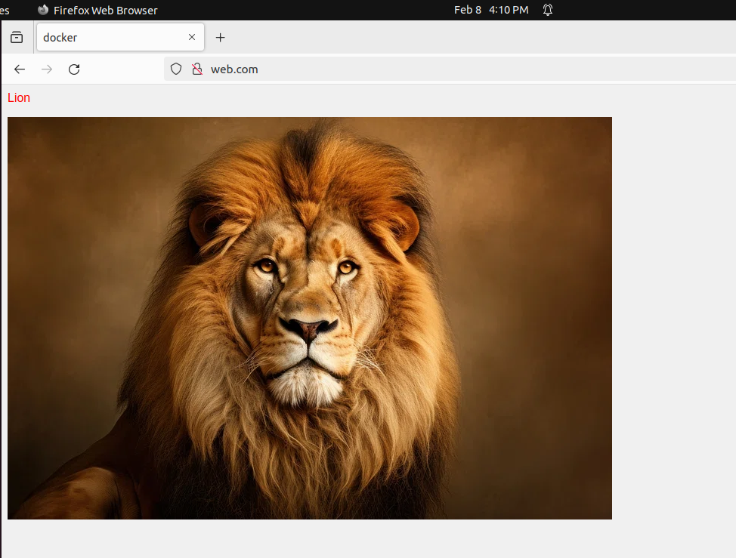
output using ingress

