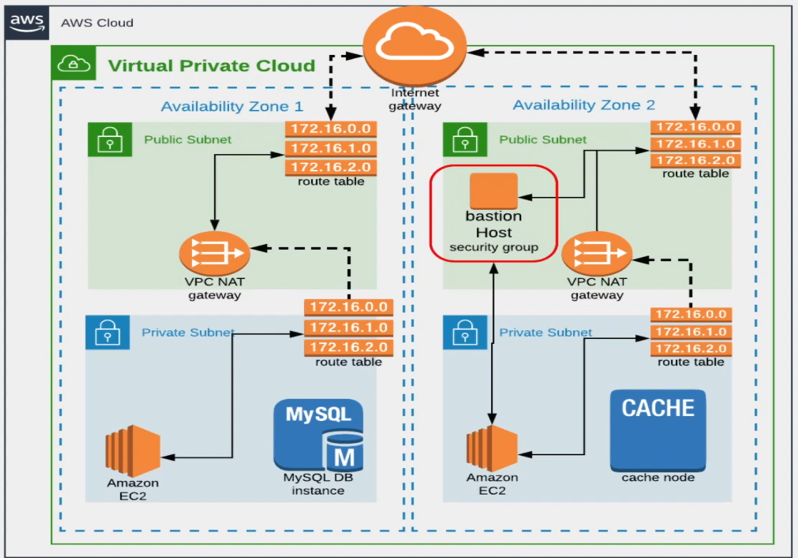

Region: us-west1

VPC Range: 172.20.0.0/16

4 subnets: 2 public subnet and 2 private subnet

2 zones: us-west-1a, us-west-1b

172.20.1.0/24 -> public subnet 1, us-west-1a

172.20.2.0/24 -> public subnet 2, us-west-1b

172.20.3.0/24 -> private subnet 1, us-west-1a

172.20.4.0/24 -> private subnet 2, us-west-1b

1 Internet GW

2 NAT Gateway (we will create only 1 )

2 Elastic IP (we will create only 1 )

2 Route Tables: 1 for public subnet and 1 for private subnet

1 Bastion host in public subnet (jumbserver)

------------------------------------------------------------------------------

NACL (Network Access Control List):

1 more VPC => VPC Peering

-------------------------------------------------------------------

network-acls.html

https://docs.aws.amazon.com/elasticloadbalancing/latest/classic/enable-access-logs.html

<https://docs.aws.amazon.com/AmazonCloudWatch/latest/logs/QuickStartEC2Instance.html>

[Build specification reference for CodeBuild - AWS CodeBuild (amazon.com)](https://docs.aws.amazon.com/codebuild/latest/userguide/build-spec-ref.html)