Enhanced Home Automation System using Internet of Things

S L S Sri Harsha1,S Chakrapani Reddy1 Department of Computer Science and Engineering School of Computing, Sathyabama University

Chennai, Tamilnadu, India

[sree1952425@gmail.com](mailto:sree1952425@gmail.com)

Prince Mary S2

Department of Computer Science and Engineering School of Computing, Sathyabama University Chennai, Tamilnadu, India [princemary26@gmail.com](mailto:princemary26@gmail.com)

***Abstract*— the more the technology advances into the future, the more it makes the life of people depending on it easier and one of such technologies is Automation. The term Automation can be coupled with- no effort, ease of performing a task and less human involvement. Internet of Things is such other term which envisions every object around us as an integral part of the Internet. In this paper, we suggest a highly intractable and environmentally sustainable form of Home Automation System using Internet of Things a means to control the appliances at home via a device with access to the Internet. The key components of this system are a pocket sized microprocessor- Raspberry Pi and a microcontroller- Arduino Uno and an Android application to visualize the data provided by the Raspberry Pi and also to send, receive and process the requests. The Raspberry Pi acts as the brain of this system, processing the requests, responding to the requests made by the Android application, communicating with the Arduino and also acts as a server to store the data given by the sensors. All the sensors and actuators are connected to the Arduino which is connected to the Pi using a USB cable. Our main objective of developing this model is to create a home automation system which interacts with the user through various push notifications based on concerned parameters which is also eco-friendly.**

**Keywords— Actuators, Android, Arduino, Home Automation System (HAS), Internet, Internet of Things (IoT), Microcontroller, Microprocessor, Raspberry Pi, Sensors.**

1. INTRODUCTION

T

HE increasing level of sophistication in basic appliances and increasing concerns for environmental sustenance demands for development of a smart system which is self- aware of its' surroundings and can analyze and respond with its own discretion without needing the aid of a human factor, called Automated systems. Recent advancements in the technological field have developed a way to create such systems with ease by using various sensors and actuators that constantly keep track of the changes around them. The pragmatic applications of automation have found their way into many domestic and industrial equipment with the advent

of faster wireless communication methods and miniaturized high-performance processors and accurate sensors. One of such applications is

Home Automation [8], which is a proactive means of monitoring every aspect of households such as power consumption, temperature, humidity levels, possible gas leakage, potential resource wastage and possible intrusion as less human intervention as possible.

1. Smart Mobiles are a robust way to provide remote home automation as they are ubiquitous nowadays and are feature- packed allowing them to perform cumbersome tasks and they can connect to any network. The majority of Smart Mobiles in recent times run on "Android", an open source mobile operating system developed by Google Inc. The Home Automation System use a wide array of sensors paired with an application to visualize the sensor data and issue commands to the HAS and prompts the user to take appropriate action or initiates a sequence to handle the situation. HAS [10] monitors general household activities such as controlling the lighting, atmospheric conditions, checking the integrity of gates and doors and so forth to provide a safe and comfortable environment for the user to live in.

A pocket-sized microprocessor called Raspberry Pi[2] and similarly sized microcontroller called Arduino Uno R3[1] satiates the core functionality of this HAS as they are highly efficient and portable chips with all the built-in capabilities to support the requirements of HAS. The main advantage of using these boards are that they can connect to existing wireless technologies such as Wi-Fi [9], ZigBee, X10 and so on, using dedicated shields. The Raspberry Pi can be loaded with database technologies such as MySQL which would cut the requirement of using a Personal Computer to process the queries.

The proposed system uses an ever present Infinite State Machine (ISM) model to oversee and analyze the data generated by the sensors efficiently. The primary aim of proposing this model is to make up for the shortcomings of the existing models and also produce a more user-friendly system that can act as a personal assistant. To make the model truly ever-present, it is connected to a cloud database (Firebase API) where all the records are maintained and synchronized

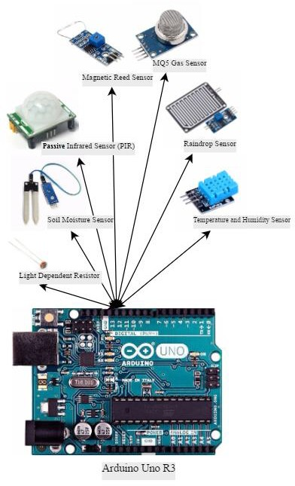on a regular basis and can be accessed by any authorized device or user.

1. SYSTEM DESIGN The proposed HAS can control the following
   * Lights, Fans, Air Conditioners (on/off/adjust)
   * Doors and Door locks
   * Windows
   * Curtains/ Blinds (if present)
   * Other/all appliances
   * Shutters (for security and rainwater harvesting)
   * Regulate Water (for watering plants)

The core components of this model are the microcontroller and the microprocessor. The computational power is provided by Raspberry Pi to which the Wi-Fi receiver is connected. The Pi is loaded with an SD card which is flashed with a low power consuming flavor of Linux called Raspbian OS. The Pi is then assigned a Static IP for it to connect to a network. The Wi-Fi receiver is then configured in the networks menu of the sudo user. The technologies or scripting languages required to read and maintain the sensors and records the readings are as follows

* + PhpMyAdmin
  + Python (Ver 2.7)
  + Arduino IDE
  + MySQL
  + Apache Webserver

All these technologies can be installed using the terminal of the Raspbian OS. Additional libraries such as MySqlDB must be installed to allow python to work with the MySQL database.

The Arduino Uno [1] does not have any memory to store data except the sketches it runs. The development environment required to create Arduino sketches is installed on the Raspberry Pi. The Arduino [7] run on basic C/C++ libraries and these libraries are used to define the processes that need to be performed.

FIG 1. SYSTEM BLOCK DIAGRAM (ARDUINO)

Firebase [6] is a cloud storage and analytics technology provided by Google Inc. It provides many functionalities such as Cloud Messaging, Authentication, Analytics, Cloud Storage, and Cloud Database. It allows cross-platform interactions and supports major mobile technologies such as Android and IOS along with web technologies such as Java, JavaScript, Swift and Objective-C.

Android [5] is a very famous mobile operating system which holds 87.6% of the mobile phone market share as of November 2016. It has many versions and the supported versions for the HAS start from ver. 4.0 (Ice cream Sandwich) to ver. 7.1 (Nougat).

I2C (Inter-Integrated Circuit) protocol governs the communication between Raspberry Pi and Arduino. Using I2C the Pi is set as the master and the Arduino is set as the slave. Any number of Arduinos can be connected to the Pi. This increases the number of Input ports to the Pi as they are very limited. Pi has special pins (3 and 5) to make this possible.

The Raspberry Pi with the Wi-Fi connectivity is connected to the internet, in turn to the cloud. All the sensors are connected to the Arduino Uno. The Raspberry Pi and Arduino

1. are connected using a USB cable and all the communications and data transfers are done using I2C protocol. There is a local Database for storing information about users and sensor data on the Pi.

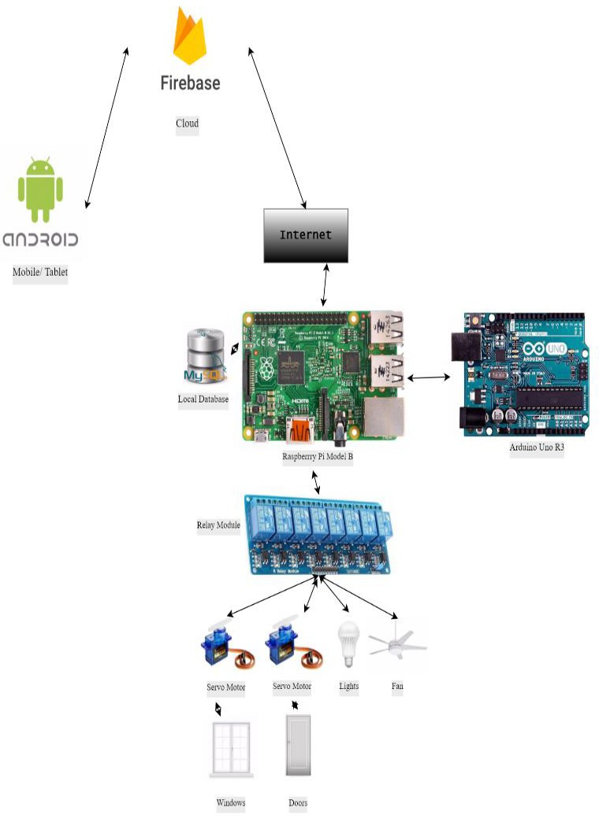

FIG 2. SYSTEM ARCHITECTURE

1. HARDWARE DESIGN

The entire design can be divided into three parts: Pi Webserver, Sensor Array with Controller, Pi Actuator.

The Pi Webserver takes care of the entire network management and database maintenance. It issues the requests to the cloud to send push notifications and react to the user input from the Android application.

Sensor array with Controller contains the Arduino Uno and the sensors connected to it. The sensors include Passive Infrared [4] Motion sensor (PIR), Temperature and Humidity sensor [3] (DHT11), Light Sensor (LDR). Soil Moisture sensor, Magnetic Reed sensor, Raindrop sensor (LM393), Gas sensor (MQ5). These sensors are continuously monitor the environment in the home and relay them to the Arduino which sends them to the Pi for processing. The magnetic reed and motion sensors also act as security by checking the integrity of the doors and windows and detecting any unwanted motion in the house. The PIR sensor is used to detect any changes in the infrared signal it monitors, gives out a HIGH output signal when motion is detected. Options like delay timer and sensitivity can be adjusted using the controls on the sensor. It has a range of 20 feet or 6 meters and a field view of 110°±15. The DHT11 is used to detect the level of humidity and the temperature of a room. It can measure temperatures up to

50°C and a relative humidity of 20% ~ 90%. The soil moisture sensor is used to measure the humidity levels of the soil. It gives out two output signals, a LOW signal when the humidity is below the trigger level and HIGH when the humidity crosses the trigger level. The trigger level can be set using a trip pot present on the sensors circuit board. The LDR gives an output digital signal ranging from 0 ~ 1023 which is digital representation of analog voltage 0 ~5V. Depending on the light intensity incident on it, the voltage levels change. Magnetic Reed sensor is a magnetically active open circuit sensor which closes the circuit when magnetic field is applied. This can be used to check for any form of tampering in the entrances or exits of the house. The LM393 is an active HIGH circuit which gives out analog/digital signal depending on the pin connection. There is a sensitivity adjuster to change the reactance to the water falling on it. The MQ5 is an LPG and Propane gas detection sensor which gives a HIGH signal on detection of gases in the environment.

Pi Actuator consists a 12V Relay module which is a two way switch that operates on the input given to it. The servo motors and appliances such as fans, lights and Air conditioners are connected to it. To automate the doors and windows, a servo motor which is installed on them and connected to the relay. Reflector panels are installed in the garden if there is one to maximize the heat and light received by the plants. Shutter are installed at every door as a security feature.

.

1. SOFTWARE DESIGN

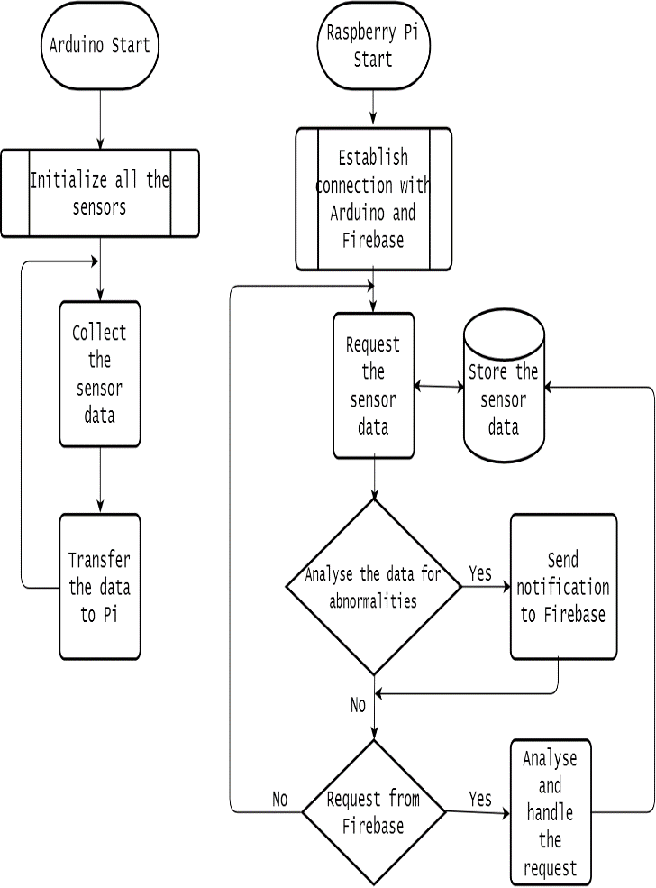

FIG 3: INFINITE STATE DATA FLOW MODEL

Software design includes the requirements and design of software in every component and in addition a novel feature is suggested in this model called Automation Perks.

Automation Perks are software additions to the proposed model and act serve a purpose towards fine-tuned automation system. They come as a part of the system and user has the option to enable and disable them at will. They are macros of an automated task

1. *Air flow Regulation:*

Depending on the temperature difference between the inside and outside of the house, the system automatically lets the air in or out to regulate the temperature and humidity levels without the intervention of the user. The flow can be regulated opening and closing the windows. If there is a breeze outside, the windows are opened for healthy circulation of oxygen.

1. *Automatic Gas Removal*

When a gas leakage is detected, all the electronic appliances are turned off, the user is notified about the leakage and a small exhaust fan is switched on to let the gas outside the house. After some time, the windows are opened and left as such until the user arrives and turns off the leak. In case of fire, MQ5 coupled with Flame sensor will detect it and the nearby fire station is notified.

1. *Garden Maintenance*

This perk requires the soil moisture sensor and the LDR to detect the levels of water in the soil and initiate a self-watering sequence until the garden has enough water. The LDR is used to detect the amount of sun rays being absorbed by the plants. If there is not adequate light, the reflector panels are engaged so that the plants receive the required amount of sunlight.

1. *Rainwater Harvester*

When the LMP393 detects rain, converging panels installed on the roof of the house act in order to effective capture the rain water and direct them to a specified storage area from where the water can be drawn later for watering the plants or washing purposes.

1. *Security*

The doors and windows of the home are fitted with Magnetic Reed sensors coupled with PIR motion detectors. Whenever an unauthorized entry is detected, the shutters are closed and the user along with local police station are notified.

1. CONCLUSION AND FUTURE ENHANCEMENTS

In conclusion, the proposed model is a fairly low cost system which can provide the user: power to do anything by doing almost nothing. This helps improve the living standards and also provide a safe environment where one can rest without any worries of break-ins or any kind of mishaps. The use of Android as the base platform makes sure this system can be available to wide range of users.

Future work on this model includes expanding the mobile platform to IOS (IPhone operating system). Integrating a speech-to-text module to understand the user and speaker to interact with the user verbally. This also allows us to install a voice recognition system as an added security feature. A low cost camera can be added for facial recognition which drastically improves the security of the system. Machine learning algorithms can be implemented to learn about user patterns and suggest improvements in the current lifestyle such as track sleep patterns, quotidian tasks, and activity cycles. Modules such as heart beat sensor can be installed to check the health of the user.

1. REFERENCES
2. <http://playground.arduino.cc/>
3. https:/[/w](http://www.raspberrypi.org/picademy/)w[w.raspberrypi.org/picademy/](http://www.raspberrypi.org/picademy/)
4. https://learn.adafruit.com/dht
5. https://learn.adafruit.com/pir-passive-infrared-proximity-motion-sensor
6. https://developer.android.com/guide/index.html
7. https://firebase.google.com/
8. <http://www.instructables.com/id/Getting-Started-With-Arduino>
9. https://en.wikipedia.org/wiki/Home_automation
10. Ahmed ElShafee, Karim Alaa Hamed, "Design and Implementation of a WiFi Based Home Automation System",World Academy of Science, Engineering and Technology International Journal of Computer,

Electrical, Automation, Control and Information Engineering Vol:6,

No:8, 2012

1. Vinay sagar K,Kusuma S,"Home Automation Using Internet of Things", International Research Journal of Engineering and Technology, Volume: 02 Issue: 03 June-2015
2. S.Anusha, M.Madhavi, R.Hemalatha, "HOME AUTOMATION USING ATmega328 MICROCONTROLLER AND ANDROID APPLICATION", International Research Journal of Engineering and Technology, Volume: 02 Issue: 06 June-2015
3. Abdelhakim Ahmim, Tam Le, Esther Ososanya and Sasan Haghani, “Design and Implementation of a Home Automation System for Smart Grid Applications”, 2016 IEEE International Conference on Consumer Electronics.