CURRICULUM VITAE
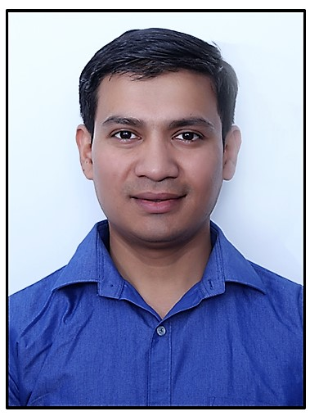

Present Address:

Name: Dilip Chhetri
Address: Mamaia-Sat Beach, Năvodari, Constanţa, Romania
Contact Number: +40732128164
E-mail: chhetri.dilip@gmail.com

Career Objective:

A reliable, trustworthy and flexible individual who has the relevant culinary experience and qualifications that you are looking for. Dilip has a comprehensive understanding of the food manufacturing industry, and of what drives sophisticated contemporary dining. He has extensive cooking knowledge, and is more than able to abide by all legal requirements, food Hygiene regulations and food safety laws. As a ‘can do’ person he will be able to hit the ground running and is confident that he will be able to exceed any employers and guest expectations. Right now he is looking for a suitable position with a company that rewards hard work and offers the opportunity of a progressive career.

Key Skill:

- Food Production, Presentation.
- Innovative, Cost control, wastage control.
- Scheduling according to business flow.
- Excellent International product trainer.
- Language known: English, Hindi, Bengali, Marathi, Nepali,
- IT Proficiency: MS Office, Excel, Word, Outlook, PowerPoint and Internet.

Qualifications:

- Diploma in hotel operation from IIAS School of hotel and tourism
management Goa with Distinction.
- Diploma in catering operation from Madurai Kamraj University DDE with
First position.
- Completed high school from NIOS New Delhi Board.

Industrial Exposure Training:

- Hotel: Successfully completed 6 months job training from Vivanta by Taj Holiday Village Goa.
- Department: Food Production.

Working Experience:

- Presently working with Corsa International & Company S.R.L. as a cook in Banquet kitchen, Continental Department from 31st July 2018.
  - Restock all items as required throughout shift.
  - Report to head chef of all set- ups and Staffing.
  - Follow recipes, piece controls and presentation specifications as set by management.
- Worked together in a team oriented environment to produce foods in a timely and orderly fashion.
- Ensured that all orders were presented in a neat and appetizing manner.
- Cooked menu items on a grill, broiler, and used a deep fryer, cooker, microwave oven, stove, and toaster.
- Train new employee.
- Perfection in best sormale Romanian food.
- Preparing mother souses and derivatives in authentic manner.

- Worked with Vivanta by Taj Panaji, Goa as a Team Leader in Continental Food Production Department from 2016 to 2017.
- Preparing, cooking and presenting dishes.
- Guest interaction, feedback.
- Managing and training any Commis or other direct reports.
- Assisting the Sous Chef and Executive Chef in developing new dishes and menus.
- Ensuring teams have high standards of food hygiene and follow the rules of health and safety.
- Daily Inventory & Storing.
- Scheduling according to business flow.
- Monitoring portion and waste control.

- Worked with M.H. Alshaya Co. in Texas Road House restaurant (American Brand) in Kuwait as a Commi 1 (line cook as well as International Training coordinator of Kitchen) from 2012 to 2016.
- Prepared orders according to the customer's preference using established recipes, portions, and methods established by the company.
- Regularly checked all food items to ensure adequacy and quality at all times.
- Maintained a clean and safe work environment.
- Followed a cleaning schedule for designated equipment and storage areas.
- Worked together in a team oriented environment to produce foods in a timely and orderly fashion.
- Ensured that all orders were presented in a neat and appetizing manner.
- Cooked menu items on a grill, broiler, and used a deep fryer, cooker, microwave oven, stove, and toaster.
- Train new employee.
- Providing helping hand to the Restaurant Manager in getting all work on time as Inventory, Cost control, Wastage control.

- Worked with Vivanta by Taj Holiday Village Goa as a GSA in Food Production from 2010 to 2011.
- Inspect food preparation and serving areas to ensure observance of safe, sanitary food-handling practices.
- Weigh, measure, and mix ingredients according to recipes or personal judgment, using various kitchen utensils and equipment.
- Portion, arrange, and garnish food, and serve food to waiters or patrons.
- Substitute for or assist other cooks during emergencies or rush periods.
- Bake, roast, broil, and steam meats, fish, vegetables, and other foods.
- Estimate expected food consumption; then requisition or purchase supplies, or procure food from storage.
- Butcher and dress animals or shellfish, or cut and bone meat prior to cooking.

- Worded with The Elgin Darjeeling from 1 March 2007 to 28 February 2009 in food production area as a cook.
  - Prepare all food items in a hygienic and timely manner.
  - Set up location in line with restaurant guidelines.
  - Assist with the cleaning, hygiene, and organization of kitchen, barge in coolers, and all storage areas.
  - Follow recipes, piece controls and presentation specifications as set by the restaurant management.
  - Restock all items as required throughout shift.
  - Perform extra responsibilities as given by the Manager.

Strengths:

- A quick learner, very optimistic, good team player.
- Enthusiastic, reliable and neat appearance.
- Can effectively manage time and responsibilities.
- Excellent teacher.
- Good Health.

Interests and Hobbies:

- Net surfing, Listening Music, Travelling, Sports.

Personal Details:

- Name: Dilip Chhetri
- D.O.B: 03/03/1984
- Father’s Name: Late: Ganga Prasad Chhetri
- Marital Status : Married
- Address: Dist. – Darjeeling, West Bengal, India.
- Nationality: Indian

Pass Port Details:

- Passport no: S1757574
- Date of issue: 10/04/2018
- Date of expiry: 09/04/2028

