CURRICULUM VITAE

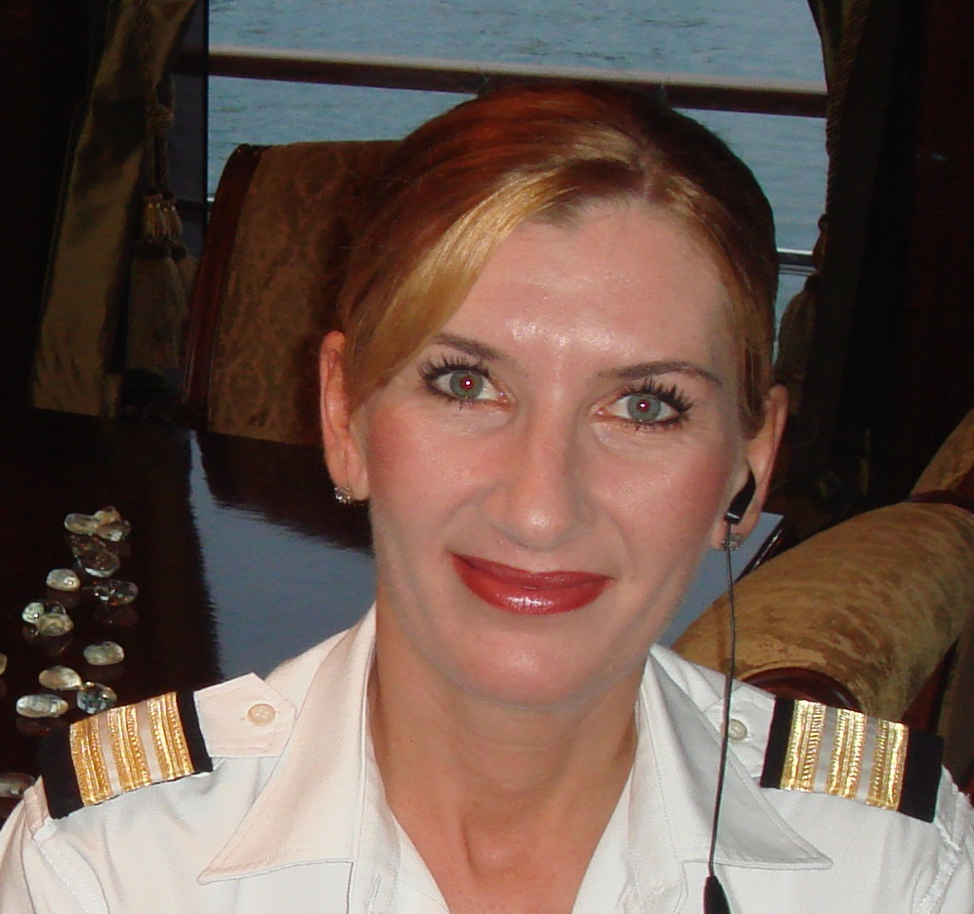

NAME: AURELIA DINCA

Personal Details

Date of Birth: 09.09.1972
Place of Birth: MEDGIDIA
Nationality: ROMANIAN
Marital status: SINGLE
Height : 168 cm, Weight: 58 kg

Contacts
Mobile: +40 733 901 200
Email: goldaura2006@yahoo.com
Address: Topolog Str. 23, Bl F5, Sc. B , Ap, 24, Constanta, Romania

Other information

Passport No: 14707943, exp. 2019
Seaman’s Book No. 20148 CT Issued by Constanta Harbor Master / Romania

B1/B2 US VISA

Objective

Seeking a permanent / temporary position on a motor yacht were I can use my experience. I am looking for a position as Chief Stewardess.

Education

Industrial No. 8 High School – Constanta, Romania, 1986-1990
Sanitary Vet Police School Bucharest – 1992-1995
Waitress & Bar tender Courses/Certificate - 2003
STCW ‘95 valid until 2019- Basic Safety Training
RO-RO Passenger ship / Passenger ship other than RO-RO ship
Hygiene course valid until 2019

Yachting Experience

25.06.2019-15.08.2019-SUPERVISOR AT ROYAL PALACE SHARMA working for the Royal Family

Name of Yacht:MY SEA RANGER-Length 74 m
Date:1st May 2018-23 January 2019
Position Held-Chief Stewardess
Job Description:In charge with all interior duties

I was hired as Chief stewardess to set up and outfit the yacht interior, setting up guest and crew areas, buying linen, crockery, decorative items, etc. to the owner’s requirements and desires – I had to be very detailed oriented.
I was fortunate to serve high profile guests and owners. Training the interior girls in all aspects of housekeeping and service with a key focus on silver service and English service. I was also responsible for planning the day of the guest and customizing their experience onboard. General interior maintenance, stock levels of all crew and guest provisions, Organizing and monitoring of cleaning schedules.

Name of Yacht:SY ELLEN-Length 44 m

Date:10 March-1st September 2017
Position Held-Chief Stewardess
Job Description:In charge with all interior duties
Boat was chartered in Mediteranean
Referee:

Name and Position:

Captain Pablo Pirenack
Email:captain@yachtellen.com
Tel:+33662451991

Name of Yacht:SY ELLEN-Length 44 m

Date:1st June-07 November 2016
Position Held-Chief Stewardess
Job Description:In charge with all interior duties
Boat was chartered in Mediteranean
Referee:

Name and Position:

Captain Pablo Pirenack
Email:captain@yachtellen.com
Tel:+33662451991

Name of Yacht:SY ELLEN-Length 44 m

Date:1st April 2015 -20 January 2016
Position Held-Chief Stewardess
Job Description:In charge with all interior duties.
Boat was in shipyard for an extended refit.
The main duty :
-planning and supervising all interior refit.
-planning&ordering all new interior equipment:
-table weare(china,cutlery,glasses,table accessories,table linen)
-guests cabins(bedlinen,towels,carpets,bathroom accessories,paintings,guests toilletries)
-crew cabins(bedlinen,towels)
-galley&laundry(all needed equipment)
-crew uniforms
-giving training for two unexperienced stewardesses
-prepare the boat for charter

Referee:

Name and Position:

Captain Pablo Pirenack
Email:captain@yachtellen.com
Tel:+39 3894447370
Tel:+33 619508609

Name of Yacht: MY DB9 - Length 52 m

Dates: 18th January 2015- 30 March 2015
Position Held: Chief Stewardess/Crew Chef
Job Description: In charge of all interior duties , the only Stewardess onboard Inventories, provisions, housekeeping ,floral arrangement & table decorations, laundry , crew chef. Stepped in after an extended yard period and prepared the boat for client inspections. Boat is for sale and looking for a more stable future.

Referee:
Name and position: Captain Septimiu Calin
Email: capt_calins@yahoo.co.uk
Mobile number: +33 623757361
+40 724510799

Name of Yacht: MY NEW SUNRISE Length 61m

Dates:6 Octomber 2012 to 30 June 2013
Position Held: Chief Stewardess/Crew Chef
Job Description: In charge of all interior duties , the only Stewardess onboard (for 7 months)
Inventories, provisions, housekeeping ,floral arrangement & table decorations, laundry , crew chef.
Referee:
Name and position: Captain Septimiu Calin
Email: capt_calins@yahoo.co.uk
Mobile number: +33 623757361
+40 724510799

Name of Yacht:MY OLIVIA Length 71 m

Dates:1st May to 2nd September 2011
Position Held:Chief stewardess
Job description:in charge with all interior duties,Inventories,Provisions,Silver Service. Stepped in during an extended refit period in Malta Shipyard and prepared the boat for summer season. Very demanding Owners, a successful summer season. In charge of a team of 4 stewardesses.
Referee:
Name and position:Captain Septimiu Calin
Email: capt_calins@yahoo.co.uk
Mobile number: +33 623757361
+40 724510799

Name of Yacht:MY IONIAN PRINCESS Lenght 47 m

Dates:1st April 2010 to 25 November 2010
Position Held:Chief Stewardess
Job description:In charge of all interior duties, Inventories, Provisions, Silver Service, housekeeping, assisting with Laundry.
Referee:
Name and position:Captain TAKIS TSAKOS
Email:captain@ionianprincess.com
tsakostakis@internet.gr
Mobile:+30 6948 200 100

Name of Yacht: MY NEW SUNRISE Length 61m

Dates: 1st June 2009 to 1st September 2009
Position Held: Chief Stewardess
Job Description: In charge of all interior duties the only Stewardess onboard .
Inventories, , provisions, housekeeping , laundry .
Referee:
Name and position: Captain Septimiu Calin
Email: capt_calins@yahoo.co.uk
Mobile number: +33 623757361
+40 724510799

Name of Yacht: MY NEW SUNRISE Length 61m

Dates: Octomber 2006 to September 2007
Position Held: Chief Stewardess
Job Description: In charge of a team of 4 stewardesses. Inventories, silver service, provisions, housekeeping supervision, laundry supervision. In charge of all aspects of interior duties.

Name of Yacht: RM ELEGANT

Dates: 19th Jun 2006 to 26th Oct 2006
Position Held: Stewardess
Job Description: Silver service, provisions, cabin/general interior cleaning, Laundry, under Chief Stewardess Supervisions.

OTHER WORK EXPERIENCE:

- OCT 2007 - MAY 2009 – Logistics Manager – BUSINESS METAL STEEL S.R.L. - CONSTANTA ROMANIA
- Aug 2005 - Feb 2006 Waitress Passenger /Ferry IONIAN QUEEN
- Feb 2005 - July 2005 Bar/Waitress Cruise ship SALAMIS GLORY
- May 2004 - Nov 2004 Bar/Waitress Cruise ship SALAMIS GLORY
- 1997-2003 Accountant SC INTERNATIONA PRO-ANTIMA Constanta

Skills :

Excellent Silver services
Table decorations
Flowers & Flower Arrangement
Laundry & Laundry Care
Inventories, Provisions
Accounting / Computer literate

Hobbies and Interests
I love reading books, Traveling, Music, Sport

