
15.09.2016


Fair Spirit Shipping Ltd.

Head Office: NAVLOMAR NEW BUILDING, 1st floor, office #2 Port GATE 1, Zip Code 900900
Constanta – Romania Web Site: www.fairspirit.ro E-mail: office@fairspirit.ro
Phone / Fax: + 40 241 541 340 / + 40 241 541 380 Mobile: + 40 722 543 591
WE HELP OUR CUSTOMERS TO BE MORE PRODUCTIVE

APPLICATION FORM (SEA STAFF) |  |  |  |  | Available |  |  |  | 29.06.2019 |  | 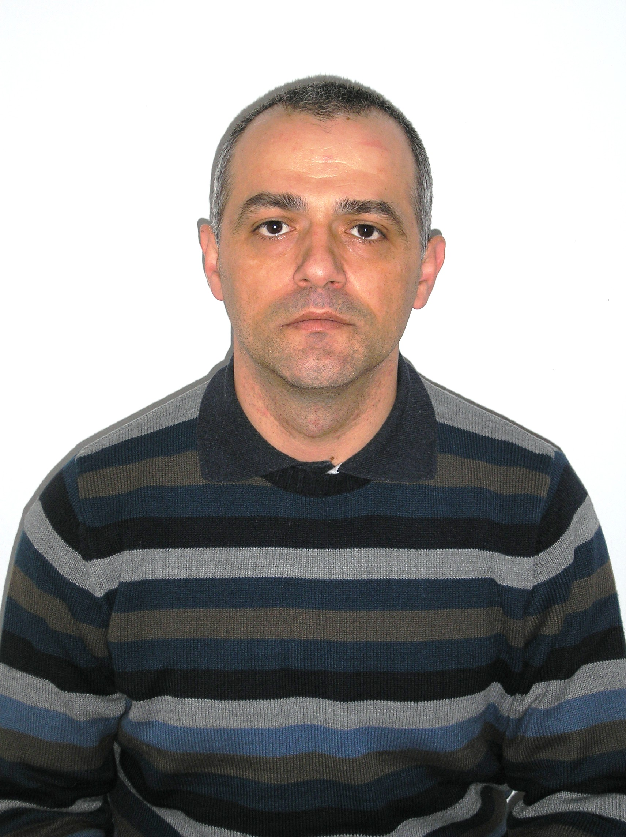
(This paragraph to be fulfilled by crewing agency’s officer only) |  |  |  |  | Salary expectation |  |  |  | 6200 usd

SEAFARER

INDENTIFICATION DETAILS:  LICENSED RANK : SECOND ENG.  LICENSE STCW CODE : III/2 |  |  |  | FIRST NAME |  |  | MIHĂIŢĂ
 |  |  |  | SURNAME |  |  | VASILE
 |  |  |  | NATIONALITY |  |  | ROMANA
PERSONAL DETAILS
MARITAL STATUS | MARRIED |  |  |  | RELIGION |  |  |  |  | ORTODOX
DATE OF BIRTH | 30.09.1970 |  |  |  | PLACE OF BIRTH |  |  |  |  | CONSTANTA
PASSPORT NO. | 057462509 |  |  |  | VALIDITY |  |  |  |  | 24.05.2029
SEAMAN’S BOOK | 9890CT |  |  |  | VALIDITY |  |  |  |  | 25.04.2021
ENGLISH LANGUAGE | GOOD |  |  |  | PHONE / MOBILE |  |  |  |  | 0040723716336
OTHER LANGUAGE |  |  |  |  | FAX / E-MAIL |  |  |  |  | VA.MIHAILE@YAHOO.COM
HEIGHT | 1.70 |  |  |  | WEIGHT |  |  |  |  | 68
OVERALL | 40L |  |  |  | SHOE SIZE |  |  |  |  | 41
USA VISA-VALIDITY |  |  |  |  | STUDIES |  |  |  |  | ACADEMY NAVY ,,MIRCEA CEL BATRAN’’
PRESENT ADDRESS : STR :ELIBERARII,NR 34, BL :DE22,SC :A,AP :6,ET :2,CONSTANTA.

NEXT OF KIN NAME, ADDRESS, PHONE NO : VASILE AURELIA,SAME,0771550670

WIFE & CHILDREN
NAME & SURNAME |  |  |  | DATE OF BIRTH |  |  |  | PLACE OF BIRTH |  |  | RELATIONSHIP
1.VASILE AURELIA |  |  |  | 31.05.1970 |  |  |  | CONSTANTA |  |  | WIFE
2.VASILE BRINDUŞA DANIELA |  |  |  | 29.08.1993 |  |  |  | CONSTANTA |  |  | DOTHER
3. VASILE ANDREI |  |  |  | 03.05.1996 |  |  |  | CONSTANTA |  |  | SAN
4.
DOCUMENTS / CERTIFICATES |  | NO. | ISSUED |  |  | VALIDITY |  |  | AUTHORITY |  |  | PLACE OF ISSUED
CERTIF. COMPETENCY |  | 65601 | 01.09.2014 |  |  | 10.08.2021 |  |  | ANR ROMANIAN |  |  | CONSTANTA
ROMANIAN S. BOOK |  | 9890CT | 14.09.2016 |  |  | 25.04.2021 |  |  | ANR ROMANIAN |  |  | CONSTANTA

RANK:SECOND ENGINEER
NAME:MIHĂIŢĂ SURNAME: VASILE

RECORD OF PREVIOUS SEA SERVICE
* Please start nominate as first as backward
COMPANY (OWNER) / FLAG | RANK | SHIP’S PARTICULARS |  |  |  | DATES
COMPANY (OWNER) / FLAG | RANK | NAME | TYPE | GRT | MAIN ENG/H.P. | FROM | TO
MASTERMIND SHIPMANAGEMENT LTD./CIPRU | SECOND ENG. | ATLANTIC PENDANT | MPC CARGO | 12993 | MAN B&W7L42MC MK VI/8523 | 07.05.2017 | 08.09.2017
TYLOS SHIPPING/BAHRAIN | SECOND ENG. | JERNAS | CARGOU | 10132 | MAN B&W5S42MC/7344 | 03.03.2016 | 11.05.2016
R&D ARMATORI SPA/ITALY | SECOND ENG. | GRAZIA BOTTIGLIERI | BLK | 39385 | SULTZER MAN B&W5RTA62U/14494 | 02.09.2015 | 19.11.2015
ESA SHIP MANAGEMENT Ltd./PANAMA | SECOND ENG. | ANDRES | CARGOU | 9810T | SULTZER MAN B&W 6RTA52U/12552 | 20.05.2015 | 19.06.2015
H WINTER /ST.JOHN’S | SECOND ENG. | TINI | PORT CONT. | 1500T | MAK7 M43 | 01.01.2015 | 05.02.1015
PCTC HOLDING IAS /PANAMA | SECOND ENG. | SILVER SKY | CAR CARRIER | 39047 | HITACHI ZOSEN B&W 6L60MCE/10000 | 02.09.2014 | 19.10.2014
CMA CGM SHIPPING/UK | 3RD ENG. | CMA CGM GEMINI | PORT CONT. | 9450T | HYUNDAI 12 LK98MC/98150 | 10.12.2013 | 17.01.2014

I.M.O. UP-DATED COURES
*CERONAV -ROMANIAN MARITIME TRANING CENTER - CONSTANTA
 | CERTIFICATES DETAILS
 | NO. / SERIES | PLACE OF ISSUED | ISSUED DATE | VALIDITY DATE | STCW’95 CODE
BASIC SAFETY TRANING | 00014966 | CERONAV | 10.08.2016 | 10.08.2021
PREVENTION OF POLLUTION | 00002219 | CERONAV | 16.10.2018 | 16.10.2023 | A-II/1;A-II/2;A-III/1; A-III/2
MEDICAL FIRST AID | 00006057 | CERONAV | 01.10.2013 |  | A – VI / 4-1
TRANSP. AND HANDLING D.G. |  |  |  |  | A-II/1; A-II/2
MARITIME ENGLISH, PROBL |  |  |  |  | A-III/1 ; A-III/2
ADVANCED FIRE-FIGHTING | 000012898 | CERONAV | 19.10.2018 | 19.10.2023 | A – VI / 3
ADVANCED MEDICAL CARE | 00005999 | CERONAV | 12.09.2016 |  | A – VI / 4-2
HELM | 00002581 | CERONAV | 19.08.2016
PERSONAL SAFETY(PSSR) | 00014966 | CERONAV | 10.08.2016 | 10.08.2021 | A- VI / 1-4
PERS. SURVIVAL TECHNIQUE | 00014966 | CERONAV | 10.08.2016 | 10.08.2021 | A – VI / 1-1
PROF. IN SURV. CRAFT | 00015530 | CERONAV | 25.09.2019 | 25.09.2023 | A – VI / 2-1
ECDIS( ELECTRONIC CHARTS) |  |  |  |  | A-II/1 ; AII/2
RO-RO PASSENGER SHIPS |  |  |  |  | A – V / 2;1 up to A – V / 2;5  A – V / 3;1 up to A – V / 3;5
SHIP SECURITY OFFICER | 00004361 | CERONAV | 22.10.2013 |  | A / 13.2
SHIP SECURITY AWARNESS | 00005591 | CERONAV | 24.10.2013 |  | A / VI / 6 ; 1-4 , 6-8
ENGINE TEAM MANAGEMENT |  |  |  |  | A – III / 2 ; A – VIII / 2
ENDORSEMENT | ABV 69319 | ANR | 01.09.2014 | 19.11.2018

I agree with the processing of my personal data by Fair Spirit Shipping

