“Politehnica” University of Timişoara

Hepatitis Data Set

Cristiana DINEA

Introduction

Pattern recognition aims to classify data (patterns) based either on a priori knowledge or on statistical information extracted from the patterns. The patterns to be classified are usually groups of measurements or observations, defining points in an appropriate multidimensional space.

Data Mining and Knowledge Discovery in Databases refer to the automation of the process of data analysis^{[9]}. The process of Knowledge Discovery in Databases consists of more than just Data Mining. Knowledge Discovery in Databases also handles the definition of the study, the pre-processing phase, the data mining phase and the validation of the results. The exact steps in the process of Knowledge Discovery in Databases are as follows:
- data cleaning
- data integration
- data selection
- data transformation
- data mining
- pattern evaluation
- knowledge representation

The current paper aims at presenting a few algorithms for data classification and doing a comparative analysis of the performance of these algorithms taking into consideration the percentage of correctly classified instances and also the time it takes to classify them.
Chapter 1 makes a short introduction to the field of Pattern Recognition and presents the data set. Chapter 2 presents the statistical analysis of the data set .Chapter 3 presents Classification methods: The Naive Bayse algorithm and one decision-tree algorithm, Id3 (or J48),cluster analysis ,tree analysis and graphical representation of the data flow with KnowledgeFlow.
Finally, Chapter 4 draws up some conclusions on the performance of the different algorithms and on the entire field of data mining.

1.1 Hepatitis data set

The data set that was chosen for processing and analyzing with different algorithms was the hepatitis set file, available for download from http://archive.ics.uci.edu/ml/datasets.html.
The data set is presented as follow:

1. Title: Hepatitis Domain

2. Sources:
(a) unknown
(b) Donor: G.Gong (Carnegie-Mellon University) via
Bojan Cestnik
Jozef Stefan Institute
Jamova 39
61000 Ljubljana
Yugoslavia (tel.: (38)(+61) 214-399 ext.287) }
(c) Date: November, 1988

3. Number of Instances: 155

4. Number of Attributes: 20 (including the class attribute)

5. Attribute information:
1. Class: DIE, LIVE
2. AGE: 10, 20, 30, 40, 50, 60, 70, 80
3. SEX: male, female
4. STEROID: no, yes
5. ANTIVIRALS: no, yes
6. FATIGUE: no, yes
7. MALAISE: no, yes
8. ANOREXIA: no, yes
9. LIVER BIG: no, yes
10. LIVER FIRM: no, yes
11. SPLEEN PALPABLE: no, yes
12. SPIDERS: no, yes
13. ASCITES: no, yes
14. VARICES: no, yes
15. BILIRUBIN: 0.39, 0.80, 1.20, 2.00, 3.00, 4.00
-- see the note below
16. ALK PHOSPHATE: 33, 80, 120, 160, 200, 250
17. SGOT: 13, 100, 200, 300, 400, 500,
18. ALBUMIN: 2.1, 3.0, 3.8, 4.5, 5.0, 6.0
19. PROTIME: 10, 20, 30, 40, 50, 60, 70, 80, 90
20. HISTOLOGY: no, yes

6.Missing Attribute Values: (indicated by "?")
Attribute Number: Number of Missing Values:
1: 0
2: 0
3: 0
4: 1
5: 0
6: 1
7: 1
8: 1
9: 10
10: 11
11: 5
12: 5
13: 5
14: 5
15: 6
16: 29
17: 4
18: 16
19: 67
20: 0

7. Class Distribution:
DIE: 32
LIVE: 123

Statistical analysis of the data set

First we imported the data set in Weka as a .arff file.We chose to work in a supervised manner.
The visualization of the data set is shown in the fig below:

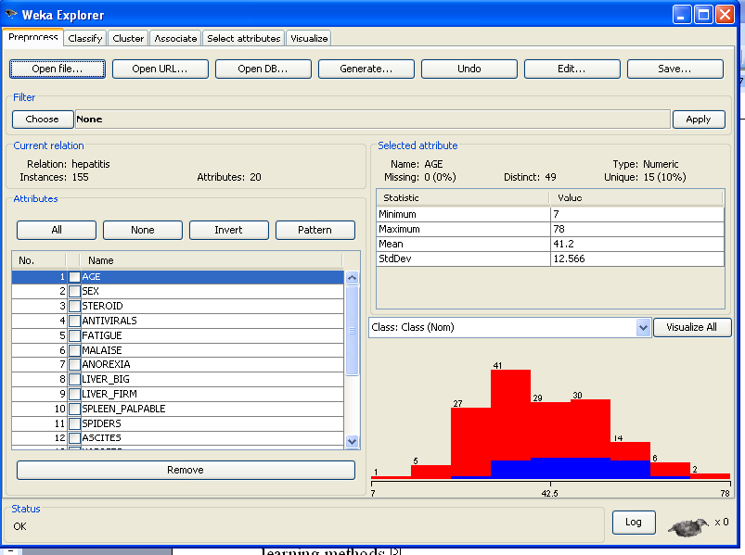

In order to select the most important atributes we chose the Ranker Search Method from <Select attributes > tabbased on InfoGainAttributeEval.The result of the searching methos is presented below:

=== Run information ===

Evaluator: weka.attributeSelection.InfoGainAttributeEval
Search: weka.attributeSelection.Ranker -T -1.7976931348623157E308 -N -1
Relation: hepatitis
Instances: 155
Attributes: 20
AGE
SEX
STEROID
ANTIVIRALS
FATIGUE
MALAISE
ANOREXIA
LIVER_BIG
LIVER_FIRM
SPLEEN_PALPABLE
SPIDERS
ASCITES
VARICES
BILIRUBIN
ALK_PHOSPHATE
SGOT
ALBUMIN
PROTIME
HISTOLOGY
Class
Evaluation mode: evaluate on all training data

=== Attribute Selection on all input data ===

Search Method:
Attribute ranking.

Attribute Evaluator (supervised, Class (nominal): 20 Class):
Information Gain Ranking Filter

Ranked attributes:
0.18246 17 ALBUMIN
0.12558 14 BILIRUBIN
0.12443 12 ASCITES
0.10263 11 SPIDERS
0.08493 19 HISTOLOGY
0.08418 5 FATIGUE
0.08092 6 MALAISE
0.07459 13 VARICES
0.06835 18 PROTIME
0.05938 1 AGE
0.03661 2 SEX
0.03441 10 SPLEEN_PALPABLE
0.01449 4 ANTIVIRALS
0.01308 3 STEROID
0.01162 7 ANOREXIA
0.00377 8 LIVER_BIG
0.00229 9 LIVER_FIRM
0 16 SGOT
0 15 ALK_PHOSPHATE

Selected attributes: 17,14,12,11,19,5,6,13,18,1,2,10,4,3,7,8,9,16,15 : 19

As seen above, we have no need for attributes 16,15 therefore we can eliminate them.

We proceed to statistically analyze the attributes determined above.We need to preprocess the nominal attributes before using them,in order to be able to calculate statistical paramaters like standard deviation, minimum,maxmium,mean.

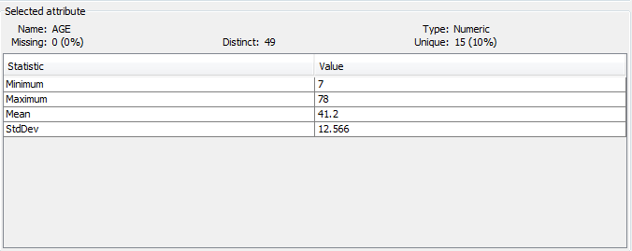

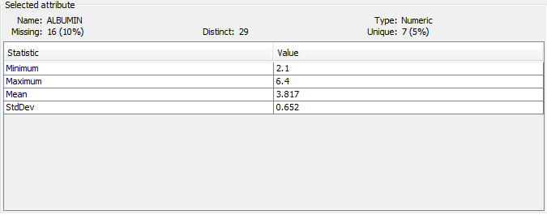

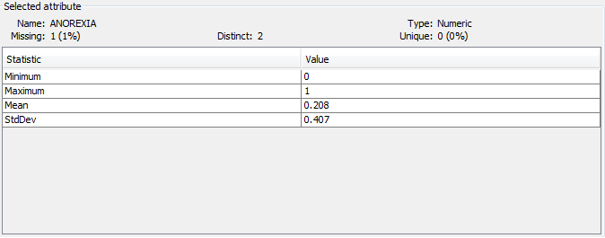

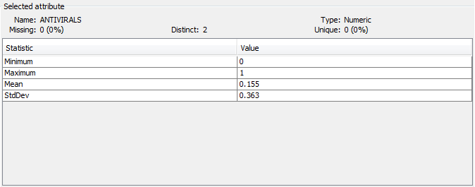

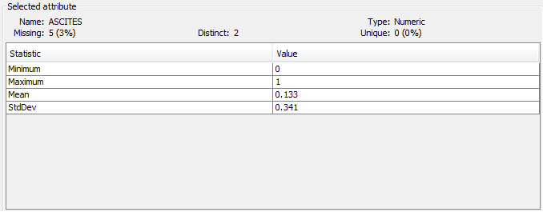

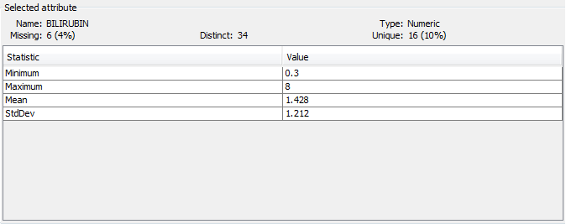

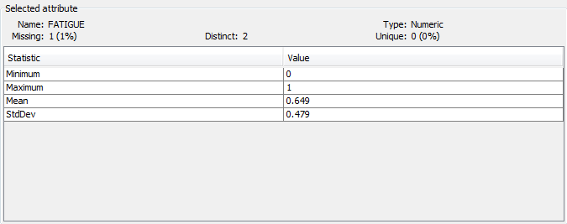

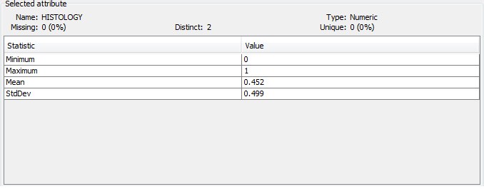

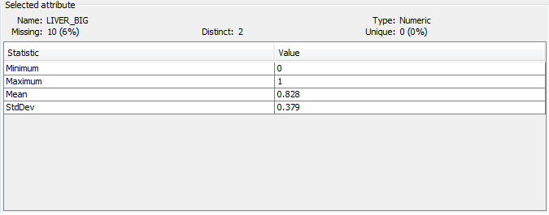

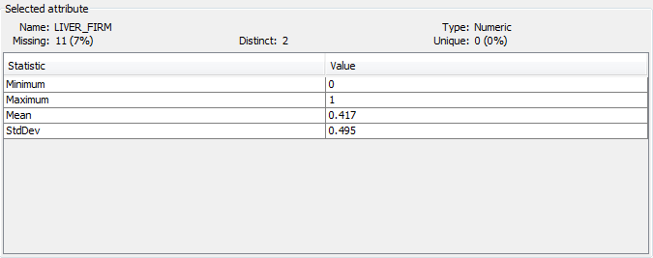

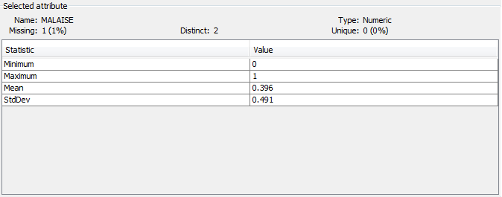

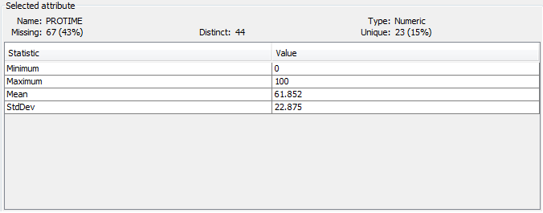

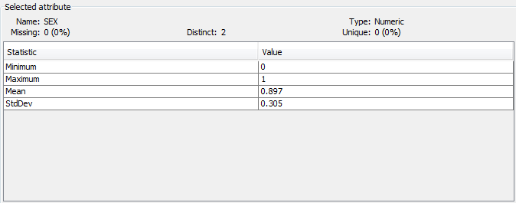

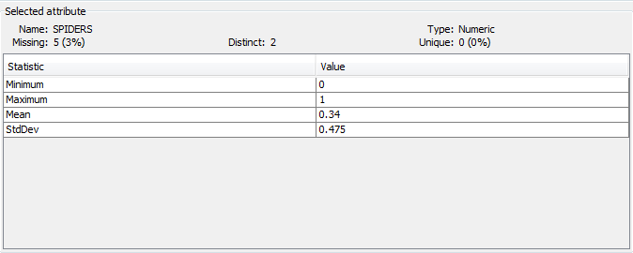

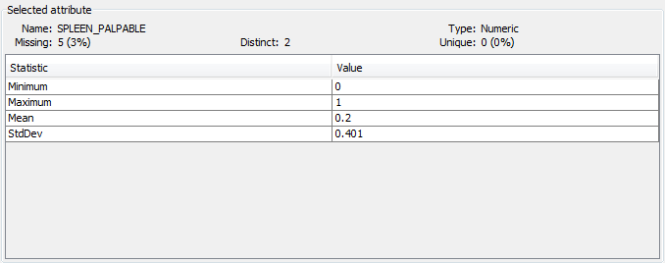

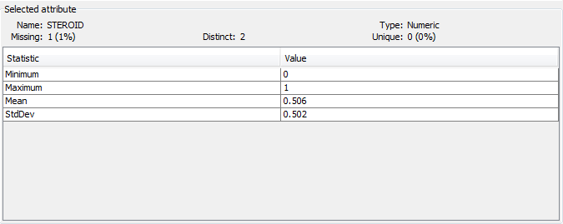

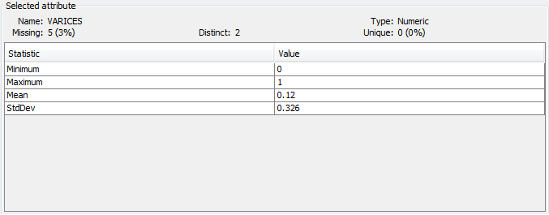

In order to visualize all attributes , we chose the <Visualize all> option, which is a comprised representation :

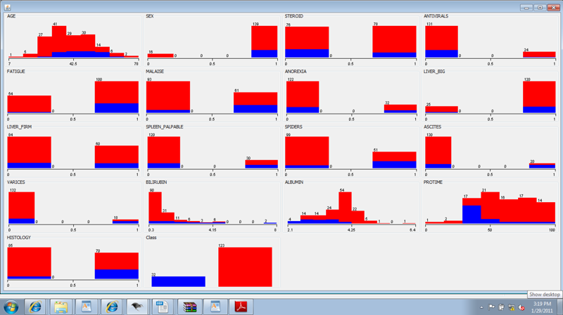

Classification methods

Classification is a predictive method part of the supervised learning methods ^{[5]}.
A class is represented by a certain attribute of the data set called class-attribute. The other attributes, different from the class-attribute are called predictors. The purpose of classification is the prediction, for a random instance, described by a set of predictor values, of the class it belongs to.
Classification has the following two stages:
- Training stage. In this stage the aim is, starting from a set of instances of the chosen data set (Training Set) and a classification algorithm, to build a model that describes as best as possible the associations (predictor values → class-attribute) for every instance of the Training Set
- Testing stage. The remainder of the data set, besides from the Training Set constitutes the Testing Set. The purpose of this stage is to estimate the accuracy of the classifier obtained in the first stage. For each instance the following steps are done to test the matching of the classifier to the certain instance:
  - The classifier predicts to which class does the instance belong to
  - The class obtained from step a. is compared with the real class of the instance
  - The accuracy of the classifier represents the percentage of the correctly classified instances.
The current paper studies these classification methods: cluster analysis, a TreeAnalysis technique in order to visualize the class structure for two types of distances and 3 compute ways when these attributes are normalized, Naive Bayse, and a decision tree algorithm: ID3.
Towards the end of this chapter we graphically represent the dataflow using KnwoledgeFlow.

Cluster analysis
Cluster analysis or clustering is the assignment of a set of observations into subsets (called clusters) so that observations in the same cluster are similar in some sense. Clustering is a method of unsupervised learning, and a common technique for statistical data analysis used in many fields, including machine learning, data mining, pattern recognition, image analysis, information retrieval, and bioinformatics.
Hierarchical algorithms find successive clusters using previously established clusters. These algorithms usually are either agglomerative ("bottom-up") or divisive ("top-down"). Agglomerative algorithms begin with each element as a separate cluster and merge them into successively larger clusters. Divisive algorithms begin with the whole set and proceed to divide it into successively smaller clusters.
Partitional algorithms typically determine all clusters at once, but can also be used as divisive algorithms in the hierarchical clustering.
Density-based clustering algorithms are devised to discover arbitrary-shaped clusters. In this approach, a cluster is regarded as a region in which the density of data objects exceeds a threshold. DBSCAN and OPTICS are two typical algorithms of this kind.
Subspace clustering methods look for clusters that can only be seen in a particular projection (subspace, manifold) of the data. These methods thus can ignore irrelevant attributes.
One of the partitional algorithms is the k-means algorithm. k-means clustering is a method of cluster analysis which aims to partition n observations into k clusters in which each observation belongs to the cluster with the nearest mean. It is similar to the expectation-maximization algorithm for mixtures of Gaussians in that they both attempt to find the centers of natural clusters in the data as well as in the iterative refinement approach employed by both algorithms.
Given a set of observations (x₁, x₂, …, x_{n}), where each observation is a d-dimensional real vector, k-means clustering aims to partition the n observations into k sets (k ≤ n) S = {S₁, S₂, …, S_{k}} so as to minimize the within-cluster sum of squares (WCSS):
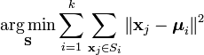
where μ_{i} is the mean of points in S_{i}.
The pseudocode for the k-means algorithm
X: a set of N data vectors Data set
C_{I}:initialized k cluster centroids Number of clusters,
C:the cluster centroids of k-clustering random initial centroids
P = {p(i) | i = 1, …, N} is the cluster label of X
KMEANS(X, C_{I}) → (C, P)
REPEAT
C_{previous} ← C_{I};
FOR all j ∈ [1, k] DO Generate optimal centroids
c_{j} ← Average of x_{i}, whose p(i) = j;
FOR all i ∈ [1, N] DO Generate new optimal paritions
p(i) ← arg min d(x_{i}, c_{j});
l ≤ j ≤ k
UNTIL C = C_{previous}

For a number of clusters equal to 2, the SimpleKMeans algorithm from Weka produces the following output:
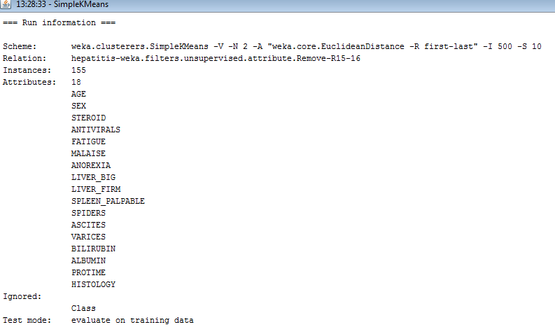
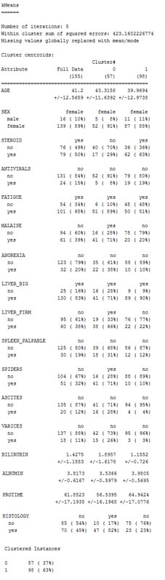

The results are interpreted as follow:
- the first cluster(Cluster 0) groups 57 objects(instances) out of 155(37 %): the centroid represents the cluster as:the average age is 43.3158,
most of the subjects are female,they are not on steroids,don’t take antivirals,do present fatique and a feeling of general discomfort,are not anoxeric,the liver is presented bigger and firmer than usual their spleen is not palpable, they do have spiders,no ascites and no varices.The representative results for bilirubin,albumin and protime is 1.8957,3.5366 respectivley 56.5395.Finally, their histology gives signs of hepatic viral when microscopically analyzed.
- For the second cluster, the percentage is significantlly higher,which means that 63% ar emore likely to live.The interpretation of the results follows the same logic as for the first cluster.
We incrementally change the no of clusters from 2( equal the number of classes to 6 ) but we keep the initial seed(10) and we reach a more uniform clusterization:

=== Run information ===

Scheme: weka.clusterers.SimpleKMeans -V -N 6 -A "weka.core.EuclideanDistance -R first-last" -I 500 -S 10
Relation: hepatitis-weka.filters.unsupervised.attribute.Remove-R15-16
Instances: 155
Attributes: 18
AGE
SEX
STEROID
ANTIVIRALS
FATIGUE
MALAISE
ANOREXIA
LIVER_BIG
LIVER_FIRM
SPLEEN_PALPABLE
SPIDERS
ASCITES
VARICES
BILIRUBIN
ALBUMIN
PROTIME
HISTOLOGY
Class
Test mode: evaluate on training data

=== Model and evaluation on training set ===

kMeans
======

Number of iterations: 6
Within cluster sum of squared errors: 309.42446987063033
Missing values globally replaced with mean/mode

Cluster centroids:
Cluster#
Attribute Full Data 0 1 2 3 4 5
(155) (25) (24) (17) (25) (41) (23)
==============================================================================================
AGE 41.2 48.64 41.4167 40.4706 40.16 35.122 45.3913
+/-12.5659 +/-13.7867 +/-12.7618 +/-12.2888 +/-13.7921 +/-8.5153 +/-11.2563

SEX female female female female female female female
male 16 ( 10%) 3 ( 12%) 3 ( 12%) 3 ( 17%) 2 ( 8%) 5 ( 12%) 0 ( 0%)
female 139 ( 89%) 22 ( 88%) 21 ( 87%) 14 ( 82%) 23 ( 92%) 36 ( 87%) 23 (100%)

STEROID yes yes no no yes yes no
no 76 ( 49%) 6 ( 24%) 18 ( 75%) 13 ( 76%) 10 ( 40%) 15 ( 36%) 14 ( 60%)
yes 79 ( 50%) 19 ( 76%) 6 ( 25%) 4 ( 23%) 15 ( 60%) 26 ( 63%) 9 ( 39%)

ANTIVIRALS no no no no no no no
no 131 ( 84%) 20 ( 80%) 18 ( 75%) 16 ( 94%) 23 ( 92%) 32 ( 78%) 22 ( 95%)
yes 24 ( 15%) 5 ( 20%) 6 ( 25%) 1 ( 5%) 2 ( 8%) 9 ( 21%) 1 ( 4%)

FATIGUE yes yes yes yes no no yes
no 54 ( 34%) 1 ( 4%) 0 ( 0%) 0 ( 0%) 19 ( 76%) 34 ( 82%) 0 ( 0%)
yes 101 ( 65%) 24 ( 96%) 24 (100%) 17 (100%) 6 ( 24%) 7 ( 17%) 23 (100%)

MALAISE no no yes yes no no yes
no 94 ( 60%) 21 ( 84%) 2 ( 8%) 4 ( 23%) 25 (100%) 40 ( 97%) 2 ( 8%)
yes 61 ( 39%) 4 ( 16%) 22 ( 91%) 13 ( 76%) 0 ( 0%) 1 ( 2%) 21 ( 91%)

ANOREXIA no no yes yes no no no
no 123 ( 79%) 25 (100%) 9 ( 37%) 8 ( 47%) 25 (100%) 41 (100%) 15 ( 65%)
yes 32 ( 20%) 0 ( 0%) 15 ( 62%) 9 ( 52%) 0 ( 0%) 0 ( 0%) 8 ( 34%)

LIVER_BIG yes yes yes no yes yes yes
no 25 ( 16%) 6 ( 24%) 0 ( 0%) 14 ( 82%) 2 ( 8%) 3 ( 7%) 0 ( 0%)
yes 130 ( 83%) 19 ( 76%) 24 (100%) 3 ( 17%) 23 ( 92%) 38 ( 92%) 23 (100%)

LIVER_FIRM no yes no yes no no no
no 95 ( 61%) 4 ( 16%) 20 ( 83%) 0 ( 0%) 19 ( 76%) 36 ( 87%) 16 ( 69%)
yes 60 ( 38%) 21 ( 84%) 4 ( 16%) 17 (100%) 6 ( 24%) 5 ( 12%) 7 ( 30%)

SPLEEN_PALPABLE no no no no no no no
no 125 ( 80%) 18 ( 72%) 20 ( 83%) 11 ( 64%) 21 ( 84%) 40 ( 97%) 15 ( 65%)
yes 30 ( 19%) 7 ( 28%) 4 ( 16%) 6 ( 35%) 4 ( 16%) 1 ( 2%) 8 ( 34%)

SPIDERS no no no yes no no yes
no 104 ( 67%) 19 ( 76%) 20 ( 83%) 2 ( 11%) 19 ( 76%) 39 ( 95%) 5 ( 21%)
yes 51 ( 32%) 6 ( 24%) 4 ( 16%) 15 ( 88%) 6 ( 24%) 2 ( 4%) 18 ( 78%)

ASCITES no no no no no no yes
no 135 ( 87%) 24 ( 96%) 23 ( 95%) 16 ( 94%) 25 (100%) 41 (100%) 6 ( 26%)
yes 20 ( 12%) 1 ( 4%) 1 ( 4%) 1 ( 5%) 0 ( 0%) 0 ( 0%) 17 ( 73%)

VARICES no no no no no no no
no 137 ( 88%) 22 ( 88%) 23 ( 95%) 14 ( 82%) 22 ( 88%) 41 (100%) 15 ( 65%)
yes 18 ( 11%) 3 ( 12%) 1 ( 4%) 3 ( 17%) 3 ( 12%) 0 ( 0%) 8 ( 34%)

BILIRUBIN 1.4275 1.456 1.6231 1.684 1.128 0.9404 2.1968
+/-1.1883 +/-0.8926 +/-1.5137 +/-1.1138 +/-0.5661 +/-0.6346 +/-1.8383

ALBUMIN 3.8173 3.636 3.8043 3.9138 4.0501 4.15 3.1102
+/-0.6167 +/-0.5908 +/-0.6332 +/-0.4294 +/-0.6034 +/-0.3615 +/-0.5084

PROTIME 61.8523 61.4268 60.1761 64.1658 62.0373 69.4997 48.5203
+/-17.1935 +/-15.6937 +/-15.4532 +/-16.6929 +/-15.973 +/-16.8555 +/-15.8487

HISTOLOGY no no no yes yes no yes
no 85 ( 54%) 18 ( 72%) 21 ( 87%) 4 ( 23%) 0 ( 0%) 41 (100%) 1 ( 4%)
yes 70 ( 45%) 7 ( 28%) 3 ( 12%) 13 ( 76%) 25 (100%) 0 ( 0%) 22 ( 95%)

Clustered Instances

0 25 ( 16%)
1 24 ( 15%)
2 17 ( 11%)
3 25 ( 16%)
4 41 ( 26%)
5 23 ( 15%)

In order to visualize a graphic of the cluster function of the instance_number, we chose the Weka Clusterer Visualizer -
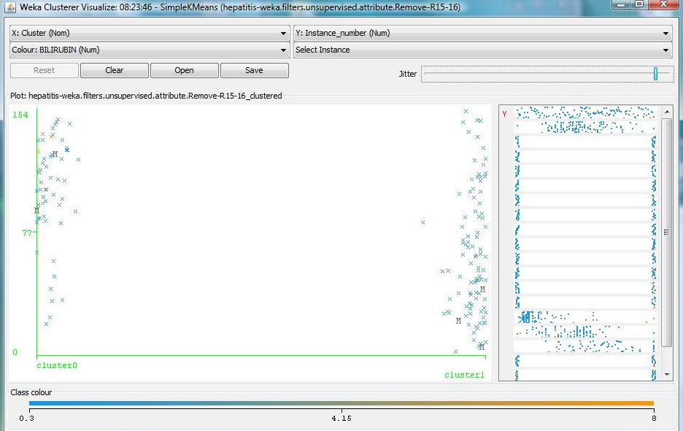

As it can be seen in the graphic, the persons with the higher level of bilirubin (from 4.15 to 8) belong to the first cluster, while the second cluster is caracterised by persons with a lower levle of bilirubin(from 0.3 to 4.15).

Tree Analysis

Hierarchical algorithms find successive clusters using previously established clusters. These algorithms usually are either agglomerative ("bottom-up") or divisive ("top-down"). Agglomerative algorithms begin with each element as a separate cluster and merge them into successively larger clusters. Divisive algorithms begin with the whole set and proceed to divide it into successively smaller clusters.

An important step in most clustering is to select a distance measure, which will determine how the similarity of two elements is calculated. This will influence the shape of the clusters, as some elements may be close to one another according to one distance and farther away according to another. For example, in a 2-dimensional space, the distance between the point (x = 1, y = 0) and the origin (x = 0, y = 0) is always 1 according to the usual norms, but the distance between the point (x = 1, y = 1) and the origin can be 2, or 1 if you take respectively the 1-norm, 2-norm or infinity-norm distance.
The choice of an appropriate metric will influence the shape of the clusters, as some elements may be close to one another according to one distance and farther away according to another. For example, in a 2-dimensional space, the distance between the point (1,0) and the origin (0,0) is always 1 according to the usual norms, but the distance between the point (1,1) and the origin (0,0) can be 2, or 1 under Manhattan distance, Euclidean distance or maximum distance respectively.
Some commonly used metrics for hierarchical clustering are :

Name | Formula
Euclidean distance | 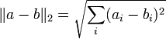
Squared Euclidean distance | 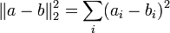
Mahalanobis distance | ,where S is the covariance matrix
Maximum distance
Cosine similarity | 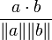
Manhattan distance | 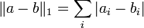

The linkage criteria determines the distance between sets of observations as a function of the pairwise distances between observations.
Some commonly used linkage criteria between two sets of observations A and B are:
Name | Formula
Complete link
Single link
Minimum energy clustering | 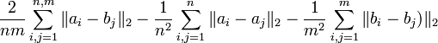
Average link | 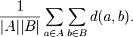

Using DM_ClusterAnalysis we have been able to perform single, complete and average hierarchical clustering while normalizing data both standard and Z-scores using 2 metrics:Squared Euclidean and Manhattan.The output trees for each clustering analysis are represented in the figures below:
For the standard normalization of the data using SquareEuclideanDistance:

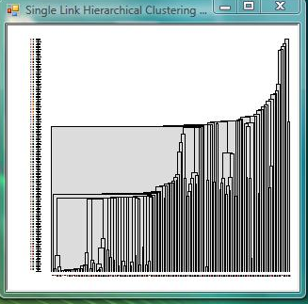
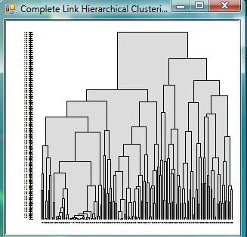
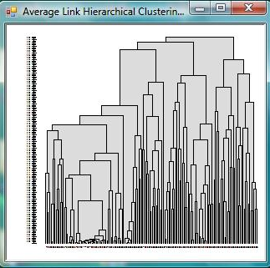
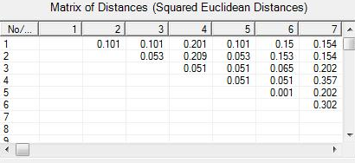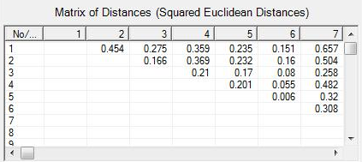
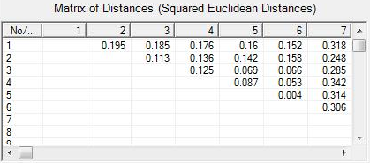

For the Standard Data normalization using Manhattan metrics:
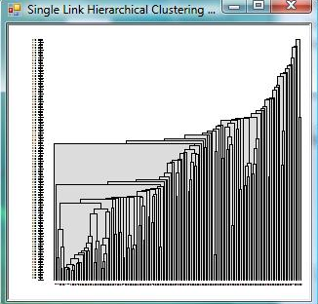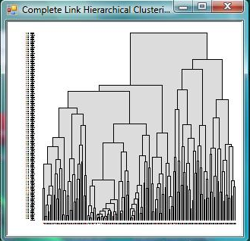
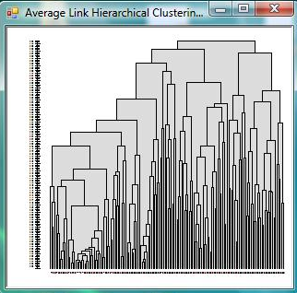

And the respective Matrix of Distances:
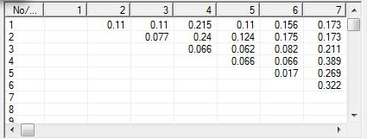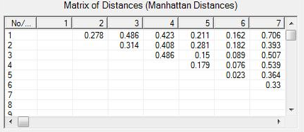
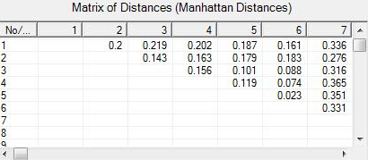

For the Z-scores Data Normalization using SquaredEuclideanDistance we obtained the following outputs
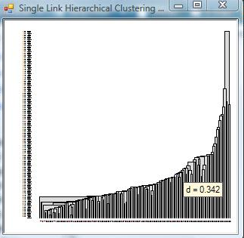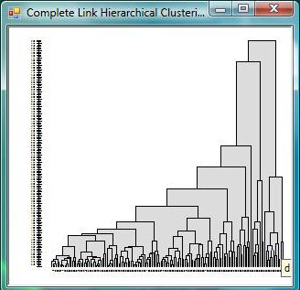
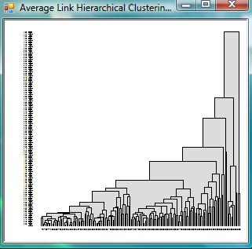
with the respective matrices.

Using the Z-score Data Normalization we were able to visualize these trees while using Manhattan distances:
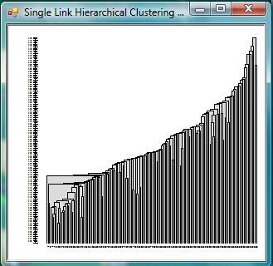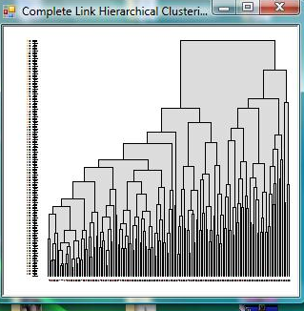
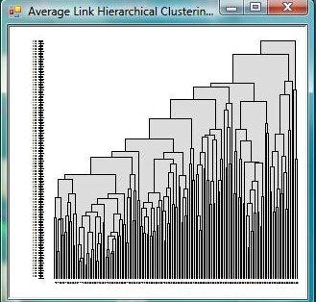

In order to compare the two above mentioned Data Normalization, we provide the 2 Normalized Matrices used in the cluster algorithm:
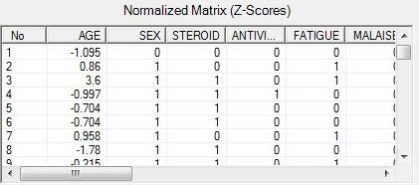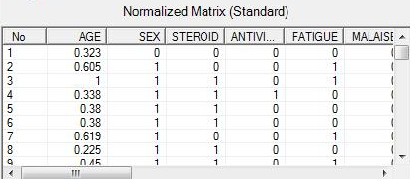
Using this software for TreeAnalysis we were also able to visualize the result of the clustering algorithm as a.txt file.We provide the sample information below for the first 10 clusters:
% This is the output of a hierarchical clustering method applied on a dataset, as follows:
% Dataset: hepatitis-weka.filters.unsupervised.attribute.Remove-R15-16,20
% Number of Instances: 155
% Number of Attributes: 17
% Data Normalization: Z-Scores
% Distance of Proximities: Manhattan
% Hierarchical Clustering Method: Single Link

% Number of Clusters: 1

Cluster 1:
Prototype:
30, male, no, no, no, no, no, no, no, no, no, no, no, 1, 4, ?, no
Data:
0. 30, male, no, no, no, no, no, no, no, no, no, no, no, 1, 4, ?, no

---------------------------------------------

Cluster 2:
Prototype:
31, female, no, yes, no, no, no, yes, no, no, no, no, no, 0.7, 4, 80, no
Data:
3. 31, female, ?, yes, no, no, no, yes, no, no, no, no, no, 0.7, 4, 80, no

---------------------------------------------

Cluster 3:
Prototype:
34.333, female, yes, no, no, no, no, yes, no, no, no, no, no, 1, 3.967, ?, no
Data:
4. 34, female, yes, no, no, no, no, yes, no, no, no, no, no, 1, 4, ?, no
51. 39, female, yes, no, no, no, no, yes, no, no, no, no, no, 1, 4, ?, no
9. 30, female, yes, no, no, no, no, yes, no, no, no, no, no, 1, 3.9, ?, no

---------------------------------------------

Cluster 4:
Prototype:
34, female, yes, no, no, no, no, yes, no, no, no, no, no, 0.9, 4, 75, no
Data:
5. 34, female, yes, no, no, no, no, yes, no, no, no, no, no, 0.9, 4, 75, no

---------------------------------------------

Cluster 5:
Prototype:
23, female, yes, no, no, no, no, yes, no, no, no, no, no, 1, ?, ?, no
Data:
7. 23, female, yes, no, no, no, no, yes, no, no, no, no, no, 1, ?, ?, no

---------------------------------------------

Cluster 6:
Prototype:
34, female, yes, no, no, no, no, yes, no, no, no, no, no, ?, ?, ?, no
Data:
44. 34, female, yes, no, no, no, no, yes, no, no, no, no, no, ?, ?, ?, no

---------------------------------------------

Cluster 7:
Prototype:
33, female, yes, no, no, no, no, yes, no, no, no, no, no, 1, 4.4, 60, no
Data:
42. 33, female, yes, no, no, no, no, yes, no, no, no, no, no, 1, 4.4, 60, no

---------------------------------------------

Cluster 8:
Prototype:
33, female, yes, no, no, no, no, no, no, no, no, no, no, 1, 4, ?, yes
Data:
92. 33, female, yes, no, no, no, no, ?, ?, no, no, no, no, 1, 4, ?, yes

---------------------------------------------

Cluster 9:
Prototype:
36, female, yes, no, no, no, no, yes, no, no, no, no, no, 0.6, 4, ?, yes
Data:
149. 36, female, yes, no, no, no, no, yes, no, no, no, no, no, 0.6, 4, ?, yes

---------------------------------------------

Cluster 10:
Prototype:
39, female, no, no, no, no, no, yes, no, no, no, no, no, 0.9, 4, ?, no
Data:
50. 39, female, no, no, no, no, no, yes, no, no, no, no, no, 0.9, 4, ?, no

Hierarchical clustering has the distinct advantage that any valid measure of distance can be used. In fact, the observations themselves are not required: all that is used is a matrix of distances.

3.3. Iterative Dichotomiser algorithm (ID3)

A decision tree is a classifier that can be represented as a tree with the following properties ^{[7]}:
- Each tree node represents a test on a certain attribute and corresponds to a certain subset of the Training Set.
- The branches that start from a node represent the results of the test
- The root represents the entire Training Set
- The leaves represent the classes.

ID3 algorithm

The ID3 algorithm can be summarized as follows:
- Take all unused attributes and count their entropy concerning test samples
- Choose attribute for which entropy is minimum (or, equivalently, information gain is maximum)
- Make node containing that attribute
The ID3 algorithm is described below:
- Create a root node for the tree
- If all examples are positive, Return the single-node tree Root, with label = +
- If all examples are negative, Return the single-node tree Root, with label = -
- If number of predicting attributes is empty, then Return the single node tree Root, with label = most common value of the target attribute in the examples
- Otherwise Begin
  - A = The Attribute that best classifies examples.
  - Decision Tree attribute for Root = A.
  - For each possible value, v_{i}, of A:
    - Add a new tree branch below Root, corresponding to the test A = v_{i}.
    - Let Examples(v_{i}), be the subset of examples that have the value v_{i} for A
    - If Examples(v_{i}) is empty then below this new branch add a leaf node with label = most common target value in the examples
    - Else below this new branch add the sub tree ID3 (Examples(v_{i}), Target_Attribute, Attributes – {A})
- End
- Return Root
For classification we used the ID3/C4.5 algorithm. In Weka, ID3/C4.5 is implemented by weka.classifiers.trees.J48.

Setting the following parameters :
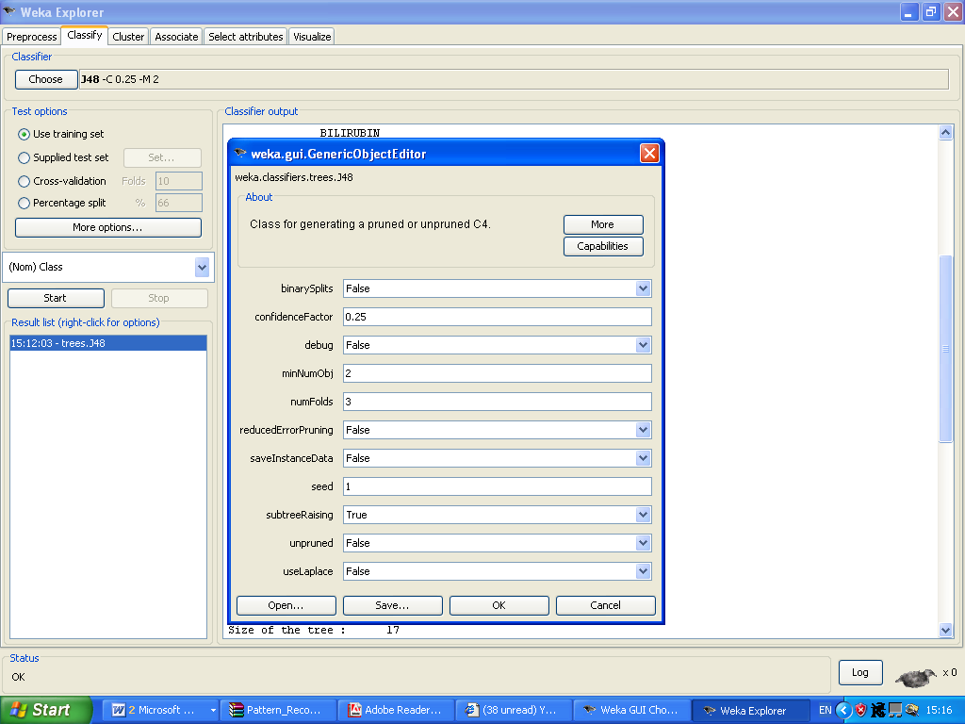

We reached these results:

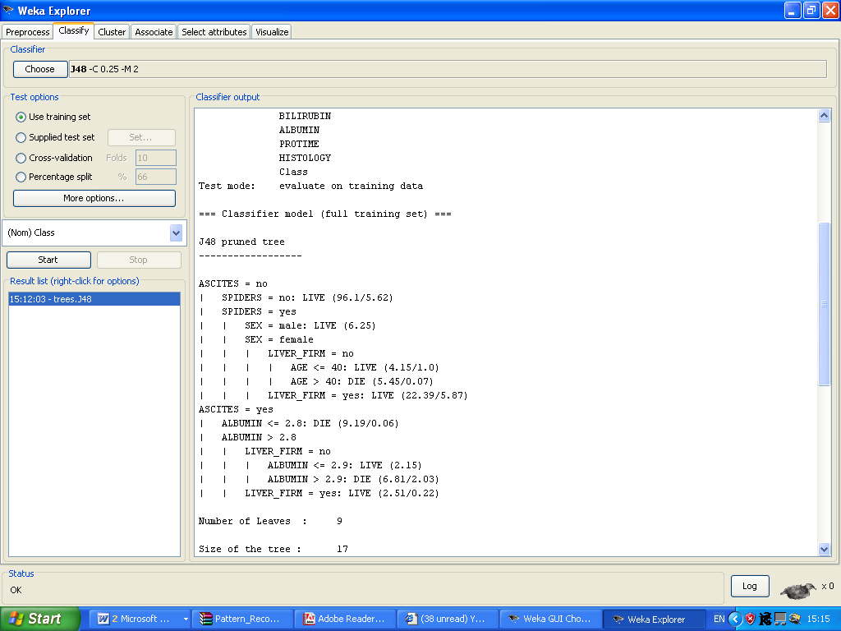

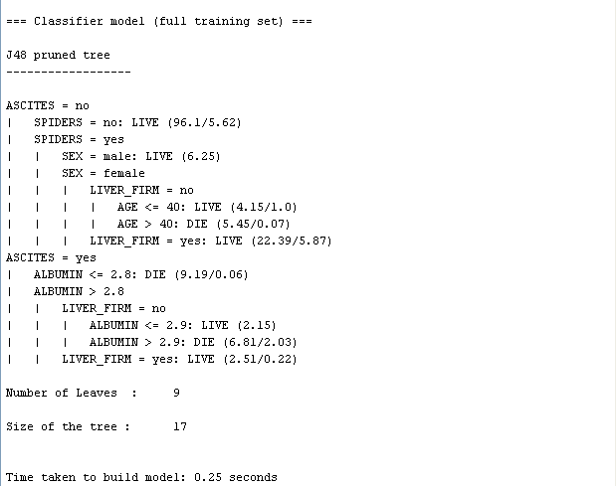
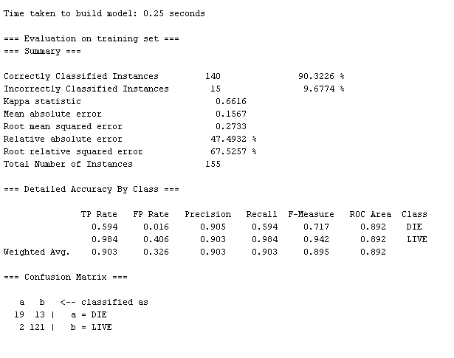
To be mentioned is that 140 instances(90.3226 %) were classified correctly - we can also conclude this fact by interpreting the confussion matrix :

=== Confusion Matrix ===

a b <-- classified as
19 13 | a = DIE
2 121 | b = LIVE

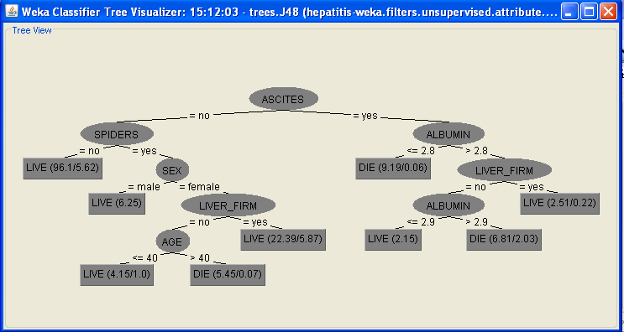

Following this tree, starting from the root we obtain the IF-THEN rules:

- IF ascites = “no” AND spiders=”no” THEN live
- IF ascites = “no” AND spiders=”yes” AND sex=”male” THEN live
- IF ascites = “no” AND spiders=”yes” AND sex=”female” AND liver_firm=”no” AND age <=40 THEN live
- IF ascites = “no” AND spiders=”yes” AND sex=”female” AND liver_firm=”no” AND age >40 THEN die
- …

We worked in a supervised manner, therefore we can see the class attribute as part of the tree(leaves).Also,we eliminated the unnecessary attributes, in order to obtain a more accurate classification.

  - Naive Bayes Classifier

A Bayes classifier is a simple probabilistic classifier based on applying Bayes' theorem (from Bayesian statistics) with strong (naive) independence assumptions. A naive Bayes classifier assumes that the presence (or absence) of a particular feature of a class is unrelated to the presence (or absence) of any other feature ^{[6]}.
Depending on the precise nature of the probability model, naive Bayes classifiers can be trained very efficiently in a supervised learning setting. In many practical applications, parameter estimation for naive Bayes models uses the method of maximum likelihood; in other words, one can work with the naive Bayes model without believing in Bayesian probability or using any Bayesian methods.
An advantage of the naive Bayes classifier is that it requires a small amount of training data to estimate the parameters (means and variances of the variables) necessary for classification. Because independent variables are assumed, only the variances of the variables for each class need to be determined and not the entire covariance matrix.
The Naive Bayes classifier assumes that:
- All attributes that describe an instance of the data set are equally important
- All attributes that describe the data set are independent, a thing that is never true in real situations.

Applying the NaiveBayes classification in Weka on hepatitis data set, we reached the following results:

Scheme: weka.classifiers.bayes.NaiveBayes
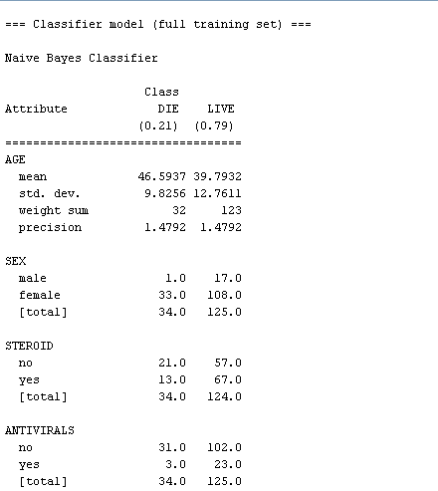
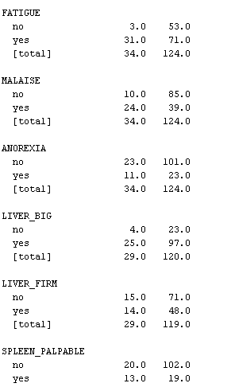
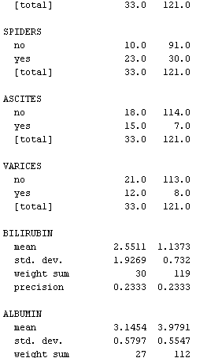
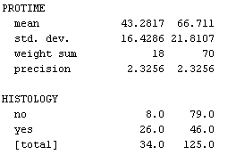

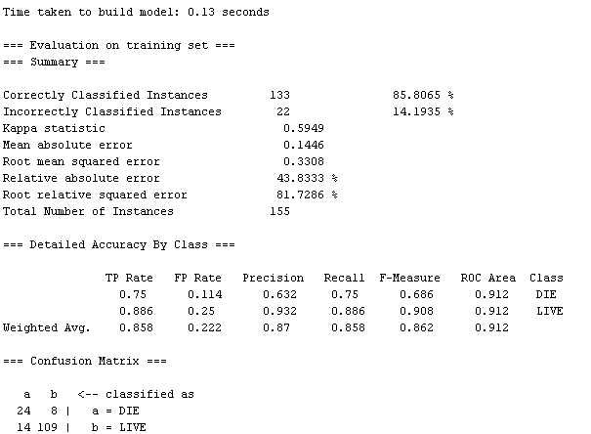

  - KnowledgeFlow

The KnowledgeFlow interface is a powerful new addition to Weka. A major advantage of the KnowledgeFlow interface is that it can handle data either incrementally or in batches while the Explorer can only handle data in batches. This is of practical importance when handling extremely large and/or unlimited data. For this to be useful, Weka also provides classifiers that can handle data incrementally and be updated on an instance by instance basis.
The main disadvantage of the KnowledgeFlow interface is that it is newer and some of Weka’s functionality is not available or not fully implemented
We examined the KnowledgeFlow on our hepatitis data set for J48 algorithm:

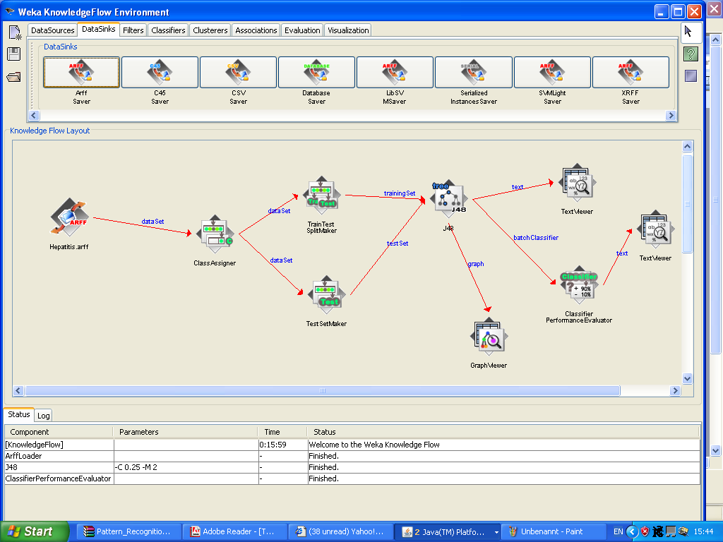

Using TextViewer Component ffrom the graph representation,we analysed the resulted tree:
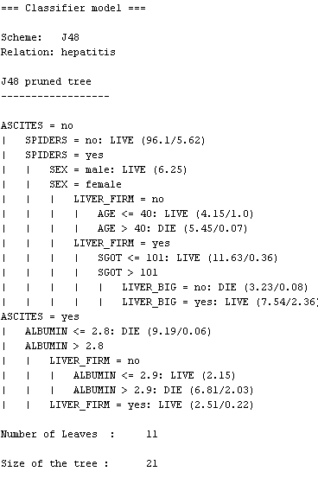
And the resulted graph:
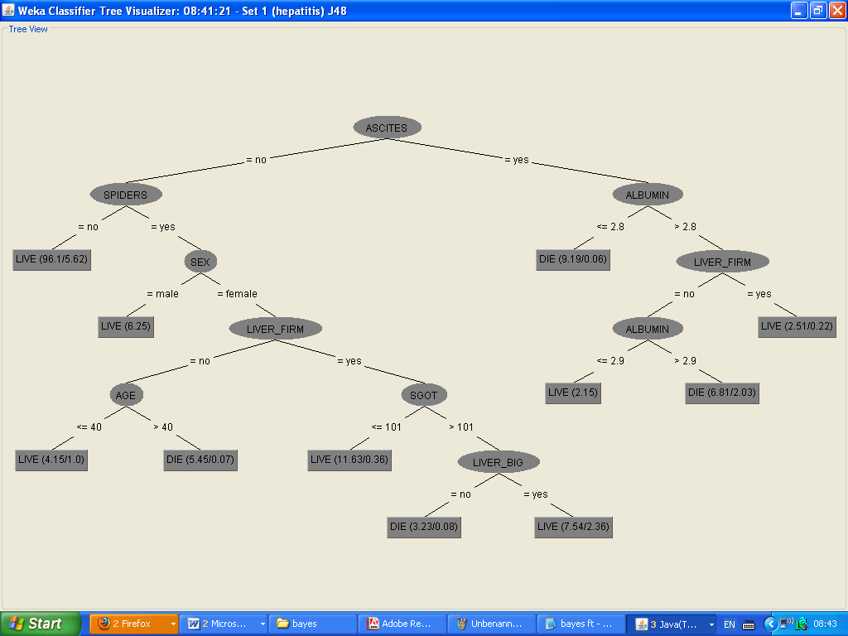

Together with the evaluation results:
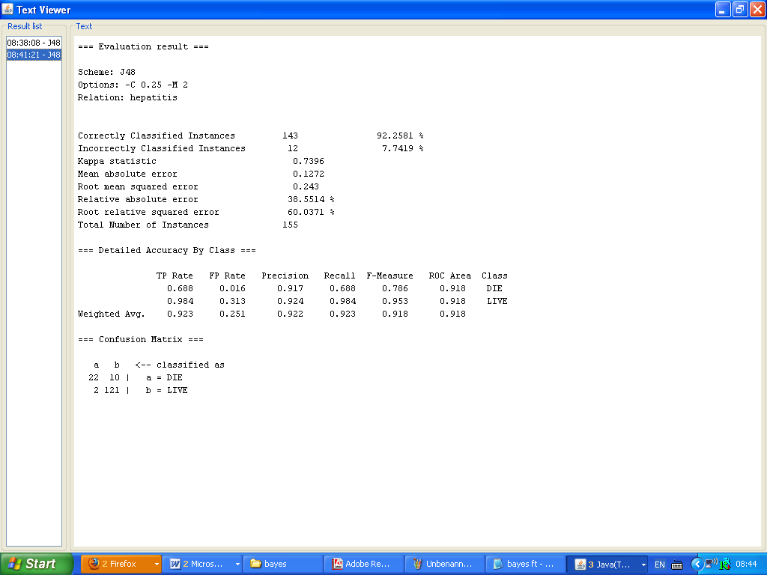

A similar approach is used when graphically representing the NaiveBayes algorithm or the cluster algorithms.
KnowledgeFlow provides graph elements for all Weka classification and cluster algorithms.

4.Classification methods

The same data set described at the beginning of this chapter was used to run four classification methods on it. The two methods that were used for this case study are: Naive Bayse and a decision tree method: J48 (an improved implementation of the ID3 algorithm). All the algorithms were analyzed with the Weka tool ^{[8]}.
In the context of Weka, each algorithm has several input parameters that can be modified in order to change the performance of the classification method. The parameters will be described for each method in particular.
For each type of algorithm the following performance indicators will be analyzed:
- Time taken to build model – the total time it took for the classification method to build a model of the data set
- Percentage of correctly classified instances
- Mean absolute error
- Root mean squared error
- Relative absolute error
Weka also presents two other output types of significant interest. One of them, the Confusion Matrix, is a matrix in which the columns represent the predictions and the rows represent the actual class. Such a matrix is presented in Figure 4. In our case, over the hepatitis data set such a matrix can be mostly useful in identifying which persons will and those who will fight the hepatic viral and live .

4.1. Naive Bayse

Naive Bayse has 2 relevant parameters that can be customized in order to change the behavior of the classification method.
- useKernelEstimator – use a kernel estimator for numeric attributes rather than a normal distribution
- useSupervisedDiscretization – use supervised discretization to convert numeric attributes to nominal ones

The following table summarizes the performance indicators for three different runs of the Naive Bayse over the chosen data set.

 | Run 1 | Run 2 | Run 3
Method parameterization
useKernelEstimator | False | True | False
useSupervisedDiscretization | False | False | True
Performance indicators
Time taken to build model (s) | 0.00 | 0.00 | 0.02
Correctly classified instances (%) | 85.8065 | 85.8065 | 87.0968
Mean absolute error | 0.1446 | 0.1419 | 0.1388
Root mean squared error | 0.3308 | 0.3266 | 0.3203
Relative absolute error (%) | 43.8333 | 43.0201 | 42.0808

=== Detailed Accuracy By Class ===

TP Rate FP Rate Precision Recall F-Measure ROC Area Class
0.835 0.414 0.71 0.835 0.768 0.78 no
0.586 0.165 0.745 0.586 0.656 0.78 yes
Weighted Avg. 0.723 0.302 0.726 0.723 0.717 0.78

Analyzing the results for all three runs using the Naive Bayse method we can conclude that using the Kernel Estimator gives a boost of performance. Using the Supervised Discretization, although increasing the performance of the algorithm, it also increases the time it takes for it to create a model. Although the difference in time at this data set is not important at bigger sets it might become a problem. Furthermore the performance is slightly better in the case of Kernel Estimator usage then when using Supervised Discretization.

4.2. Decision trees: J48

The relevant customizable parameters for J48 are as follows:
- binarySplits – Whether to use binary splits on nominal attributes when building the trees
- confidenceFactor – The confidence factor used for pruning (smaller values incur more pruning)
- minNumObj – The minimum number of instances per leaf
- numFolds – Determines the amount of data used for reduced-error pruning. One fold is used for pruning, the rest for growing the tree
- reducedErrorPruning – Whether reduced-error pruning is used instead of C.4.5 pruning
- saveInstanceData – Whether to save the training data for visualization
- seed – The seed used for randomizing the data when reduced-error pruning is used
- subtreeRaising – Whether to consider the subtree raising operation when pruning
- unpruned – Whether pruning is performed
- useLaplace – Whether counts at leaves are smoothed based on Laplace

The following table summarizes the performance of different configurations of the J48 method ran on our data set.

 | Run 1 | Run 2 | Run 3 | Run 4
Method parameterization
binarySplits | False | False | True | True
confidenceFactor | 0.25 | 0.25 | 0.025 | 0.025
minNumObj | 2 | 2 | 2 | 2
numFolds | 3 | 3 | 10 | 50
reducedErrorPruning | False | False | False | True
saveInstanceData | False | False | False | False
seed | 1 | 1 | 1 | 1
subtreeRaising | True | True | True | True
unpruned | False | True | False | False
useLaplace | False | True | True | True
Performance indicators
Time taken to build model (s) | 0.00 | 1.20 | 0.08 | 0.02
Correctly classified instances (%) | 90.3226 | 94.8387 | 84.5161 | 84.5161
Mean absolute error | 0.1567 | 0.151 | 0.2617 | 0.2638
Root mean squared error | 0.273 | 0.23 | 0.3575 | 0.357
Relative absolute error (%) | 47.4932 | 45.7865 | 79.3523 | 79.9608

=== Detailed Accuracy By Class ===

TP Rate FP Rate Precision Recall F-Measure ROC Area Class
0.594 0.016 0.905 0.594 0.717 0.892 DIE
0.984 0.406 0.903 0.984 0.942 0.892 LIVE
Weighted Avg. 0.903 0.326 0.903 0.903 0.895 0.892

The first two columns are the TP Rate (True Positive Rate) and the FP Rate (False Positive Rate). For the first level TP Rate is the ratio of ‘die’ cases predicted correctly cases to the total of positive cases.Therefore,TP=19/32=0.594.Similar,for the ‘live’ cases, the TP=121/123=0.984.
The next two columns are terms related to information retrieval theory. When one is conducting a search for relevant documents, it is often not possible to get to the relevant documents easily or directly. In many cases, a search will yield lots results many of which will be irrelevant. Under these circumstances, it is often impractical to get all results at once but only a portion of them at a time. In such cases, the terms recall and precision are important to consider. Recall is the ratio of relevant documents found in the search result to the total of all relevant documents. Thus, higher recall values imply that relevant documents are returned more quickly. A recall of 30% at 10% means that 30% of the relevant documents were found with only 10% of the results examined. Precision is the proportion of relevant documents in the results returned. Thus a precision of 0.90 means that 90% of the returned documents were relevant. Lastly, the F-measure is a way of combining recall and precision scores into a single measure of performance. The formula for it is:
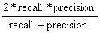
The following conclusions can be drawn up from the results in the above table:
- The J48 method has a low rate of errors, a low mean absolute error and a low root mean squared error. However, the percentage of correctly classified instances doesn’t get very high for every parameterization of the input properties
- If unprunned then the error measurements decrease so the overall performance of the method increases
- The number of folds used for prunning is important also in the percentage of correctly classified instances. Increasing this number too much (like in Run 4) can result in bad percentages
- Overall the J48 method is a relatively fast method with acceptable to high hit rates

5. Conclusions

Comparing in turn the two classification methods studied in the previous chapter we can conclude the following advantages and disadvantages for each classification method:
- An advantage of the naive Bayes classifier is that it requires a small amount of training data to estimate the parameters (means and variances of the variables) necessary for classification. Because independent variables are assumed, only the variances of the variables for each class need to be determined and not the entire covariance matrix
- Due to the fact that the variables are independent the Naive Bayse algorithm usually need less time to run, the time performance being its major advantage. However, the best results obtained for our data set, a value of around 88% correctly classified instances is not a very good value, the other algorithm having better performance in this regard

- J48 is slower than NaiveBayes providing decent classification percentages. As in the case of Naive Bayse, this method can be better used when the time in which the model is being built is more important than the number of correctly classified instances.

- On the other hand, J48 handles both continuous and discrete attributes - In order to handle continuous attributes, C4.5 creates a threshold and then splits the list into those whose attribute value is above the threshold and those that are less than or equal to it.
Moreover, it handles training data with missing attribute values - C4.5 allows attribute values to be marked as ? for missing. Missing attribute values are simply not used in gain and entropy calculations. Another strong points for choosing J48 are: handling attributes with differing costs, pruning trees after creation - C4.5 goes back through the tree once it's been created and attempts to remove branches that do not help by replacing them with leaf nodes.
- As a counter argument ,J48 algorithm is not recommended for data sets with continuous values for attributes, it does not reveal correlation between attributes; overall ,it is strongly suggested to not choose this algorithm when dealing with data sets with a large number of classes and a small number of examples.
- When balancing the accuracy of these two algorithms, our suggestion is to choose J48 when analyzing hepatitis data set because, except the time performance, this algorithm provides the largest percent of correctly classified instances(aprox 95%) – this aspect is very important when dealing with a life of human being.

Bibliography:

- Pattern Recocgnition ,Stefan Holban
- http://archive.ics.uci.edu/ml/datasets.html
- A comparative assessment of classification methods, Melody Y. Kiang, Decision Support Systems, July 2003
- Naive Bayes Classifier example, Eric Meisner, November 2003
- A Comparative Study for Email Classification, Seongwook Youn and Dennis McLeod, University of Southern California, 2007
- Weka online documentation at http://www.cs.waikato.ac.nz/~ml/weka/
- Data mining definitions at
http://www.kdnuggets.com/data_mining_course/index.html

