Conexiuni circuit
Intel Galileo
- GND
- 5V
- A4
- A5

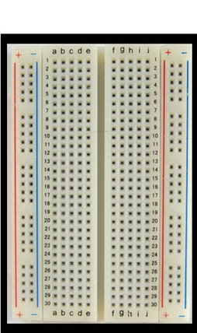
HMC5883L
- GND
- VCC
- SDA
- SCL

Schema functionare circuit
Magnetic sensor
Vehicle
Laptop
Intel Galileo
Connecting board
Collect data
C
O
N
N
E
C
T

S
E
N
S
O
R

Collect data
Apply algorithm

