XPATH

Xpath is a query language for XML, it is used to acceed to information contained in a XML file.

It is:
- used to select parts of the XML file
- to navigate the hierarchy of the XML file
- to check if some condition are satisfied.

In Xpath we have 3 different types of expressions:
- Value expressions, to define proposition on values
- Path expression, to select parts of the XML file
- Node set expressions, used to combine the results of different expressions

PATH EXPRESSIONS
They can be:
- relative
- absolute if they starts with /

Are made by a sequence of steps separated by /

Each one step has 3 different parts:
- an axis
- a node-test
- 0 or more predicates

At each one step the context (the result) is modified folowing the axis, then is restricted to the elements with the name of the node-test and eventually filtered by predicates.

AXIS
The axis modify the context.
We have different valid axis that are:
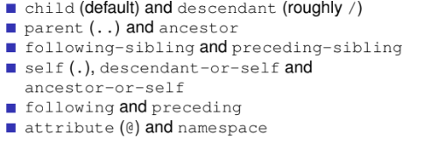

Examples:
All ancestors of professors who were professors:

//professor/ancestor::professor

NODE-TESTS
They are used to restrict the context
Valid node-tests are are:
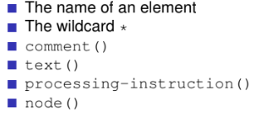

When we use * we are restricting the contexts to elements only.
Using node we restrict it to elements and attributes only.

PREDICATES
They are used to filter the context.
We can use in it any possible value expressions.

Non boolean expressions are interpreted as follows:
- integer, are equivalent to the position()
- strings, is true if ithe string is not empty
- node sets, are true if the node sets are not empty

VALUE EXPRESSIONS

Value expressions include
- strings and numeric literals: “home”, 5, 1.3...
- variable reference: $x, $y …
- function invocation
  - fn:upper-case($x) …
- logic and arithmetic comparison: $x <10 …
- Path expressions

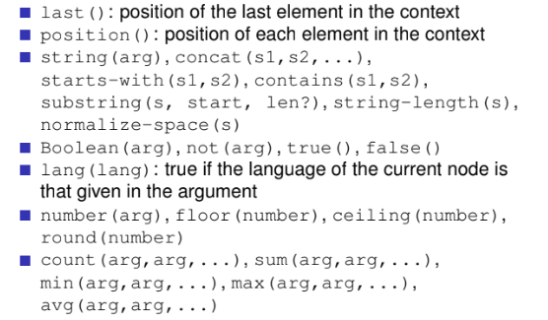

For convention we use fn: before the functions

NODE-SETS EXPRESSIONS
Allow to combine contexts obtained by several expressions. They are:
- | (or union)
- intersect
- except
- , (or concatenation)

EXAMPLES

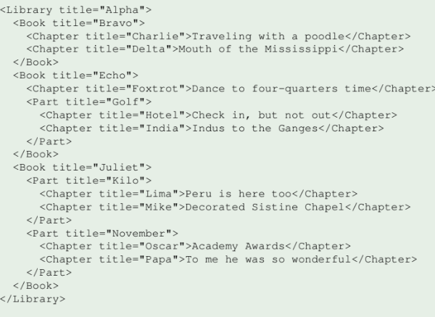

For example:
- //Chapter[contains(@title, “r”)]
  - we select all the chapters that contains in the title the r, starting from the root of the document //
- //Chapter[@title=”Papa”]/..
  - we get the chapter with title Papa and we select the ancestor of it (Part with title November
- //Part[@title=”Kilo”]/Chapter
  - we select Chapter Lima and Chapter Mike
- /Library/Book/Chapter
  - we select the chapter under Book tag, so Charlie, Delta, Foxtrot (not the others)

