  - LAB 04 / CLOUD INFRASTRUCTURE

AWS Foundations: IAM, VPC, and EC2
  - Identity permissions, network segmentation, and compute lifecycle
Cristian K. Leung | Academic Lab Portfolio

Executive Summary
Completed introductory AWS exercises covering user and group permissions, a custom VPC, and EC2 web-server deployment. The report documents access-control checks, public and private subnet routing, instance monitoring, and protection settings.

Skills Demonstrated
AWS IAM · VPC · EC2 · Security groups · CloudWatch · Apache
- Compared read-only and instance-management permissions through IAM groups.
- Configured public and private subnets, route tables, and gateways.
- Documented EC2 deployment, monitoring, resizing, and protection settings.

Evidence Included
IAM access-denial screenshots, VPC and route-table views, web-server output, and EC2 monitoring and lifecycle screenshots.

Objective
The objective was to develop practical familiarity with the AWS Management Console through exercises in identity and access management, virtual networking, and compute deployment.

Technical Background
AWS Identity and Access Management (IAM) controls access to AWS resources. Users can be assigned permissions through groups and policies; roles provide temporary access for defined tasks. The lab compares S3 read access, EC2 read access, and a limited EC2 instance-management policy.
Amazon Virtual Private Cloud (VPC) provides a logically isolated network for AWS resources. Subnets, route tables, internet gateways, NAT gateways, security groups, and network ACLs determine network placement and connectivity. Public and private subnet routing is a central focus of the exercise.
Amazon Elastic Compute Cloud (EC2) provides configurable virtual servers. The exercises use EC2 to host a web server and examine instance monitoring, network access, storage changes, instance types, and protection settings.

Procedure and Evidence

Lab 1: Introduction to AWS IAM

Task 1: Explore the Users and Groups
In the AWS search bar, search for IAM and open the IAM console.
In the left navigation pane, select IAM Users. There should be 3 users similar to below:
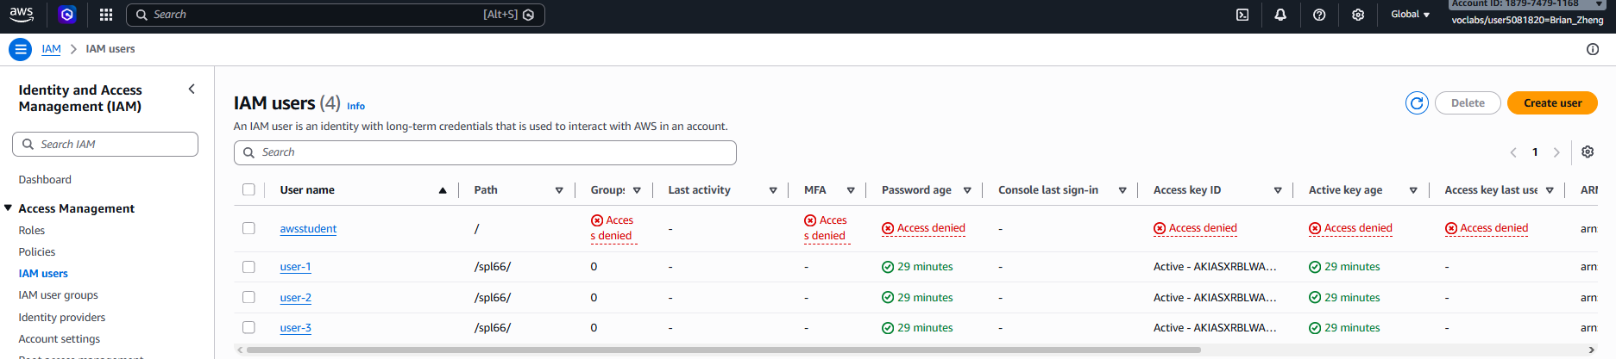
Figure 01. In the left navigation pane, select IAM Users. There should be 3 users similar to below
Select user-1. On the summary page you should see:
Permissions tab: No permissions assigned.
Groups tab: Not a member of any groups.
Security credentials tab: Has a console password.
In the left navigation pane, select User groups. The following groups should be available: EC2-Admin, EC2-Support, S3-Support
Select EC2-Support and open the Permissions tab. Here are some things you can check out:
The group has the managed policy AmazonEC2ReadOnlyAccess attached.
This policy allows users to view EC2, Elastic Load Balancing, CloudWatch, and Auto Scaling resources, but you can’t modify them.
IAM policies contain:
Effect Allow or Deny
Action Permitted AWS API operations
Resource Resources the policy applies to
Return to User groups, select S3-Support, and open the Permissions tab.
The group uses the AmazonS3ReadOnlyAccess managed policy.
Expand the policy to view details.
This policy allows users to list and retrieve Amazon S3 resources.
Collapse the policy when finished.
Return to User groups, select EC2-Admin, and click on the Permissions tab.
This group uses an inline policy, which is attached only to this specific group.
Expand the policy to view details.
The policy allows users to describe EC2 resources and start or stop EC2 instances.
Collapse the policy when finished.
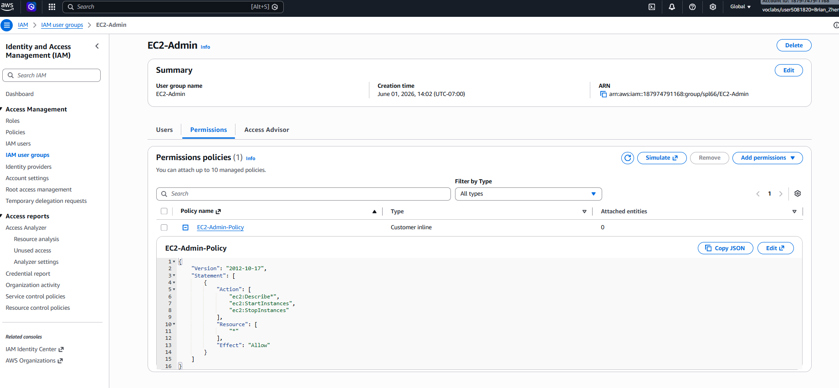
Figure 02. Collapse the policy when finished.

Task 2: Add Users to Groups
In the left navigation pane, select User groups.
Choose the S3-Support group and open the Users tab.
Select Add users, choose user-1, and then select Add users to add the user to the group.
Verify that user-1 now appears in the group's user list.
Return to User groups, select EC2-Support, and open the Users tab.
Select Add users, choose user-2, and then select Add users.
Verify that user-2 has been added to the EC2-Support group.
Return to User groups, select EC2-Admin, and open the Users tab.
Select Add users, choose user-3, and then select Add users.
Verify that user-3 has been added to the EC2-Admin group.
Return to User groups and confirm that each group displays 1 in the Users column, it should look like the following:
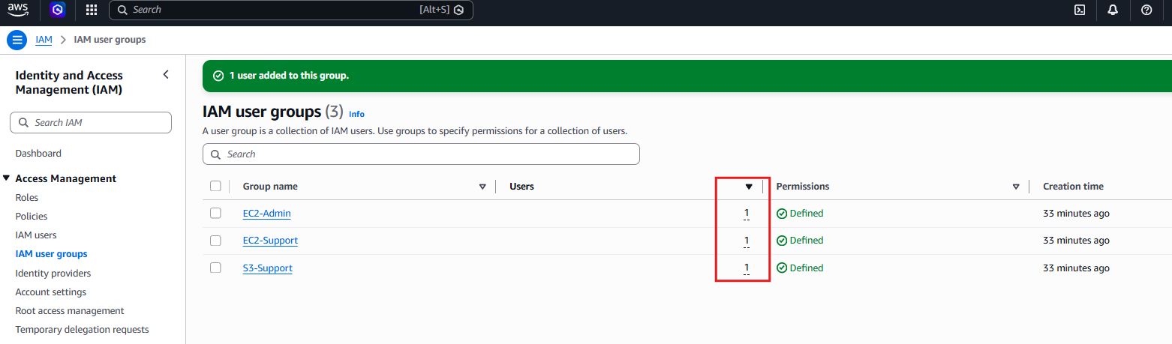
Figure 03. Return to User groups and confirm that each group displays 1 in the Users column, it should look like the following
If any group does not show 1 user, review the previous steps and ensure the following assignments are correct:
user-1 → S3-Support
user-2 → EC2-Support
user-3 → EC2-Admin

Task 3: Sign-In and Test Users
In the left navigation pane, select Dashboard.
Copy the Sign-in URL for IAM users in this account and save it in a text editor for later use.
Open a private browsing window:
Chrome: New Incognito Window
Edge: New InPrivate Window
Firefox: New Private Window
Internet Explorer: InPrivate Browsing
Test Access as user-1 (S3 Support)
Paste the IAM sign-in URL into the private browser and sign in using:
IAM user name: user-1
Password: Lab-Password1
Search for and open Amazon S3.
Open the existing S3 bucket and review its contents.
user-1 can view S3 buckets and objects because of the S3-Support permissions.
The bucket does not contain any objects.
Search for and open Amazon EC2.
Select Instances from the navigation pane.
You will receive a message stating that you are not authorized to perform this operation:
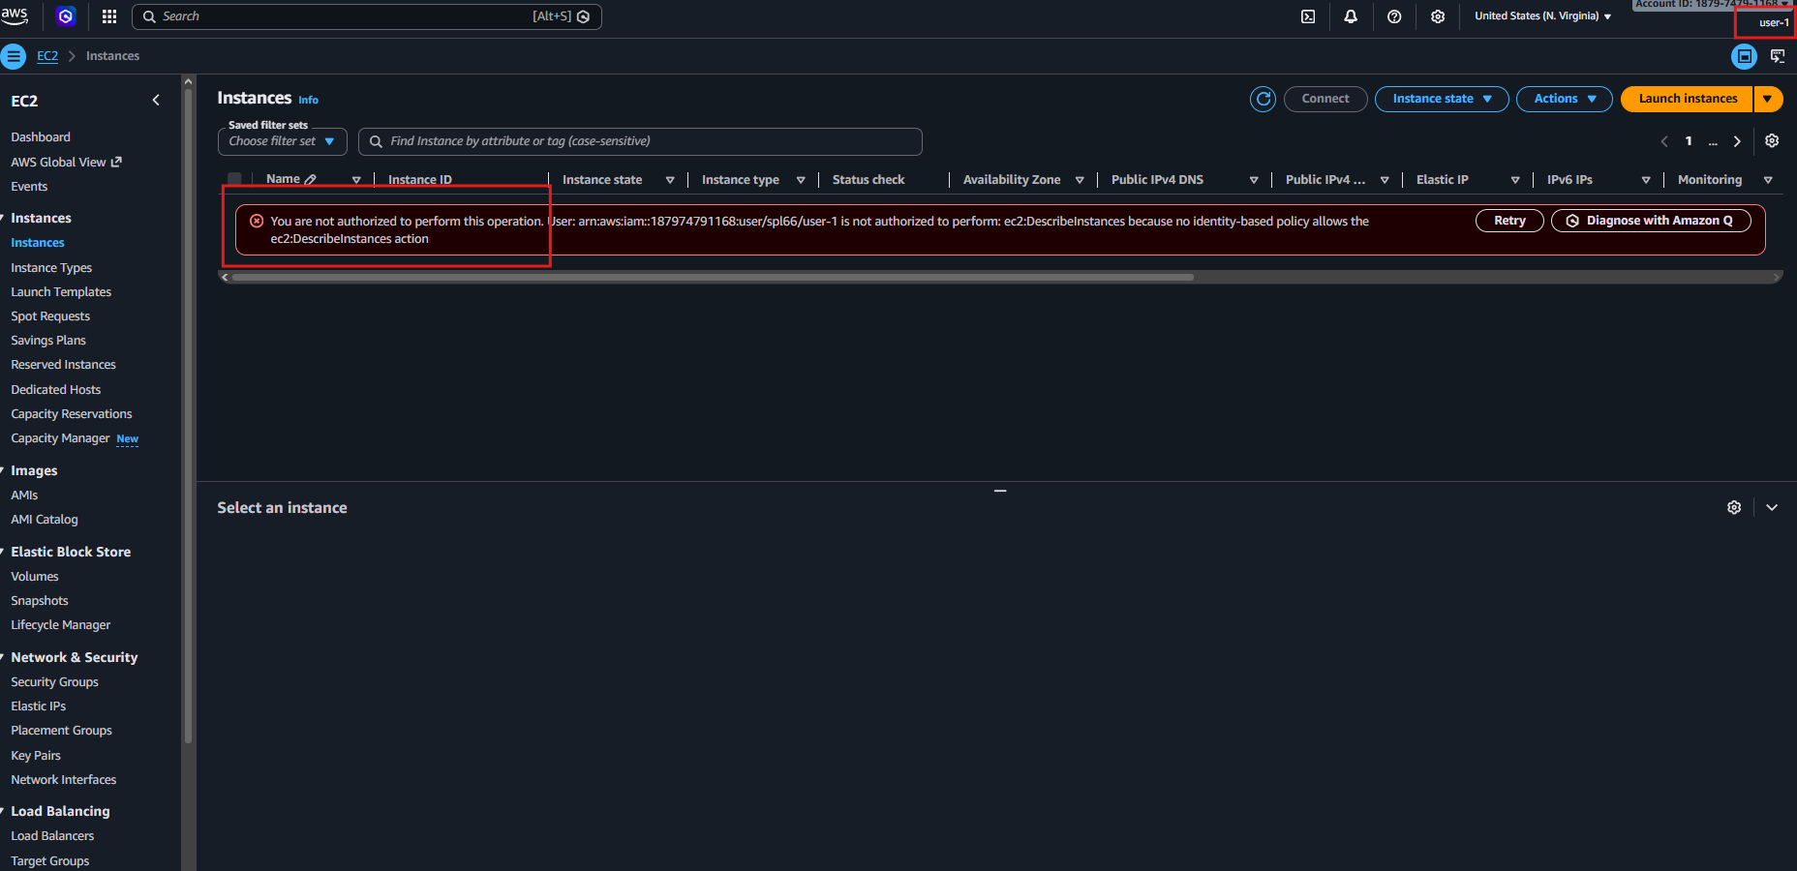
Figure 04. You will receive a message stating that you are not authorized to perform this operation
This confirms that user-1 does not have EC2 permissions.
Test Access as user-2 (EC2 Support)
Sign out of the AWS Management Console.
Return to the IAM sign-in URL and sign in using:
IAM user name: user-2
Password: Lab-Password2
Search for and open Amazon EC2.
Select Instances.
user-2 can view EC2 instances because of the EC2-Support permissions.
If no instance appears, verify that you are in the correct AWS Region.
Select the LabHost instance.
From the Instance state menu, choose Stop instance, then select Stop.
An authorization error will appear.
This confirms that user-2 has read-only access and cannot make changes to EC2 resources.
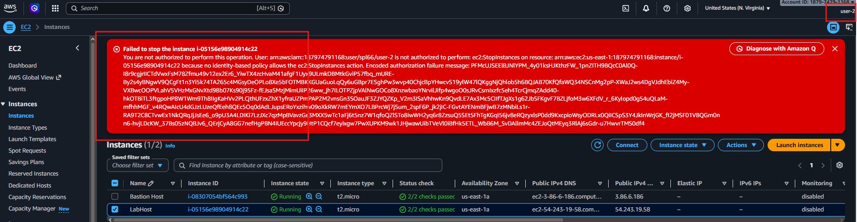
Figure 05. This confirms that user-2 has read-only access and cannot make changes to EC2 resources.
Close the error message.
Search for and open Amazon S3.
You will receive a message indicating that you do not have permission to list buckets.
This confirms that user-2 does not have S3 access.
Test Access as user-3 (EC2 Administrator)
Sign out of the AWS Management Console.
Return to the IAM sign-in URL and sign in using:
IAM user name: user-3
Password: Lab-Password3
Search for and open Amazon EC2.
Select Instances and locate the LabHost instance.
If the instance is not visible, verify that you are using the correct AWS Region.
Select the LabHost instance.
From the Instance state menu, choose Stop instance, then select Stop.
The instance will successfully enter the Stopping state like below:
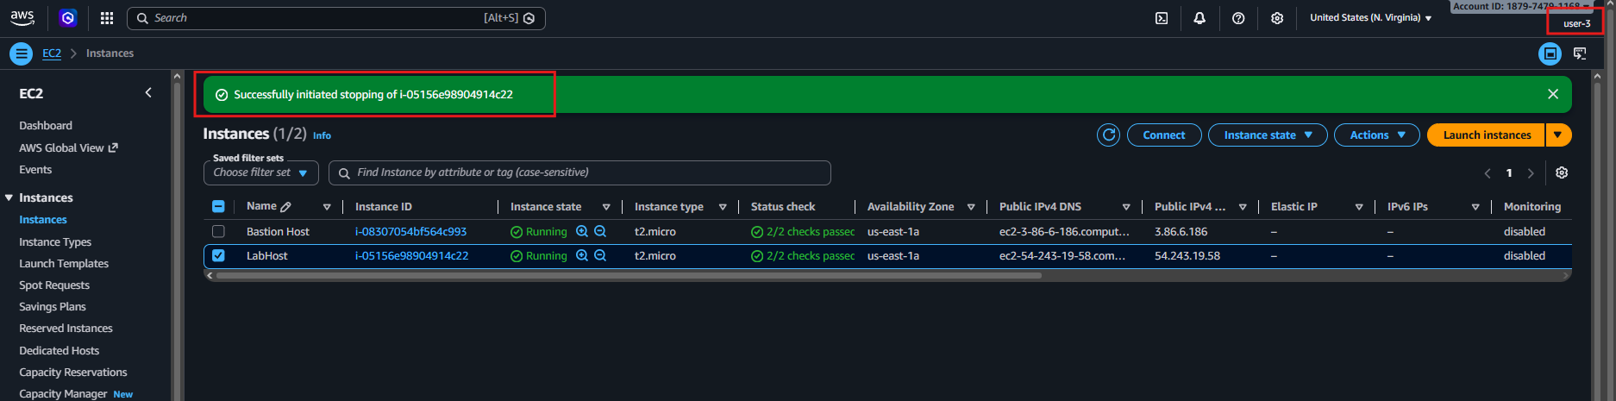
Figure 06. The instance will successfully enter the Stopping state like below
This confirms that user-3 can perform the instance-management actions allowed by the attached policy.
Close the private browser window.

Lab 2: Build your VPC and Launch a Web Server

Task 1: Create Your VPC
In the AWS search bar, search for and open VPC.
Verify that the selected Region is N. Virginia (us-east-1).
From the VPC console, select VPC Dashboard, then choose Create VPC.
If Create VPC is not available, select Launch VPC Wizard instead.
Configure the VPC using the following settings:
Resources to create: VPC and more
Name tag auto-generation: Auto-generate = lab
IPv4 CIDR block: 10.0.0.0/16
Availability Zones: 1
Public subnets: 1
Private subnets: 1
Expand Customize subnets CIDR blocks and configure:
Public subnet CIDR: 10.0.0.0/24
Private subnet CIDR: 10.0.1.0/24
Configure the remaining settings:
NAT gateways: In 1 AZ
VPC endpoints: None
DNS hostnames: Enabled
DNS resolution: Enabled
Review the preview panel and confirm the following resources will be created:
VPC: lab-vpc
Public subnet: lab-subnet-public1-us-east-1a
Private subnet: lab-subnet-private1-us-east-1a
Route tables: lab-rtb-public and lab-rtb-private1-us-east-1a
Internet Gateway: lab-igw
NAT Gateway: lab-nat-public1-us-east-1a
Select Create VPC.
Wait for all resources to finish provisioning. The NAT Gateway may take several minutes to become available.
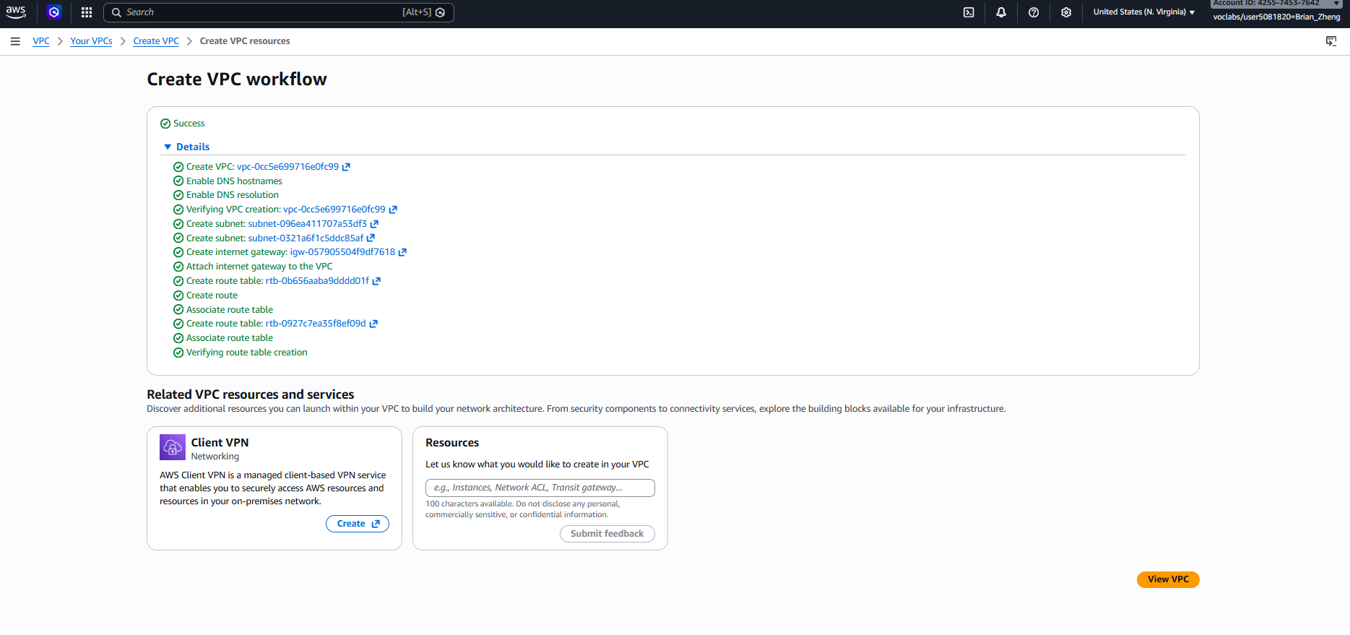
Figure 07. Wait for all resources to finish provisioning. The NAT Gateway may take several minutes to become available.
Once deployment is complete, select View VPC.
Review the resources created by the wizard:
One VPC
One public subnet
One private subnet
Separate route tables for each subnet
One Internet Gateway
One NAT Gateway
Explore the VPC resources using the navigation pane. For example:
Select Subnets to view subnet details.
Select Route tables to review routing configurations.
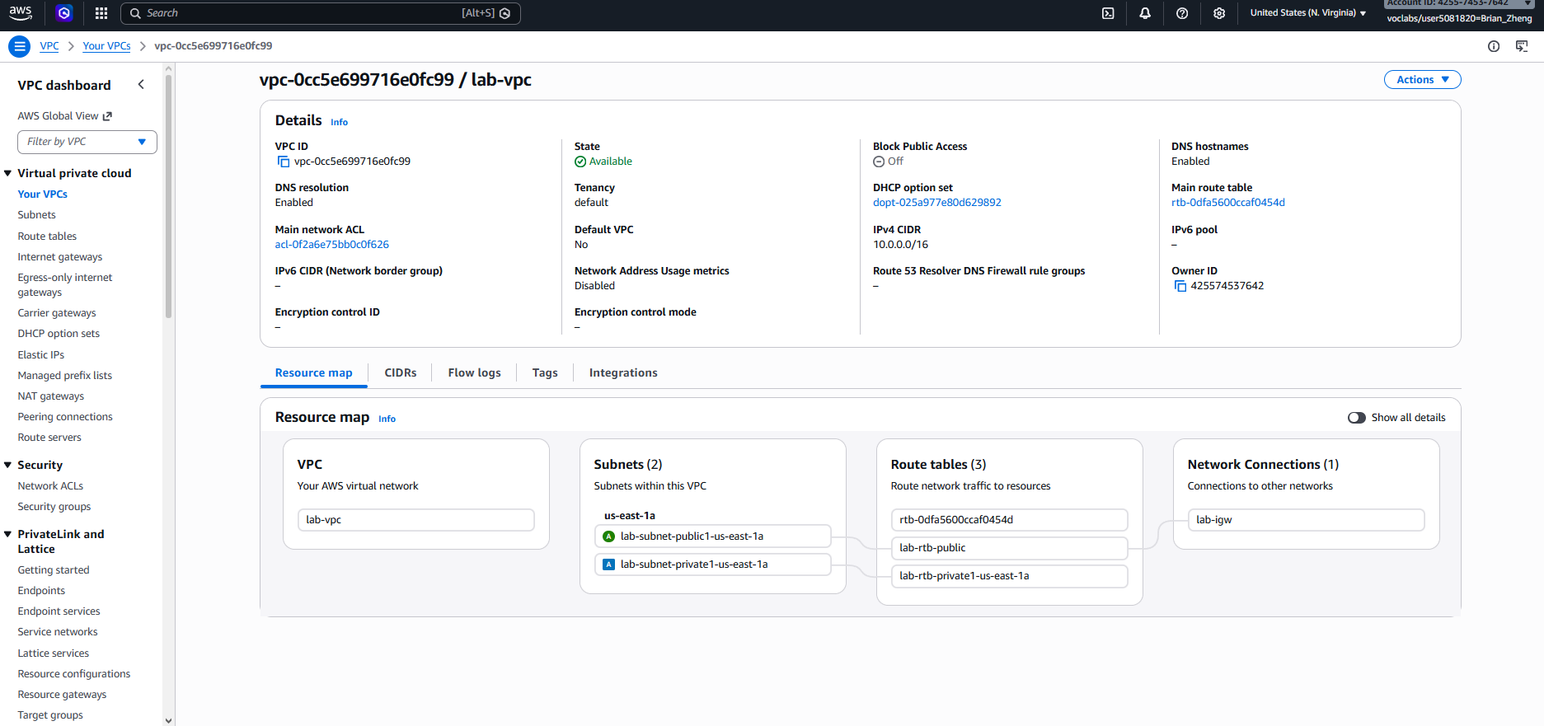
Figure 08. Select Route tables to review routing configurations.
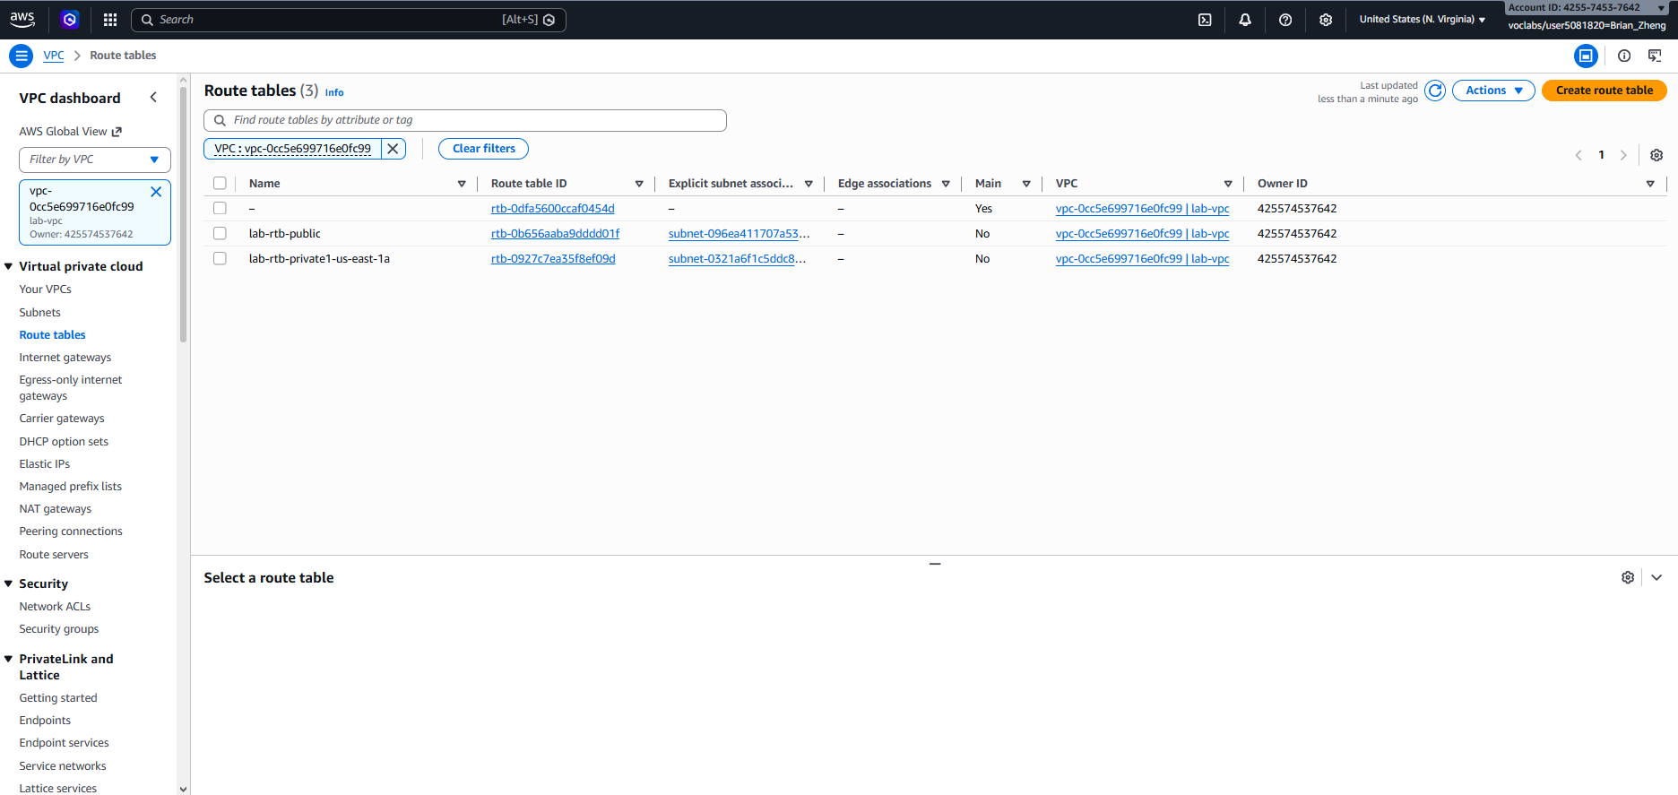
Figure 09. Select Route tables to review routing configurations.
Understanding the Network Configuration:
The Internet Gateway enables communication between resources in the VPC and the public internet.
The public subnet (10.0.0.0/24) contains addresses in the range 10.0.0.x.
It is considered public because its route table sends internet-bound traffic (0.0.0.0/0) to the Internet Gateway.
The NAT Gateway allows instances in private subnets to access the internet without being directly reachable from the internet.
The private subnet (10.0.1.0/24) contains addresses in the range 10.0.1.x and uses the NAT Gateway for outbound internet access.

Task 2: Create Additional Subnets
In the left navigation pane, select Subnets.
Create a Second Public Subnet:
Choose Create subnet and configure:
VPC ID: lab-vpc
Subnet name: lab-subnet-public2
Availability Zone: Select the second Availability Zone (for example, us-east-1b)
IPv4 CIDR block: 10.0.2.0/24
Select Create subnet.
This subnet will use IP addresses in the range 10.0.2.x.
Create a Second Private Subnet:
Choose Create subnet again and configure:
VPC ID: lab-vpc
Subnet name: lab-subnet-private2
Availability Zone: Select the second Availability Zone (for example, us-east-1b)
IPv4 CIDR block: 10.0.3.0/24
Select Create subnet.
This subnet will use IP addresses in the range 10.0.3.x.
It should look similar to this after these steps:
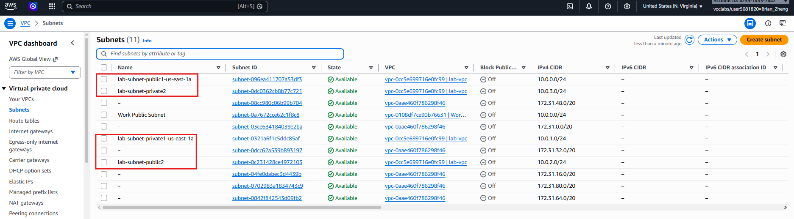
Figure 10. It should look similar to this after these steps
Associate the Private Route Table:
In the left navigation pane, select Route tables.
Select the lab-rtb-private1-us-east-1a route table.
If it is not visible, refresh the page.
Open the Routes tab.
Notice that the destination 0.0.0.0/0 points to a NAT Gateway.
This allows instances in private subnets to access the internet without being publicly accessible.
Open the Subnet associations tab.
Select Edit subnet associations.
Keep lab-subnet-private1-us-east-1a selected and also select lab-subnet-private2.
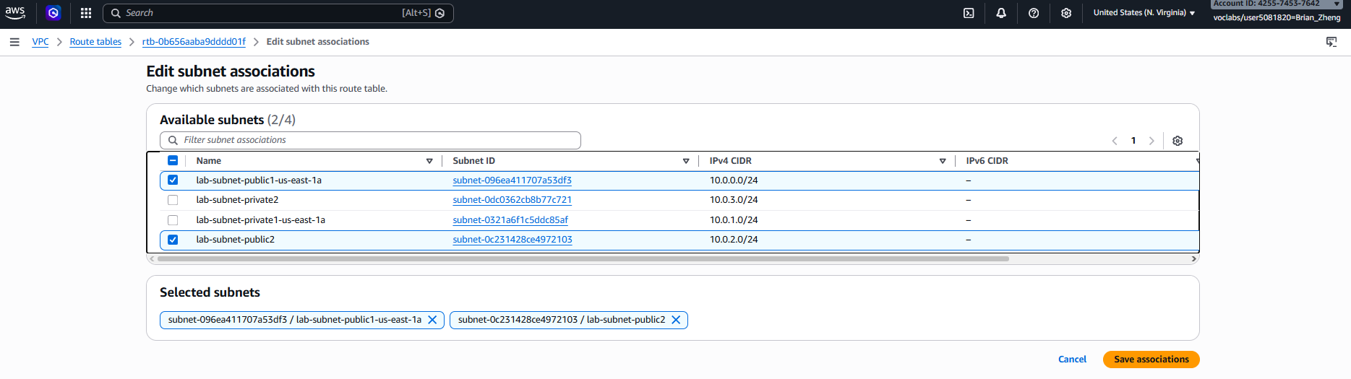
Figure 11. Keep lab-subnet-private1-us-east-1a selected and also select lab-subnet-private2.
Choose Save associations.
Figure 12. Choose Save associations.
Both private subnets now use the same route table and NAT Gateway.
Associate the Public Route Table:
Select the lab-rtb-public route table.
Open the Routes tab.
Notice that the destination 0.0.0.0/0 points to an Internet Gateway (IGW).
This allows resources in public subnets to communicate directly with the internet.
Open the Subnet associations tab.
Select Edit subnet associations.
Keep lab-subnet-public1-us-east-1a selected and also select lab-subnet-public2.
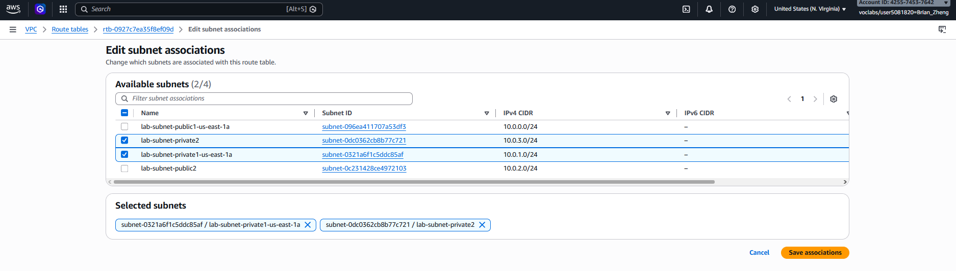
Figure 13. Keep lab-subnet-public1-us-east-1a selected and also select lab-subnet-public2.
Choose Save associations.
Figure 14. Choose Save associations.
Result:
Your VPC now contains:
Two public subnets across two Availability Zones
Two private subnets across two Availability Zones
A public route table connected to the Internet Gateway
A private route table connected to the NAT Gateway
The new subnets are now configured to route network traffic correctly based on whether they are public or private.

Task 3: Create a VPC Security Group
In the left navigation pane, select Security groups.
Choose Create security group and configure:
Security group name: Web Security Group
Description: Enable HTTP access
VPC: lab-vpc
Under Inbound rules, select Add rule and configure:
Type: HTTP
Source: Anywhere-IPv4
Description: Permit web requests
After these two steps it should look like this:
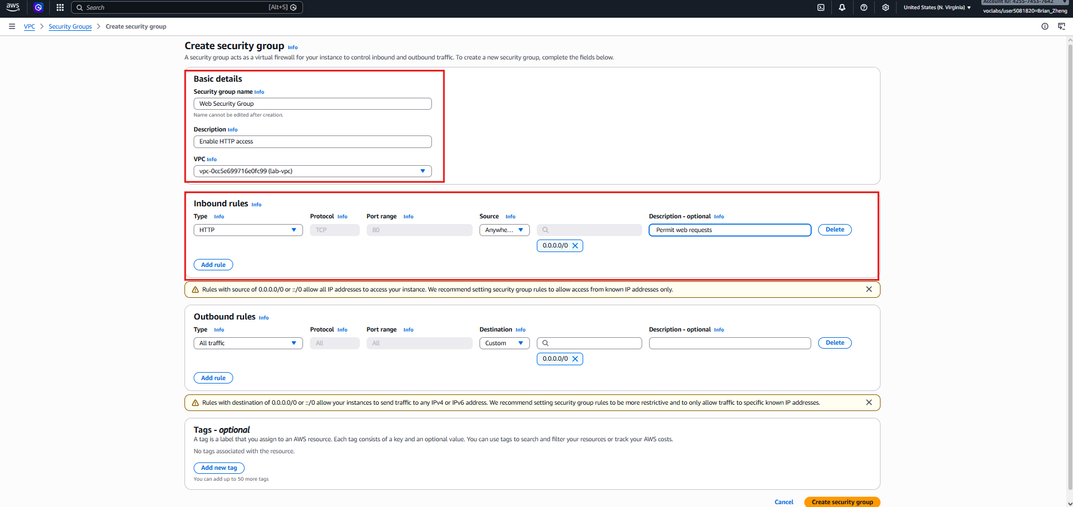
Figure 15. After these two steps it should look like this
Scroll to the bottom of the page and choose Create security group.
The Web Security Group will be used when launching the EC2 web server.

Task 4: Launch a Web Server Instance
Search for and open EC2 from the AWS search bar.
Select Launch instance.
Configure the instance:
Name: Web Server 1
AWS automatically creates a Name tag using this value.
Under Application and OS Images (AMI):
Keep the default Amazon Linux 2023 AMI selected.
Under Instance type:
Keep the default t2.micro instance type.
Under Key pair:
Select vockey.
Under Network settings, choose Edit and configure:
Network: lab-vpc
Subnet: lab-subnet-public2
Auto-assign public IP: Enable
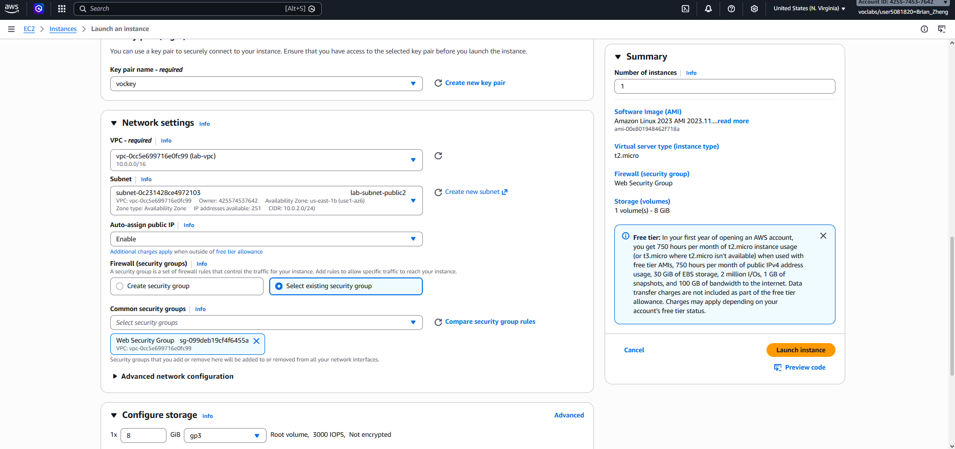
Figure 16. Auto-assign public IP: Enable
Under Firewall (security groups):
Select Choose existing security group
Select Web Security Group
Leave the default storage settings unchanged.
Configure User Data
Expand Advanced details and scroll to User data.
Paste the following script into the User data box:
#!/bin/bash
# Install Apache Web Server and PHP
dnf install -y httpd wget php mariadb105-server
# Download Lab files
wget https://aws-tc-largeobjects.s3.us-west-2.amazonaws.com/CUR-TF-100-ACCLFO-2/2-lab2-vpc/s3/lab-app.zip
unzip lab-app.zip -d /var/www/html/
# Turn on web server
chkconfig httpd on
service httpd start
This script automatically:
Installs Apache, PHP, and database components
Downloads the lab application
Configures and starts the web server
Review the settings and choose Launch instance.
When the success message appears, select View all instances.
Verify the Web Server
Wait until Web Server 1 displays 2/2 checks passed in the Status Check column.
Refresh the page periodically to monitor progress.
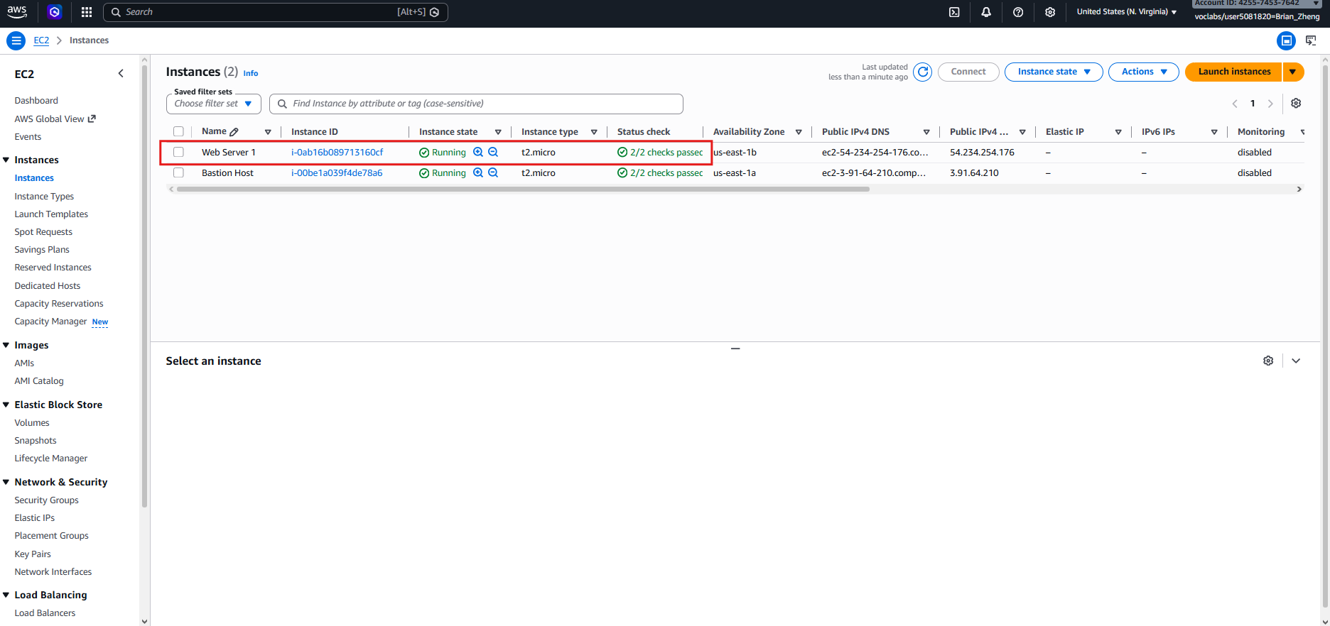
Figure 17. Refresh the page periodically to monitor progress.
Select Web Server 1.
In the Details tab, copy the Public IPv4 DNS value.
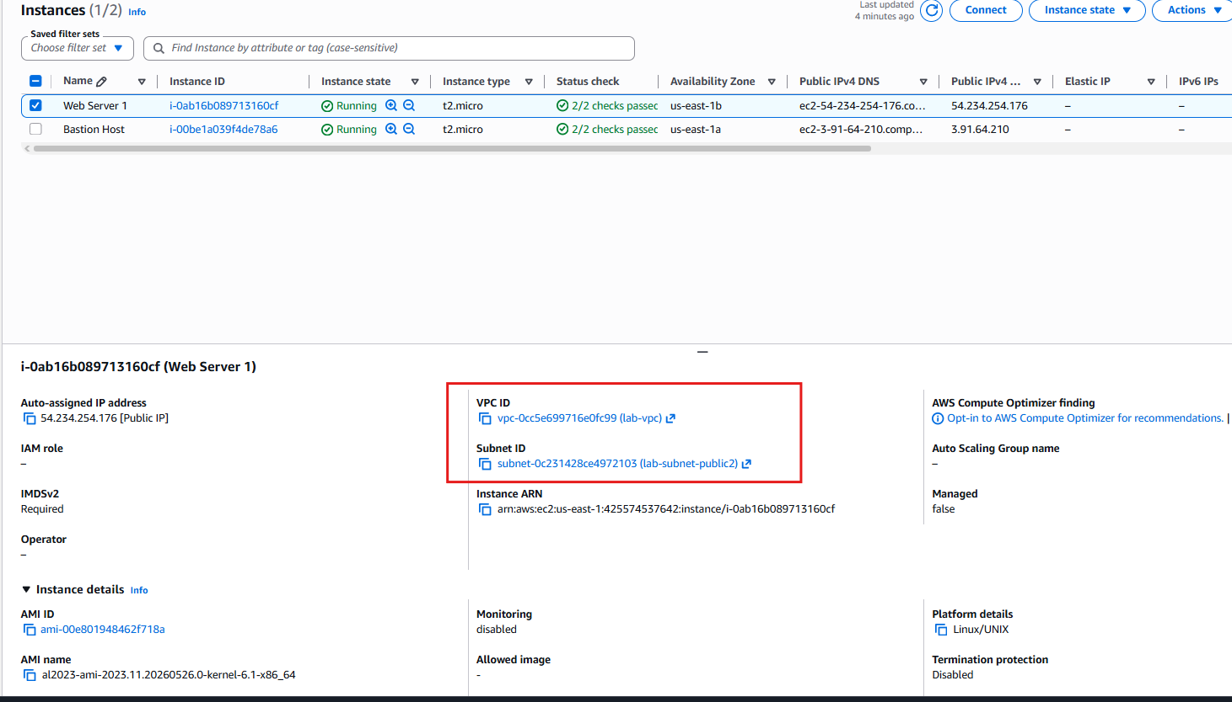
Figure 18. In the Details tab, copy the Public IPv4 DNS value.
Open a new browser tab, paste the DNS address, and press Enter.
Verify that the web page loads successfully and displays the AWS logo along with instance metadata.
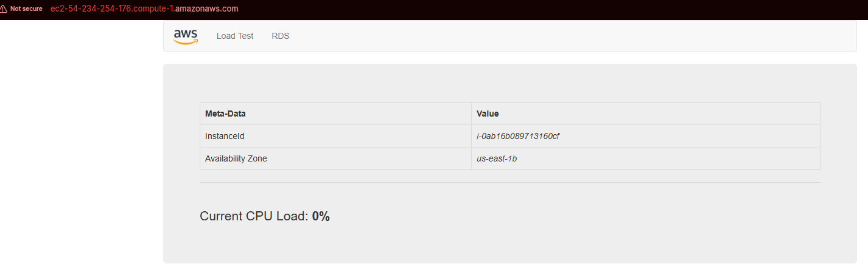
Figure 19. Verify that the web page loads successfully and displays the AWS logo along with instance metadata.
The deployed architecture now includes:
A custom VPC
Public and private subnets across two Availability Zones
Internet and NAT Gateways
Security Groups
An EC2 instance hosting a web application

Lab 3: Introduction to Amazon EC2

Task 1: Launch Your Amazon EC2 Instance
Launch an Amazon EC2 Instance
Open EC2 from the AWS Management Console.
Verify that the selected Region is N. Virginia (us-east-1).
Select Launch instance.
Configure the Instance
Under Name and tags, enter:
Name: Web Server
AWS will automatically create a Name tag for the instance using this value.
Under Application and OS Images (AMI):
Keep the default Amazon Linux 2023 AMI selected.
The AMI determines the operating system and software configuration used by the instance.
Under Instance type:
Keep the default t2.micro instance type selected.
This instance type includes 1 vCPU and 1 GiB of memory.
Under Key pair (login):
Select vockey.
This key pair enables secure SSH access to the instance if needed.
Configure Networking
Under Network settings, choose Edit.
Configure:
VPC: Lab VPC
Subnet: PublicSubnet1
Auto-assign public IP: Enabled
Under Firewall (security groups):
Select Create security group
Configure:
Security group name: Web Server security group
Description: Security group for my web server
Under Inbound security group rules, remove the default rule.
Configure Storage
Leave the default storage settings unchanged.
The instance will use an 8 GiB Amazon EBS root volume.
Configure Advanced Settings
Expand Advanced details.
Under Termination protection, select Enable.
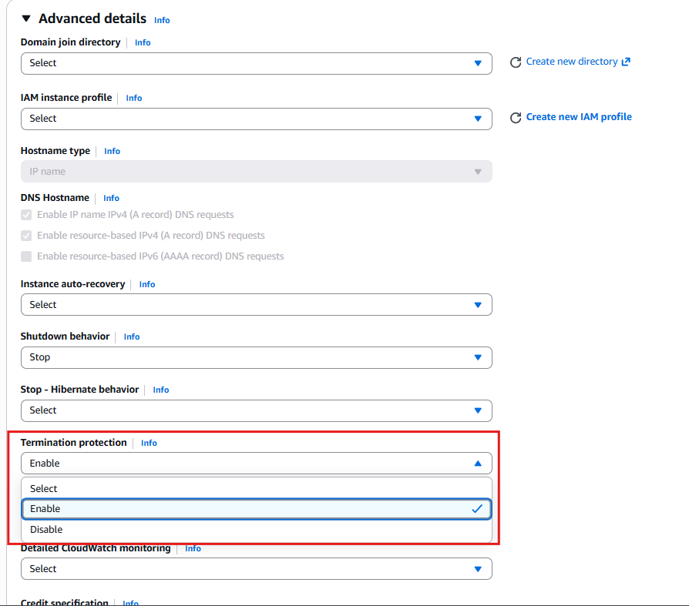
Figure 20. Under Termination protection, select Enable.
This prevents the instance from being accidentally terminated.
Scroll to the User data section and paste the following script:
#!/bin/bash
dnf install -y httpd
systemctl enable httpd
systemctl start httpd
echo '<html><h1>Hello From Your Web Server!</h1></html>' > /var/www/html/index.html
This script will:
Install Apache HTTP Server
Configure the service to start automatically
Start the web server
Create a simple web page
Launch and Verify
Review the configuration and select Launch instance.
When the success message appears, choose View all instances.
Select the Web Server instance from the Instances list.
Review the information in the Details tab, including:
Instance type
Security group settings
Network configuration
Public IPv4 DNS address
Wait for the instance to reach the following status:
Instance State: Running
Status Checks: 2/2 checks passed
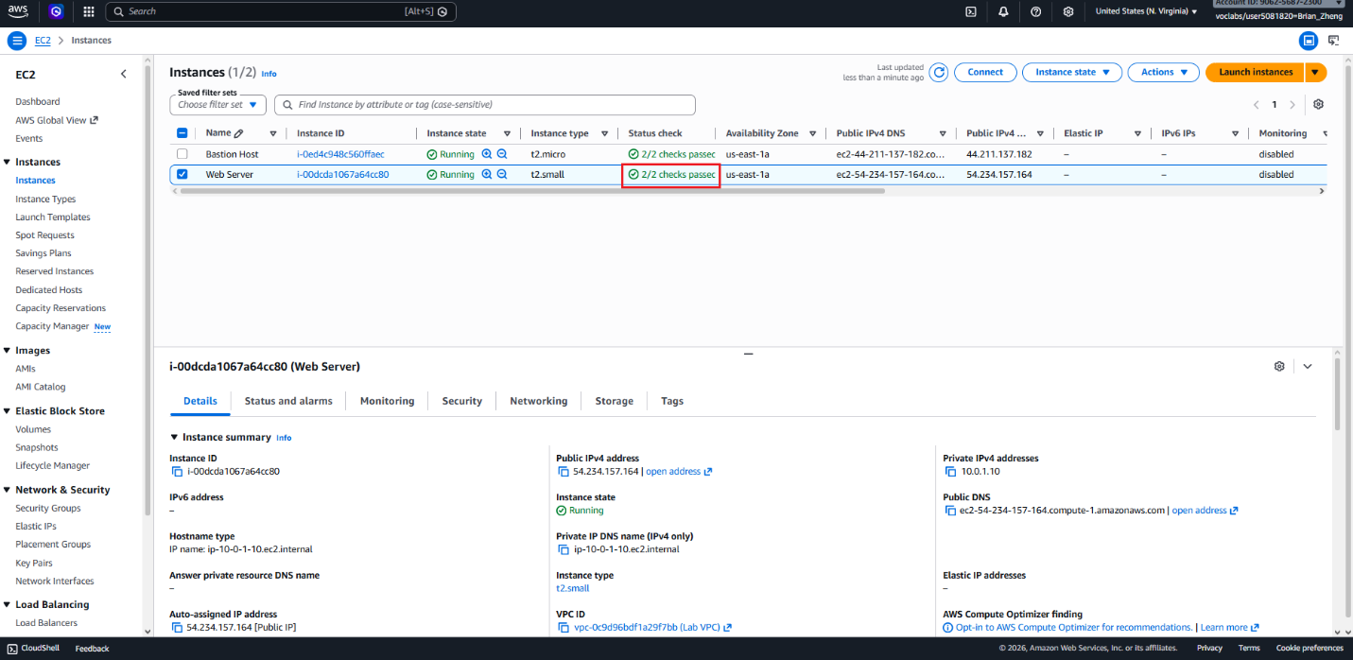
Figure 21. Status Checks: 2/2 checks passed
Once these checks are complete, the EC2 instance is fully operational and ready to host the web page created by the user data script.

Task 2: Monitor Your Instance
Monitor and Troubleshoot the Instance
Select the Status checks tab.
Verify that both checks show Passed:
System reachability
Instance reachability
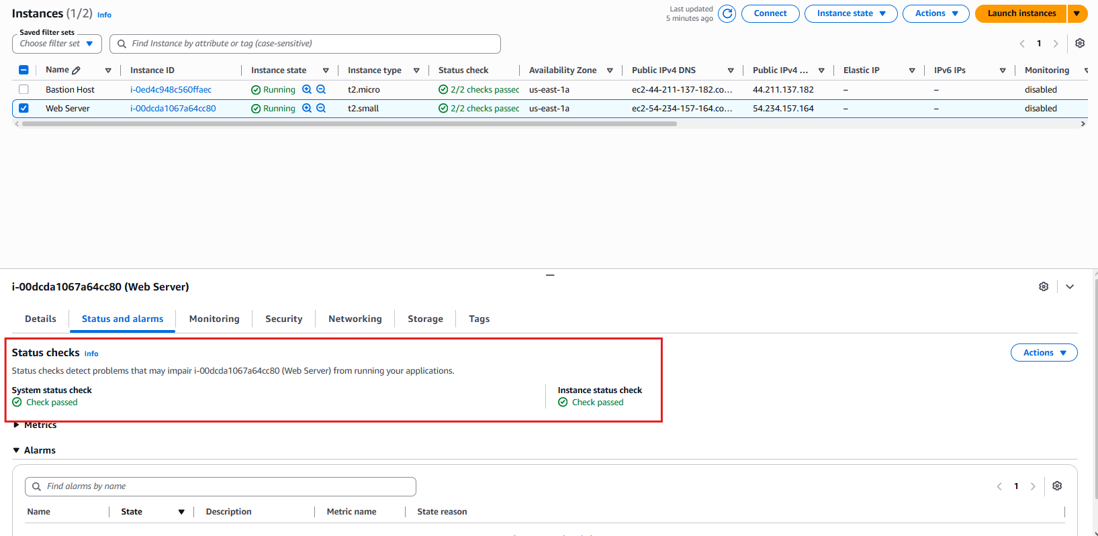
Figure 22. Instance reachability
These automated checks help identify hardware or software issues that could affect instance availability.
View CloudWatch Metrics
Open the Monitoring tab.
Review the Amazon CloudWatch metrics for the instance.
Since the instance was recently launched, only a limited amount of data may be available.
To view a larger version of a graph, select the three-dot menu and choose Enlarge.
By default, EC2 sends basic monitoring data to CloudWatch every five minutes. Detailed monitoring can be enabled for one-minute intervals.
View the System Log
From the Actions menu, select:
Monitor and troubleshoot
Get system log
Review the system log output.
The system log records console messages generated during startup.
It is useful for diagnosing boot, kernel, and service-related issues.
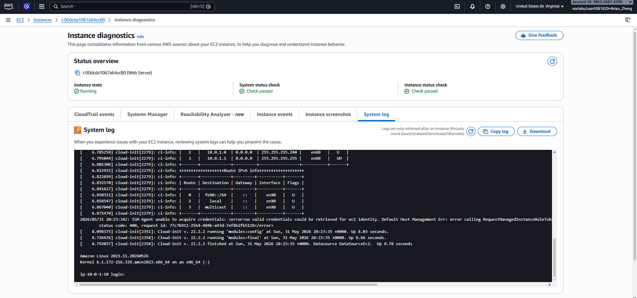
Figure 23. It is useful for diagnosing boot, kernel, and service-related issues.
Scroll through the log and verify that the Apache HTTP package was installed by the user data script.
Choose Cancel to close the log window.
View an Instance Screenshot
Ensure the Web Server instance is still selected.
From the Actions menu, select:
Monitor and troubleshoot
Get instance screenshot
Review the screenshot of the instance console.
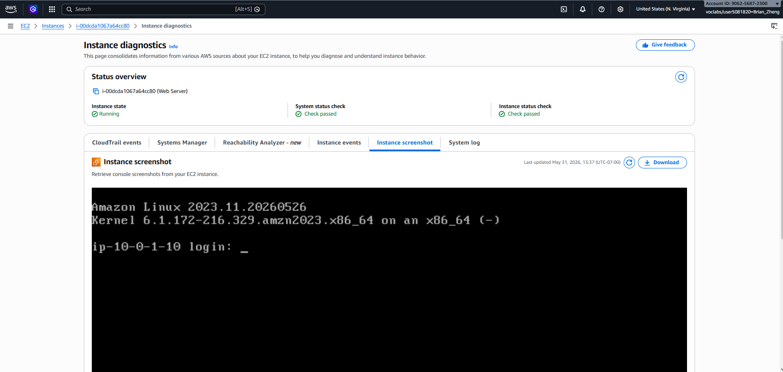
Figure 24. Review the screenshot of the instance console.
This displays what would appear on a monitor connected directly to the instance.
Instance screenshots can be useful when troubleshooting systems that are unreachable through SSH or Remote Desktop.
Choose Cancel to close the screenshot window.

Task 3: Update Your Security Group and Access the Web Server
Test Access to the Web Server
Ensure the Web Server instance is selected and open the Details tab.
Copy the instance's Public IPv4 address.
Open a new browser tab, paste the IP address into the address bar, and press Enter.
Notice that the web page does not load.
The security group currently does not allow inbound HTTP traffic on port 80 which is why web results are blocked.
Update the Security Group
Keep the browser tab open and return to the EC2 Console.
In the left navigation pane, select Security Groups.
Choose Web Server security group.
Open the Inbound rules tab.
Notice that there are currently no inbound rules configured.
Select Edit inbound rules, then choose Add rule.
Configure the rule:
Type: HTTP
Source: Anywhere-IPv4
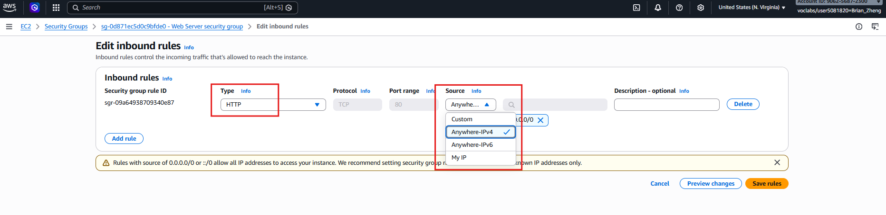
Figure 25. Source: Anywhere-IPv4
Choose Save rules.
Verify Access
Return to the browser tab containing the web server's IP address.
Refresh the page.
The web page should now load successfully and display:
Hello From Your Web Server!
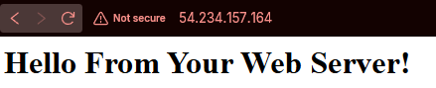
Figure 26. Hello From Your Web Server!

Task 4: Resize Your Instance: Instance Type and EBS Volume
Stop the Instance
In the EC2 Console, select Instances and choose the Web Server instance.
From the Instance state menu, select Stop instance, then choose Stop to confirm.
Wait until the instance state changes to Stopped.
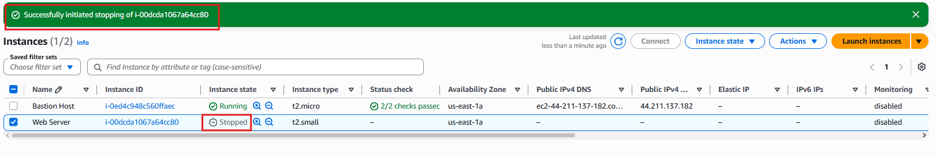
Figure 27. Wait until the instance state changes to Stopped.
A stopped instance does not incur compute charges.
Any attached EBS volumes continue to incur storage charges.
Resize the Instance
With the Web Server instance selected, open:
Actions → Instance settings → Change instance type
Set:
Instance type: t2.small
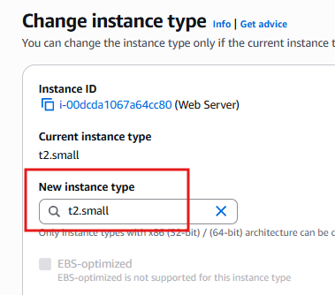
Figure 28. Instance type: t2.small
Choose Apply.
The t2.small instance provides twice the memory of a t2.micro instance.
Enable Stop Protection
Select:
Actions → Instance settings → Change stop protection
Enable Stop protection and save the change.
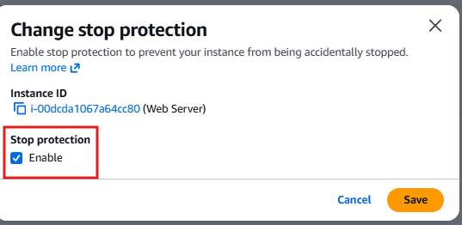
Figure 29. Enable Stop protection and save the change.
Stop protection helps prevent accidental shutdowns.
When an instance is stopped and restarted, it may receive a new public IPv4 address, but it retains its private IPv4 address and EBS volumes.
Increase the EBS Volume Size
Open the Storage tab and select the attached Volume ID.
Select the volume, then choose:
Actions → Modify volume
Change the volume size from 8 GiB to 10 GiB.
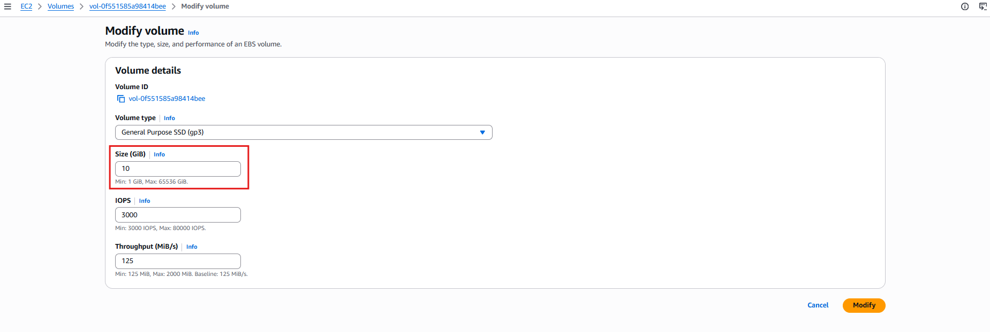
Figure 30. Change the volume size from 8 GiB to 10 GiB.
Choose Modify, then confirm by selecting Modify again.
Start the Updated Instance
Return to Instances.
Select the Web Server instance.
From the Instance state menu, choose Start instance.
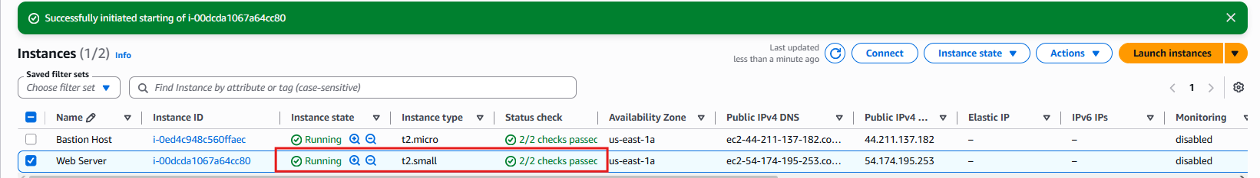
Figure 31. From the Instance state menu, choose Start instance.
The instance now runs with:
t2.small instance type
10 GiB EBS root volume

Task 5: Explore EC2 Limits
Search for and open Service Quotas.
In the navigation pane, select AWS services.
Search for and select Amazon Elastic Compute Cloud (Amazon EC2).
In the Find quotas search box, enter:
running on-demand:
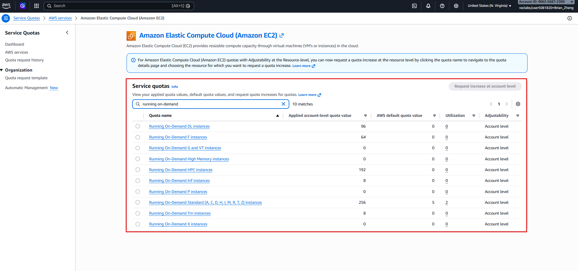
Figure 32. running on-demand
Review the displayed quotas.
These limits control the number and types of EC2 instances that can run within a region.
AWS account owners can request increases for many service quotas if needed.

Task 6: Test Stop Protection
Return to the EC2 Console and open Instances.
Select the Web Server instance.
From the Instance state menu, choose Stop instance, then select Stop.
Notice the error message indicating that the instance cannot be stopped.s
Notice the error message indicating that the instance cannot be stopped.
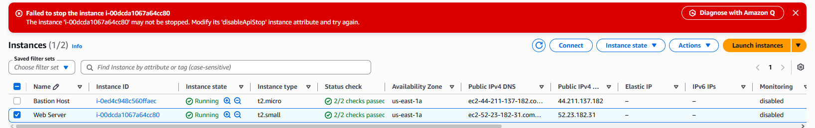
Figure 33. Notice the error message indicating that the instance cannot be stopped.
This occurs because Stop Protection is enabled.
Disable Stop Protection
Select:
Actions → Instance settings → Change stop protection
Clear the Enable checkbox.
Choose Save.
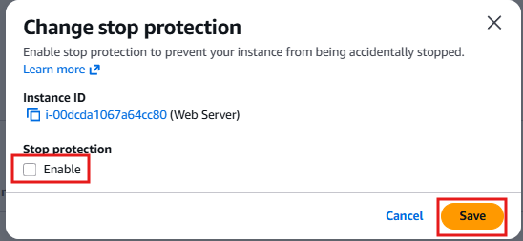
Figure 34. Choose Save.
Stop the Instance
Select the Web Server instance again.
From the Instance state menu, choose Stop instance.
Select Stop to confirm.
The instance will now stop successfully because stop protection has been disabled.
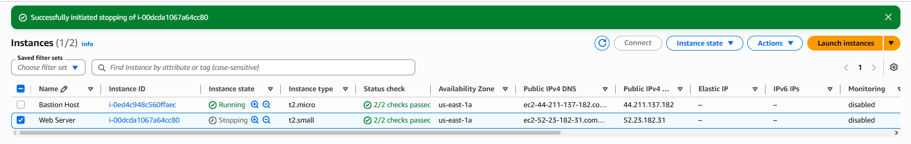
Figure 35. The instance will now stop successfully because stop protection has been disabled.

Troubleshooting and Lessons Learned
The AWS Academy grading interface did not consistently register completed steps. Rechecking the grading status during the exercise helped identify steps that needed to be repeated.

Conclusion
The exercises connected IAM permissions, VPC routing, and EC2 operations in a practical workflow. They reinforced permission testing, public and private subnet design, web-server deployment, instance monitoring, and lifecycle controls.

