  - LAB 05 / CLOUD INFRASTRUCTURE

AWS Storage, Databases, and High Availability
  - EBS, Amazon RDS, load balancing, and Auto Scaling
Cristian K. Leung | Academic Lab Portfolio

Executive Summary
Documented AWS exercises covering persistent block storage, a managed database, and a load-balanced application architecture. The work includes storage and snapshot procedures, database connectivity, launch templates, health checks, and scaling under load.

Skills Demonstrated
Amazon EBS · Amazon RDS · Application Load Balancer · EC2 Auto Scaling · CloudWatch
- Documented EBS volume and snapshot workflows.
- Configured an RDS database and connected it to the lab application.
- Recorded load-balancer health checks and CPU-based Auto Scaling behavior.

Evidence Included
EBS procedures, RDS configuration and application screenshots, load-balancer target health, and Auto Scaling observations.

Objective
The objective was to work with persistent storage, deploy a managed database, and configure an application architecture that distributes traffic and scales with demand.

Technical Background
Amazon Elastic Block Store (EBS) provides persistent block storage for EC2 instances. Volumes can retain data independently of an instance stop or restart, while snapshots support backup and restoration. The lab covers volume management and snapshot workflows.
A database server stores and serves structured application data. Amazon Relational Database Service (RDS) manages infrastructure tasks for supported relational database engines. This exercise configures an RDS database and connects a lab web application to it.
Load balancing distributes application traffic across multiple targets. Auto Scaling adjusts instance capacity in response to demand. The exercise combines an Application Load Balancer, launch template, Auto Scaling group, and CloudWatch metrics to examine availability and scaling behavior.

Procedure and Evidence

Lab 4: Working with EBS

Task 1: Create an EBS Volume
Open EC2 from the AWS Management Console.
Select Instances and locate the Lab instance.
Note the instance's Availability Zone (for example, us-east-1a).
In the left navigation pane, choose Volumes.
Select Create volume and configure:
Volume type: General Purpose SSD (gp2)
Size: 1 GiB
Availability Zone: Same AZ as the Lab instance
Add a tag:
Key: Name
Value: My Volume
Choose Create volume.
Wait for the volume state to change from Creating to Available.

Task 2: Attach the Volume to the EC2 Instance
Select My Volume.
Choose Actions → Attach volume.
Configure:
Instance: Lab
Device name: /dev/sdb
Choose Attach volume.
Verify that the volume state changes to In-use.

Task 3: Connect to the EC2 Instance
Return to Instances and select the Lab instance.
Choose Connect.
Open the Session Manager tab and select Connect.
In the terminal, switch to the ec2-user account:
sudo su -l ec2-user

Task 4: Create and Configure a File System
Check Existing Storage
Display current storage devices:
df -h
Only the original 8 GiB root volume should appear.
Format the New Volume
Create an ext3 file system on the new volume:
sudo mkfs -t ext3 /dev/sdb
Create a Mount Point
Create a directory for the new volume:
sudo mkdir /mnt/data-store
Mount the Volume
Mount the volume:
sudo mount /dev/sdb /mnt/data-store
Configure Automatic Mounting
Add the volume to /etc/fstab:
echo "/dev/sdb /mnt/data-store ext3 defaults,noatime 1 2" | sudo tee -a /etc/fstab
Verify the configuration:
cat /etc/fstab
Verify Storage
Check storage again:
df -h
You should now see /dev/xvdb mounted at /mnt/data-store.
Create and Verify a Test File
Create a text file on the volume:
sudo sh -c "echo some text has been written > /mnt/data-store/file.txt"
Confirm the file contents:
cat /mnt/data-store/file.txt

Task 5: Create an EBS Snapshot
In the EC2 Console, select Volumes and choose My Volume.
Select Actions → Create snapshot.
Add a tag:
Key: Name
Value: My Snapshot
Choose Create snapshot.
Open Snapshots from the navigation pane.
Wait for the snapshot status to change from Pending to Completed.
Remove the Test File
In the terminal, delete the file:
sudo rm /mnt/data-store/file.txt
Verify the file has been removed:
ls /mnt/data-store/

Task 6: Restore the Snapshot
Create a Volume from the Snapshot
Select My Snapshot.
Choose Actions → Create volume from snapshot.
Configure:
Availability Zone: Same AZ used previously
Add a tag:
Key: Name
Value: Restored Volume
Choose Create volume.
Attach the Restored Volume
Open Volumes and select Restored Volume.
Choose Actions → Attach volume.
Configure:
Instance: Lab
Device name: /dev/sdc
Choose Attach volume.
Verify the volume state changes to In-use.
Mount the Restored Volume
Create a mount directory:
sudo mkdir /mnt/data-store2
Mount the restored volume:
sudo mount /dev/sdc /mnt/data-store2
Verify the Restored Data
List the contents of the restored volume:
ls /mnt/data-store2/
Confirm that file.txt is present.
This demonstrates that the EBS snapshot successfully preserved the data and restored it to a new volume.

Lab 5: Build a Database Server

Task 1: Create a Security Group for the Database
Open VPC from the AWS Management Console.
In the left navigation pane, select Security Groups.
Choose Create security group and configure:
Security group name: DB Security Group
Description: Permit access from Web Security Group
VPC: Lab VPC
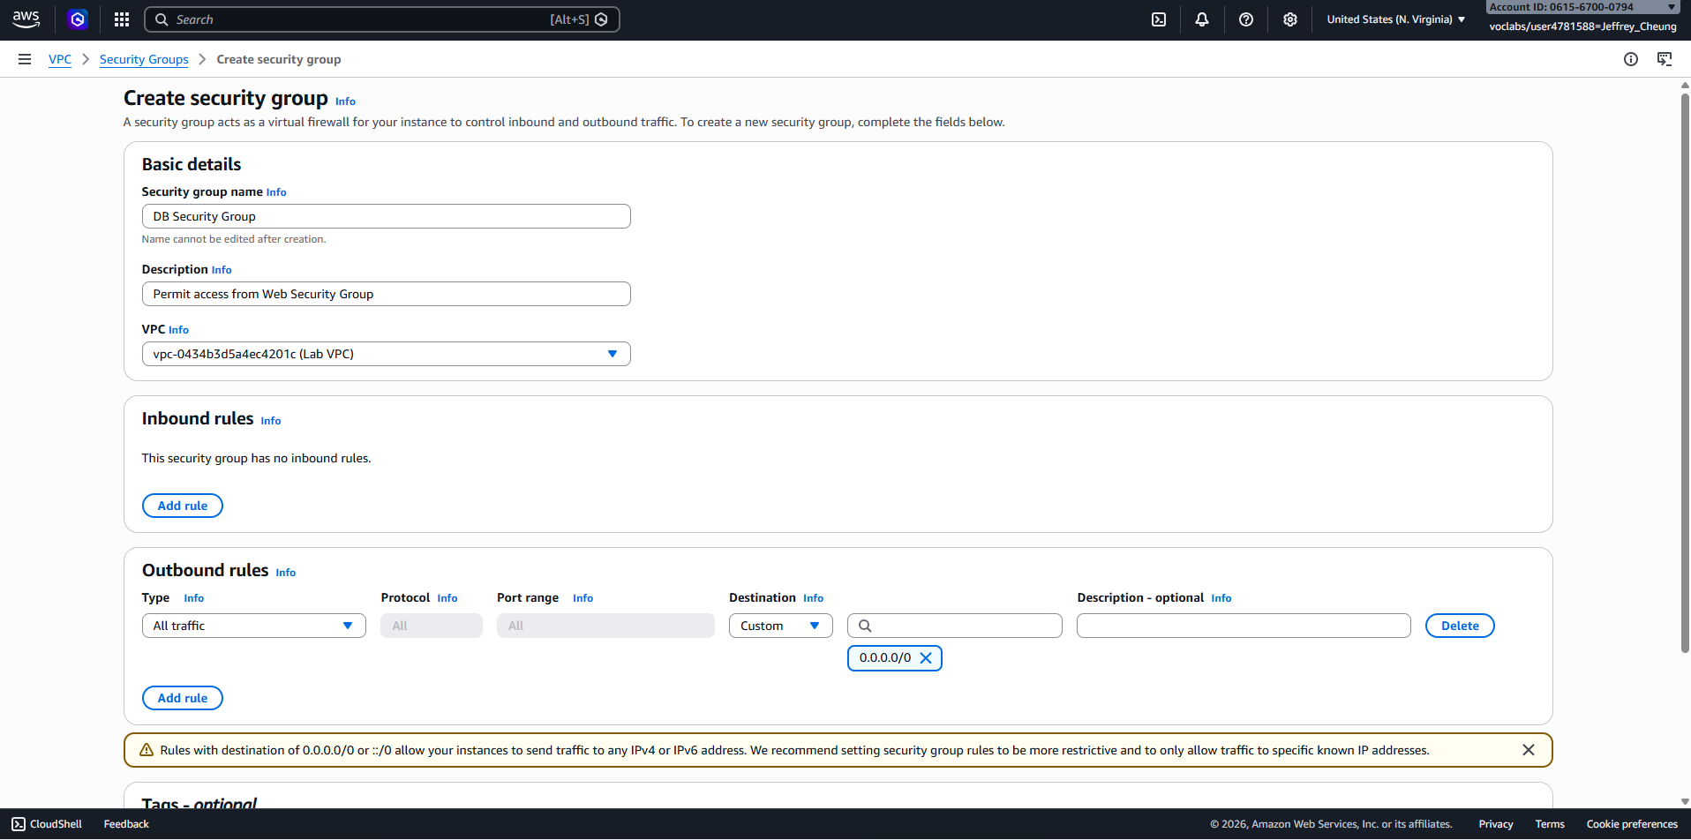
Figure 01. VPC: Lab VPC
Under Inbound rules, choose Add rule.
Configure the rule:
Type: MySQL/Aurora (3306)
Source: Web Security Group
Choose Create security group.
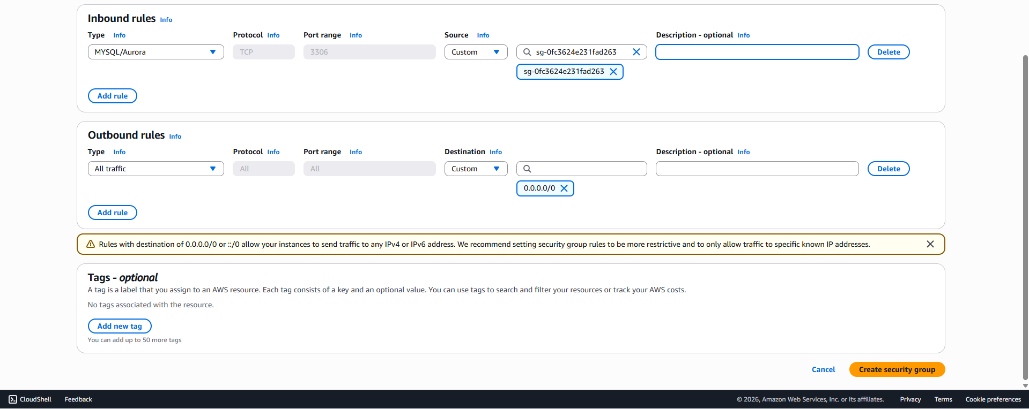
Figure 02. Choose Create security group.
This security group allows EC2 instances associated with the Web Security Group to connect to the database on port 3306.

Task 2: Create a DB Subnet Group
Open RDS from the AWS Management Console.
In the left navigation pane, select Subnet groups.
Choose Create DB subnet group.
Configure:
Name: DB-Subnet-Group
Description: DB Subnet Group
VPC: Lab VPC
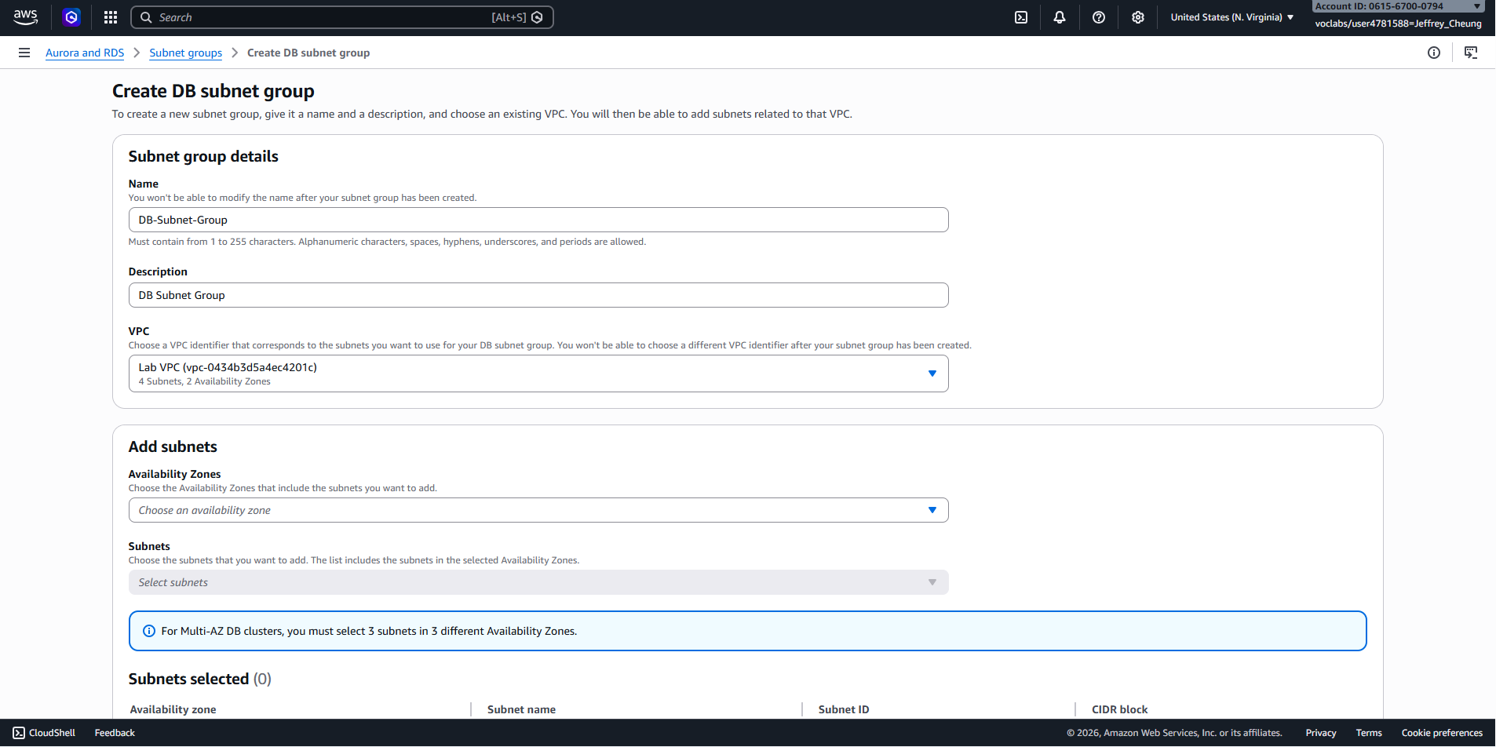
Figure 03. VPC: Lab VPC
Under Availability Zones, select:
us-east-1a
us-east-1b
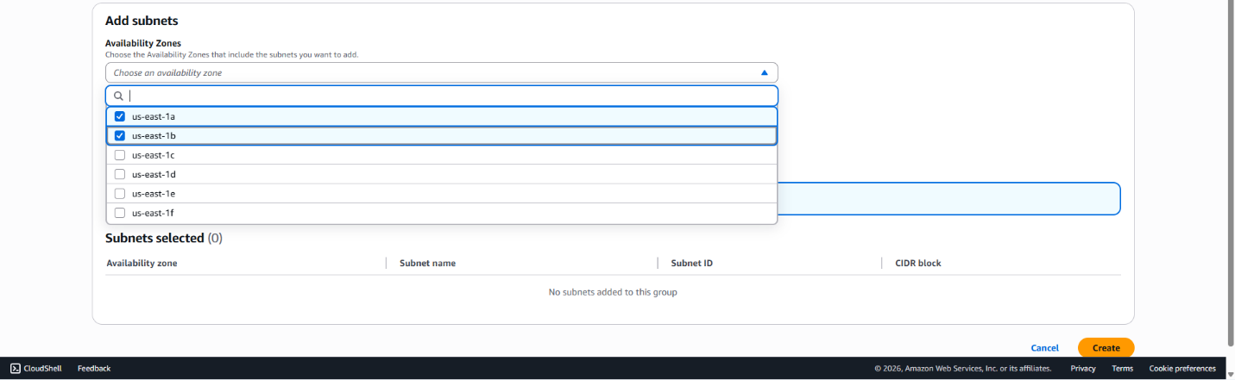
Figure 04. us-east-1b
Under Subnets, select the private subnets with CIDR ranges:
10.0.1.0/24
10.0.3.0/24
Verify that both subnets appear in the selected subnet list.
Choose Create.
The subnet group defines which subnets Amazon RDS can use when deploying the database.

Task 3: Create an Amazon RDS Database
In the left navigation pane, select Databases.
Choose Create database.
Under Engine options, select:
MySQL
Under Templates, choose:
Dev/Test
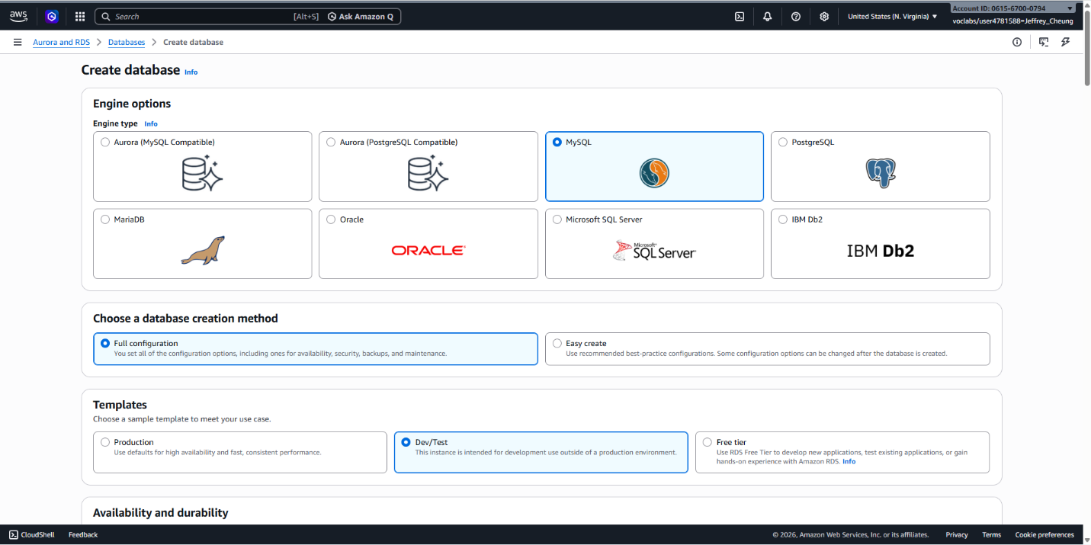
Figure 05. Dev/Test
Under Availability and durability, select:
Multi-AZ DB instance
Database Settings
Configure:
DB instance identifier: lab-db
Master username: main
Master password: lab-password
Confirm password: lab-password
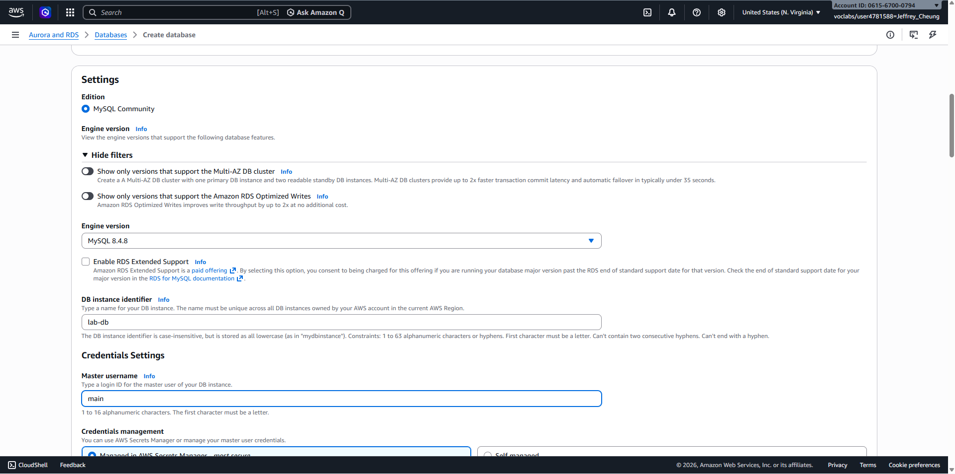
Figure 06. Confirm password: lab-password
Instance Configuration
Under DB instance class:
Select Burstable classes
Choose db.t3.micro
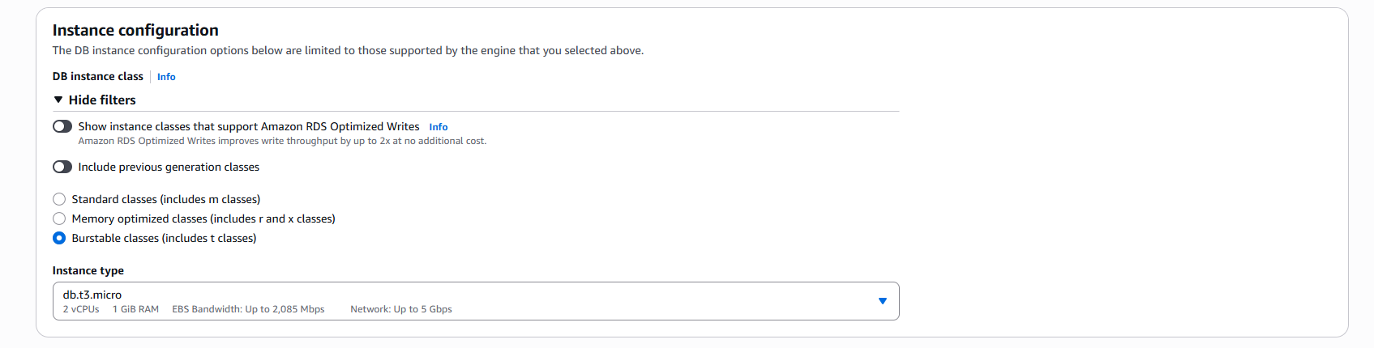
Figure 07. Choose db.t3.micro
Storage Configuration
Configure:
Storage type: General Purpose (SSD)
Allocated storage: 20 GiB
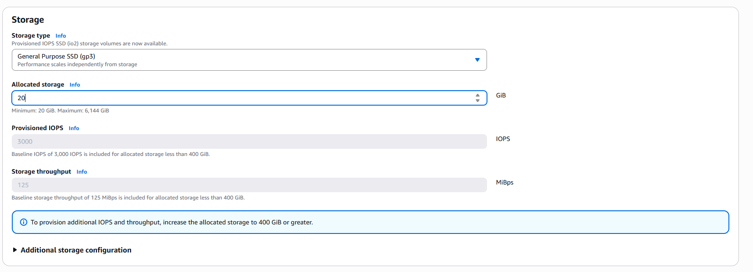
Figure 08. Allocated storage: 20 GiB
Connectivity
Configure:
VPC: Lab VPC
Security group: DB Security Group
Remove the default security group if present
Additional Settings
Expand Monitoring and disable:
Enable Enhanced Monitoring
Under Additional configuration, configure:
Initial database name: lab
Disable Automatic backups
Disable Encryption
Choose Create database.
Wait for Deployment
Select the lab-db database.
Wait until the database status changes to Modifying or Available.
Deployment may take several minutes because a Multi-AZ configuration is being created.
Open the Connectivity & Security section.
Copy the database Endpoint and save it for later use.
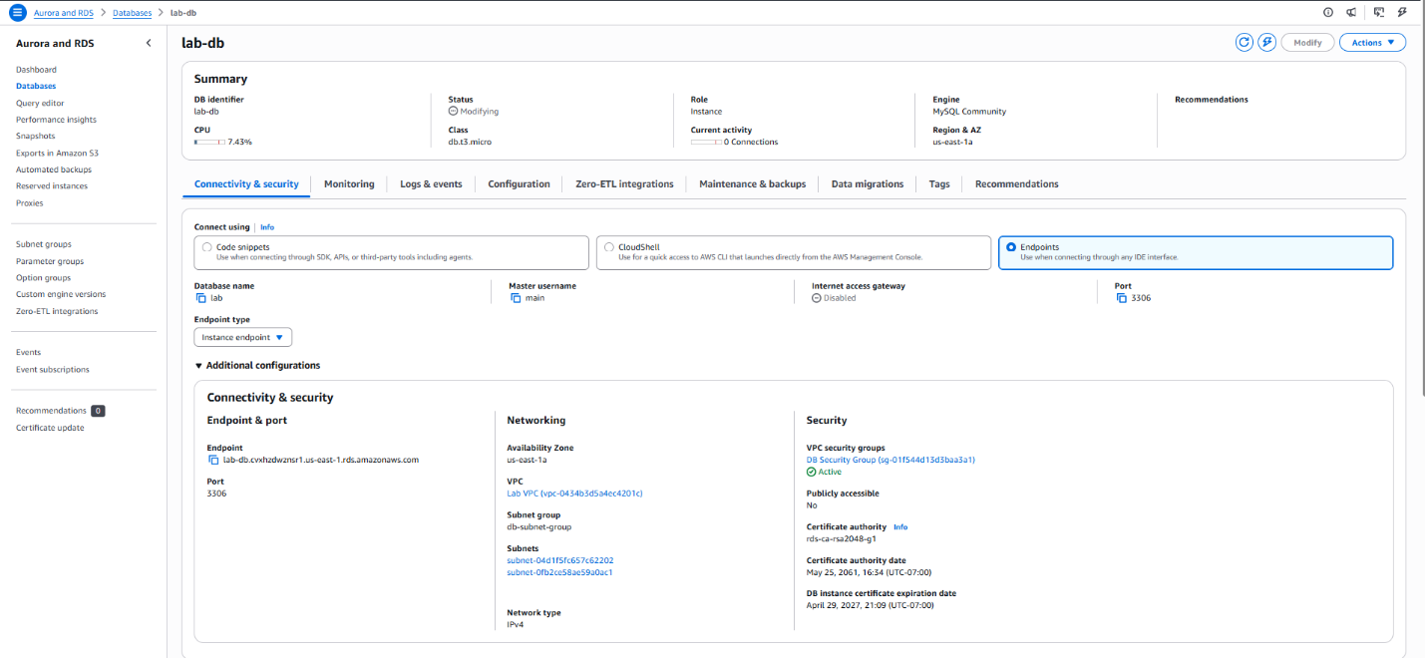
Figure 09. Copy the database Endpoint and save it for later use.
Example: lab-db.xxxx.us-east-1.rds.amazonaws.com
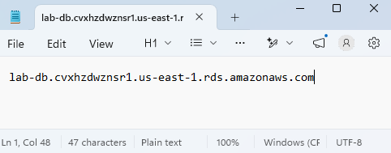
Figure 10. Example: lab-db.xxxx.us-east-1.rds.amazonaws.com

Task 4: Connect the Application to the Database
Obtain the WebServer IP address from the AWS Details panel.
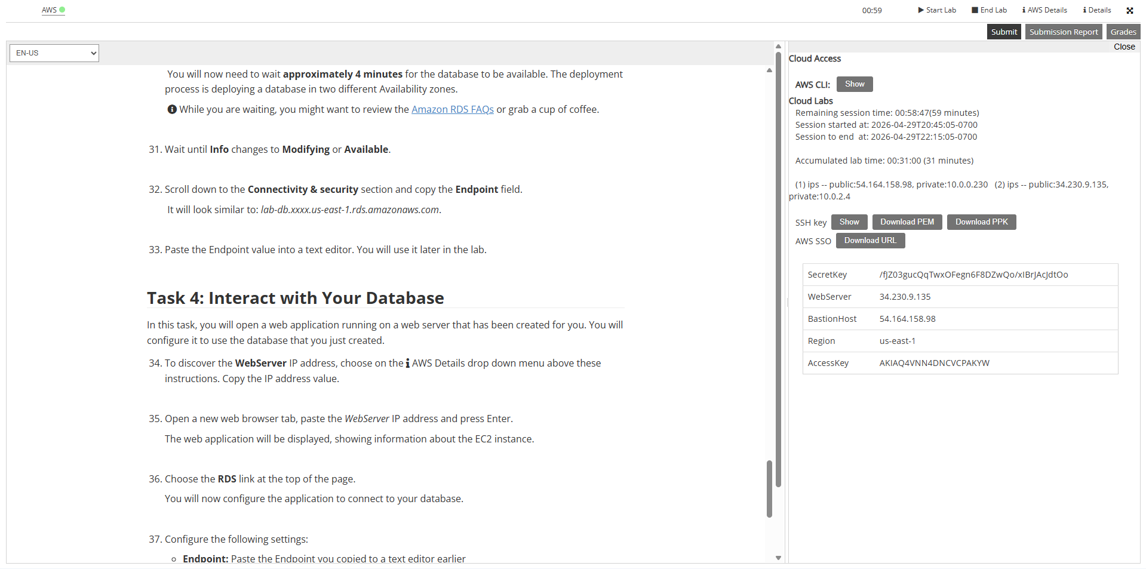
Figure 11. Obtain the WebServer IP address from the AWS Details panel.
Open a new browser tab and navigate to the WebServer IP address.
Verify that the web application loads successfully.
Select the RDS link at the top of the page.
Configure Database Access
Enter the following information:
Endpoint: Database endpoint copied earlier
Database: lab
Username: main
Password: lab-password
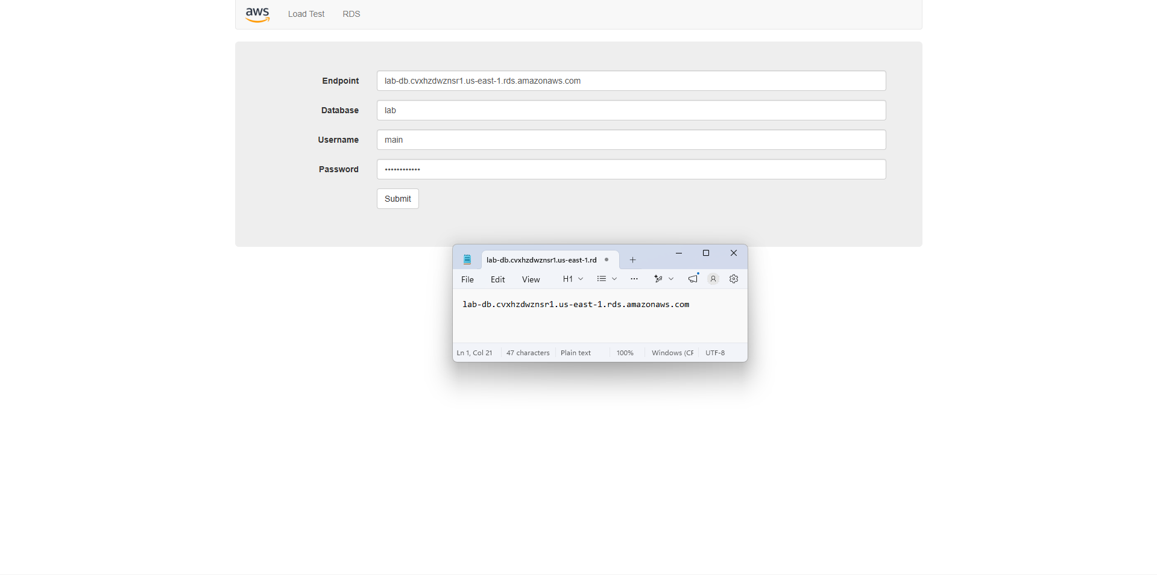
Figure 12. Password: lab-password
Choose Submit.
Wait for the application to initialize the database connection.
Once complete, the Address Book application will appear.
Test Database Functionality
Create a new contact.
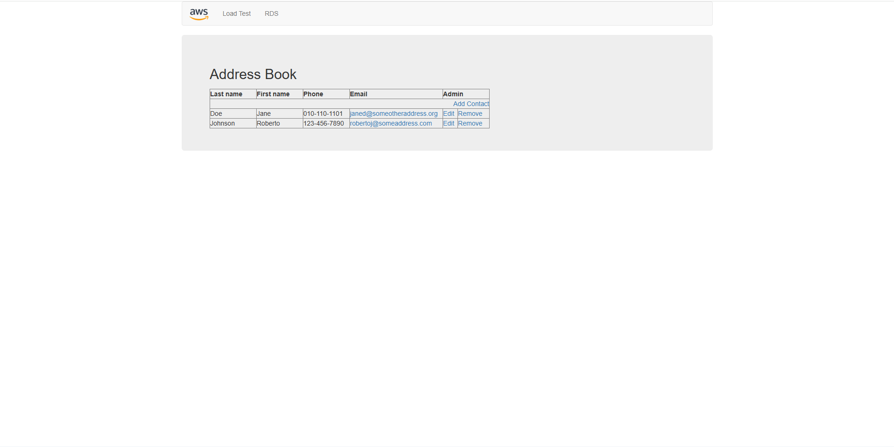
Figure 13. Create a new contact.
Edit an existing contact.
Delete a contact.
Verify that all changes are saved successfully.
The application is now using the Amazon RDS database to store data, and the database is automatically replicated across multiple Availability Zones for improved availability and durability.

Lab 6: Scale and Load balance Your Architecture

Task 1: Create an AMI for Auto Scaling
Open EC2 from the AWS Management Console.
Select Instances and verify that Web Server 1 shows 2/2 Status Checks Passed.
Select Web Server 1.
Choose:
Actions → Image and templates → Create image
Configure:
Image name: WebServerAMI
Image description: Lab AMI for Web Server
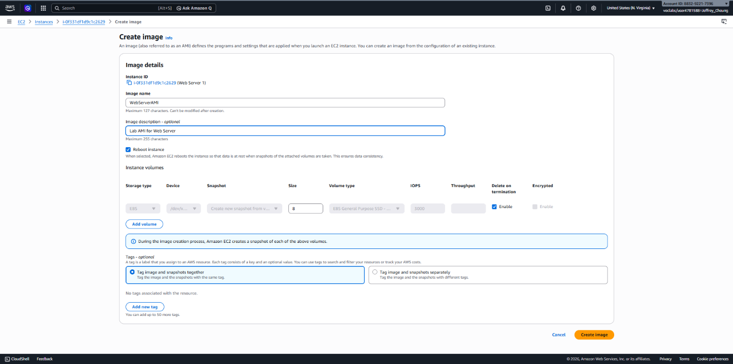
Figure 14. Image description: Lab AMI for Web Server
Choose Create image.
Record the AMI ID displayed in the confirmation message.
This AMI captures the current state of the web server and will be used to launch identical instances through Auto Scaling.

Task 2: Create a Target Group and Load Balancer
Create a Target Group
In the EC2 console, select Target Groups.
Choose Create target group.
Configure:
Target type: Instances
Target group name: LabGroup
VPC: Lab VPC
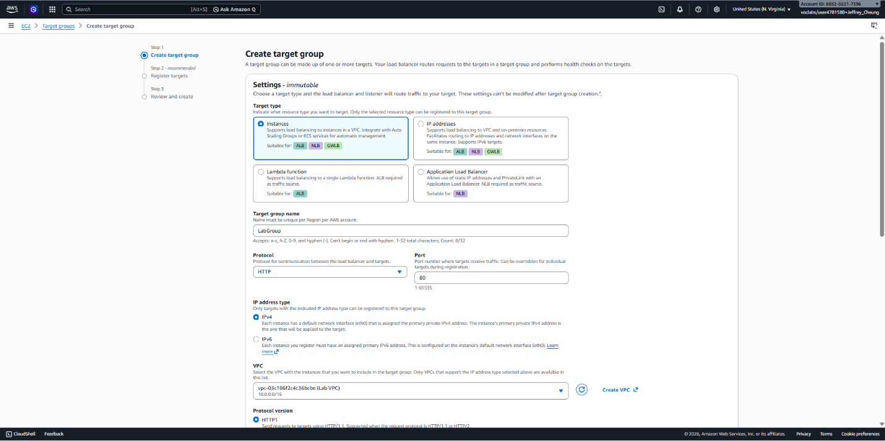
Figure 15. VPC: Lab VPC
Choose Next.
Skip target registration since no Auto Scaling instances exist yet.
Choose Create target group.
Create an Application Load Balancer
Select Load Balancers.
Choose Create load balancer.
Under Application Load Balancer, select Create.
Configure:
Load balancer name: LabELB
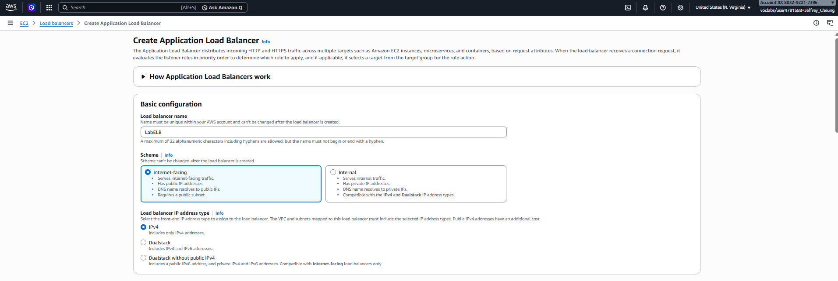
Figure 16. Load balancer name: LabELB
Under Network mapping:
VPC: Lab VPC
Select Public Subnet 1 in the first Availability Zone
Select Public Subnet 2 in the second Availability Zone
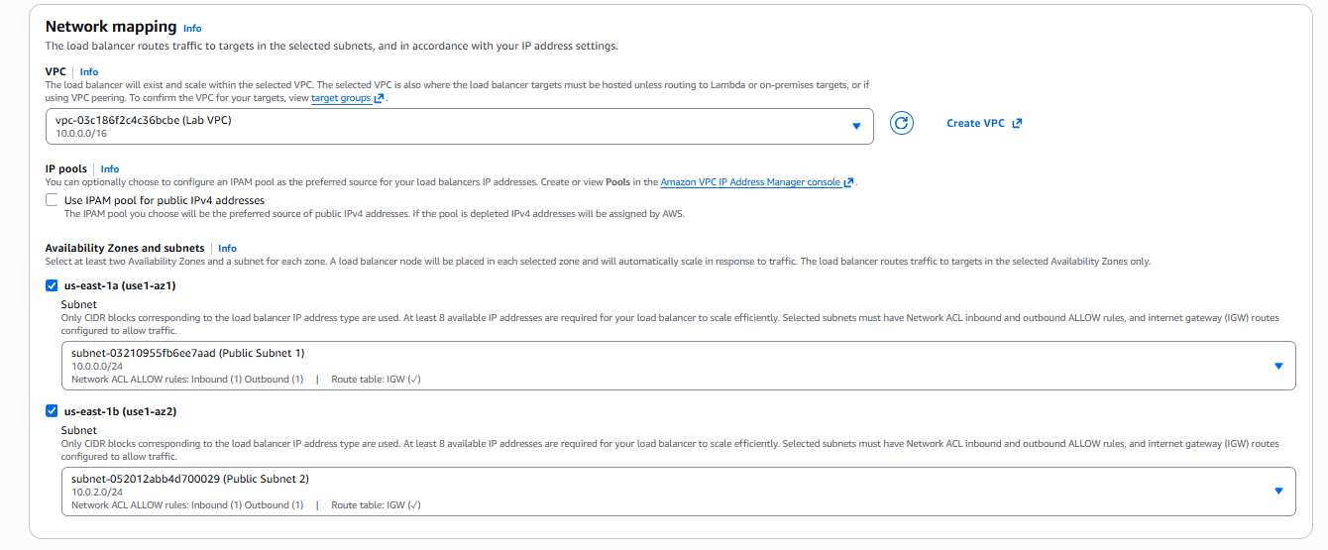
Figure 17. Select Public Subnet 2 in the second Availability Zone
Under Security Groups:
Select Web Security Group
Remove the default security group
Configure the HTTP listener:
Default action: Forward to LabGroup
Choose Create load balancer.
Once creation is complete, select View load balancer.
The load balancer may still show a status of Provisioning, which is expected.

Task 3: Create a Launch Template and Auto Scaling Group
Create a Launch Template
Select Launch Templates.
Choose Create launch template.
Configure:
Launch template name: LabConfig
Enable Auto Scaling guidance
Under My AMIs, select:
AMI: WebServerAMI
Configure:
Instance type: t2.micro
Key pair: vockey
Under Security Groups:
Select Existing security group
Choose Web Security Group
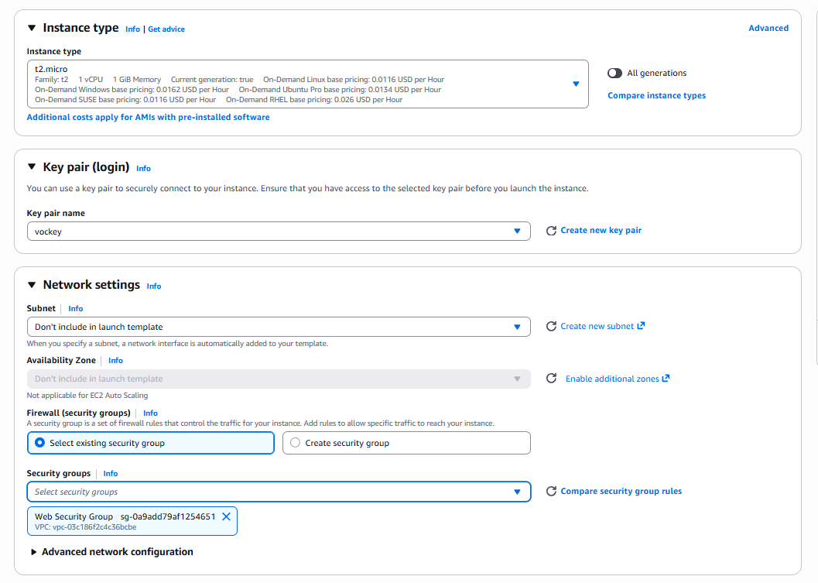
Figure 18. Choose Web Security Group
Expand Advanced Details.
Enable Detailed CloudWatch Monitoring.
Choose Create launch template.
Create the Auto Scaling Group
Open the newly created LabConfig template.
Choose:
Actions → Create Auto Scaling Group
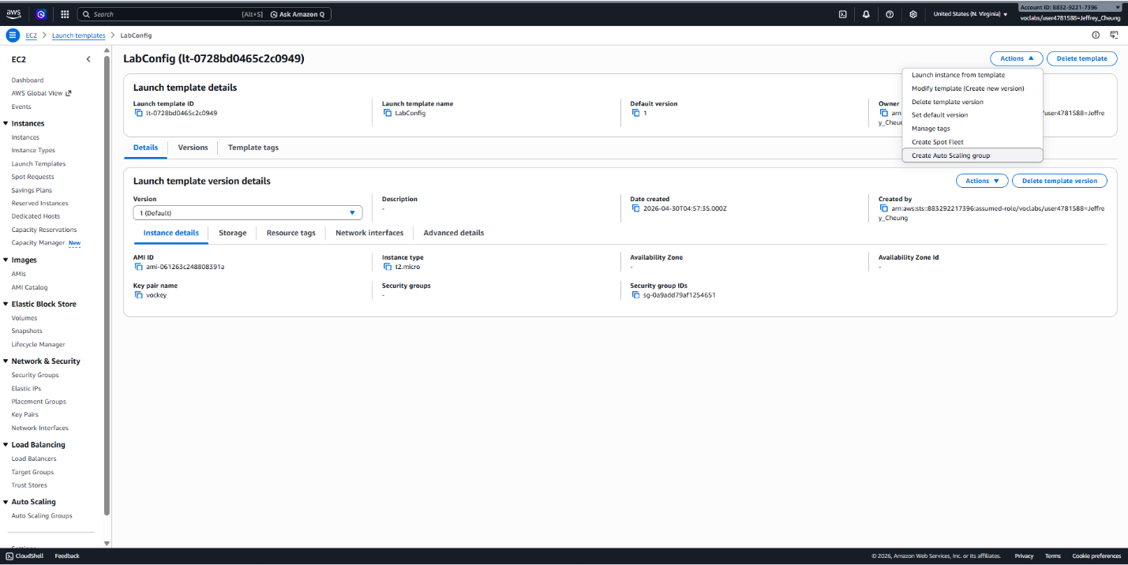
Figure 19. Actions → Create Auto Scaling Group

Step 1: Basic Configuration
Configure:
Auto Scaling group name: Lab Auto Scaling Group
Launch template: LabConfig
Choose Next.

Step 2: Networking
Configure:
VPC: Lab VPC
Subnets: Private Subnet 1 and Private Subnet 2
Choose Next.

Step 3: Load Balancing
Select:
Attach to an existing load balancer
Target group: LabGroup
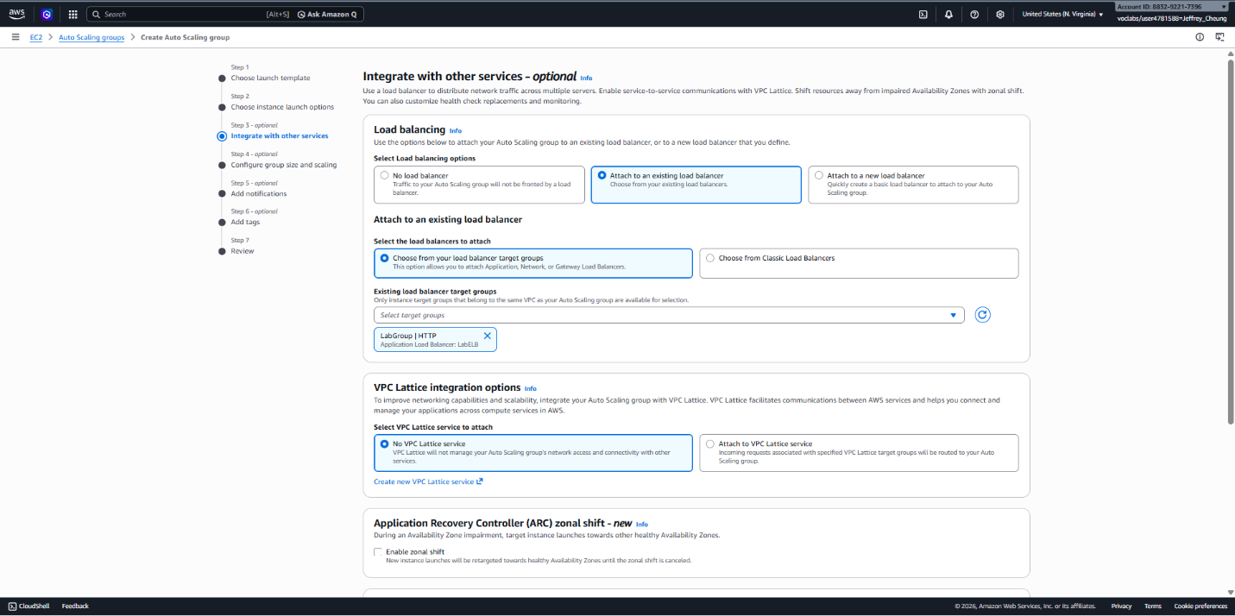
Figure 20. Target group: LabGroup
Enable:
Group metrics collection within CloudWatch
Choose Next.

Step 4: Scaling Configuration
Configure:
Desired capacity: 2
Minimum capacity: 2
Maximum capacity: 6
Configure the scaling policy:
Policy type: Target Tracking
Policy name: LabScalingPolicy
Metric: Average CPU Utilization
Target value: 60%
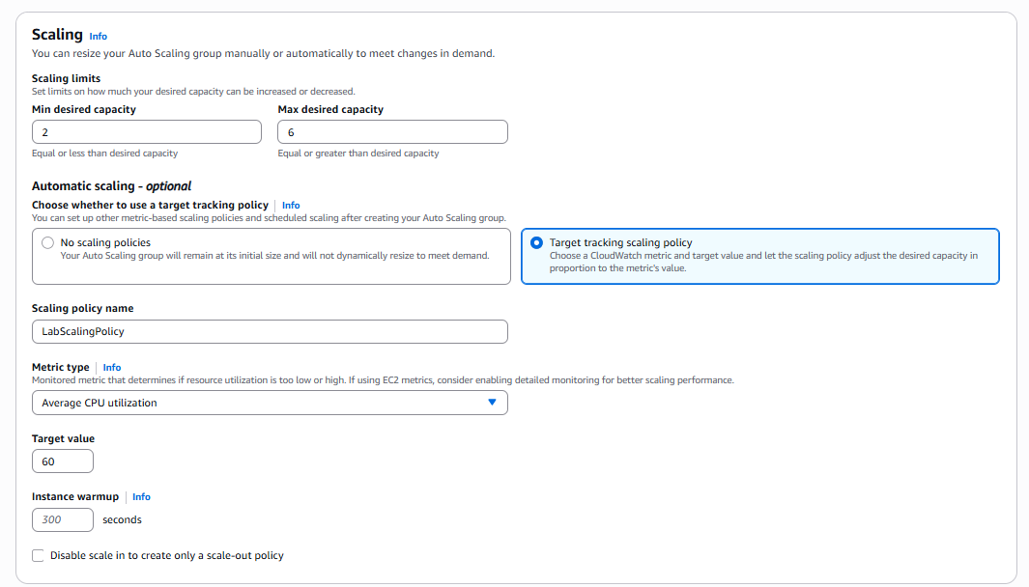
Figure 21. Target value: 60%
Choose Next.

Step 5: Notifications
Leave the default settings and choose Next.

Step 6: Tags
Add a tag:
Key: Name
Value: Lab Instance
Choose Next.
Review the configuration and choose Create Auto Scaling Group.
The group will automatically launch two instances to meet the desired capacity.

Task 4: Verify Load Balancing
Open Instances.
Confirm that two instances named Lab Instance have been launched.
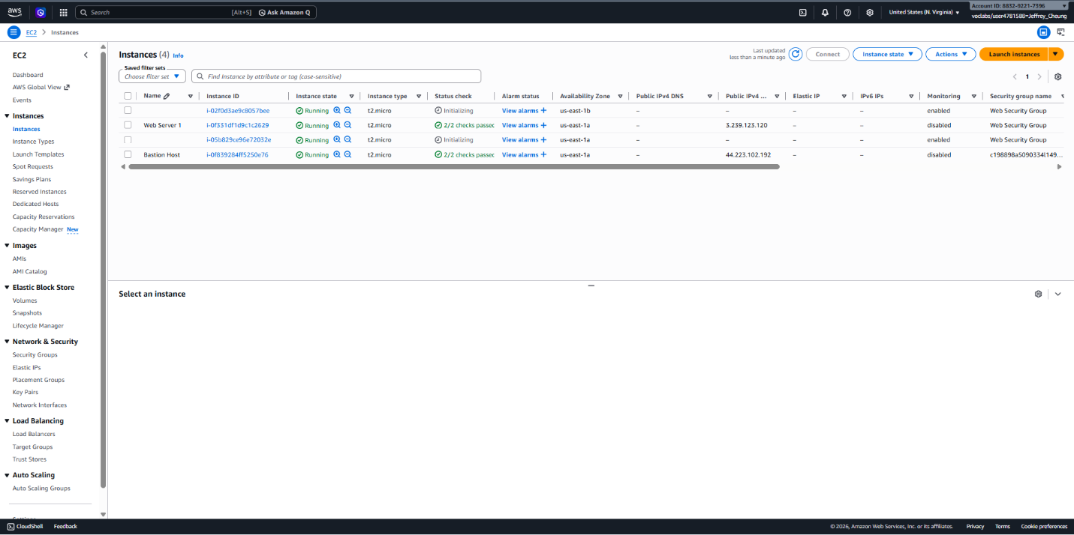
Figure 22. Confirm that two instances named Lab Instance have been launched.
Select Target Groups and open LabGroup.
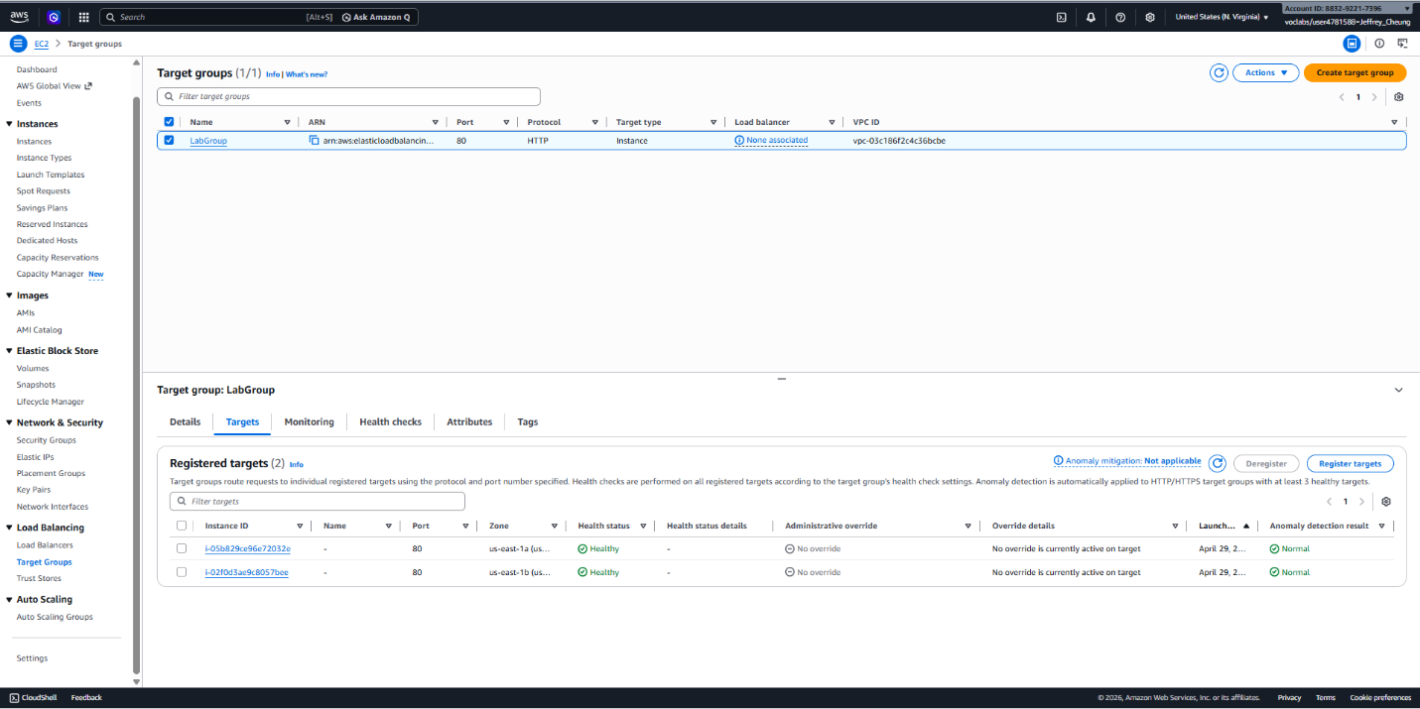
Figure 23. Select Target Groups and open LabGroup.
Open the Targets tab.
Wait until both instances display a status of Healthy.
Healthy targets have passed the load balancer health checks and are eligible to receive traffic.
Select Load Balancers.
Open LabELB.
Copy the load balancer DNS Name.
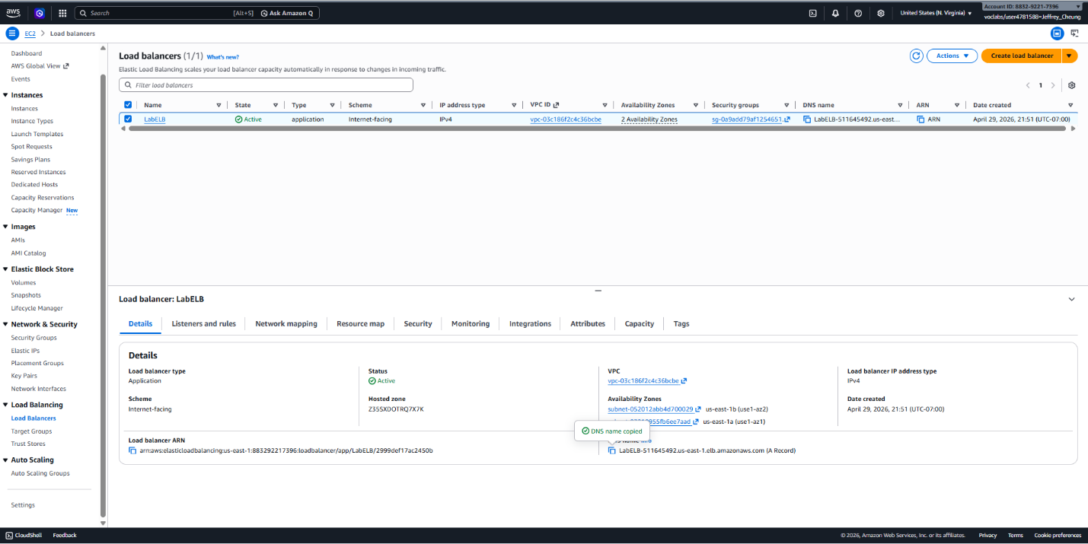
Figure 24. Copy the load balancer DNS Name.
Paste the DNS name into a web browser.
Verify that the application loads successfully.
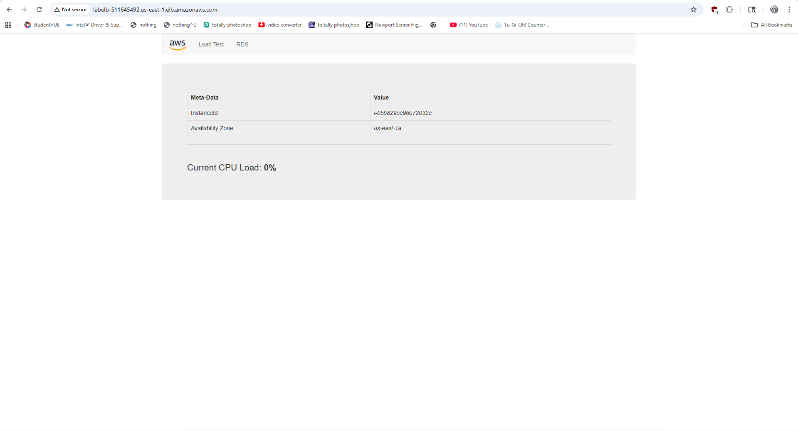
Figure 25. Verify that the application loads successfully.
This confirms that traffic is being routed through the load balancer to the Auto Scaling instances.

Task 5: Test Auto Scaling
Review Scaling Alarms
Open CloudWatch.
Select All Alarms.
Locate the two alarms automatically created by the Auto Scaling policy.
Open the alarm containing AlarmHigh in its name.
Verify that the alarm is currently in the OK state.
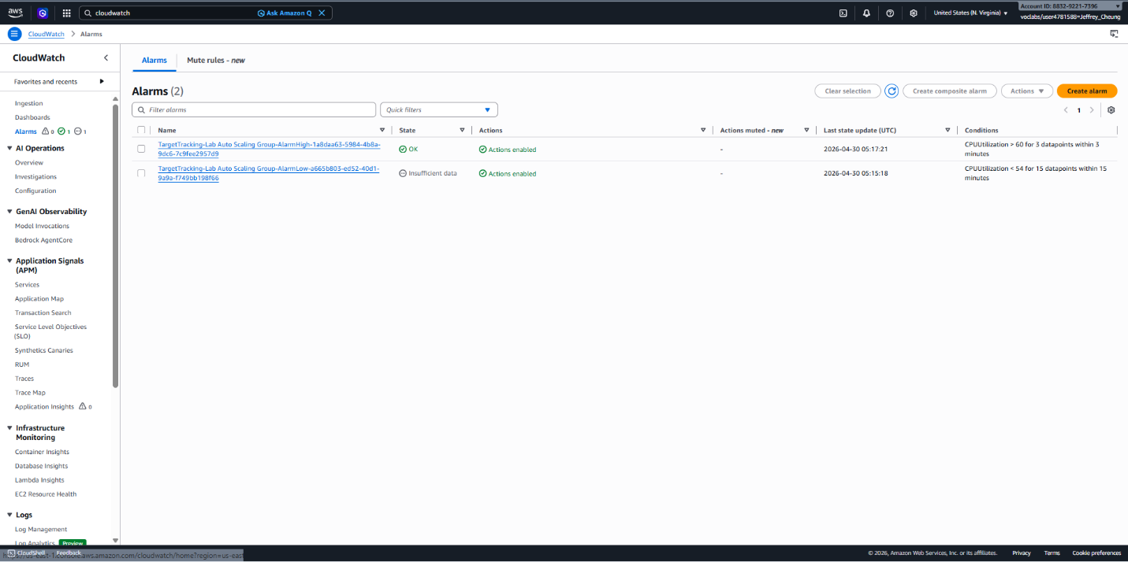
Figure 26. Verify that the alarm is currently in the OK state.
Generate Load
Return to the web application.
Select Load Test.
Leave the page open so the load continues to run.
Monitor Scaling Activity
Return to CloudWatch.
Refresh the alarms periodically.
Wait for:
AlarmHigh to change to In Alarm
CPU utilization to exceed the target threshold
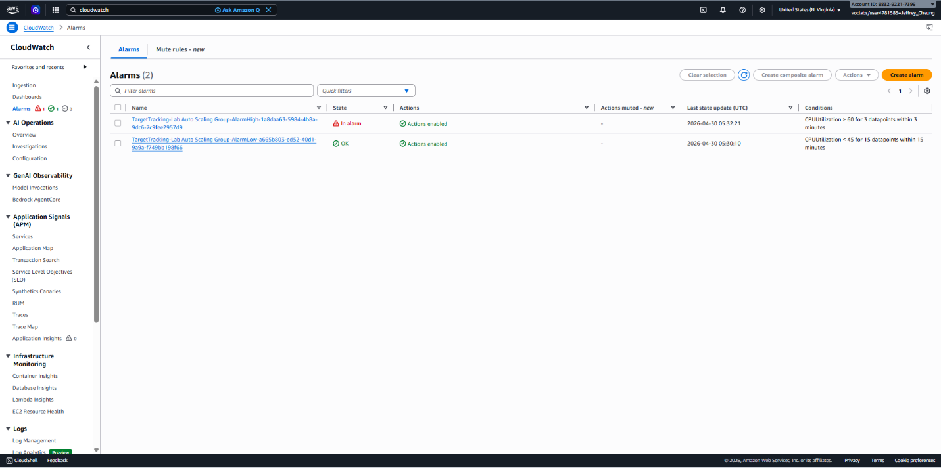
Figure 27. CPU utilization to exceed the target threshold
Once the alarm is triggered, Auto Scaling launches additional instances automatically.
Verify New Instances
Return to EC2 → Instances.
Confirm that more than two Lab Instance servers are running.
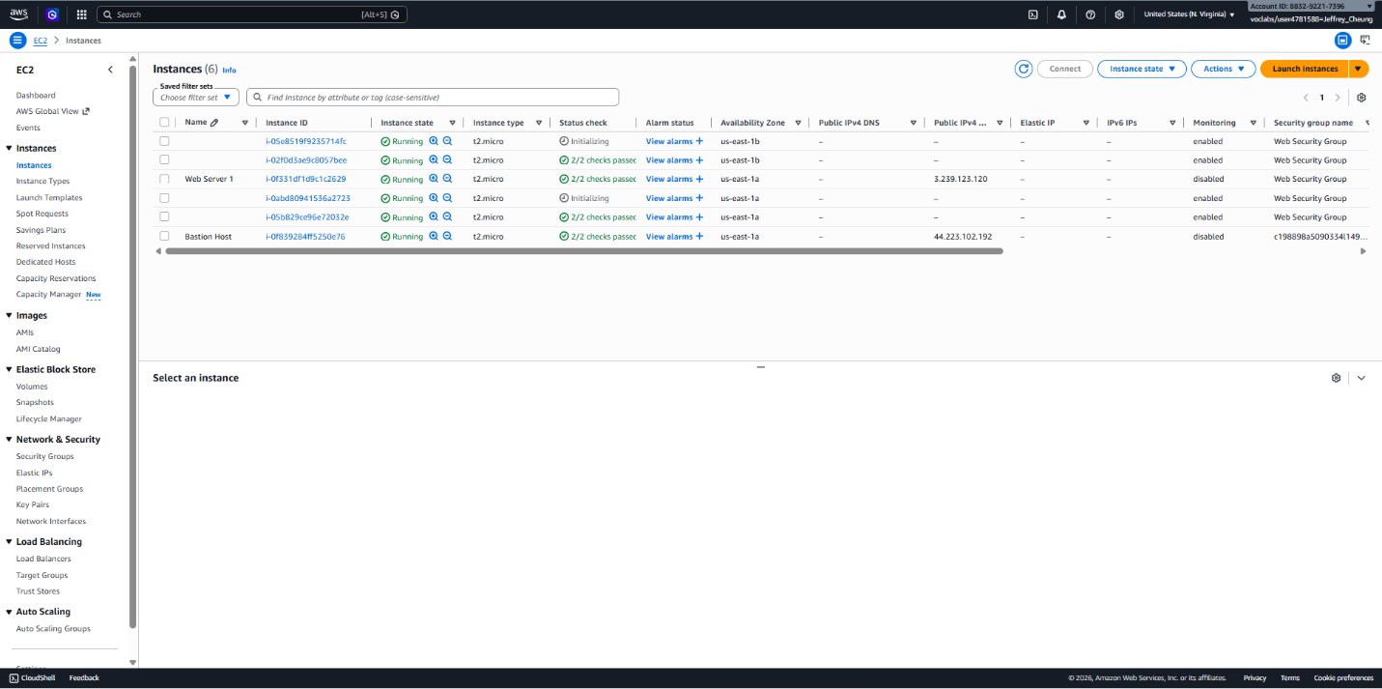
Figure 28. Confirm that more than two Lab Instance servers are running.
This demonstrates Auto Scaling responding automatically to increased demand.

Task 6: Terminate the Original Web Server
Return to Instances.
Select Web Server 1 only.
Choose:
Instance State → Terminate Instance
Confirm by selecting Terminate.
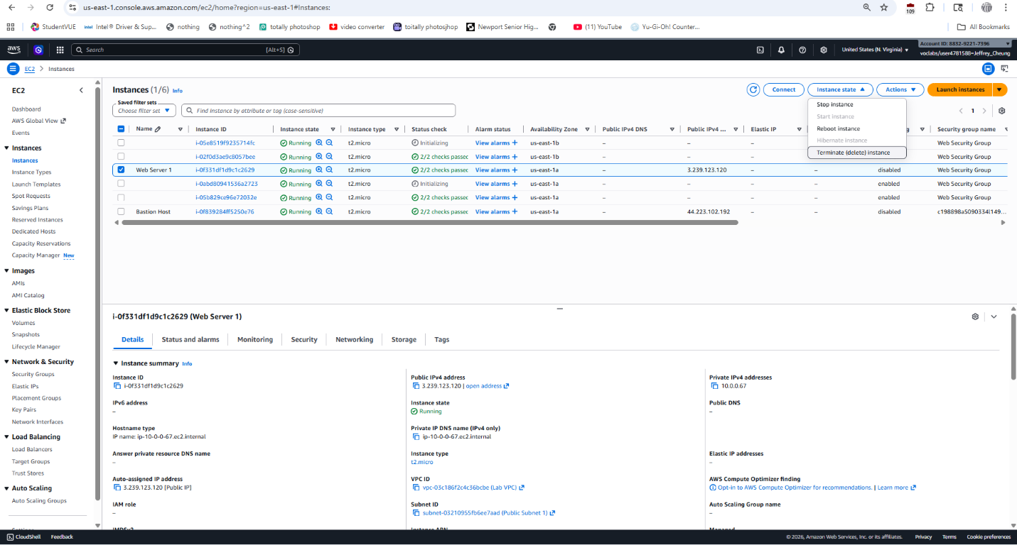
Figure 29. Confirm by selecting Terminate.
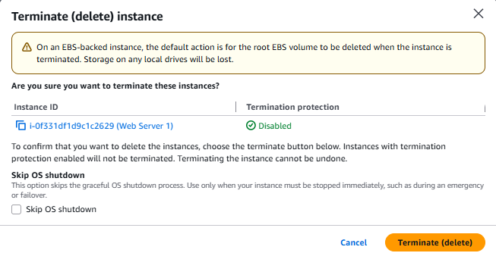
Figure 30. Confirm by selecting Terminate.
The original instance is no longer needed because its configuration has been captured in the AMI and is now managed through the Auto Scaling group.

Troubleshooting and Lessons Learned
The AWS Academy grading interface occasionally failed to register completed steps. Reviewing the grading status throughout the exercise reduced the need to retrace earlier work and helped identify steps that required repetition.

Conclusion
The exercises linked EBS storage, managed database connectivity, load balancing, and automated scaling. They provided practical experience with persistent data, application health checks, launch templates, and capacity adjustments driven by monitored demand.

