  - LAB 02 / NETWORK ROUTING

Multi-Area OSPF Routing
  - Cisco router configuration and adjacency troubleshooting
Cristian K. Leung | Academic Lab Portfolio

Executive Summary
Documented a multi-area OSPF exercise using Cisco routers and switches. The work covers interface addressing, router IDs, area assignments, and troubleshooting missing neighbor relationships caused by mistyped addresses.

Skills Demonstrated
OSPF · IPv4 and IPv6 · Cisco IOS · PuTTY · Packet Tracer
- Organized a topology around backbone and non-backbone OSPF areas.
- Recorded IPv4 and IPv6 interface configuration and router IDs.
- Identified incorrect interface addresses while troubleshooting missing neighbors.

Evidence Included
Annotated topology, per-device configuration screenshots, route information, and OSPF process output.
The reference configurations are reconciled with the original IPv4 and IPv6 topology diagrams. Original console screenshots remain labeled as historical evidence. Corrected examples were checked for addressing and area consistency, without a new device run.

Objective
The objective was to configure and troubleshoot a multi-area OSPF network using Cisco routers and switches. PuTTY provided command-line access, while Packet Tracer supported topology planning and visualization.

Technical Background
Open Shortest Path First (OSPF) is a link-state interior gateway protocol. Routers exchange link-state information and calculate routes using a shortest-path algorithm. Neighbor formation, consistent interface addressing, and compatible area settings are essential to operation.
Multi-area OSPF divides routing information into areas connected through the backbone, Area 0. An area border router (ABR) connects multiple areas. This structure can reduce the amount of topology information processed within each area and support larger networks.
PuTTY is a terminal client used to access device command-line interfaces. In this exercise, it was used to configure interfaces, routing processes, router IDs, and verification commands.
Cisco routers and switches form the lab topology. Routed interfaces connect network segments, and OSPF exchanges route information between participating devices. Both IPv4 and IPv6 addressing appear in the configuration record.

Procedure and Evidence
The lab covers interface addressing, OSPF areas, and router IDs. The corrected reference configurations below follow the original topology diagrams. Original device screenshots are retained separately and may reflect earlier configuration states.

Configuration Record

Network Topology
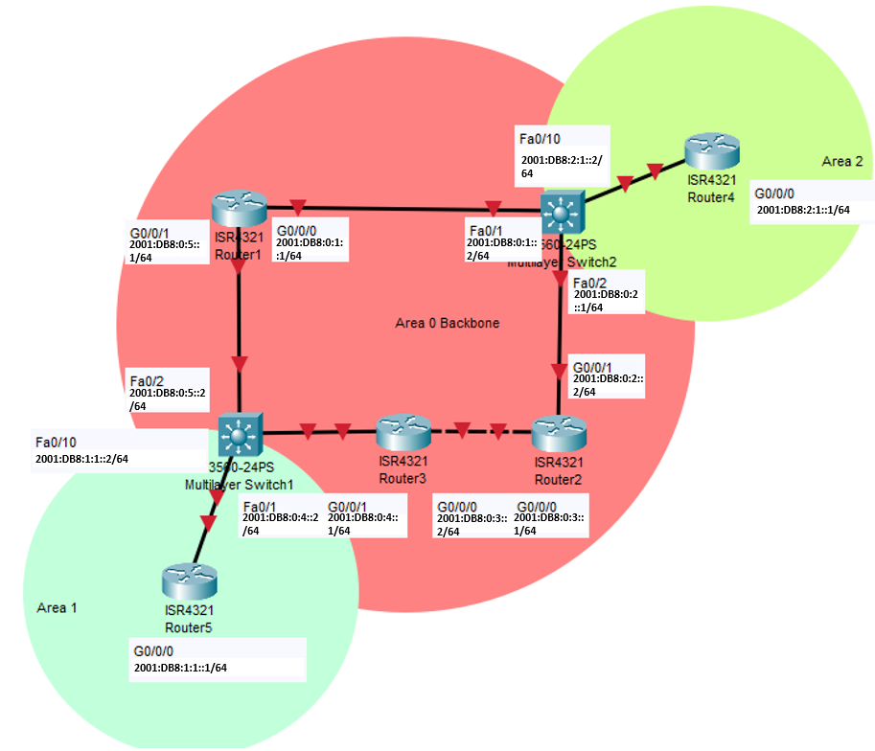
Figure 01. Network Topology
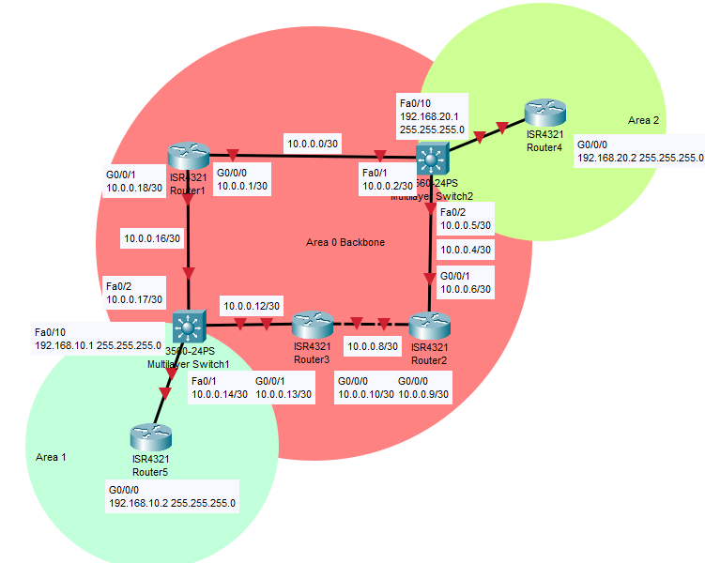
Figure 02. Network Topology

Corrected Addressing Reference
The table below follows the original topology diagrams: five backbone links in Area 0, S1–R5 in Area 1, and S2–R4 in Area 2. Router IDs are unique. Use a clean lab configuration and IOS images supporting routed switch ports and classic OSPFv3 commands; interface names and IPv6 routing support depend on the platform.
Device / Interface | IPv4 / Prefix | IPv6 / Prefix | Area
R1 g0/0/0 | 10.0.0.1/30 | 2001:db8:0:1::1/64 | 0
S2 fa0/1 | 10.0.0.2/30 | 2001:db8:0:1::2/64 | 0
S2 fa0/2 | 10.0.0.5/30 | 2001:db8:0:2::1/64 | 0
R2 g0/0/1 | 10.0.0.6/30 | 2001:db8:0:2::2/64 | 0
R2 g0/0/0 | 10.0.0.9/30 | 2001:db8:0:3::1/64 | 0
R3 g0/0/0 | 10.0.0.10/30 | 2001:db8:0:3::2/64 | 0
R3 g0/0/1 | 10.0.0.13/30 | 2001:db8:0:4::1/64 | 0
S1 fa0/1 | 10.0.0.14/30 | 2001:db8:0:4::2/64 | 0
S1 fa0/2 | 10.0.0.17/30 | 2001:db8:0:5::2/64 | 0
R1 g0/0/1 | 10.0.0.18/30 | 2001:db8:0:5::1/64 | 0
S1 fa0/10 | 192.168.10.1/24 | 2001:db8:1:1::2/64 | 1
R5 g0/0/0 | 192.168.10.2/24 | 2001:db8:1:1::1/64 | 1
S2 fa0/10 | 192.168.20.1/24 | 2001:db8:2:1::2/64 | 2
R4 g0/0/0 | 192.168.20.2/24 | 2001:db8:2:1::1/64 | 2
Per-interface OSPF activation replaces the mismatched network statements. Both OSPFv2 and OSPFv3 have explicit router IDs. These are corrected reference examples, not a transcript of the retained screenshots.

R1: Corrected Reference Configuration
enable
configure terminal
hostname R1
ipv6 unicast-routing
router ospf 1
router-id 1.1.1.1
exit
ipv6 router ospf 1
router-id 1.1.1.1
exit
interface g0/0/0
description Link to S2 fa0/1
ip address 10.0.0.1 255.255.255.252
ip ospf 1 area 0
ipv6 address 2001:db8:0:1::1/64
ipv6 ospf 1 area 0
no shutdown
exit
interface g0/0/1
description Link to S1 fa0/2
ip address 10.0.0.18 255.255.255.252
ip ospf 1 area 0
ipv6 address 2001:db8:0:5::1/64
ipv6 ospf 1 area 0
no shutdown
exit
end
show running-config
show ip ospf neighbor
show ipv6 ospf neighbor
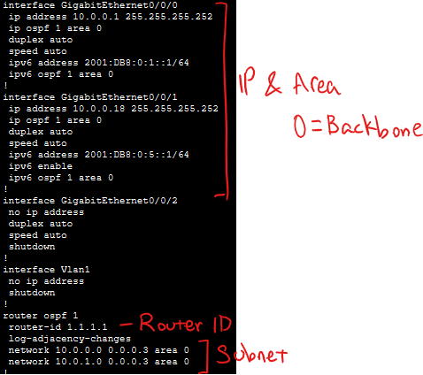
Figure 03. Original lab capture for R1; separate from the corrected reference configuration.

R2: Corrected Reference Configuration
enable
configure terminal
hostname R2
ipv6 unicast-routing
router ospf 1
router-id 2.2.2.2
exit
ipv6 router ospf 1
router-id 2.2.2.2
exit
interface g0/0/1
description Link to S2 fa0/2
ip address 10.0.0.6 255.255.255.252
ip ospf 1 area 0
ipv6 address 2001:db8:0:2::2/64
ipv6 ospf 1 area 0
no shutdown
exit
interface g0/0/0
description Link to R3 g0/0/0
ip address 10.0.0.9 255.255.255.252
ip ospf 1 area 0
ipv6 address 2001:db8:0:3::1/64
ipv6 ospf 1 area 0
no shutdown
exit
end
show running-config
show ip ospf neighbor
show ipv6 ospf neighbor
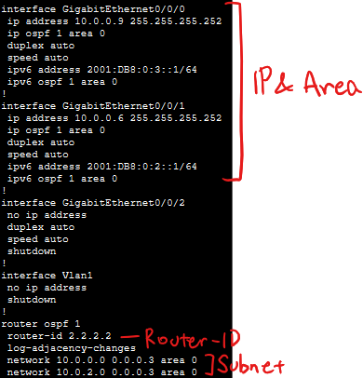
Figure 04. Original lab capture for R2; separate from the corrected reference configuration.

R3: Corrected Reference Configuration
enable
configure terminal
hostname R3
ipv6 unicast-routing
router ospf 1
router-id 3.3.3.3
exit
ipv6 router ospf 1
router-id 3.3.3.3
exit
interface g0/0/0
description Link to R2 g0/0/0
ip address 10.0.0.10 255.255.255.252
ip ospf 1 area 0
ipv6 address 2001:db8:0:3::2/64
ipv6 ospf 1 area 0
no shutdown
exit
interface g0/0/1
description Link to S1 fa0/1
ip address 10.0.0.13 255.255.255.252
ip ospf 1 area 0
ipv6 address 2001:db8:0:4::1/64
ipv6 ospf 1 area 0
no shutdown
exit
end
show running-config
show ip ospf neighbor
show ipv6 ospf neighbor
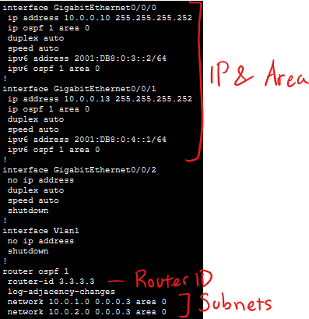
Figure 05. Original lab capture for R3; separate from the corrected reference configuration.

S1: Corrected Reference Configuration
enable
configure terminal
hostname S1
ip routing
ipv6 unicast-routing
router ospf 1
router-id 10.10.10.10
exit
ipv6 router ospf 1
router-id 10.10.10.10
exit
interface fa0/1
description Link to R3 g0/0/1
no switchport
ip address 10.0.0.14 255.255.255.252
ip ospf 1 area 0
ipv6 address 2001:db8:0:4::2/64
ipv6 ospf 1 area 0
no shutdown
exit
interface fa0/2
description Link to R1 g0/0/1
no switchport
ip address 10.0.0.17 255.255.255.252
ip ospf 1 area 0
ipv6 address 2001:db8:0:5::2/64
ipv6 ospf 1 area 0
no shutdown
exit
interface fa0/10
description Link to R5 g0/0/0
no switchport
ip address 192.168.10.1 255.255.255.0
ip ospf 1 area 1
ipv6 address 2001:db8:1:1::2/64
ipv6 ospf 1 area 1
no shutdown
exit
end
show running-config
show ip ospf neighbor
show ipv6 ospf neighbor
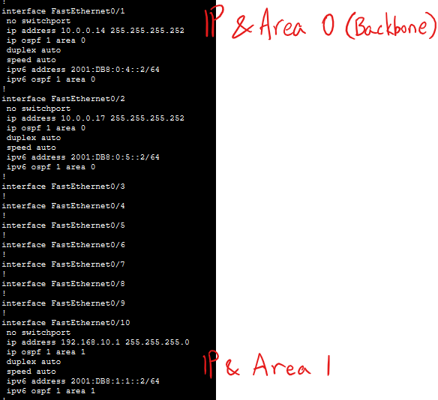
Figure 06. Original lab capture for S1; separate from the corrected reference configuration.
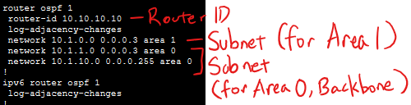
Figure 07. Original lab capture for S1; separate from the corrected reference configuration.

S2: Corrected Reference Configuration
enable
configure terminal
hostname S2
ip routing
ipv6 unicast-routing
router ospf 1
router-id 11.11.11.11
exit
ipv6 router ospf 1
router-id 11.11.11.11
exit
interface fa0/1
description Link to R1 g0/0/0
no switchport
ip address 10.0.0.2 255.255.255.252
ip ospf 1 area 0
ipv6 address 2001:db8:0:1::2/64
ipv6 ospf 1 area 0
no shutdown
exit
interface fa0/2
description Link to R2 g0/0/1
no switchport
ip address 10.0.0.5 255.255.255.252
ip ospf 1 area 0
ipv6 address 2001:db8:0:2::1/64
ipv6 ospf 1 area 0
no shutdown
exit
interface fa0/10
description Link to R4 g0/0/0
no switchport
ip address 192.168.20.1 255.255.255.0
ip ospf 1 area 2
ipv6 address 2001:db8:2:1::2/64
ipv6 ospf 1 area 2
no shutdown
exit
end
show running-config
show ip ospf neighbor
show ipv6 ospf neighbor
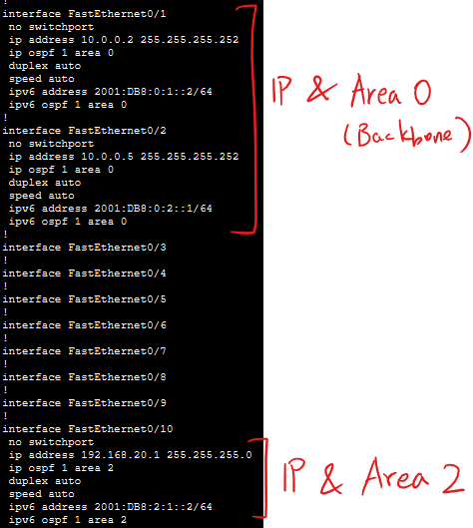
Figure 08. Original lab capture for S2; separate from the corrected reference configuration.
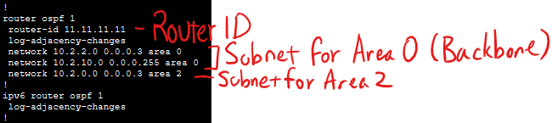
Figure 09. Original lab capture for S2; separate from the corrected reference configuration.

R4: Corrected Reference Configuration
enable
configure terminal
hostname R4
ipv6 unicast-routing
router ospf 1
router-id 4.4.4.4
exit
ipv6 router ospf 1
router-id 4.4.4.4
exit
interface g0/0/0
description Link to S2 fa0/10
ip address 192.168.20.2 255.255.255.0
ip ospf 1 area 2
ipv6 address 2001:db8:2:1::1/64
ipv6 ospf 1 area 2
no shutdown
exit
end
show running-config
show ip ospf neighbor
show ipv6 ospf neighbor
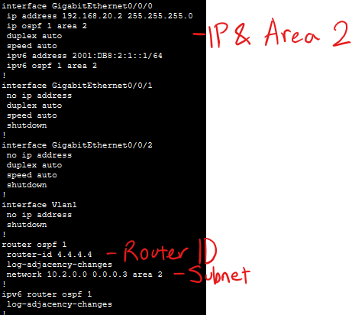
Figure 10. Original lab capture for R4; separate from the corrected reference configuration.

R5: Corrected Reference Configuration
enable
configure terminal
hostname R5
ipv6 unicast-routing
router ospf 1
router-id 5.5.5.5
exit
ipv6 router ospf 1
router-id 5.5.5.5
exit
interface g0/0/0
description Link to S1 fa0/10
ip address 192.168.10.2 255.255.255.0
ip ospf 1 area 1
ipv6 address 2001:db8:1:1::1/64
ipv6 ospf 1 area 1
no shutdown
exit
end
show running-config
show ip ospf neighbor
show ipv6 ospf neighbor
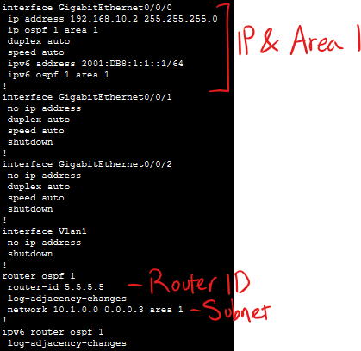
Figure 11. Original lab capture for R5; separate from the corrected reference configuration.
Verification Commands and Original Routing Output
Use these IOS verification commands after applying the reference configuration. When the topology converges, the diagram predicts two neighbors each for R1, R2, and R3, three each for S1 and S2, and one each for R4 and R5. These are expected counts, not newly measured results.
show ip interface brief
show ipv6 interface brief
show ip ospf neighbor
show ip route ospf
show ip ospf
show ipv6 ospf neighbor
show ipv6 route ospf
show ipv6 ospf
From R1, test IPv4 reachability to 192.168.10.2 and 192.168.20.2, and IPv6 reachability to 2001:db8:1:1::1 and 2001:db8:2:1::1. Inspect learned inter-area routes and resolve missing neighbors before claiming convergence. The following images are original lab output.

Router 1
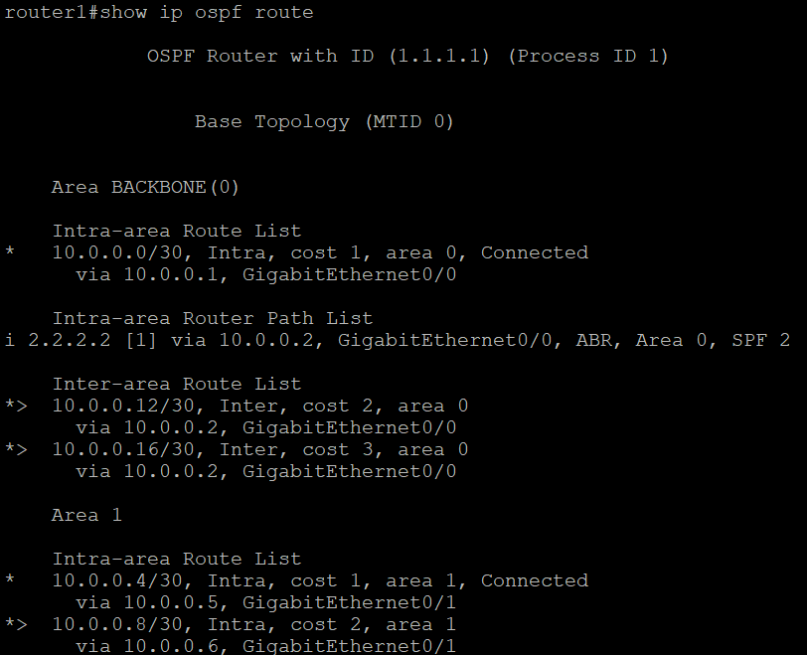
Figure 12. Router 1

Router 2
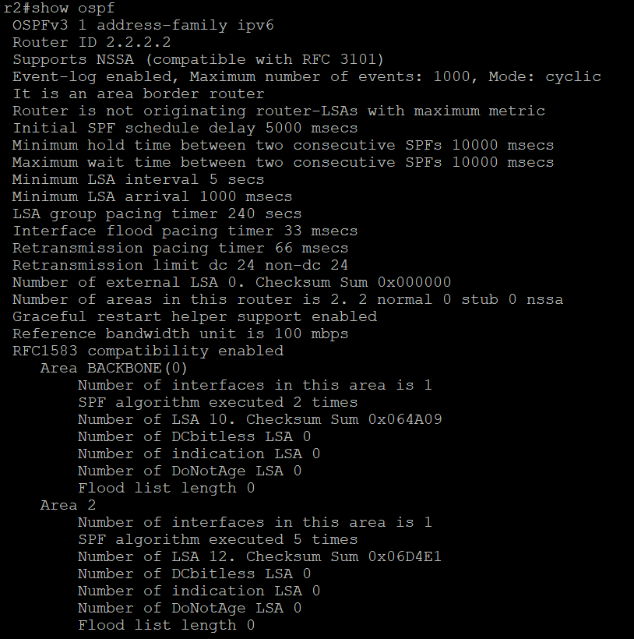
Figure 13. Router 2

Router 3
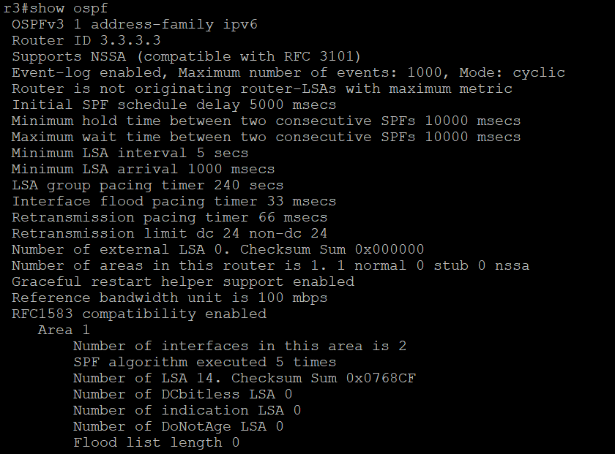
Figure 14. Router 3

Router 4
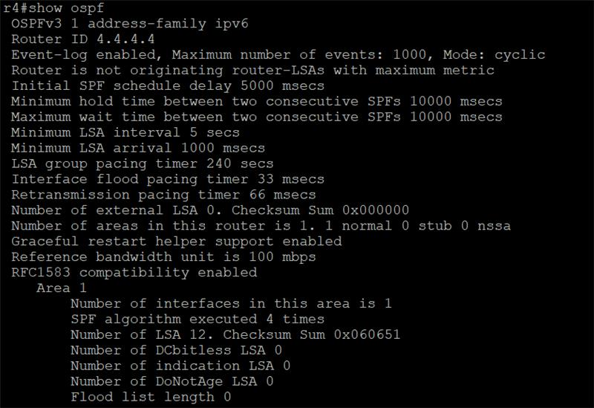
Figure 15. Router 4

Router 5
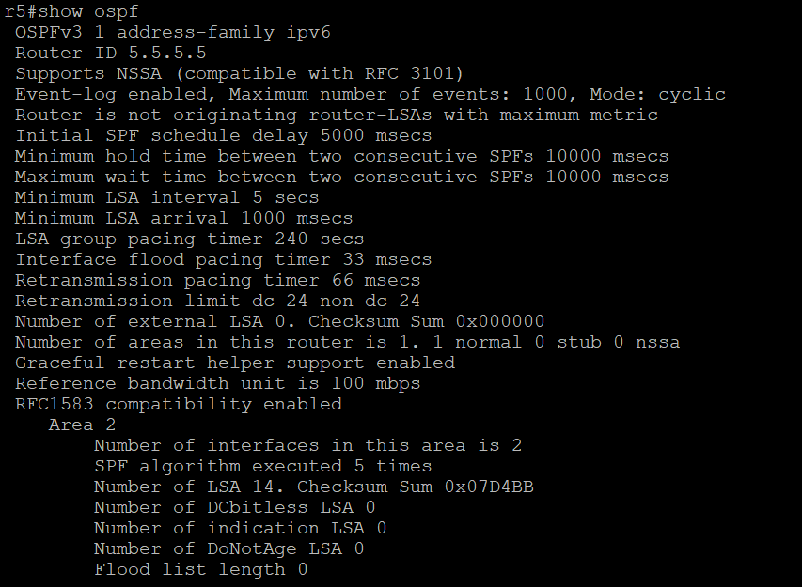
Figure 16. Router 5
Original OSPF Process Output

Router 1
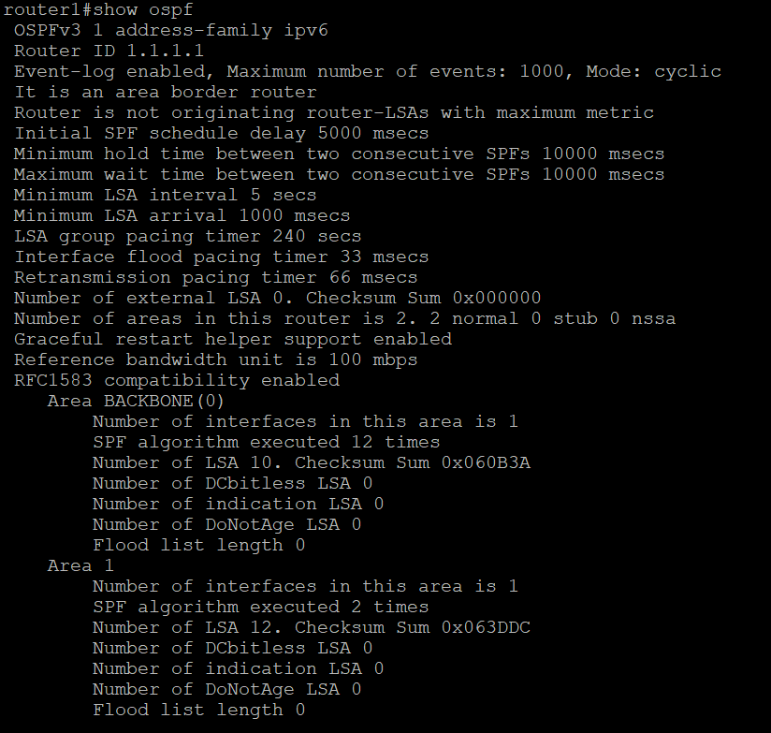
Figure 17. Router 1

Router 2
Figure 18. Router 2

Router 3
Figure 19. Router 3

Router 4
Figure 20. Router 4

Router 5
Figure 21. Router 5

Troubleshooting and Lessons Learned
OSPF neighbors did not initially appear. After reviewing the configuration and discussing the issue with peers, the lab team identified mistyped IP addresses on two routers. Correcting those addresses resolved the reported neighbor issue.

Conclusion
The exercise developed experience with multi-area OSPF design, router IDs, interface addressing, and command-line troubleshooting. It also reinforced the importance of checking IPv4 and IPv6 addresses and validating area membership when adjacencies fail.

