  - LAB 03 / NETWORK ROUTING

BGP and Route Redistribution
  - Interconnecting OSPF, EIGRP, and IS-IS routing domains
Cristian K. Leung | Academic Lab Portfolio

Executive Summary
Documented a routing lab that connects different interior routing domains through BGP. Addressing tables, command references, device configurations, and routing-table excerpts show the structure of the exercise and the troubleshooting process.

Skills Demonstrated
eBGP · OSPF · EIGRP · IS-IS · Route redistribution · Dual-stack addressing
- Documented BGP integration across OSPF, EIGRP, and IS-IS domains.
- Organized device addressing and protocol commands for review.
- Diagnosed mismatched network statements and autonomous system numbers.

Evidence Included
IPv4 and IPv6 topology diagrams, eight reference tables, six router configurations, and routing-table excerpts.

Objective
The objective was to configure BGP between routing domains that use different interior gateway protocols and document how those domains exchange reachability information.

Technical Background
Border Gateway Protocol (BGP) exchanges reachability information between autonomous systems. Interior gateway protocols such as OSPF, EIGRP, and IS-IS provide routing within a domain. This lab connects those domains using BGP and route redistribution.
OSPF and IS-IS are link-state routing protocols. Their suitability depends on network design and operational requirements. This lab uses them in separate routing domains and examines their integration with BGP.
Enhanced Interior Gateway Routing Protocol (EIGRP) is used in another part of the topology. The exercise includes redistribution between EIGRP and BGP to exchange routes across domain boundaries.
IPv4 uses 32-bit addresses and IPv6 uses 128-bit addresses. The lab records both address families in its topology and interface tables.

Network Topology

IPv4
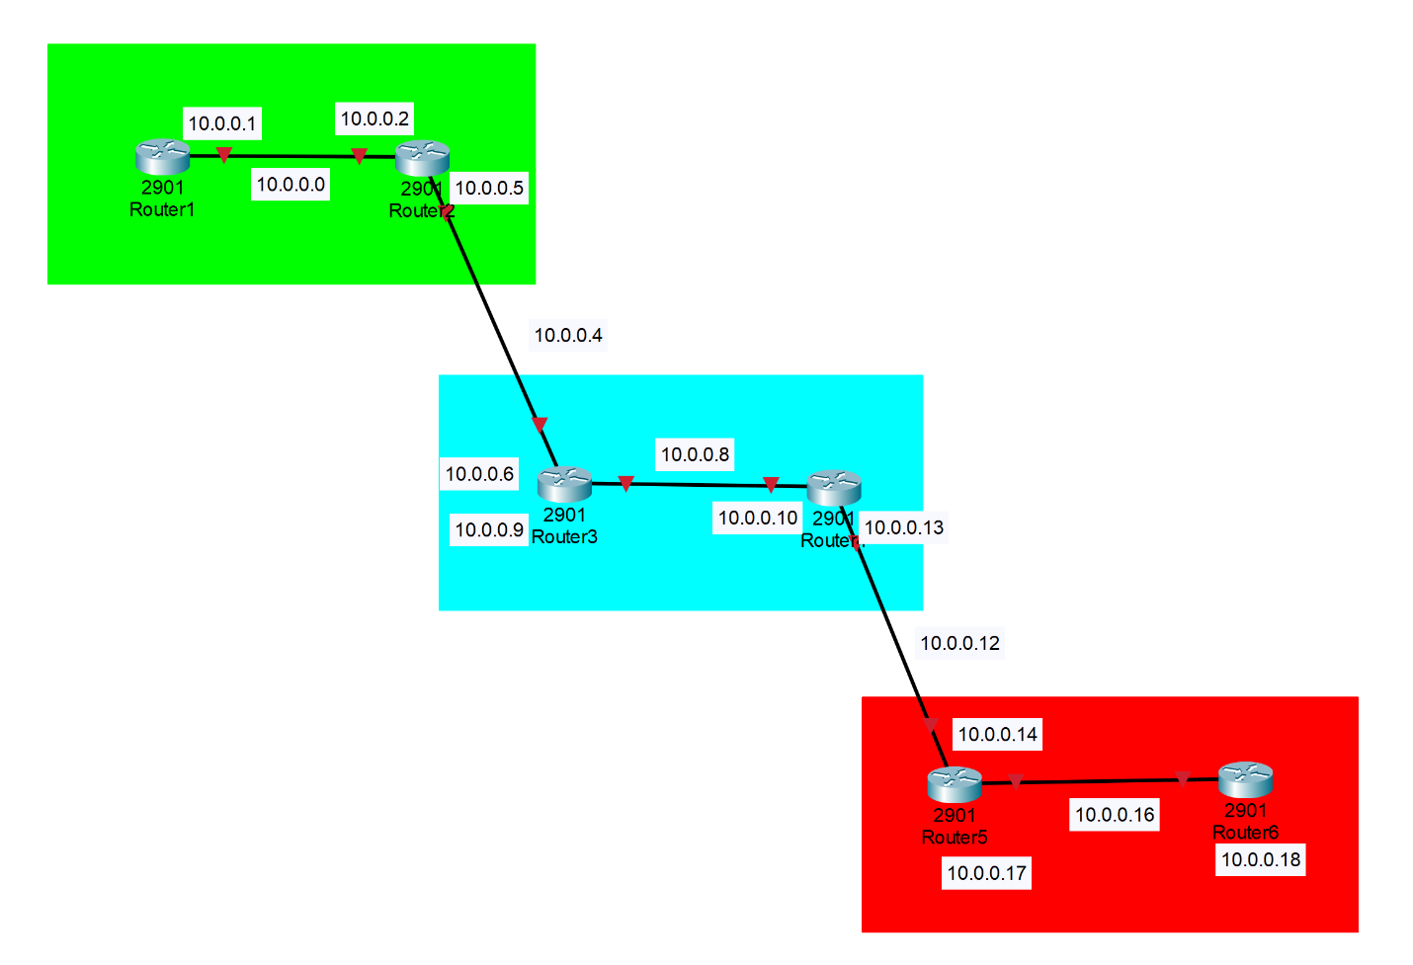
Figure 01. IPv4

IPv6
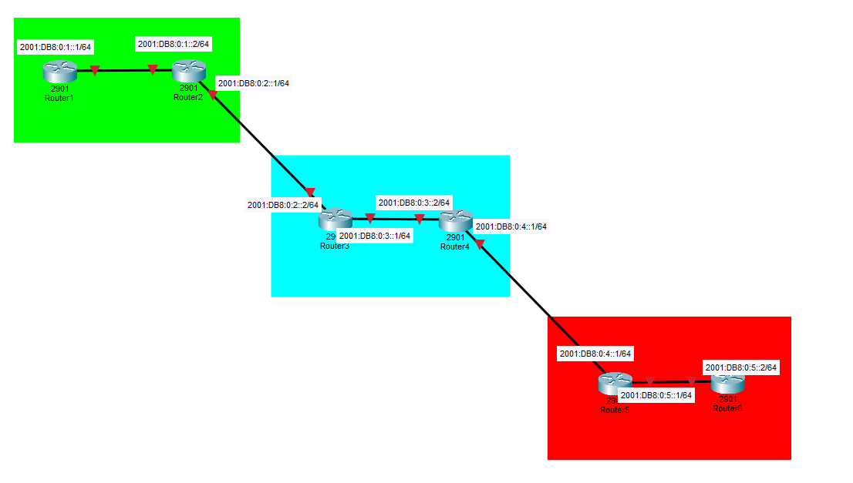
Figure 02. IPv6

Procedure and Evidence

Device Addressing Reference
Device name | Interface | IPv4 address | Subnet mask | IPv6 address
R1 | G0/1 | 10.0.0.1 | 255.255.255.252 | 2001:DB8:0:1::1/64
R2 | G0/0 | 10.0.0.2 | 255.255.255.252 | 2001:DB8:0:1::2/64
R2 | G0/1 | 10.0.0.5 | 255.255.255.252 | 2001:DB8:0:2::1/64
R3 | G0/0 | 10.0.0.6 | 255.255.255.252 | 2001:DB8:0:2::2/64
R3 | G0/1 | 10.0.0.9 | 255.255.255.252 | 2001:DB8:0:3::1/64
R4 | G0/0 | 10.0.0.10 | 255.255.255.252 | 2001:DB8:0:3::2/64
R4 | G0/1 | 10.0.0.13 | 255.255.255.252 | 2001:DB8:0:4::1/64
R5 | G0/0 | 10.0.0.14 | 255.255.255.252 | 2001:DB8:0:4::2/64
R5 | G0/1 | 10.0.0.17 | 255.255.255.252 | 2001:DB8:0:5::1/64
R6 | G0/0 | 10.0.0.18 | 255.255.255.252 | 2001:DB8:0:5::2/64

Command Reference
Common commands | Description
Hostname <name> | Sets the router’s device name.
ipv6 unicast-routing | Enables IPv6 routing on the router.
interface <interface number> | Enters interface configuration mode
ip address <ip address> <subnet mask> | Designates IPv4 addresses and subnet mask.
ipv6 address address <ipv6 address>/<CIDR> | Designates IPv6 addresses and subnet.
Router 1 commands | Description
router ospf <#> | Starts OSPF process #.
router-id X.X.X.X | Manually sets the OSPF Router ID.
network <ip address> <wildcard mask> area <#> | Enables OSPF on matching interfaces.
ipv6 router ospf # | Starts OSPFv3 process #
ipv6 ospf # area # | Assigns an interface to use OSPF #
Router 2 commands | Description
router ospf <#> | Starts OSPF process #.
router-id X.X.X.X | Manually sets the OSPF Router ID.
network <ip address> <wildcard mask> area <#> | Enables OSPF on matching interfaces.
ipv6 router ospf # | Starts OSPFv3 process #.
ipv6 ospf # area # | Assigns an interface to use OSPF #.
router bgp <AS> | Starts BGP for the given AS.
bgp router-id 2.2.2.2 | Sets BGP router ID.
neighbor <IP address> remote-as <AS> | Defines an IPv4 BGP neighbor for connectivity.
neighbor <IPv6 address> remote-as <AS> | Defines an IPv6 BGP neighbor for connectivity.
address-family ipv4 | Enters IPv4 BGP configuration mode.
address-family ipv6 | Enters IPv6 BGP configuration mode.
redistribute connected | Injects connected routes into BGP
redistribute ospf 1 | Injects OSPF routes into BGP
neighbor <IPv4 or IPv6> activate | Enables BGP for that neighbor in the address family.
exit-address-family | Exits IP BGP configuration mode.
Router 3 commands | Description
router eigrp <AS> | Starts EIGRP AS.
network <IP address> <wildcard bit> | Enables EIGRP on interfaces matching the network.
redistribute bgp <AS> metric <BW> <DLY> <REL> <LOAD> <MTU> | Injects BGP routes into EIGRP.
eigrp router-id X.X.X.X | Sets EIGRP router ID.
ipv6 eigrp 1 | Enables IPv6 EIGRP on interface.
router bgp <AS> | Starts BGP for the given AS.
bgp router-id 2.2.2.2 | Sets BGP router ID.
neighbor <IP address> remote-as <AS> | Defines an IPv4 BGP neighbor for connectivity.
neighbor <IPv6 address> remote-as <AS> | Defines an IPv6 BGP neighbor for connectivity.
address-family ipv4 | Enters IPv4 BGP configuration mode.
address-family ipv6 | Enters IPv6 BGP configuration mode.
redistribute connected | Injects connected routes into BGP
redistribute eigrp 1 | Injects EIBRP routes into BGP
neighbor <IPv4 or IPv6> activate | Enables BGP for that neighbor in the address family.
exit-address-family | Exits IP BGP configuration mode.
ip prefix-list <name> seq 5 permit 0.0.0.0/0 le 32 (OPTIONAL) | Creates a list that permits all matched IPv4 routes.
route-map <name> permit 20 (OPTIONAL) | Creates a routing policy.
set local-preference 200 (OPTIONAL) | Sets BGP local preference. (Higher is more preferred.)
match ip address prefix-list <name> (OPTIONAL) | Matches the routing policy to the prefix list.
neighbor <IP> route-map <Route-map name> in (OPTIONAL) | Applies route-map routing policy to the neighbor.
Router 4 commands | Description
router eigrp <AS> | Starts EIGRP AS.
network <IP address> <wildcard bit> | Enables EIGRP on interfaces matching the network.
redistribute bgp <AS> metric <BW> <DLY> <REL> <LOAD> <MTU> | Injects BGP routes into EIGRP.
eigrp router-id X.X.X.X | Sets EIGRP router ID.
ipv6 eigrp 1 | Enables IPv6 EIGRP on interface.
router bgp <AS> | Starts BGP for the given AS.
bgp router-id X.X.X.X | Sets BGP router ID.
neighbor <IP address> remote-as <AS> | Defines an IPv4 BGP neighbor for connectivity.
neighbor <IPv6 address> remote-as <AS> | Defines an IPv6 BGP neighbor for connectivity.
address-family ipv4 | Enters IPv4 BGP configuration mode.
address-family ipv6 | Enters IPv6 BGP configuration mode.
redistribute connected | Injects connected routes into BGP
redistribute eigrp 1 | Injects EIBRP routes into BGP
neighbor <IPv4 or IPv6> activate | Enables BGP for that neighbor in the address family.
exit-address-family | Exits IP BGP configuration mode.
Router 5 commands | Description
router isis | Starts IS-IS routing process.
net 49.XXXX.XXXX.XXXX.XXXX.XX | Sets the IS-IS NET (Network Entity Title).
is-type level-1 | Configures to only operate as a Level-1 Router.
metric-style wide | Enables modern wide metrics.
redistribute bgp 3 metric 30 level-1 | Injects BGP routes into IS-IS level 1.
ip router isis | Enables IS-IS for IPv4 on an interface.
ipv6 router isis | Enables IS-IS for IPv6 on an interface.
router bgp <AS> | Starts BGP for the given AS.
bgp router-id X.X.X.X | Sets BGP router ID.
neighbor <IP address> remote-as <AS> | Defines an IPv4 BGP neighbor for connectivity.
neighbor <IPv6 address> remote-as <AS> | Defines an IPv6 BGP neighbor for connectivity.
address-family ipv4 | Enters IPv4 BGP configuration mode.
address-family ipv6 | Enters IPv6 BGP configuration mode.
redistribute connected | Injects connected routes into BGP
redistribute isis level-1 metric 10 | Injects IS-IS routes into BGP
redistribute bgp 3 metric 30 level-1 | Injects BGP routes into IS-IS Level-1
neighbor <IPv4 or IPv6> activate | Enables BGP for that neighbor in the address family.
exit-address-family | Exits IP BGP configuration mode.
Router 6 commands | Description
router isis | Starts IS-IS routing process.
net 49.XXXX.XXXX.XXXX.XXXX.XX | Sets the IS-IS NET (Network Entity Title).
is-type level-1 | Configures to only operate as a Level-1 Router.
metric-style wide | Enables modern wide metrics.
redistribute bgp 3 metric 30 level-1 | Injects BGP routes into IS-IS level 1.
ip router isis | Enables IS-IS for IPv4 on an interface.
ipv6 router isis | Enables IS-IS for IPv6 on an interface.

Device Configurations
The following sections retain device configurations and routing output from the original lab. Review the addressing table and protocol-specific command references alongside these excerpts.

Router 1
version 15.2
!
hostname R1
!
!
ipv6 unicast-routing
!
interface Loopback0
ip address 1.1.1.1 255.255.255.255
!
interface GigabitEthernet0/0
no ip address
duplex auto
speed auto
!
interface GigabitEthernet0/1
ip address 10.0.0.1 255.255.255.252
ip ospf dead-interval 6
ip ospf hello-interval 2
duplex auto
speed auto
ipv6 address 2001:DB8:0:1::1/64
ipv6 ospf 1 area 0
!
router ospf 1
router-id 1.1.1.1
network 1.1.1.1 0.0.0.0 area 0
network 2.2.2.2 0.0.0.0 area 0
network 10.0.0.0 0.0.0.3 area 0
network 10.0.0.4 0.0.0.3 area 0
!
ipv6 router ospf 1
router-id 1.1.1.1
!
!
end

Router 2
version 15.4
!
hostname router2
!
interface GigabitEthernet0/0
ip address 10.0.0.2 255.255.255.252
duplex auto
speed auto
ipv6 address 2001:DB8:0:1::2/64
ipv6 ospf 1 area 0
!
interface GigabitEthernet0/1
ip address 10.0.0.5 255.255.255.252
duplex auto
speed auto
ipv6 address 2001:DB8:0:2::1/64
!
router ospf 1
router-id 2.2.2.2
redistribute bgp 1 metric 10 subnets
network 10.0.0.0 0.0.0.3 area 0
network 10.0.0.4 0.0.0.3 area 0
network 10.0.0.12 0.0.0.3 area 0
!
router bgp 1
bgp router-id 2.2.2.2
bgp log-neighbor-changes
neighbor 10.0.0.6 remote-as 2
neighbor 2001:DB8:0:2::2 remote-as 2
!
address-family ipv4
redistribute connected
redistribute ospf 1
neighbor 10.0.0.6 activate
no neighbor 2001:DB8:0:2::2 activate
exit-address-family
!
address-family ipv6
redistribute connected
redistribute ospf 1 metric 10
neighbor 2001:DB8:0:2::2 activate
exit-address-family
!
ipv6 router ospf 1
router-id 2.2.2.2
redistribute bgp 1 metric 10
!
!
end

Router 3
version 15.4
hostname router3
ipv6 unicast-routing
!
!
interface GigabitEthernet0/0
ip address 10.0.0.9 255.255.255.252
duplex auto
speed auto
ipv6 address 2001:DB8:0:3::1/64
!
interface GigabitEthernet0/1
ip address 10.0.0.6 255.255.255.252
duplex auto
speed auto
ipv6 address 2001:DB8:0:2::2/64
ipv6 eigrp 1
!
!
router eigrp 1
network 10.0.0.4 0.0.0.3
network 10.0.0.8 0.0.0.3
redistribute bgp 2 metric 100 1 255 1 1500
eigrp router-id 3.3.3.3
!
router bgp 2
bgp router-id 3.3.3.3
bgp log-neighbor-changes
neighbor 10.0.0.5 remote-as 1
neighbor 2001:DB8:0:2::1 remote-as 1
!
address-family ipv4
redistribute connected
redistribute eigrp 1
neighbor 10.0.0.5 activate
neighbor 10.0.0.5 weight 200
neighbor 10.0.0.5 route-map jeffreymap in
no neighbor 2001:DB8:0:2::1 activate
exit-address-family
!
address-family ipv6
redistribute connected
redistribute eigrp 1
neighbor 2001:DB8:0:2::1 activate
exit-address-family
!
!
!
ip prefix-list jeffrey seq 5 permit 0.0.0.0/0 le 32
ipv6 router eigrp 1
eigrp router-id 3.3.3.3
redistribute bgp 2 metric 100 1 255 1 1500
!
!
route-map jeffreymap permit 20
match ip address prefix-list jeffrey
set local-preference 200
!
end

Router 4
version 15.2
!
ipv6 unicast-routing
!
interface Loopback0
ip address 4.4.4.4 255.255.255.255
!
interface GigabitEthernet0/0
ip address 10.0.0.13 255.255.255.252
duplex auto
speed auto
ipv6 address 2001:DB8:0:4::1/64
ipv6 eigrp 1
!
interface GigabitEthernet0/1
ip address 10.0.0.10 255.255.255.252
duplex auto
speed auto
ipv6 address 2001:DB8:0:3::2/64
ipv6 eigrp 1
!
!
router eigrp 1
network 4.4.4.4 0.0.0.0
network 10.0.0.8 0.0.0.3
network 10.0.0.12 0.0.0.3
redistribute bgp 2 metric 100 1 255 1 1500
eigrp router-id 4.4.4.4
!
router bgp 2
bgp router-id 4.4.4.4
bgp log-neighbor-changes
neighbor 10.0.0.14 remote-as 3
neighbor 2001:DB8:0:4::2 remote-as 3
!
address-family ipv4
redistribute connected
redistribute eigrp 1
neighbor 10.0.0.14 activate
neighbor 10.0.0.14 weight 200
no neighbor 2001:DB8:0:4::2 activate
exit-address-family
!
address-family ipv6
redistribute connected
redistribute eigrp 1
neighbor 2001:DB8:0:4::2 activate
exit-address-family
!
ip forward-protocol nd
!
no ip http server
no ip http secure-server
!
!
ipv6 router eigrp 1
eigrp router-id 4.4.4.4
redistribute bgp 2 metric 100 1 255 1 1500
!
end

Router 5
version 15.4
!
hostname router5
!
ipv6 unicast-routing
!
interface Loopback0
ip address 5.5.5.5 255.255.255.255
ip router isis
!
interface GigabitEthernet0/0
ip address 10.0.0.17 255.255.255.252
ip router isis
duplex auto
speed auto
ipv6 address 2001:DB8:0:5::1/64
ipv6 router isis
!
interface GigabitEthernet0/1
ip address 10.0.0.14 255.255.255.252
ip router isis
duplex auto
speed auto
ipv6 address 2001:DB8:0:4::2/64
ipv6 router isis
!
router isis
net 49.0001.0000.0000.000a.00
is-type level-1
metric-style wide
log-adjacency-changes
redistribute bgp 3 metric 30 level-1
!
address-family ipv6
redistribute bgp 3 metric 30 level-1
exit-address-family
!
router bgp 3
bgp router-id 5.5.5.5
bgp log-neighbor-changes
no bgp default ipv4-unicast
neighbor 10.0.0.13 remote-as 2
!
address-family ipv4
redistribute connected
redistribute isis level-1 metric 10
neighbor 10.0.0.13 activate
exit-address-family
!
end

Router 6
version 15.4
!
ipv6 unicast-routing
!
interface Loopback0
ip address 6.6.6.6 255.255.255.255
ip router isis
!
interface GigabitEthernet0/0
ip address 10.0.0.18 255.255.255.252
ip router isis
duplex auto
speed auto
ipv6 address 2001:DB8:0:5::2/64
ipv6 router isis
!
interface GigabitEthernet0/1
no ip address
duplex auto
speed auto
!
router isis
net 49.0001.0000.0000.000b.00
is-type level-1
metric-style wide
log-adjacency-changes
!
end
Show routes (Use “show ip route” to double check everything matches up with the text below):
Router 1:
C 1.1.1.1/32 is directly connected, Loopback0
C 10.0.0.0/30 is directly connected, Gi0/1
O E2 4.4.4.4/32 [110/10] via 10.0.0.2, Gi0/1
O E2 5.5.5.5/32 [110/10] via 10.0.0.2, Gi0/1
O E2 6.6.6.6/32 [110/10] via 10.0.0.2, Gi0/1
O E2 10.0.0.4/30 [110/10] via 10.0.0.2, Gi0/1
O E2 10.0.0.8/30 [110/10] via 10.0.0.2, Gi0/1
O E2 10.0.0.12/30 [110/10] via 10.0.0.2, Gi0/1
O E2 10.0.0.16/30 [110/10] via 10.0.0.2, Gi0/1

Router 2
C 10.0.0.0/30 is directly connected, Gi0/0
L 10.0.0.1/30 is directly connected, Gi0/0
O 1.1.1.1/32 [110/10] via 10.0.0.1, Gi0/0
B 4.4.4.4/32 [20/0] via 10.0.0.6
B 5.5.5.5/32 [20/25600512] via 10.0.0.6
B 6.6.6.6/32 [20/25600512] via 10.0.0.6
C 10.0.0.4/30 is directly connected, Gi0/1
L 10.0.0.6/30 is directly connected, Gi0/1
B 10.0.0.8/30 [20/??] via 10.0.0.6
B 10.0.0.12/30 [20/??] via 10.0.0.6
B 10.0.0.16/30 [20/??] via 10.0.0.6

Router 3
B 10.0.0.0/30 [20/0] via 10.0.0.6
C 10.0.0.4/30 is directly connected, GigabitEthernet0/1
L 10.0.0.5/30 is directly connected, Gi0/1
D EX 10.0.0.16/30
D 4.4.4.4/32 [90/3072] via 10.0.0.10, Gi0/0
C 10.0.0.8/30 is directly connected, Gi0/0
L 10.0.0.10/30 is directly connected, Gi0/0
B 1.1.1.1/32 [20/2] via 10.0.0.5, Gi0/1
B 5.5.5.5/32 [20/0] via 10.0.0.5, Gi0/1
B 6.6.6.6/32 [20/2] via 10.0.0.5, Gi0/1

Router 4
D EX 10.0.0.0/30
[170/25600512] via 10.0.0.8, 01:08:02, Gi0/0
C 10.0.0.8/30 is directly connected, Gi0/0
L 10.0.0.10/30 is directly connected, Gi0/0
B 10.0.0.16/30 [20/0] via 10.0.0.14, 01:08:50
D 10.0.0.4/30 [90/3072] via 10.0.0.9, 01:08:02, Gi/0/0
10.0.0.12/30 is variably subnetted, 2 subnets, 2 masks
C 10.0.0.12/30 is directly connected, Gi0/1
L 10.0.0.14/30 is directly connected, Gi0/1

Router 5
B 10.0.0.0/30 [20/25600512] via 10.0.0.12, 01:08:36
B 10.0.0.8/30 [20/0] via 10.0.0.13, 01:08:36
C 10.0.0.16/30 is directly connected, Gi0/1
L 10.0.0.17/30 is directly connected, Gi0/1
B 10.0.0.4/30 [20/3072] via 10.0.0.13, 01:08:36
10.0.0.12/30 is variably subnetted, 2 subnets, 2 masks
C 10.0.0.12/30 is directly connected, Gi0/0
L 10.0.0.14/30 is directly connected, Gi0/0

Router 6
i L1 10.0.0.0/30 [115/40] via 10.0.0.17, 01:08:35, Gi0/0
i L1 10.0.0.8/30 [115/40] via 10.0.0.17, 01:08:35, Gi0/0
C 10.0.0.16/30 is directly connected, Gi0/0
L 10.0.0.18/30 is directly connected, Gi0/0
i L1 10.0.0.4/30 [115/40] via 10.0.0.17, 01:08:35, Gi0/0
i L1 10.0.0.8/30 [115/20] via 10.0.0.17, 01:09:26, Gi0/0

Troubleshooting and Lessons Learned
The team revised the initial topology after discussion and trial configurations. Mismatched network statements and autonomous system numbers then caused repeated BGP console errors. Temporarily suppressing console logging made the session easier to use, but it did not correct the routing configuration. Reviewing AS numbers, neighbors, and network statements identified the configuration issue. Console logging should be restored after troubleshooting.

Conclusion
The lab provided experience integrating multiple interior routing domains through BGP. It reinforced careful tracking of autonomous system numbers, neighbor relationships, redistribution settings, and device addressing when diagnosing routing failures.

