  - LAB 01 / NETWORK SECURITY

Layer 2 Attacks and Mitigations
  - MAC flooding, ARP spoofing, and DHCP starvation
Cristian K. Leung | Academic Lab Portfolio

Executive Summary
Examined three Layer 2 attack techniques in a lab network and documented switch controls intended to reduce their impact. The report pairs packet and network observations with configuration excerpts and troubleshooting lessons.

Skills Demonstrated
Cisco switching · DHCP snooping · Dynamic ARP inspection · Port security · Wireshark
- Compared MAC flooding, ARP spoofing, and DHCP starvation behavior.
- Documented port security, DHCP snooping, and trusted-port configuration.
- Troubleshot DHCP recovery delays and virtual-machine stability.

Evidence Included
Topology diagram, host network settings, packet-capture screenshots, and switch configuration excerpts.
The text includes corrected IOS mitigation examples. The original screenshots document the lab session; the reference configuration assumes VLAN 1, a trusted router uplink on Fa0/1, and an untrusted client on Fa0/2.

Objective
The objective was to observe MAC flooding, ARP spoofing, and DHCP starvation in a lab network and document switch controls intended to mitigate those behaviors.

Technical Background
Ethernet switching relies on mechanisms such as MAC learning, ARP, and DHCP. When these mechanisms lack sufficient validation, an attacker connected to the network may disrupt forwarding, manipulate address resolution, or exhaust address leases. The lab examines those behaviors and related switch controls.
Port security can limit learned MAC addresses. DHCP snooping distinguishes trusted DHCP-server paths from untrusted access ports and builds binding information. Dynamic ARP inspection uses configured validation rules and, commonly, DHCP snooping bindings to inspect ARP traffic.
MAC flooding sends many source MAC addresses to stress a switch’s forwarding table. The forwarding behavior depends on the device and its configuration; packet captures and table inspection provide evidence of the observed lab behavior.
ARP spoofing sends misleading ARP messages to associate an IP address with an incorrect MAC address. This can redirect or disrupt local network traffic.
DHCP starvation consumes available address leases through repeated client requests, potentially preventing legitimate hosts from obtaining an address.

Network Topology
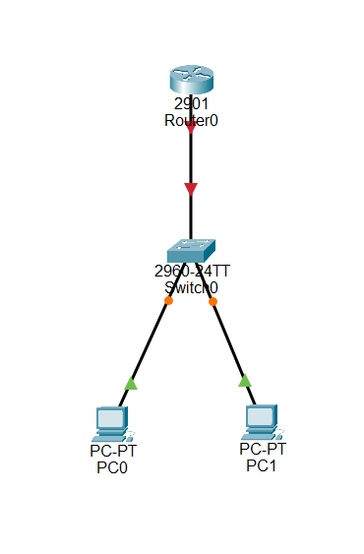
Figure 01. Network Topology

Procedure and Evidence
The exercise used a Linux environment and Cisco network devices. The following procedure retains the original lab sequence and supporting screenshots.
Configure DHCP on the lab router using the original address pool below. The mitigation examples assume untagged VLAN 1, a verified router/DHCP uplink on Fa0/1, and an untrusted client on Fa0/2; confirm these physical connections before applying them.
!
hostname R1
!
ip dhcp excluded-address 192.168.1.1 192.168.1.10
!
ip dhcp pool LAN
network 192.168.1.0 255.255.255.0
default-router 192.168.1.1
!
interface G0/0
ip address 192.168.1.1 255.255.255.0
no shut
!
Next go to control panel and configure your ethernet port your using to receive addresses from DHCP
Configure the host Ethernet adapter to obtain its IPv4 settings through DHCP.
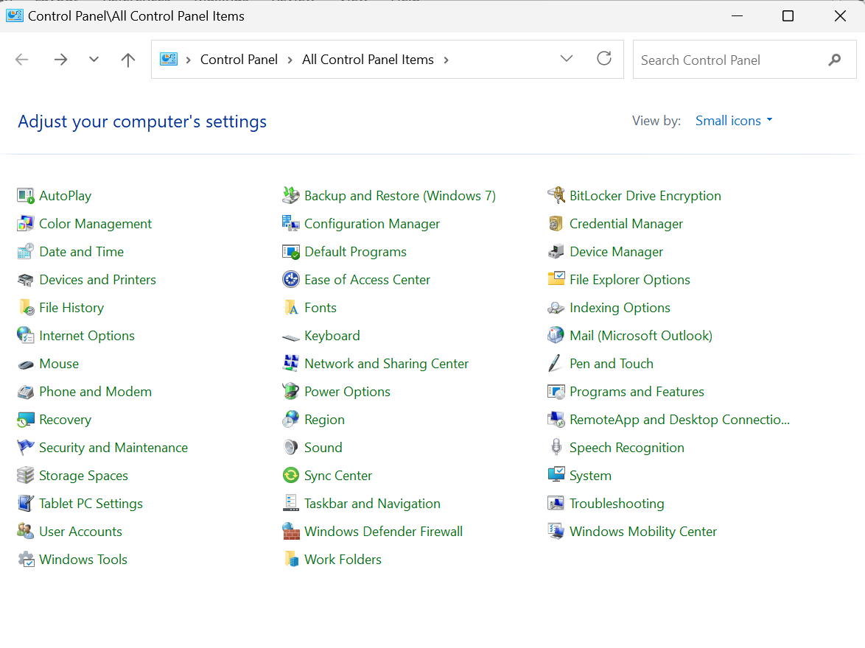
Figure 02. Configure the host Ethernet adapter to obtain its IPv4 settings through DHCP.
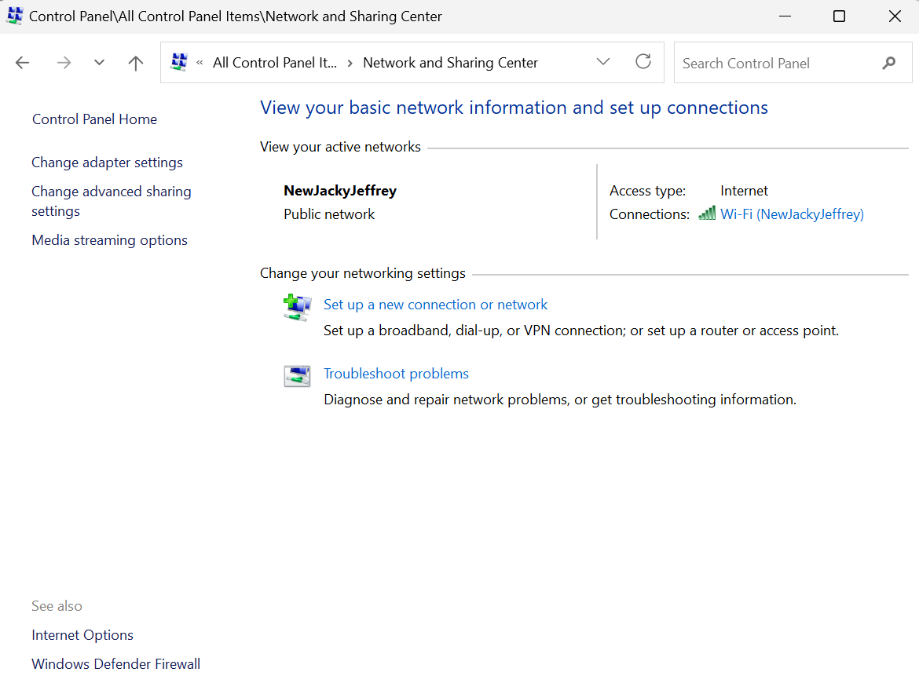
Figure 03. Configure the host Ethernet adapter to obtain its IPv4 settings through DHCP.
With DHCP configured, proceed to the attack observations and mitigation sections.

MAC Flooding
In Linux open the terminal and install Dsniff with the following command:
sudo apt install dsniff
To start flooding MAC addresses use the next command:
sudo macof -i eth0
Use Ctrl+C to stop the command. Observe traffic in Wireshark and inspect the switch MAC address table to compare forwarding behavior during the exercise.
During the lab, compare the victim host’s connectivity with the packets visible in the capture. The extent of visible traffic depends on the switch and its forwarding state.
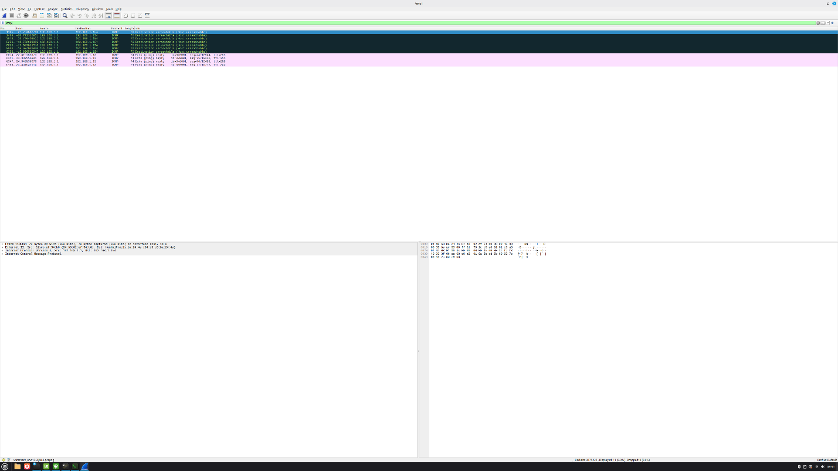
Figure 04. During the lab, compare the victim host’s connectivity with the packets visible in the capture. The extent of visible traffic depends on the…

Mitigation
Apply port security to the untrusted client access port. This example permits at most five learned MAC addresses and disables the port on a port-security violation.
hostname S1
!
interface FastEthernet0/2
switchport mode access
switchport port-security
switchport port-security maximum 5
switchport port-security violation shutdown
!

ARP Spoofing
Open Linux terminal and install dsniff with following command:
sudo apt install dsniff
Afterward configure port forwarding:
sudo sysctl -w net.ipv4.ip_forward=1
Then use this command to start the attack:
sudo arpspoof -i eth0 -t 192.168.1.13 192.168.1.1
Check arp table to verify that the attack is working. To find this go to command prompt on victim PC and use following command:
arp -a
Compare the gateway MAC address in the victim’s ARP cache before and during the exercise. Connectivity may fail or remain available depending on traffic forwarding; a failed ping alone does not prove that ARP spoofing succeeded.

Mitigation
Enable DHCP snooping and dynamic ARP inspection for the lab VLAN. Trust only the verified router/DHCP uplink; client access ports remain untrusted. Dynamic ARP inspection normally relies on valid DHCP snooping bindings. Statically addressed clients require an appropriate ARP ACL or another supported binding method.
hostname S1
!
ip dhcp snooping
ip dhcp snooping vlan 1
ip arp inspection vlan 1
interface FastEthernet0/1
ip dhcp snooping trust
ip arp inspection trust
!
interface FastEthernet0/2
!
Access ports are untrusted by default for these controls unless explicitly configured otherwise.

DHCP Starvation
Install Yersinia in the Linux environment:
sudo apt install yersinia
Next use this command
sudo yersinia -I
Your screen should look like this:
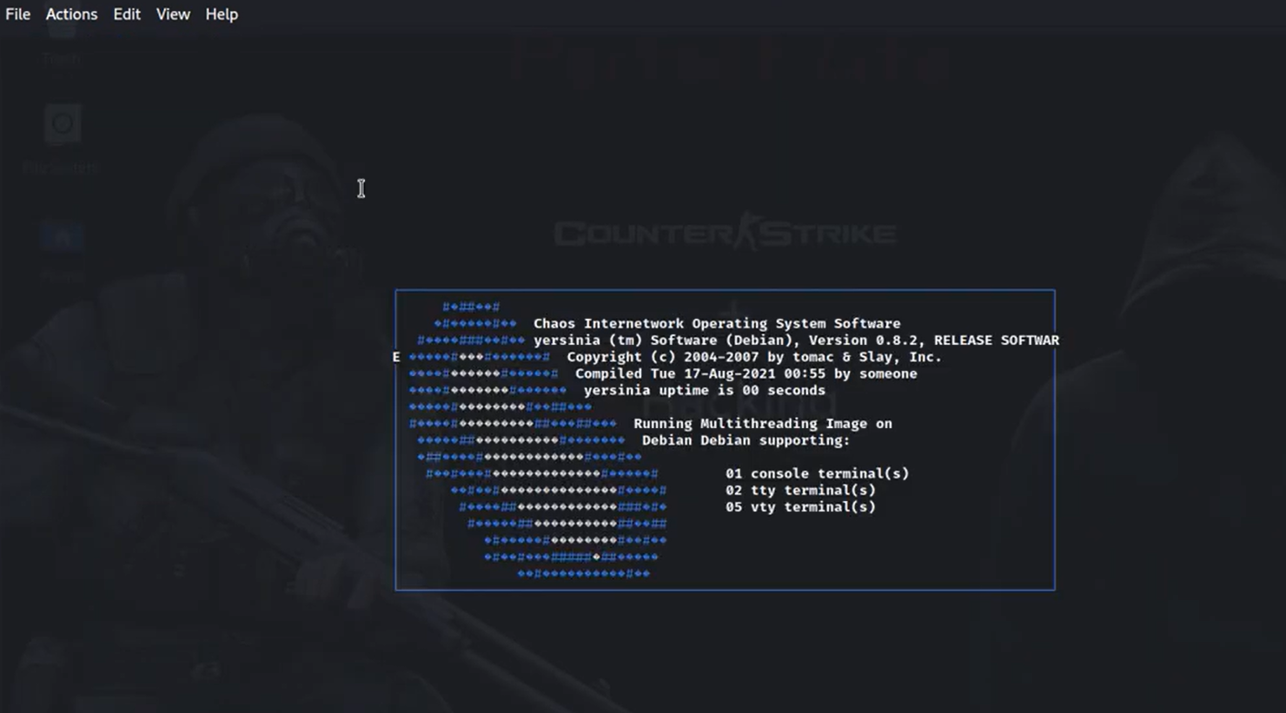
Figure 05. Your screen should look like this
Consult the tool’s help menu to review the available commands.
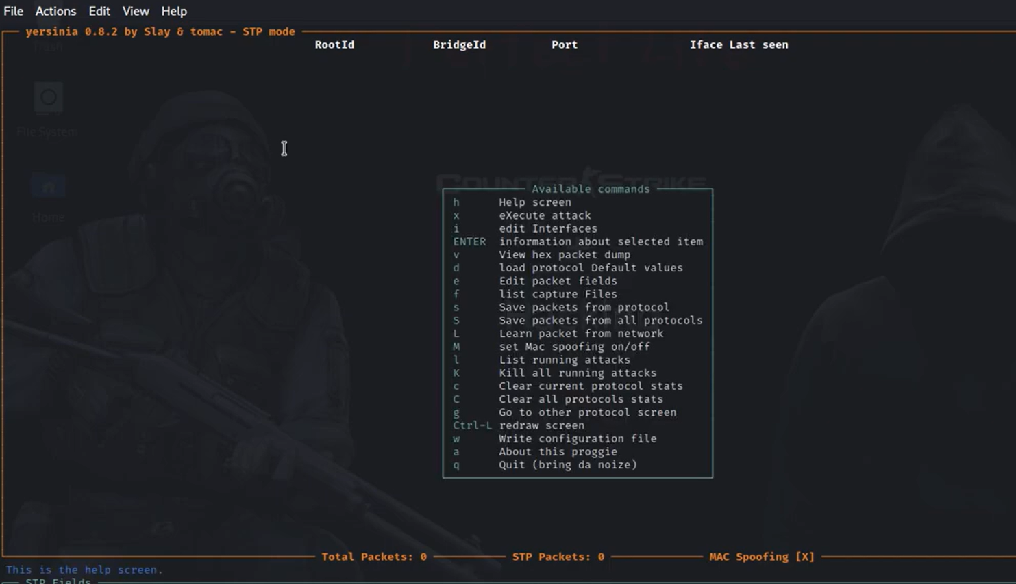
Figure 06. Consult the tool’s help menu to review the available commands.
Press g to go to the protocol menu and navigate to the DHCP protocols option.
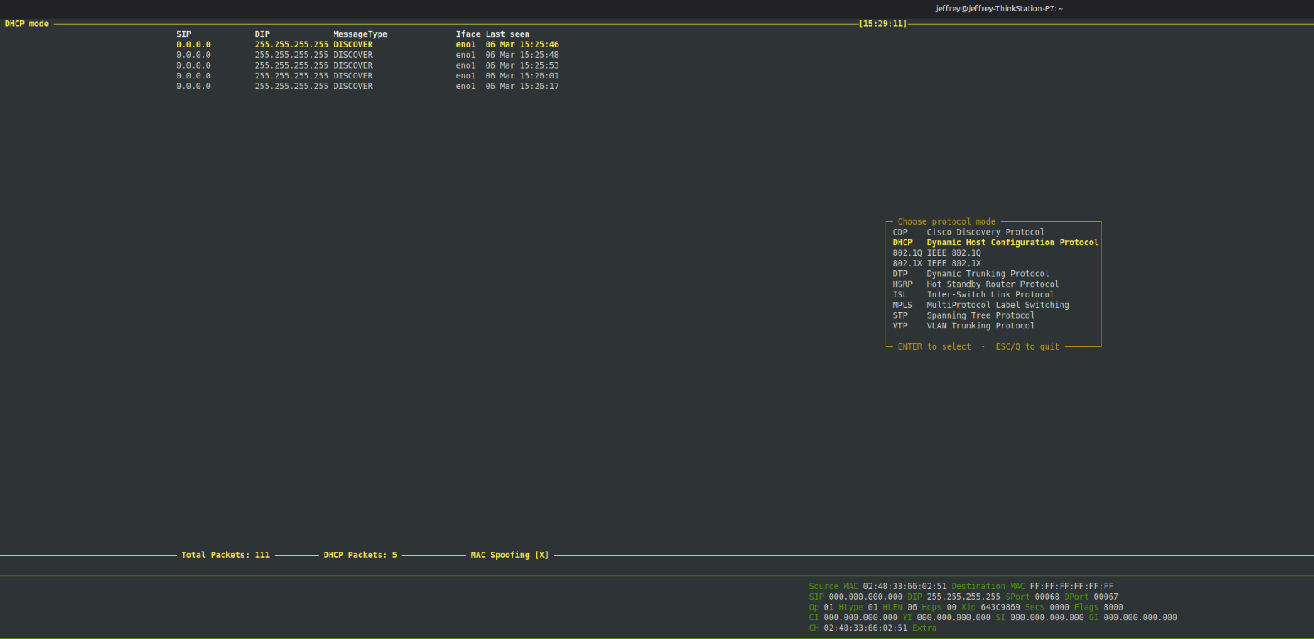
Figure 07. Press g to go to the protocol menu and navigate to the DHCP protocols option.
Select DHCP Starvation and then start the attack.
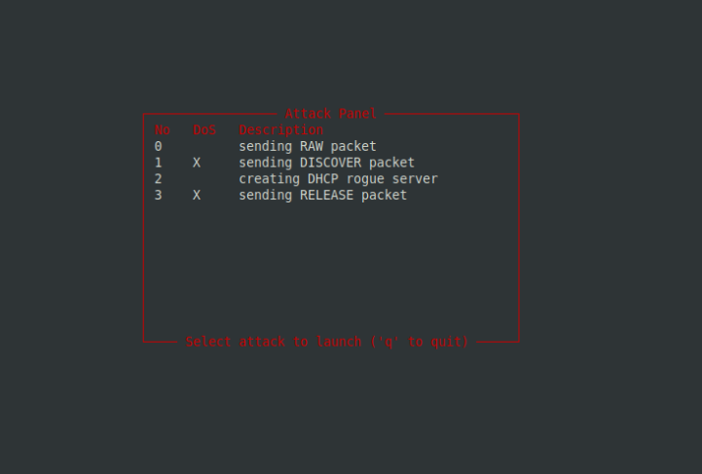
Figure 08. Select DHCP Starvation and then start the attack.
Review DHCP traffic in Wireshark. On the router acting as the DHCP server, inspect leases with the command below. On the switch, use show ip dhcp snooping binding to inspect learned bindings.
show ip dhcp binding

Figure 09. Review DHCP traffic in Wireshark. On the router acting as the DHCP server, inspect leases with the command below. On the switch, use show ip…

Mitigation
Enable DHCP snooping on VLAN 1 and configure the verified DHCP uplink as trusted. Apply a DHCP packet-rate limit and port security to the untrusted client port. These controls address different behaviors: excessive DHCP requests, excessive source MAC addresses, and ARP validation.
hostname S1
!
ip dhcp snooping
ip dhcp snooping vlan 1
ip arp inspection vlan 1
!
interface FastEthernet0/1
switchport mode access
ip arp inspection trust
ip dhcp snooping trust
!
interface FastEthernet0/2
switchport mode access
switchport port-security
switchport port-security maximum 5
switchport port-security violation shutdown
ip dhcp snooping limit rate 15
!
A port-security violation can disable the client port when its learned-MAC limit is exceeded. DHCP snooping rate limiting can also place a port into an error-disabled state on supported platforms. Inspect the actual violation and packet counters; neither outcome should be assumed from a failed ping alone.

Consolidated Mitigation Reference
This complete switch example combines the controls described above. It assumes VLAN 1, Fa0/1 toward the verified router/DHCP server, and Fa0/2 toward an untrusted client. The five-MAC limit and 15-packet-per-second DHCP limit are lab example values. Change them to match the platform and expected client behavior.
enable
configure terminal
hostname S1
ip dhcp snooping
ip dhcp snooping vlan 1
ip arp inspection vlan 1
interface FastEthernet0/1
description Verified router / DHCP-server uplink
switchport mode access
switchport access vlan 1
ip dhcp snooping trust
ip arp inspection trust
exit
interface FastEthernet0/2
description Untrusted client access port
switchport mode access
switchport access vlan 1
switchport port-security
switchport port-security maximum 5
switchport port-security violation shutdown
ip dhcp snooping limit rate 15
exit
end
show ip dhcp snooping
show ip dhcp snooping binding
show ip arp inspection vlan 1
show port-security interface FastEthernet0/2
Renew the DHCP client lease and confirm a valid snooping binding before testing ARP inspection. For a statically addressed client, configure the platform’s ARP ACL or supported binding mechanism. Monitor DHCP and port-security counters, inspect interface status, and review logs when a test changes connectivity.

Troubleshooting and Lessons Learned
Some observations were delayed because DHCP recovery and mitigation behavior required time to stabilize. Longer attack runs also caused virtual-machine instability, so the team shortened test intervals. A separate VM cursor issue was resolved through display and input settings.

Conclusion
The exercise connected Layer 2 attack behavior with defensive switch configuration. It reinforced the need to validate trusted ports, address-learning controls, packet observations, and recovery behavior rather than relying on configuration alone.

