iGEM Teams Dataset Stats Report

Data Provenance
Original data from the iGEM competition provided by Marc Santolini (ISERM, Learning Planet Institute). Teams data from 2009 onwards was sourced from the teams project wikis’ public URLs using an automated Python script. Teams project data from 2004 - 2008 was manually sourced from archived project wikis, which are also publicly available.
This dataset combines iGEM team metadata and team project descriptions sourced from curated TSV exports used in this project (team_meta_full.tsv and team_project_descriptions_manual_entries_v2.tsv). The workflow keeps accepted teams and then retains records with non-empty project abstracts.
- Year range available: 2004–2025
- Date of retrieval/report generation: 2026-05-19
- Records (Teams) listed in files: 5096
- Records accepted (Teams with status ‘Accepted’): 4883
- Records with non-empty project abstracts: 4,707
- Total records used in this report: 4,707

Yearly Trends
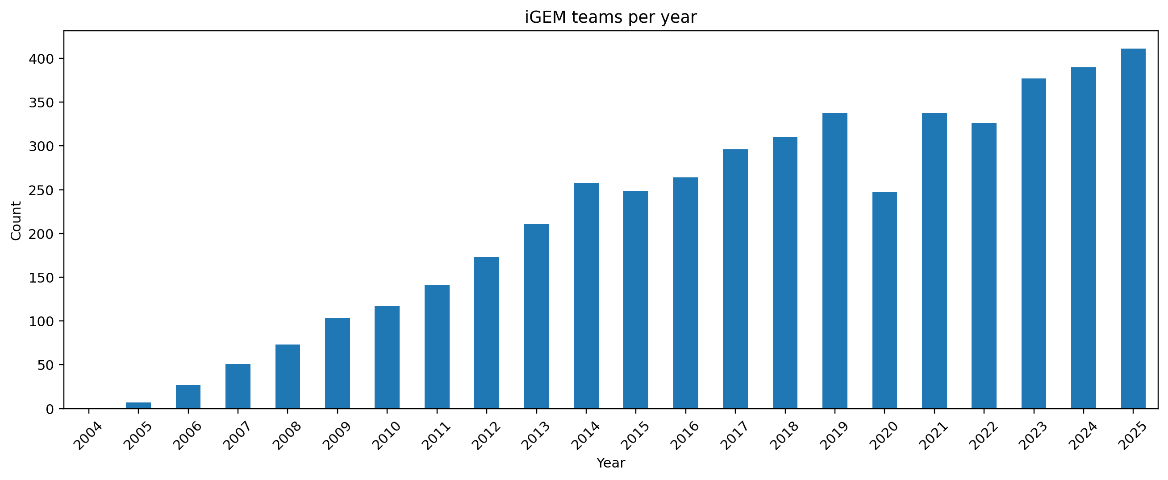
iGEM teams per year
Team participation changes substantially over time, with visible growth periods and fluctuations year to year.

Country Stats
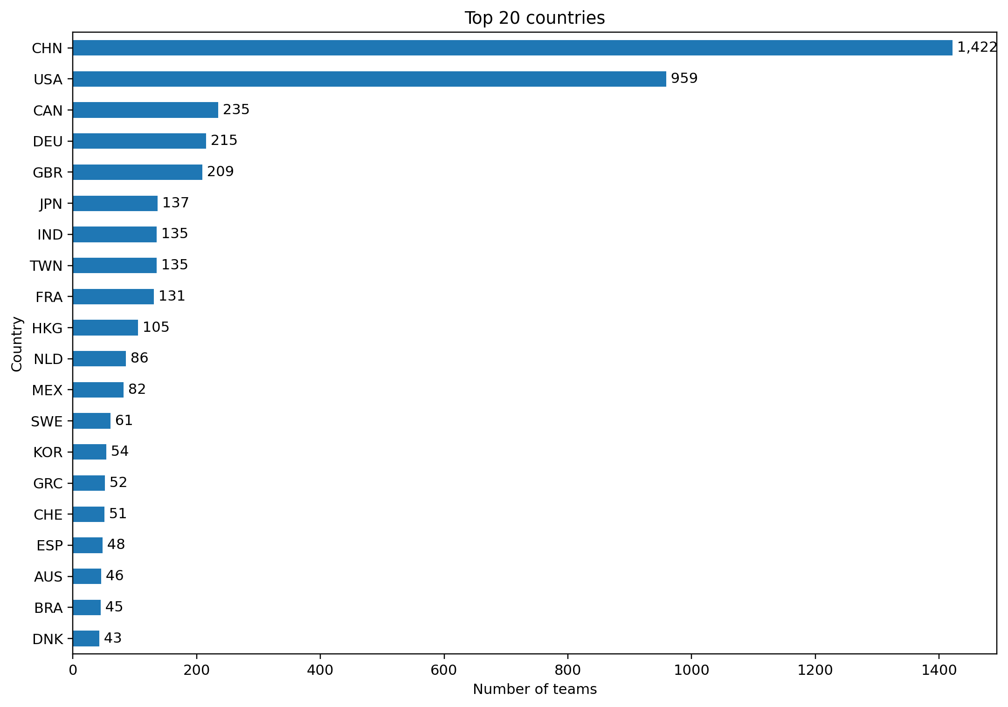
Top countries
The country distribution is concentrated in a small set of leading contributors.

Country Yearly Trends (Raw Frequency)
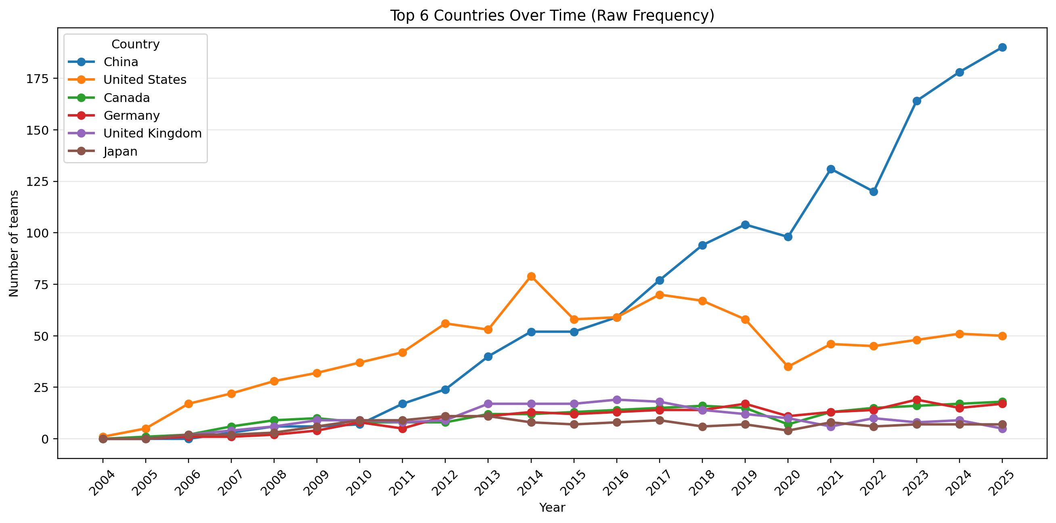
Country yearly raw trend
This chart shows annual team counts for the six leading countries using the same color palette used in the papers report.

Country Yearly Trends (Normalized)
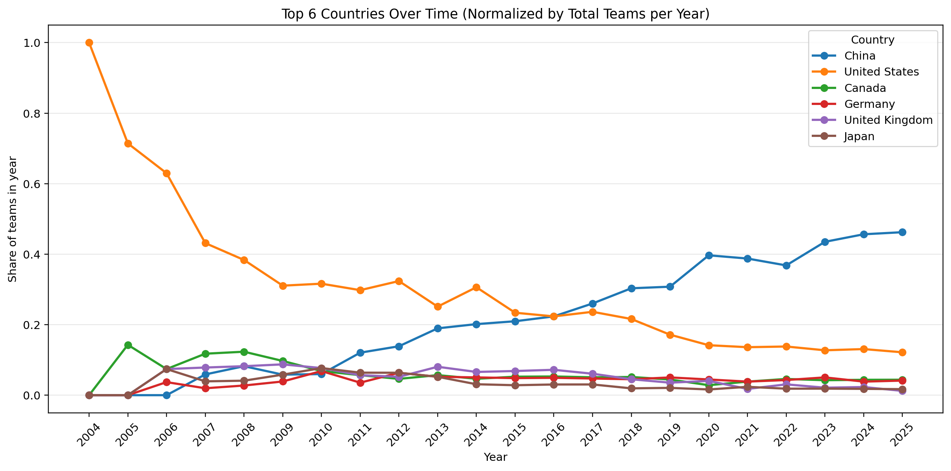
Country yearly normalized trend
Normalization divides each country count by the total teams in that year, highlighting relative share dynamics independent of yearly cohort size.

Others (Tracks)
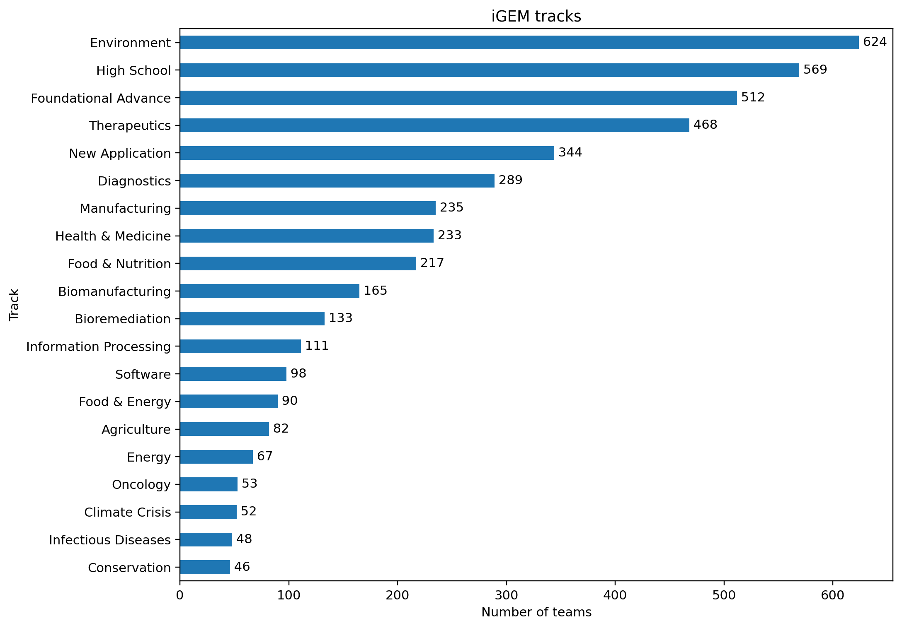
Top tracks
Top tracks summarize the thematic distribution of iGEM projects in this filtered corpus.

