OpenAlex SynBio Dataset Stats Report

Data Provenance
Data sourced from OpenAlex through the public API as specified in the accompanying Python Notebook using the Synthetic Biology query terms present in the file query.yml taken from Baaden, P., Bröring, S., Rennings, M., & Shapira, P. (2026). Records acquisition was conducted in 7 parts due to the OpeAlex API's query length restrictions. Data sourced by Cristian Mejia (University of Tokyo).
This dataset is built by merging all local OpenAlex part exports (synbio_openalex_PART_*.txt) generated by the project retrieval notebook, then deduplicating by work ID, and removing records without abstracts.
- Year range available: 1950–2025
- Date of retrieval/report generation: 2025-11-30
- Records downloaded: 32,597
- Records with non-empty abstracts: 24,202
- Total records used in this report: 24,202

Yearly Trends
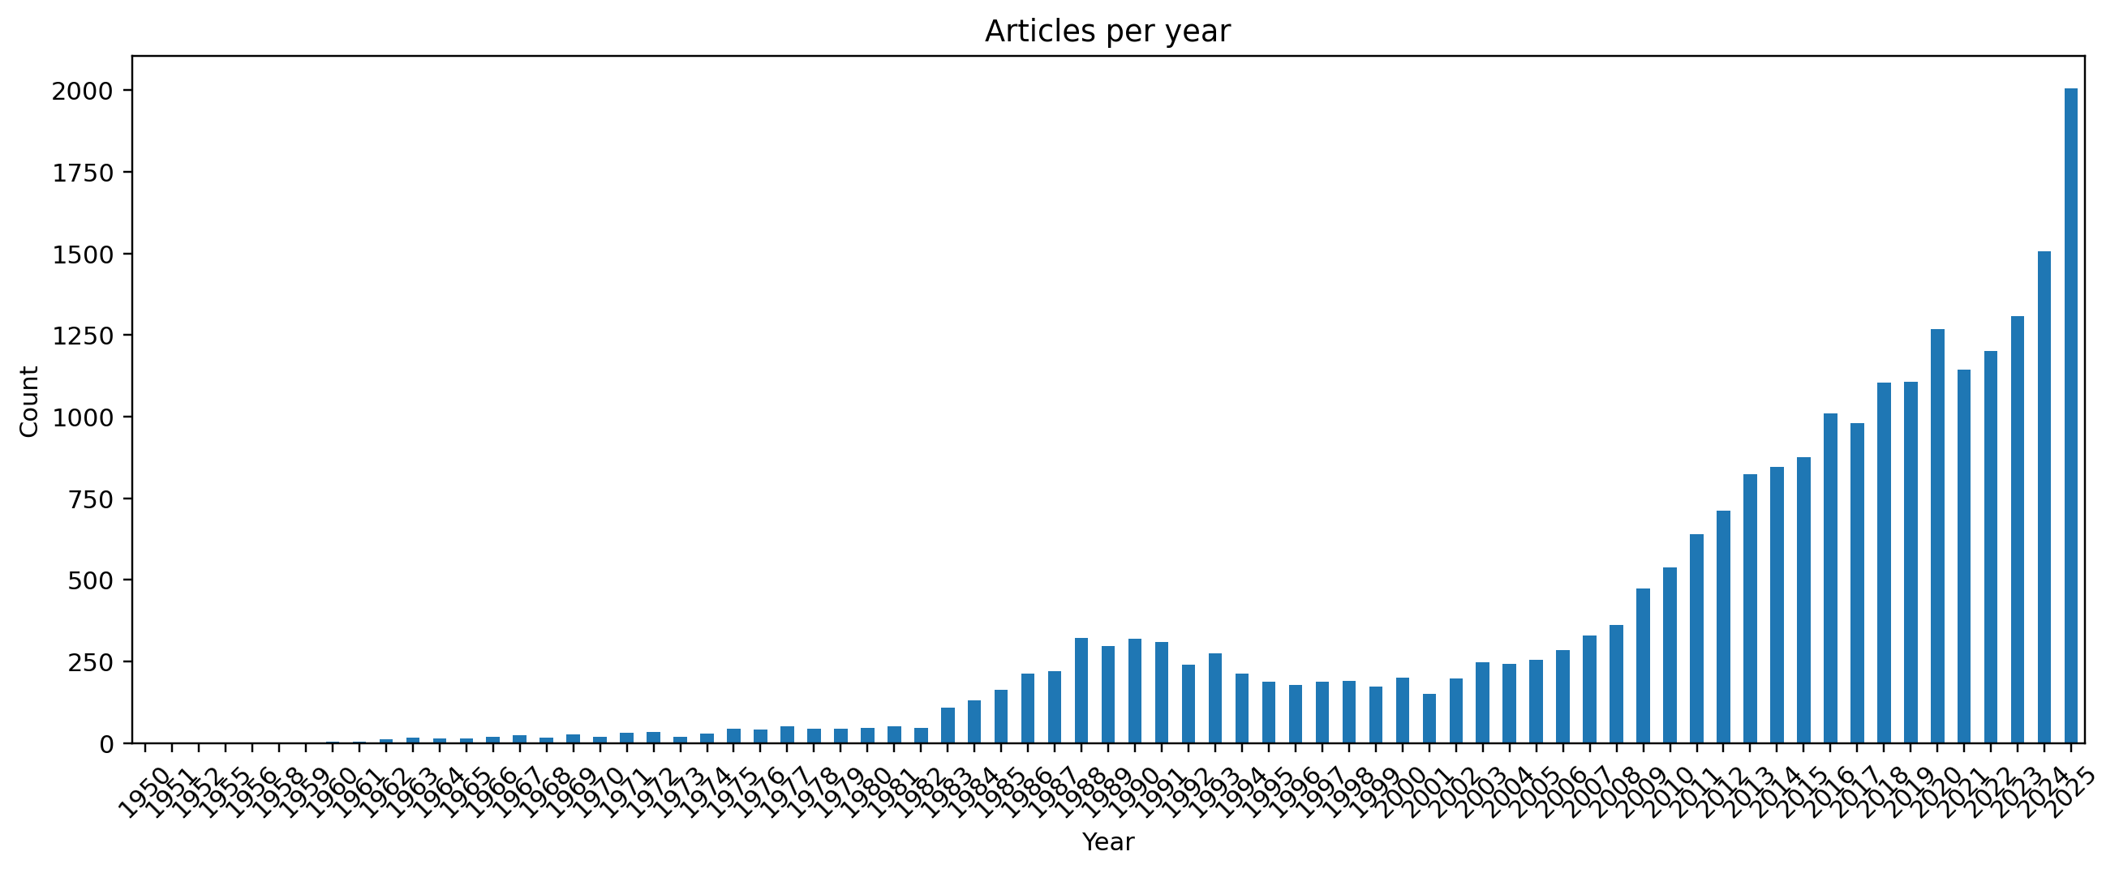
Articles per year
Publication volume increases substantially over time, indicating sustained expansion of the synthetic biology literature.

Country Stats
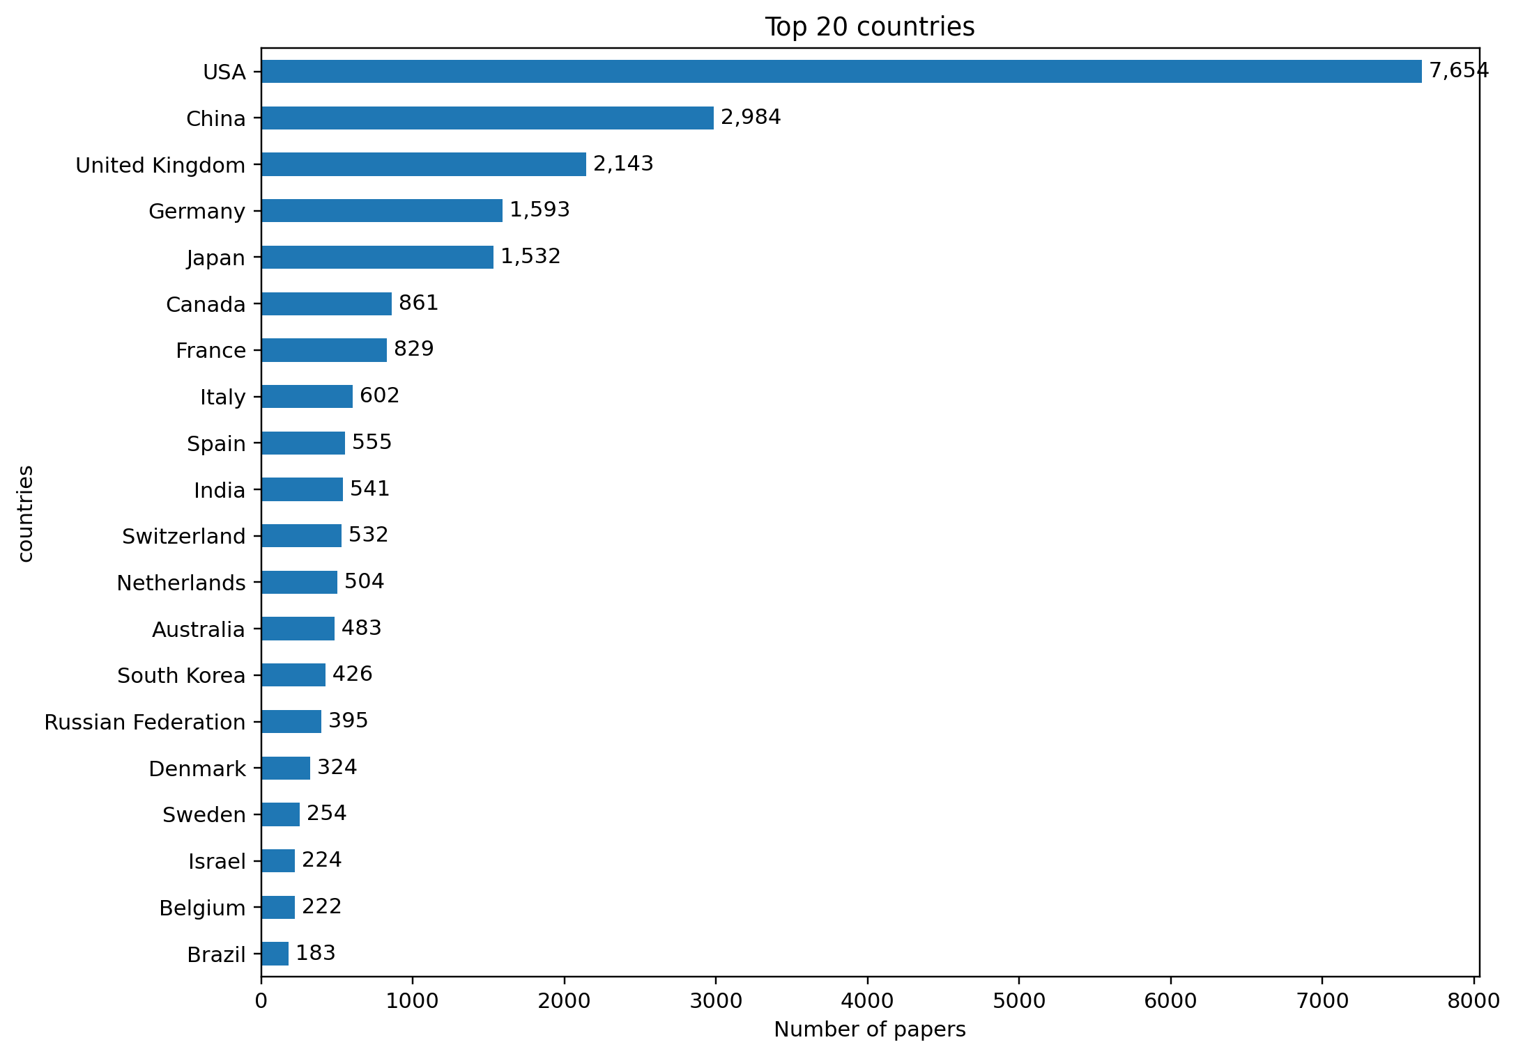
Top countries
Country contribution is concentrated in a core set of high-output countries.

Country Yearly Trends (Raw Frequency)
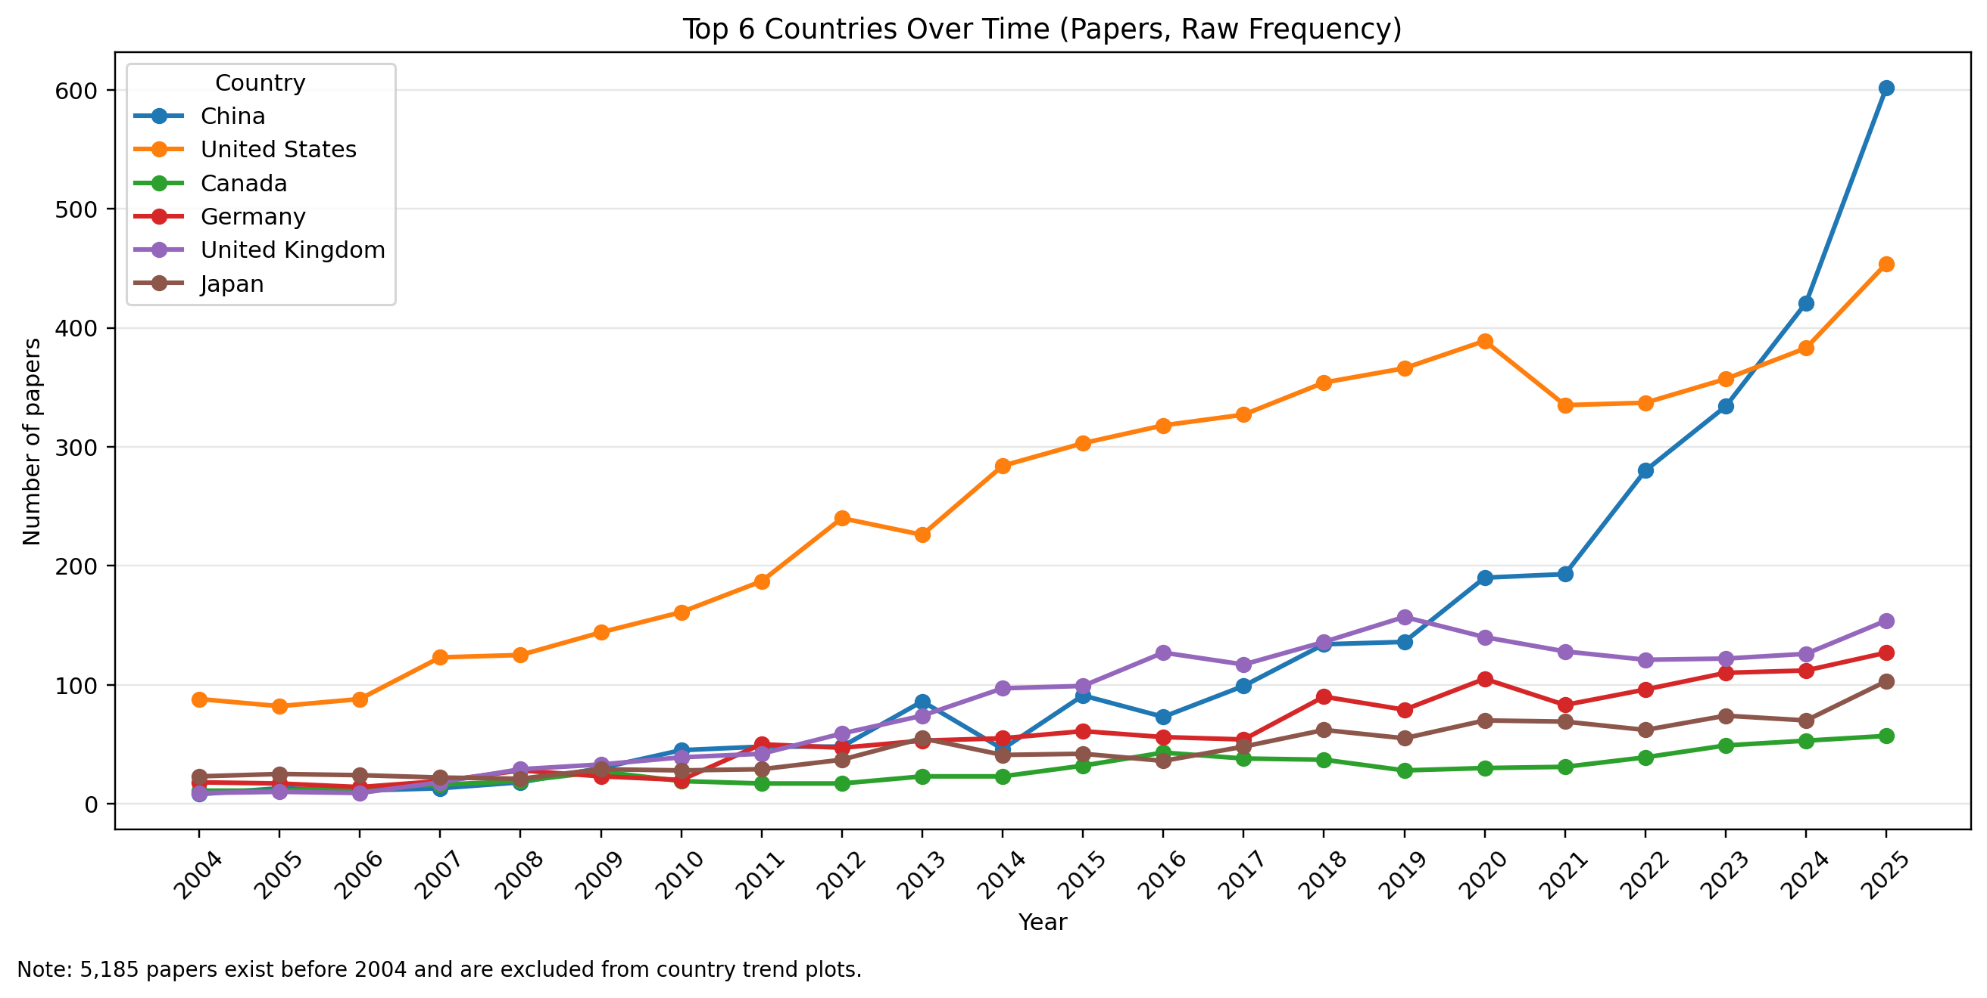
Country yearly raw trend
The trend starts in 2004 for comparability with iGEM, while the note in the figure reports how many papers exist before 2004.

Country Yearly Trends (Normalized)
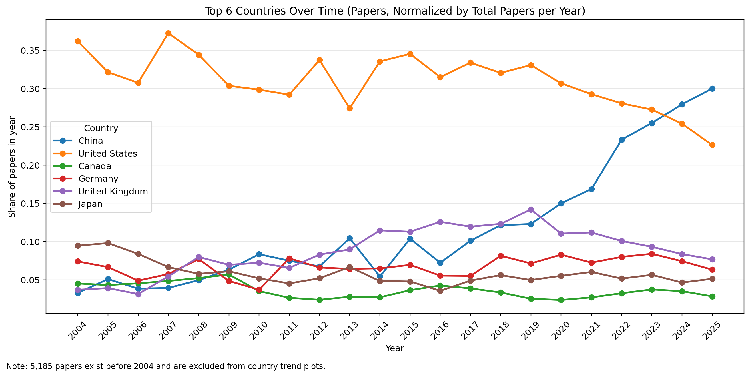
Country yearly normalized trend
Normalization divides each country count by the total papers in that year to show relative contribution shares over time.

Others (Concepts)
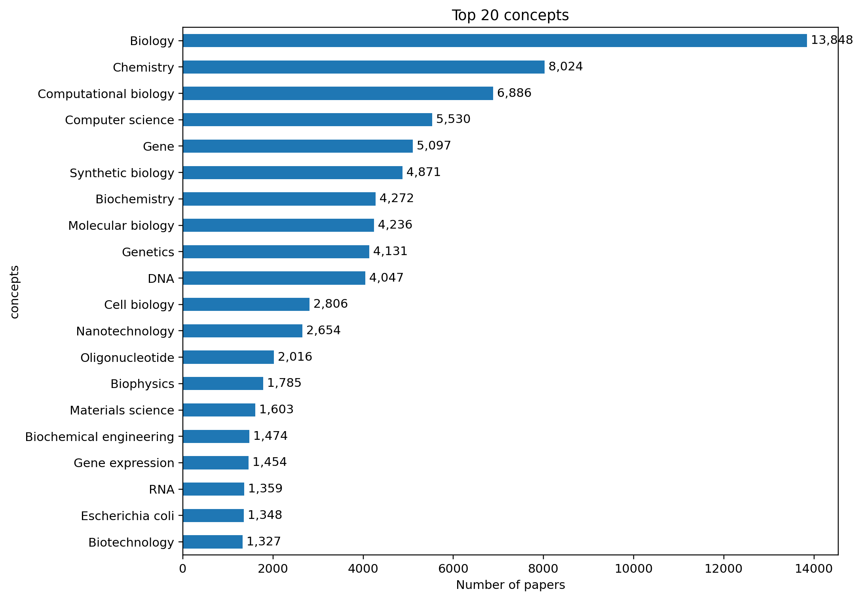
Top concepts
Top concepts summarize major themes represented in the OpenAlex corpus.

