Secondary z-curve analysis
2026-01-04

Secondary z-curve analyses

Sensitivity analysis 1
We conducted a z-curve analysis excluding p-values that could be not recomputed when reported as “p < 0.001”, “p < 0.005” and “p < 0.003” but were imputed as p = 0.0001 and 0.0005 in the primary z-curve.
## Call:
## zcurve(p = sensitivity_1)
##
## model: EM via EM
##
## Estimate l.CI u.CI
## ERR 0.427 0.288 0.546
## EDR 0.131 0.050 0.355
## Soric FDR 0.348 0.096 1.000
## File Drawer R 6.605 1.821 19.000
## Expected N 1300 482 3420
## Missing N 1044 226 3164
##
## Model converged in 51 + 1214 iterations
## Fitted using 164 p-values. 256 supplied, 171 significant (ODR = 0.67, 95% CI [0.61, 0.72]).
## Q = -138.47, 95% CI[-163.83, -109.94]
Plot the results:
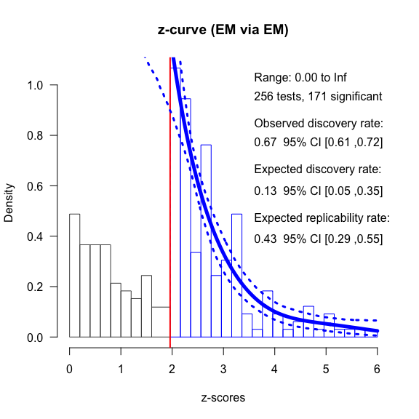

Sensitivity analysis 2
We conducted a z-curve analysis replacing p-values reported as p < 0.05 for p < 0.25
## Call:
## zcurve(p = combined_pvalues)
##
## model: EM via EM
##
## Estimate l.CI u.CI
## ERR 0.489 0.350 0.609
## EDR 0.112 0.050 0.345
## Soric FDR 0.417 0.100 1.000
## File Drawer R 7.923 1.900 19.000
## Expected N 1642 534 3680
## Missing N 1360 252 3398
##
## Model converged in 56 + 708 iterations
## Fitted using 177 p-values. 282 supplied, 184 significant (ODR = 0.65, 95% CI [0.59, 0.71]).
## Q = -162.11, 95% CI[-187.73, -131.34]
Plot the results:
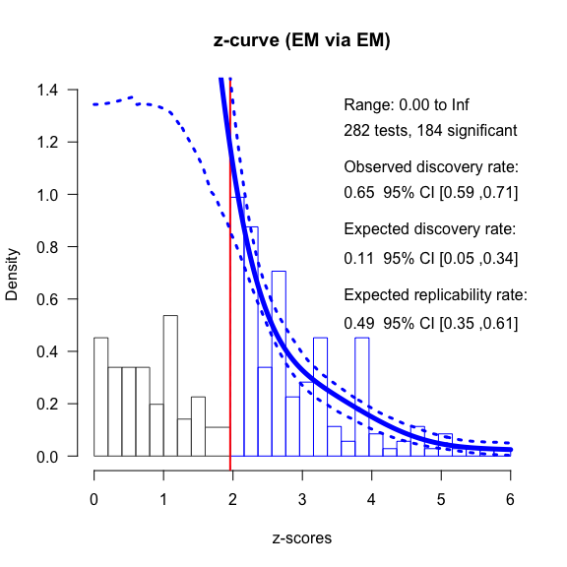

Sensitivity analysis 3
Conduct a z-curve analysis replacing p-values reported as p > 0.05 for p = 0.25
## Call:
## zcurve(p = combined_pvalues)
##
## model: EM via EM
##
## Estimate l.CI u.CI
## ERR 0.491 0.362 0.620
## EDR 0.110 0.050 0.310
## Soric FDR 0.425 0.117 1.000
## File Drawer R 8.082 2.228 19.000
## Expected N 1789 636 3940
## Missing N 1507 354 3658
##
## Model converged in 78 + 1039 iterations
## Fitted using 177 p-values. 282 supplied, 197 significant (ODR = 0.70, 95% CI [0.64, 0.75]).
## Q = -162.12, 95% CI[-188.78, -132.74]
Plot the results:
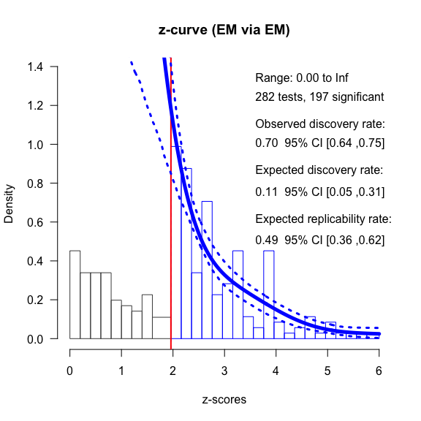

Sensitivity analysis 4
Conduct a z-curve analysis replacing p-values reported as p > 0.05 for p = 0.25 and replacing p-values reported as p < 0.05 for 0.05
## Call:
## zcurve(p = combined_pvalues)
##
## model: EM via EM
##
## Estimate l.CI u.CI
## ERR 0.491 0.369 0.612
## EDR 0.110 0.050 0.278
## Soric FDR 0.426 0.137 1.000
## File Drawer R 8.100 2.602 19.000
## Expected N 1793 710 3940
## Missing N 1498 415 3645
##
## Model converged in 13 + 577 iterations
## Fitted using 177 p-values. 295 supplied, 197 significant (ODR = 0.67, 95% CI [0.61, 0.72]).
## Q = -162.12, 95% CI[-185.63, -134.16]
Plot the results:
