ADC Resolution vs Sensor Less Motor Control Performance

Cristian Ornelas

Tyler Hawkins

Tamara Basfar

John Adam King

**Interface Control Document**

REVISION – 1

26 September 2024

Interface Control Document

for

ADC Resolution vs Sensor Less Motor Control Performance

Prepared by:

_____________________________

Author Date

Approved by:

_____________________________

Project Leader Date

_____________________________

John Lusher II, P.E. Date

_____________________________

T/A Date

**Change Record**

| **Rev.** | **Date** | **Originator** | **Approvals** | **Description** |
| --- | --- | --- | --- | --- |
| **1** | [9/26/24] | [ADC Resolution vs Sensor Less Motor Control Performance] |  | Draft Release |
| **2** | [12/04/2024] | [ADC Resolution vs Sensor Less Motor Control Performance] |  | Second Revision |

**Table of Contents**

**Table of Contents III**

**List of Tables** **I****V**

**List of Figures V**

**1.** **Overview 1**

**2.** **References and Definitions 1**

2.1. References 1

2.2. Definitions 2

**3.** **Physical Interface 2**

3.1. Weight 2

3.2. Dimensions 3

3.3. Mounting Locations 4

**4.** **Electrical Interface 4**

4.1. Primary Input Power 4

4.2. Voltage and Current Levels 4

4.3. User Control Interface 4

**5.** **Communications / Device Interface Protocols 5**

5.1. Host Device 5

5.2. Device Peripheral Interface 5

**List of Tables**

Table 1. Component’s Weight……………………………………………..………..…………2

Table 2. Component Dimensions………………………………………..………..………..…3

# 

**List of Figures**

Figure 1. Mounting Location of the DRV8300Cxxx-EVM………………………..…………4

# 

# 1. Overview

This Interface Control Document (ICD) defines the technical specifications and interface requirements for the ADC Resolution vs Sensor Less Motor Control Performance project. It outlines how the subsystems defined in the Concept of Operations report and the Functional System Requirements report will be implemented and integrated. The ICD includes detailed descriptions of reference documents, key definitions, and physical and electrical interfaces. The report outlines the physical interface specifications, such as weight, dimensions, and mounting locations, as well as the electrical interface, covering primary input power, polarity reversal protection, and signal interfaces. Additionally, it details the user control interface and communication protocols necessary for seamless integration between the host device and peripheral components. This ICD shows how all subsystems are going to be implemented and produced in accordance with the defined requirements, facilitating compatibility and seamless operation across the entire system.

# 2. References and Definitions

## 2.1 References

**SBVS144C**

**Integrated MCU Power Solution for C2000 Microcontrollers**

2012

**IEEE-STD-1241**

**IEEE Standard for Terminology and Test Methods for Analog-to-Digital Converters**

2001

**v1.3**

**C2000 software guide**

2021

**SLVUBV6**

**DRV8300Dxxx-EVM User’s Guide**

2020

**Motor Control Compendium**

2011

**Sensor vs Sensorless Motor Controllers: A Head-to-Head Comparison**

2024

## 2.2 Definitions

CCS Code Compiler Studio

mA Milliamp

mW Milliwatt

MHz Megahertz (1,000,000 Hz)

TBD To Be Determined

TTL Transistor-Transistor Logic

VME VERSA-Module Europe

PWM pulse width modulation

ADC Analog to Digital converter

INV inverter

c2000 real-time microcontroller

SysConfig development tool for c2000

# 3. Physical Interface

## 3.1 Weight

| **Component** | **Weight** |
| --- | --- |
| C2000™ real-time MCU F28P65x LaunchPad™ development kit | 1 oz |
| DRV8300DIPW evaluation module for three-phase BLDC | 1 oz |
| Low Voltage Servo Motor - Low voltage servo (encoder) motor and wiring harness | 23.1 oz |
| Total | 25.1 oz |

*Table 1. Component’s Weight*

## 3.2 Dimensions

| **Component** | **Length** | **Width** | **Height** |
| --- | --- | --- | --- |
| C2000™ real-time MCU F28P65x LaunchPad™ development kit | 6.75 in. | 2.3 in. | 0.925 in. |
| DRV8300DIPW evaluation module for three-phase BLDC | 3.5 in. | 3.125 in. | 0.75 in. |
| Low Voltage Servo Motor - Low voltage servo (encoder) motor and wiring harness | 2.73 in. | 2.73 in. | 3.98 in. |

### *Table 2. Component Dimensions*

## 3.3 Mounting Locations

**3.1.1 Mounting of the DRV8300Dxxx-EVM**

The DRV8300Dxxx-EVM must plug into the lower LAUNCHXL-F280049C Launchpad headers as shown below.

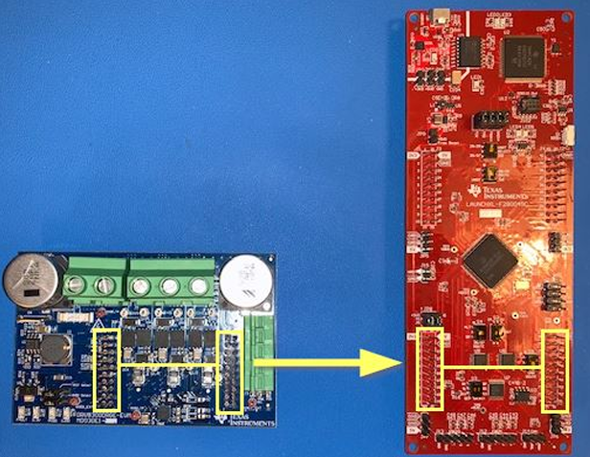

*Figure 1. Mounting Location of the DRV8300Cxxx-EVM*

# 4. Electrical Interface

## 4.1 Primary Input Power

Primary power through the DRV8300 board shall be connected to an external power supply.

Power to the F28P65x board shall be provided through the USB connection.

## 4.2 Voltage Levels

The F28P65x Board shall use 5 VDC

The DRV8300 Board shall use 6 VDC to 100 VDC

## 4.3 User Control Interface

The user control interface will be the Sysconfig IDE on the host device.

# 5. Communications / Device Interface Protocols

## 5.1 Host Device

The host device will be the computer system connected to the microcontroller. Here, there commands will be given to the motor. As the host device requires Texas Instruments Code Composer Studio, it is recommended that the host device meet the same minimum and recommended requirements. The minimum hardware requirements are 4GB memory, 2.5 GB of disk space, and a 2.0 GHz single-core processor. The recommended hardware requirements are 8GB of memory, 5.0 GB of disk space, and a multicore processor.

## 5.2 Device Peripheral Interface

For connecting the computer system to the microcontroller, the project will be utilizing a wire protocol. The wire required is a USB to UART connector. The launchpad used in this project features a Fast Serial Communications Peripheral, enabling robust high-speed communications. See document Users Guide C2000™ F28P65x Series LaunchPad™ Development Kit, paragraph 3.1.5 FSI for specific details, and 3.1.6 and 3.1.7 for additional attributes.