433 Ana Costa Avenue  Suite 184 - Santos/Brazil  11060-003 | Telephone: +55 13 33940655  email: surveyors@naabsa.com  www.naabsa.com

Survey Report
Ref:201/2026 Capa C4

Draft Survey

“MV PERSEUS I” Capa C13
Flag Liberia Capa C14 – IMO 9544073 Capa C17
at Paranagua Capa C5 Port/Brazil – May 21st, 2026 Capa L9

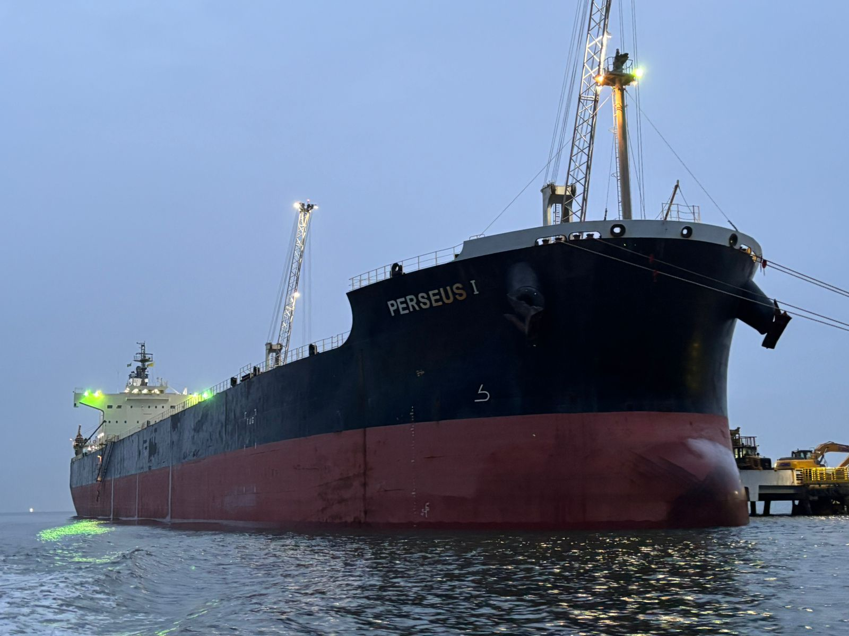

PERSON / COMPANIES CONTACTED

Client | Langlois Enterprises Ltd (capa C33)  Mr. Alex Mantzavinos (Capa 34)
Undersigned Surveyor | NAABSA Marine Surveyors  Mr. Wagner de Abreu
Vessel’s Command | Master / Chief Officer  Mr. Alfonso Villadarez Jr. (capa c28) / Mr. Julius Cabrera (capa C29)

Contents

- Background…………………………………..………………………….…………………………………………………………………………………………….…..3
- Ship’s Particulars…………………………………………………………………………………………………………………………………………………………3
- Draft Survey………………………………....……………………………………………………………………………………………………………………….……3
- Initial…………………………………………………………………………………………………………………………….……..............………….…………..….3
4.1. Draft readings.............................................................................................................................................................3
4.2. Sea water density.......................................................................................................................................................3
4.3. Ballast water and fresh water....................................................................................................................................3
4.4. Fuel R.O.B...................................................................................................................................................................4
4.5. Initial Draft details…………………………………………………………………………………………………………………………………………..……4
- Initermediate……………………………………………………………………………………………………………….……..............………….…………..….3
5.1. Draft readings.............................................................................................................................................................3
5.2. Sea water density.......................................................................................................................................................3
5.3. Ballast water and fresh water....................................................................................................................................3
5.4. Fuel R.O.B...................................................................................................................................................................4
5.5. Intermediate Draft details………………..……………………………………………………………………………………………………………..……4
- Final……………………………………………………………………………………………………….……………………………………………………………………8
6.1. Draft readings.............................................................................................................................................................8
6.2. Sea water density.......................................................................................................................................................8
6.3. Ballast water and fresh water....................................................................................................................................9
6.4. Fuel R.O.B...................................................................................................................................................................9
6.5. Final Draft details……………………………………………………………………………………………………………………………………………….…9
7. Photographic Report…………………………………………………………………………………………………………………………………………….…9
7.1. Initial………………………………………………………………………………………………………………………………………………………………….…9
7.2. Intermediate…………………………………………………………………………………………………………………………………………………….…10
7.3. Final……………………………………………………………………………………………………………………………………………………………………10
- Attachment...…………………………………………………………………………………………………………………………………………………….…..….10

Background

In compliance with the appointment survey from Messrs. LANGLOIS ENTERPRISES LTD (capa c33), we attended the vessel to carry out the Draft Survey to ascertain the total quantity of cargo loaded/discharged and to compare it with the Shore scale/Bills of lading.

She called Paranagua (capa C5) Port to load/discharge a cargo of fertilizer (capa C8) in bulk bound/loaded to/in Vancouver, Canada (capa C7).

- Ship’s Particulars

Flag | : | Marshall Islands (capa c14)
Port registry | : | Majuro (capa c15)
Call sign | : | V7B2615 (capa c16)
IMO number | : | 9544073 (capa c17)
Type | : | Bulk Carrier (capa c18)
Delivered | : | 2013 (capa c19)
LOA | : | 228.99 m (capa c20)
LBP | : | 222.00 m (capa c21)
Depth moulded | : | 20.05 m (capa c22)
Breadth moulded | : | 32.26 m (capa c23)
Net tonnage | : | 27,239 mt (capa c24)
Gross tonnage | : | 27,239 mt (capa c25)
Summer DWT | : | 27,239 mt (capa c26)

- Initial (Neste item as partes envolvidas devem aparecer se forem inclusas na planilha. O que sempre terá seremos nós (undersigned surveyor) e o navio (ship´s command). As outras partes são variáveis (terminal’s surveyor, customs’ surveyor)

The initial Draft Survey was carried out on May 8th, 2026 (capa L3), upon berthing at FOSPAR (capa C6) Terminal, shed (capa C7) from 06:30h (Capa M7) up to 08:30h (Capa N7) local time jointly with ship’s command, terminal’s surveyor (DSfinal B49), Shipper´s surveyor (DSfinal B50), Customs’ surveyor (DSfinal B51) and the undersigned surveyor. As partes envolvidas realçadas em amarelo só devem aparecer se citadas no atendimento

  - Draft readings: Starboard side (capa C31) from shore, alongside vessel and Port side (automático) from boat. Neste item, se for escolhido um bordo, o outro deve aparecer automaticamente na segunda opção. O bordo atracado sempre será feita leitura por terra e o lado contrário por lancha.

Draft Mark | Means | Mean corrected |  | Trim obs | Ini D15 0,1800 m
Fwd | Ini D10 7,820 m | Ini H10 7,8111 m |  | Trim correct | Ini G15 0,1978 m
Ms | Ini D11 7,965 m | Ini H11 7,9647 m |  | Heel | Ini Z24 0,48° Port Side Ini Y25
Aft | Ini D12 8,000 m | Ini H12 8,0088 m |  | Deflection | Ini G17 5,4 cm Sagging Ini G18

  - Sea water density: A seawater sample was collected in way of the midship draft mark, on the sea side. The vessel’s hydrometer was considered the official instrument for all readings.

  - Ballast water and fresh water: All ballast water tanks were gauged individually, and the volumes were calculated by applying the applicable trim and list corrections. The fresh water quantity was provided by the Chief Officer

  - Fuel R.O.B.: Accordind to the logbook – FWE.

  - Initial Draft details

Print da planilha aba initial

- Intermediate (só deve aparecer se estiver preenchido na planilha Excel)

The intermediate Draft Survey was carried out on May 21st, 2026 (Capa L8), from 03:20 (Capa M8) up to 05:30 (Capa N8) h local time jointly with ship’s command, terminal’s surveyor (DSInt B51), Shipper´s surveyor (DSInt B52), Customs’ surveyor (DSInt B53) and the undersigned surveyor to ascertain the total quantity of the cargo discharged being the following figures disclosed:

Shore Scale/BsL figures (Official)..........: 5,000.000 MT (DSInt C37)
NAABSA’s surveyor figures.......: 5,079.578 MT (DSInt C38)
Difference as per our figures...: + 79.578 MT (DSInt C39) or + 1.592 % (DSInt C40)

Vessel’s figures................: 5,083.500 MT (DSInt J38)
Terminal’s figures(DSInt B51)..............: 5,061.408 MT (DSInt J51)
Buyer’s figures(DSInt B52).................: 5,077.337 MT (DSInt J52)
Customs’ figures(DSInt B53)................: 5,051.056 MT (DSInt J53)

  - Draft readings: Draft readings: Starboard side (capa C31) from shore, alongside vessel and Port side (automático) from boat. Neste item, se for escolhido um bordo, o outro deve aparecer automaticamente na segunda opção. O bordo atracado sempre será feita leitura por terra e o lado contrário por lancha.

Draft Mark | Means | Mean corrected |  | Trim obs | Int D14 2,2500 m
Fwd | Int D9 4,875 m | Int H9 4,7624 m |  | Trim correct | Int G14 2,4723 m
Ms | Int D10 5,925 m | Int H10 5,9217 m |  | List | Int AA23 0,16° SS Int Z24
Aft | Int D11 7,125 m | Int H11 7,2347 m |  | Deflection | Int G16 7,6 cm Hog Int G17

  - Sea water density: A seawater sample was collected in way of the midship draft mark, on the sea side. The vessel’s hydrometer was considered the official instrument for all readings.

  - Ballast water and fresh water: All ballast water tanks were gauged individually, and the volumes were calculated by applying the applicable trim and list corrections. The fresh water quantity was provided by the Chief Officer

  - Fuel R.O.B.: Declared by Ch/Eng at time of survey.

  - Intermediate Draft Details
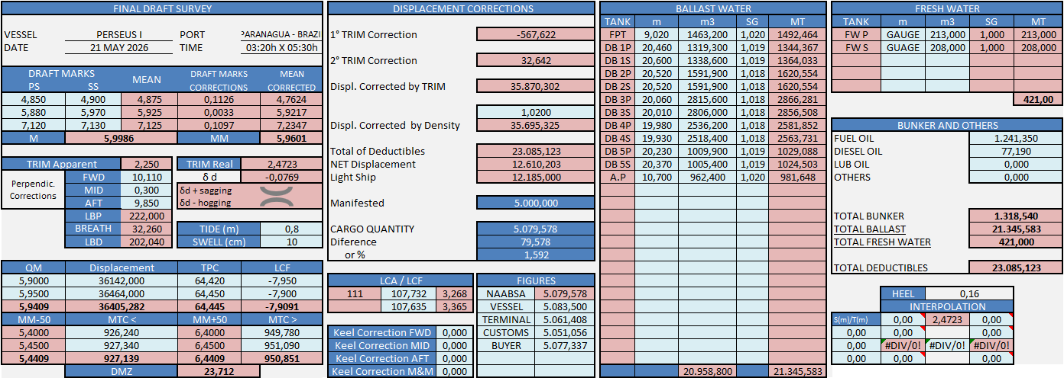
Print da planilha aba intermediario

- Final

The final Draft Survey was carried out on May 21st, 2026 (capa L9), from 03:20 (capa M9) up to 05:30 (capa N9) h local time jointly with ship’s command, terminal’s surveyor (DSFinal B50), Shipper´s surveyor (DSFinal B51), Customs’ surveyor (DSFinal B52) and the undersigned surveyor to ascertain the total quantity of the cargo discharged being the following figures disclosed:

Shore Scale/BsL figures (Official)..........: 5,000.000 MT DSFinal C37
NAABSA’s surveyor figures.......: 5,079.578 MT DSFinal C38
Difference as per our figures...: + 79.578 MT DSFinal C39 or + 1.592 % DSFinal C40

Vessel’s figures.......................: 5,083.500 MT DSFinal J49
Terminal’s figures DSFinal B50..............: 5,061.408 MT DSFinal J50
Canpotex’s figures DSFinal B51..............: 5,077.337 MT DSFinal J51
Customs’ figures DSFinal B52................: 5,051.056 MT DSFinal J52

  - Draft readings: Draft readings: Starboard side (capa C31) from shore, alongside vessel and Port side (automático) from boat. Neste item, se for escolhido um bordo, o outro deve aparecer automaticamente na segunda opção. O bordo atracado sempre será feita leitura por terra e o lado contrário por lancha.

Draft Mark | Means | Mean corrected |  | Trim obs | Final H28 2,2500 m
Fwd | Final F28 4,875 m | Final G28 4,7624 m |  | Trim correct | Final H29 2,4723 m
Ms | Final F29 5,925 m | Final G29 5,9217 m |  | Heel | Final H30 0,16° SS Final I30
Aft | Final F30 7,125 m | Final G30 7,2347 m |  | Deflection | Final H31 7,6 cm Hog Final I31

  - Sea water density: A water sample was collected in front of the mid draft, sea side.
The vessel hydrometer was considered as official.

  - Ballast water and fresh water: The ballast quantity and fresh water was informed by Chief Officer.

  - Fuel R.O.B.: Declared by Ch/Eng at time of survey.

  - Final Draft Details


- Photographic Report

  - Initial

  - Intermediate

  - Final

Attachment

- Draft Survey Certificates issued by undersigned surveyor
- Draft Survey Certificate issued by vessel
- Draft Survey Certificate issued by Terminal’s surveyor

