433 Ana Costa Avenue  Suite 184 - Santos/Brazil  11060-003 | Telephone: +55 13 33940655  email: surveyors@naabsa.com  www.naabsa.com

Survey Report
Voy {voy}

{appointed_service}
“{vessel_name:0:6}{vessel_name:6:5}{vessel_name:11:}“
Flag: {flag} / IMO {imo}
at {port} Port – {cover_date_month} {cover_date_day}^{{cover_date_ordinal}}, {cover_date_year:0:3}{cover_date_year:3:}

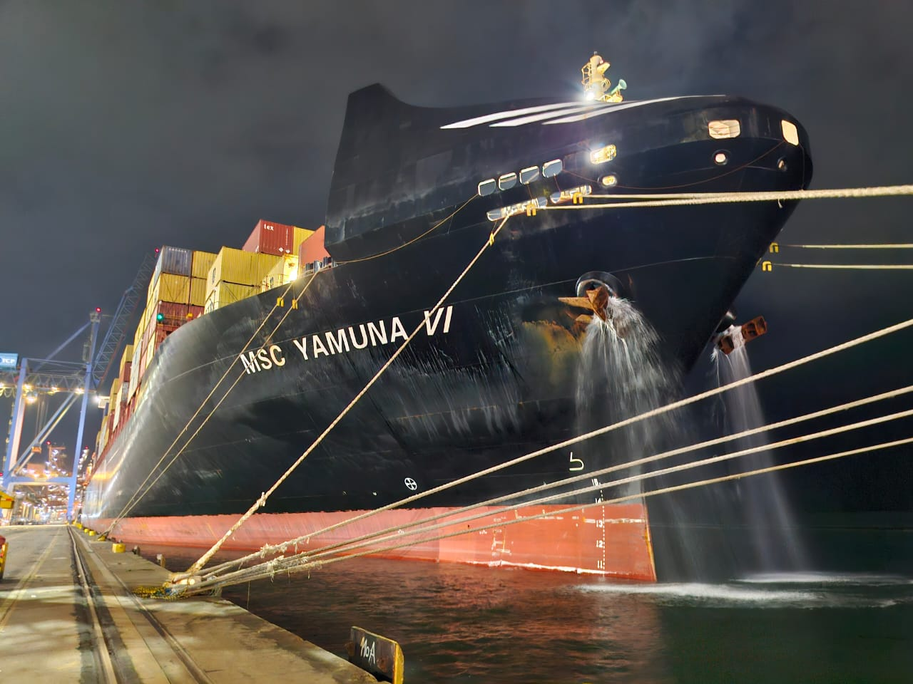

PERSON / COMPANIES CONTACTED

Manager | {contact_manager_company}  {contact_manager_name}
Surveyor | NAABSA Marine Surveyors  {surveyors}
Vessel’s Command | {vessel_name:0:4}{vessel_name:4:}  Capt. {captain} / Ch Engº. {chief_engineer}

Contents

- Vessel´s details (Ship´s Particulars).………………………….………………………………………………………………………………....……….{toc_s1}
- Background…………………………………………………………………………………………………………………………………………….….…………{toc_s2}
- Found at Survey.……………………………………………………………………………………………………………………………………………………{toc_s3}
  - Purifiers Settings……………………………………………………………………………………………………………………………………..{toc_s3_1}
  - Temperature.………………………………………………………………………………………………………………………………….........{toc_s3_2}
  - Specific gravity.…………………………………….…………………………………………………………………………………….…..........{toc_s3_3}
  - Gross volume.…………….………………………………………………………………………………………….…………….…….….……….{toc_s3_4}
  - Sludge Disposal……………………………………………………………………………………………………………………………………….{toc_s3_5}
  - Sludge rate production……………………………………………………………………………………………………………………………{toc_s3_6}
  - Consumption x Flowmeter…………….……………………………………………………………………………………………………….{toc_s3_7}
  - Last attendances…………………………………………………………………………………………………………………………..………..{toc_s3_8}
- Time log……………………………………………………………………………………………………………………………………….……………………….{toc_s4}
- Photographic report………………………………………………………………………………………………………………….……………….………...{toc_s5}
  - Vessel...………………………………...……………………………………………………………………………….……………………………….{toc_s5_1}
  - Engine Room…………………………………………………………………………………………………………………………………………..{toc_s5_2}
  - Survey attendance ….…………………………………………………………………………………………………………………………..…{toc_s5_3}
  - ECR………………………………………………………………………………………………………………………………………………………….{toc_s5_4}
- Attachment……………………………………………………………………………………………………………………………………………….….……..{toc_s6}

Vessel´s details (Ship´s Particulars)

Manager : {manager}
Name : {vessel_name:0:4}{vessel_name:4:}
Flag : {flag}
Port registry : {port_registry}
Call sign : {call_sign}
IMO number : {imo:0:1}{imo:1:}
Type : {type}
Delivered : {delivered:0:2}{delivered:2:}
LOA : {loa:0:3}{loa:3:1}{loa:4:} m
LBP : {lbp:0:3}{lbp:3:1}{lbp:4:} m
Breadth : {breadth:0:1}{breadth:1:1}{breadth:2:1}{breadth:3:1}{breadth:4:} m
Depth : {depth:0:1}{depth:1:1}{depth:2:1}{depth:3:} m
Net tonnage : {net_tonnage:0:2}{net_tonnage:2:1}{net_tonnage:3:} mt
Gross tonnage : {gross_tonnage:0:2}{gross_tonnage:2:1}{gross_tonnage:3:} mt
Light ship : {light_ship:0:2}{light_ship:2:1}{light_ship:3:} mt

Background

Complying with Messrs. Mediterranean Shipping Company S.A. (Geneva) we did attend {vessel_name:0:1}{vessel_name:1:3}{vessel_name:4:} at {terminal:0:4}{terminal:4:} in order, to:

- Carry out the R.O.B. and update the VRS and Logbook with actual figures at time of survey;
- Follow-up the sludge disposal;
- To disclose the fuel oil consumption and to ascertain the sludge rate production.

Found at Survey

We did attend vessel on {survey_date_month} {survey_date_day}^{{survey_date_ordinal}}, {survey_date_year:0:3}{survey_date_year:3:} , to disclose the total of fuel remaining on board, to compare it with vessel’s logbook and to verify the total amount of sludge disposed.
The opening and closing soundings took place with cargo operation/movement in progress.
The purifiers were found switched off and no transfers were carried out.
The soundings were performed by {surveyed_by}^{{surveyed_by_ordinal}}{surveyed_by_role} .

  - Purifiers Settings

Temperature.........…………………..: {purifier_temp:0:1}{purifier_temp:1:} °C
Flow setting by each purifier…….: {purifier_flow:0:1}{purifier_flow:1:3}{purifier_flow:4:1}{purifier_flow:5:} m³
Bowl discharging frequency……..: {purifier_bowl_freq:0:1}{purifier_bowl_freq:1:} minutes

  - Temperature

Fuel oil Storage tank – {temp_storage_infrared}
Fuel oil Service tanks – {temp_service}
Diesel oil storage and Service tanks – {temp_do}
Miscellaneous – not applied
Engine room temperature: {temp_engine_room} °C
Sea water temperature: {temp_sea_water:0:1}{temp_sea_water:1:} °C

  - Specific Gravities

Applied according to the vessel´s records (BDNs) presented by Chief Engineer at time of survey.

  - Gross volume - m³

Calculated according to the ship´s tanks sounding table provided by Chief Engineer at time of survey. All corrections were applied accordingly.
{records_updated_sentence:0:24}{records_updated_sentence:24:7}{records_updated_sentence:31:1}{records_updated_sentence:32:5}{records_updated_sentence:37:3}{records_updated_sentence:40:1}{records_updated_sentence:41:1}{records_updated_sentence:42:1}{records_updated_sentence:43:3}{records_updated_sentence:46:9}{records_updated_sentence:55:17}{records_updated_sentence:72:7}{records_updated_sentence:79:1}{records_updated_sentence:80:21}{records_updated_sentence:101:1}{records_updated_sentence:102:}

Grades | Surveyor (mt) | VRS (mt) | Diff (mt) | Diff (%)
{grade_1:0:8}{grade_1:8:1}{grade_1:9:} | {grade_1_surveyor} | {grade_1_vrs} | {grade_1_difference:0:1}{grade_1_difference:1:1}{grade_1_difference:2:2}{grade_1_difference:4:1}{grade_1_difference:5:} | {grade_1_percentage:0:1}{grade_1_percentage:1:1}{grade_1_percentage:2:1}{grade_1_percentage:3:1}{grade_1_percentage:4:}
{grade_2} | {grade_2_surveyor} | {grade_2_vrs} | {grade_2_difference:0:1}{grade_2_difference:1:1}{grade_2_difference:2:1}{grade_2_difference:3:1}{grade_2_difference:4:} | {grade_2_percentage:0:1}{grade_2_percentage:1:1}{grade_2_percentage:2:1}{grade_2_percentage:3:1}{grade_2_percentage:4:}
{grade_3} | {grade_3_surveyor} | {grade_3_vrs} | {grade_3_difference} | {grade_3_percentage}
{grade_4} | {grade_4_surveyor} | {grade_4_vrs} | {grade_4_difference} | {grade_4_percentage}

  - Sludge Disposal

Berthing message..…………: {sludge_berthing} m³
Surveyor’s figures…………..: {sludge_surveyor} m³
Quantity disposed………….: {sludge_disposed} m³ of Sludge
Quantity retained….……….: {retained_chief:0:2}{retained_chief:2:} m³ (Ch./Eng. figures) / {retained_after_discharge:0:1}{retained_after_discharge:1:1}{retained_after_discharge:2:} m³ (Surveyor figures)

  - Sludge Rate Production

Period: From {last_discharge_date_month} {last_discharge_date_day:0:1}{last_discharge_date_day:1:}^{{last_discharge_date_ordinal}}, {last_discharge_date_year:0:3}{last_discharge_date_year:3:} , up to {survey_date_month:0:2}{survey_date_month:2:} {survey_date_day}^{{survey_date_ordinal}}, {survey_date_year:0:3}{survey_date_year:3:} .
Retained at last disposal….: {retained_after_last_discharge:0:2}{retained_after_last_discharge:2:1}{retained_after_last_discharge:3:} m³
Sludge production……………: {sludge_generated_chief} m³ (Ch. Eng. Figures) / {sludge_generated_surveyor:0:2}{sludge_generated_surveyor:2:1}{sludge_generated_surveyor:3:} m³ (Surveyor figures)
Consumption…………………..: {consumption_chief:0:5}{consumption_chief:5:} mt (Logbook) / {consumption_surveyor} mt (Surveyor figures)
Sludge rate production……: {sludge_rate_chief:0:2}{sludge_rate_chief:2:} % (Ch. Eng. figures) / {sludge_rate_surveyor} % (Surveyor figures)

  - Consumption X Flowmeters

Ch. Eng. Figures Surveyors figures
Logbook………..: {flowmeter_logbook_total} mt Soundings……..: {flowmeter_soundings:0:3}{flowmeter_soundings:3:} mt
Flowmeters…..: {flowmeter_total} mt Flowmeters……: {flowmeter_total} mt
Dif…………………: {flowmeter_difference} mt or {flowmeter_accuracy:0:2}{flowmeter_accuracy:2:1}{flowmeter_accuracy:3:} % Dif………………….: {consumption_flowmeter_difference} mt or {consumption_flowmeter_percentage} %

Last attendences

Description | {last_attendance_1_date:0:1}{last_attendance_1_date:1:6}{last_attendance_1_date:7:2}{last_attendance_1_date:9:1}{last_attendance_1_date:10:5}{last_attendance_1_date:15:} | {last_attendance_2_date:0:5}{last_attendance_2_date:5:}
R HS Surveyor | {last_attendance_1_grade_1_surveyor} MT | {last_attendance_2_grade_1_surveyor} MT
R HS VRS | {last_attendance_1_grade_1_vrs} MT | {last_attendance_2_grade_1_vrs:0:6}{last_attendance_2_grade_1_vrs:6:} MT
Diff | {last_attendance_1_grade_1_difference} MT | {last_attendance_2_grade_1_difference} MT
DISTILL Surveyor | {last_attendance_1_grade_3_surveyor} MT | {last_attendance_2_grade_3_surveyor} MT
DISTILL VRS | {last_attendance_1_grade_3_vrs} MT | {last_attendance_2_grade_3_vrs} MT
Diff | {last_attendance_1_grade_3_difference} MT | {last_attendance_2_grade_3_difference} MT
Sludge Surveyor | {last_attendance_1_sludge_surveyor} m³ | {last_attendance_2_sludge_surveyor} m³
Sludge berthing message | {last_attendance_1_sludge_berthing} m³ | {last_attendance_2_sludge_berthing} m³
Diff | {last_attendance_1_sludge_difference} m³ | {last_attendance_2_sludge_difference} m³
Discharged | {last_attendance_1_sludge_disposed} m³ | {last_attendance_2_sludge_disposed} m³
Consumption (Logbook) | {last_attendance_1_consumption_chief} MT | {last_attendance_2_consumption_chief} MT
Consumption (Flw) | {last_attendance_1_flowmeter_total} MT | {last_attendance_2_flowmeter_total} MT
Diff | {last_attendance_1_flowmeter_difference} MT | {last_attendance_2_flowmeter_difference} MT
Sludge production | {last_attendance_1_sludge_generated_chief} m³ | {last_attendance_2_sludge_generated_chief} m³
Sludge rate production | {last_attendance_1_sludge_rate_chief} % | {last_attendance_2_sludge_rate_chief} %

Time log
 | Date | Time
{time_log_1_event} | {time_log_1_date:0:10}{time_log_1_date:10:} | {time_log_1_start:0:5}{time_log_1_start:5:} | {time_log_1_flag} | {time_log_1_end}
{time_log_2_event} | {time_log_2_date:0:10}{time_log_2_date:10:} | {time_log_2_start:0:5}{time_log_2_start:5:} | {time_log_2_flag} | {time_log_2_end}
{time_log_3_event} | {time_log_3_date} | {time_log_3_start:0:5}{time_log_3_start:5:} | {time_log_3_flag} | {time_log_3_end}
{time_log_4_event} | {time_log_4_date:0:10}{time_log_4_date:10:} | {time_log_4_start:0:5}{time_log_4_start:5:} | {time_log_4_flag} | {time_log_4_end:0:5}{time_log_4_end:5:}
{time_log_5_event} | {time_log_5_date:0:10}{time_log_5_date:10:} | {time_log_5_start:0:5}{time_log_5_start:5:} | {time_log_5_flag} | {time_log_5_end:0:5}{time_log_5_end:5:}
{time_log_6_event} | {time_log_6_date:0:10}{time_log_6_date:10:} | {time_log_6_start:0:5}{time_log_6_start:5:} | {time_log_6_flag} | {time_log_6_end}
{time_log_7_event:0:5}{time_log_7_event:5:} | {time_log_7_date:0:10}{time_log_7_date:10:} | {time_log_7_start:0:5}{time_log_7_start:5:} | {time_log_7_flag} | {time_log_7_end}
{time_log_8_event} | {time_log_8_date:0:10}{time_log_8_date:10:} | {time_log_8_start:0:5}{time_log_8_start:5:} | {time_log_8_flag} | {time_log_8_end:0:5}{time_log_8_end:5:}
{time_log_9_event} | {time_log_9_date:0:10}{time_log_9_date:10:} | {time_log_9_start:0:5}{time_log_9_start:5:} | {time_log_9_flag} | {time_log_9_end:0:5}{time_log_9_end:5:}
{time_log_10_event} | {time_log_10_date:0:10}{time_log_10_date:10:} | {time_log_10_start:0:5}{time_log_10_start:5:} | {time_log_10_flag} | {time_log_10_end:0:5}{time_log_10_end:5:}
{time_log_11_event} | {time_log_11_date:0:10}{time_log_11_date:10:} | {time_log_11_start:0:5}{time_log_11_start:5:} | {time_log_11_flag} | {time_log_11_end}
{time_log_12_event} | {time_log_12_date:0:10}{time_log_12_date:10:} | {time_log_12_start:0:5}{time_log_12_start:5:} | {time_log_12_flag} | {time_log_12_end}

Photographic Report

  - Vessel
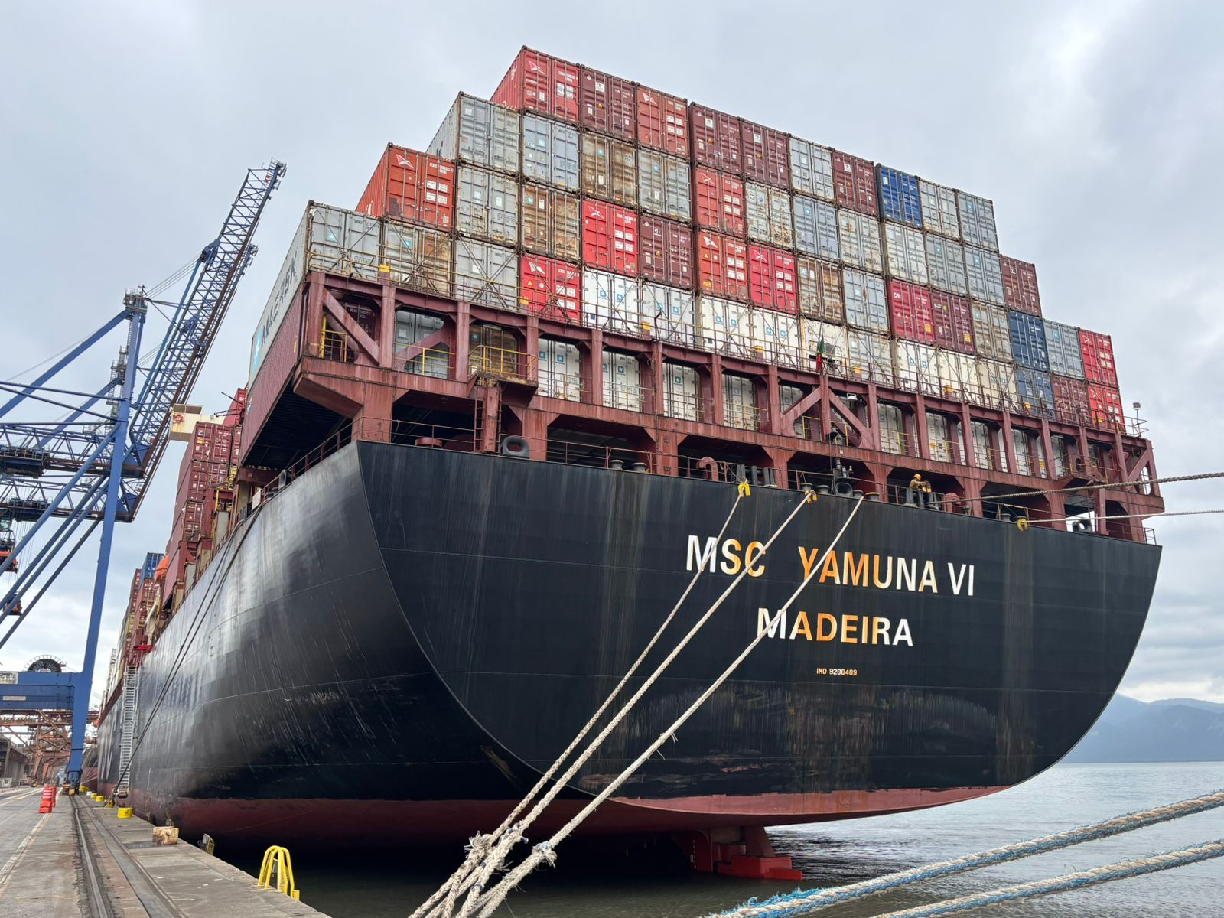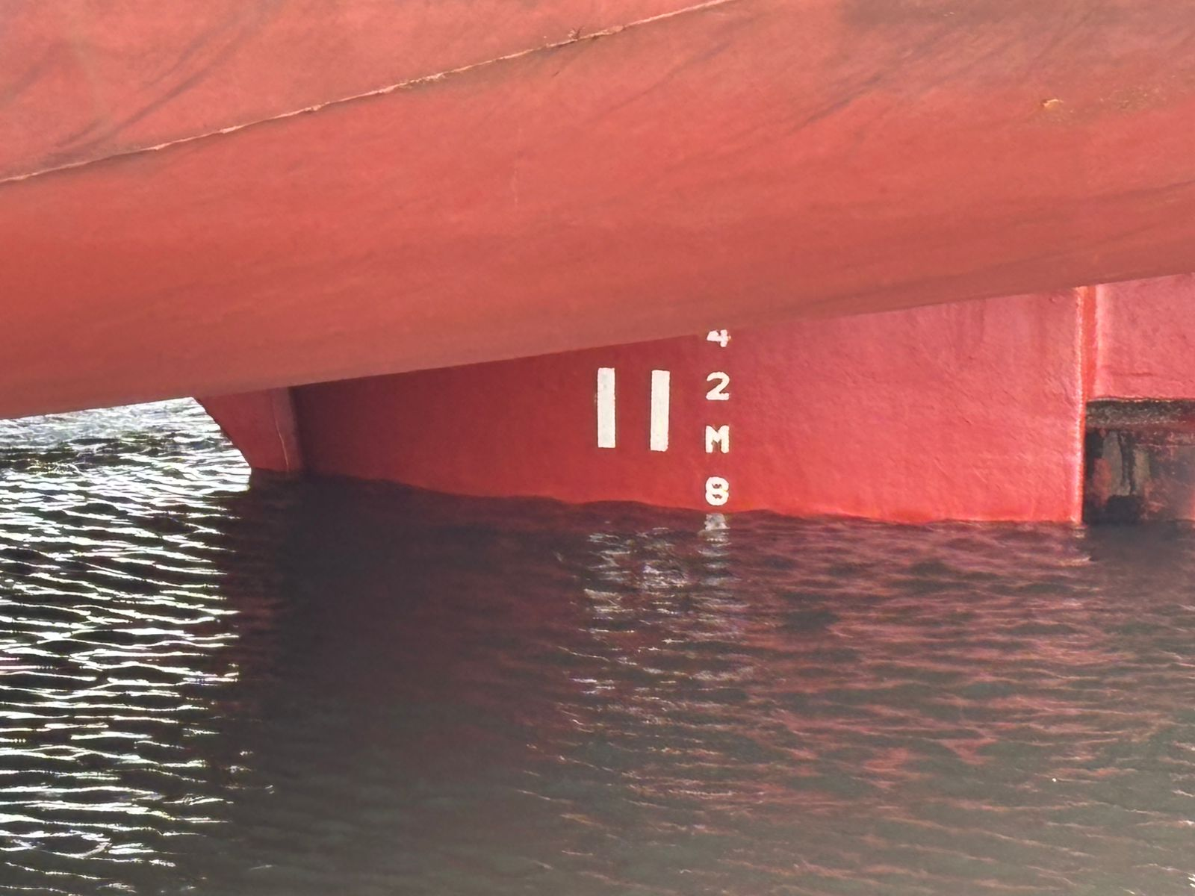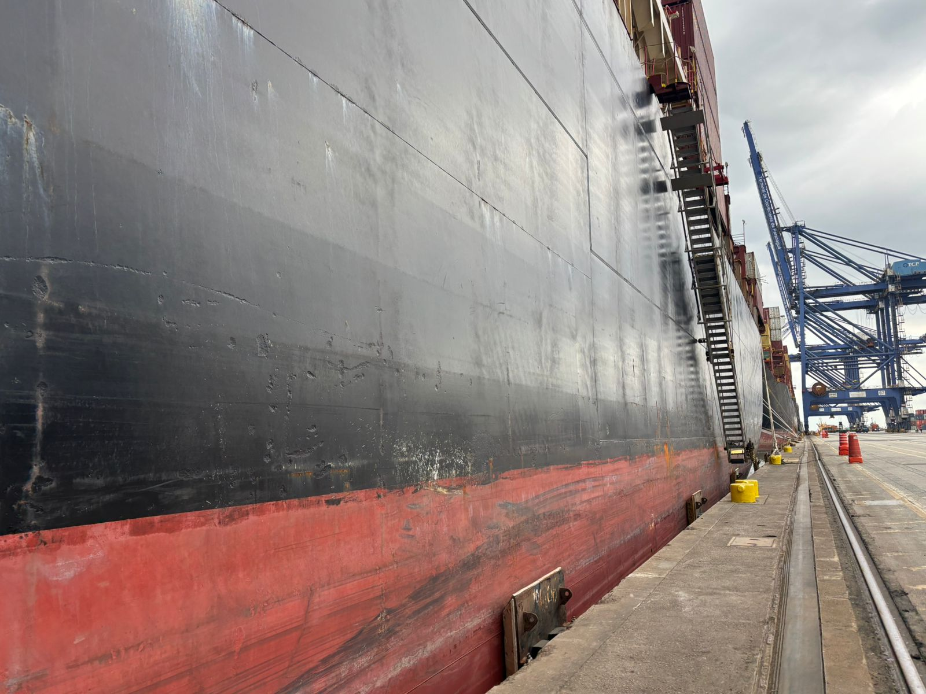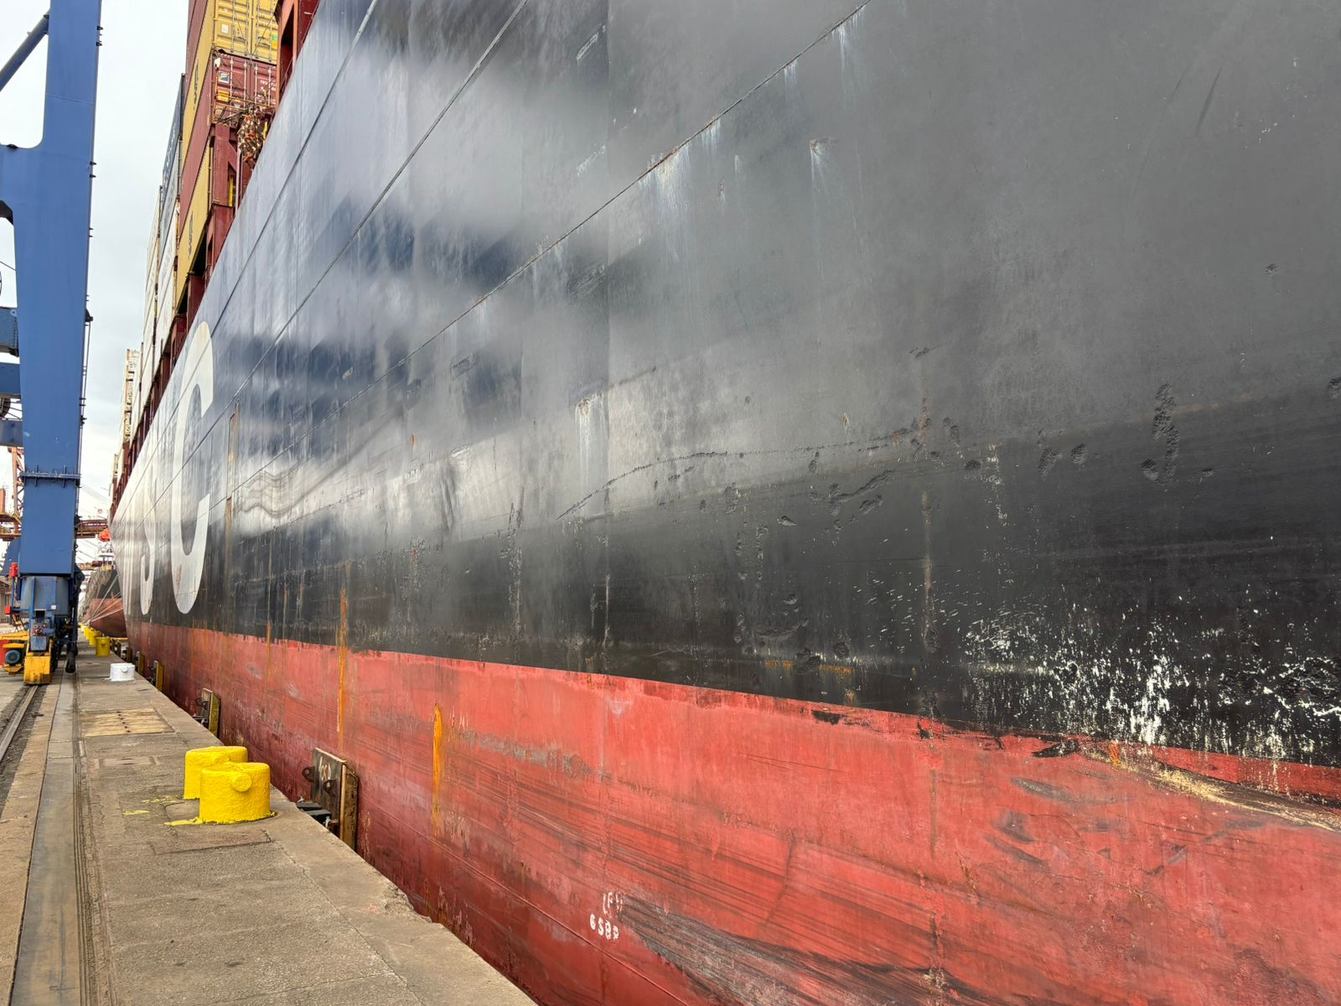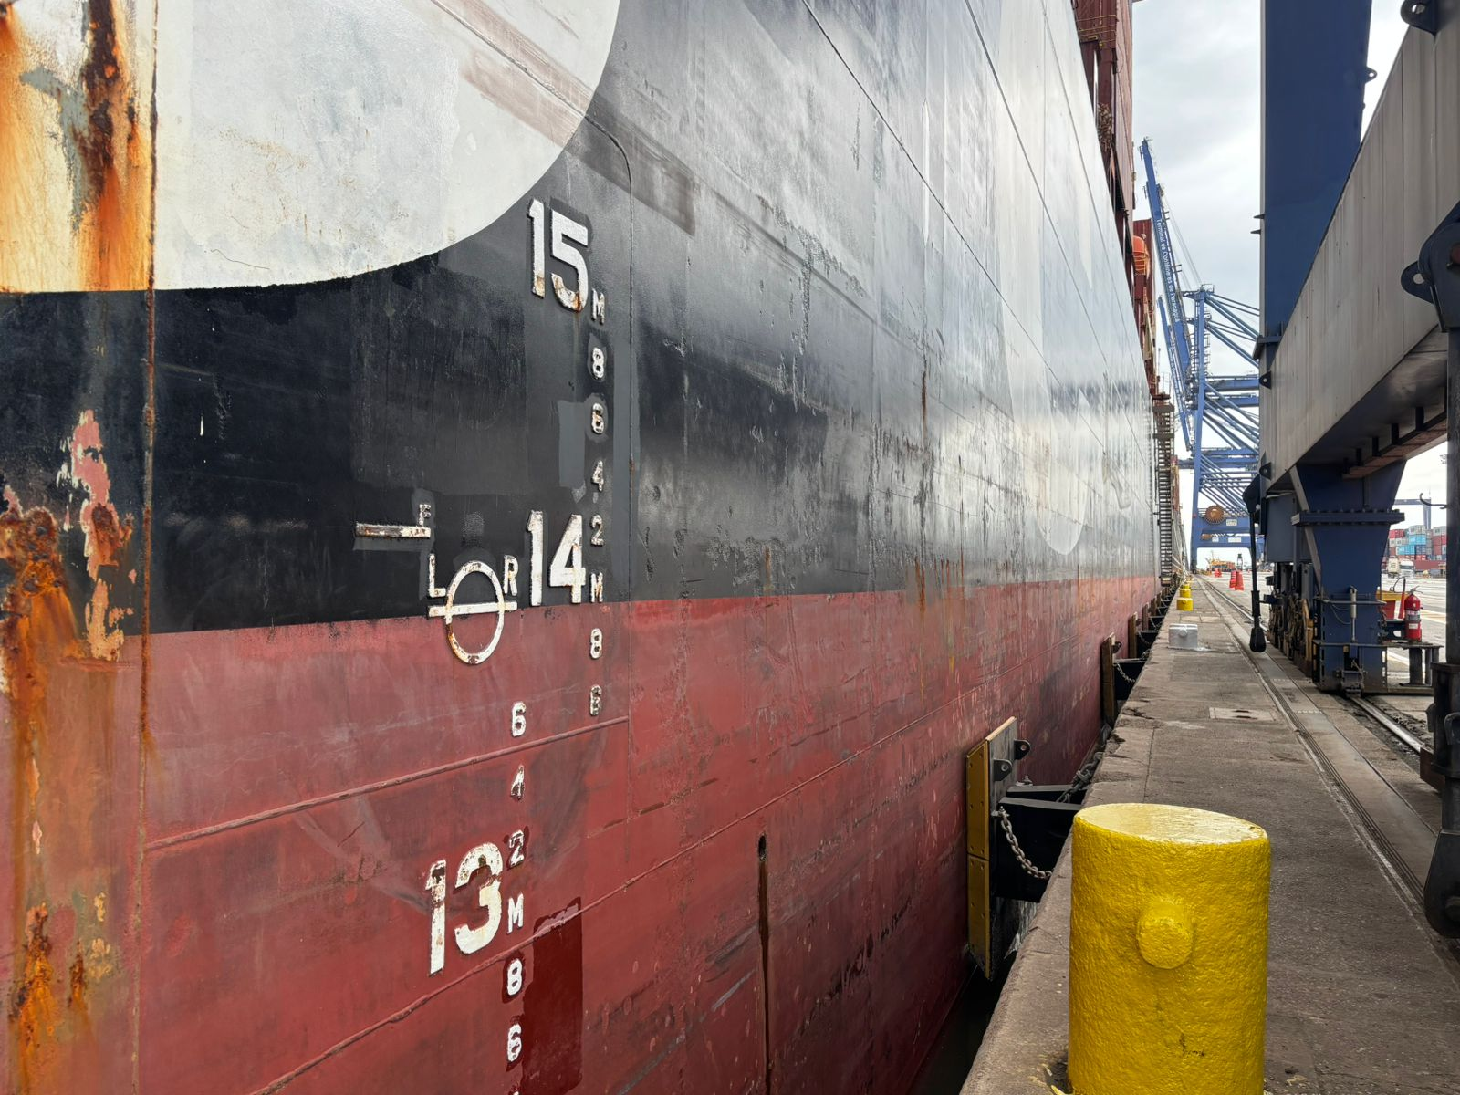

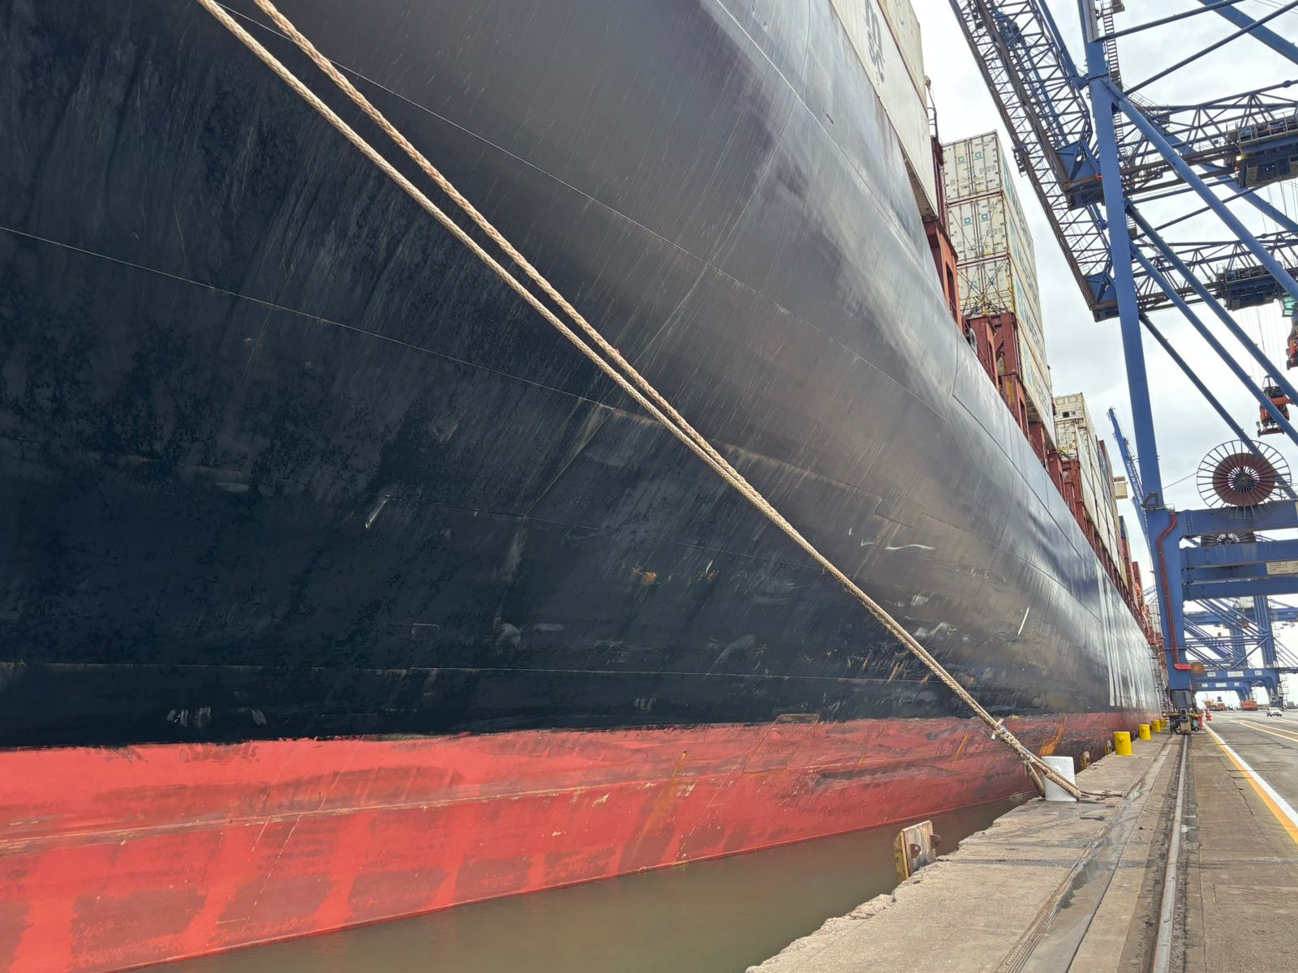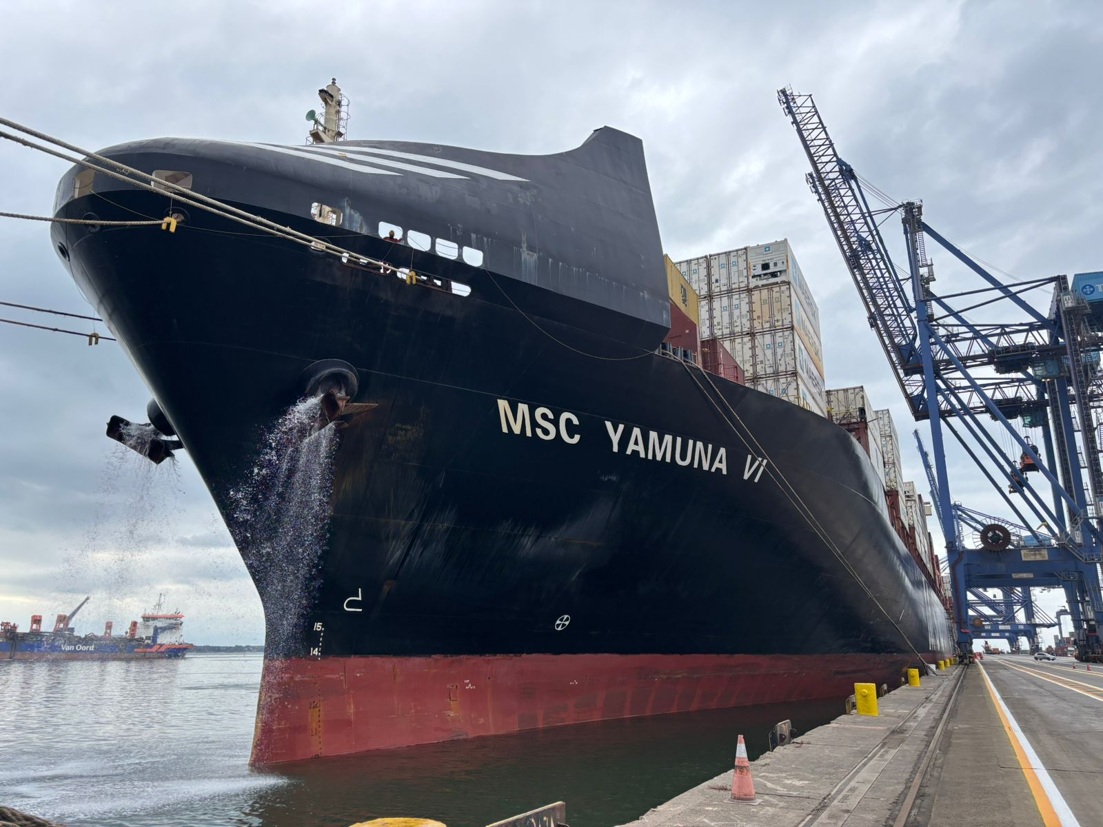
  - Engine Room
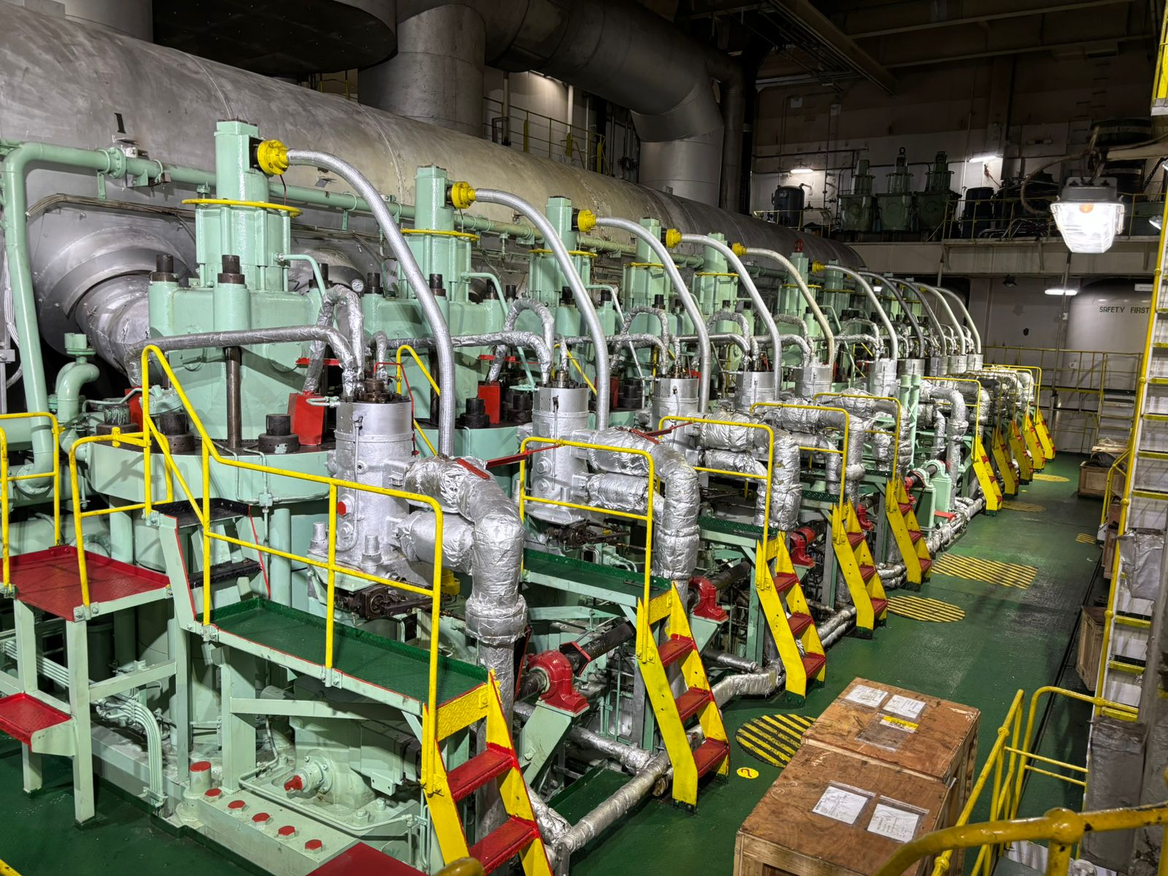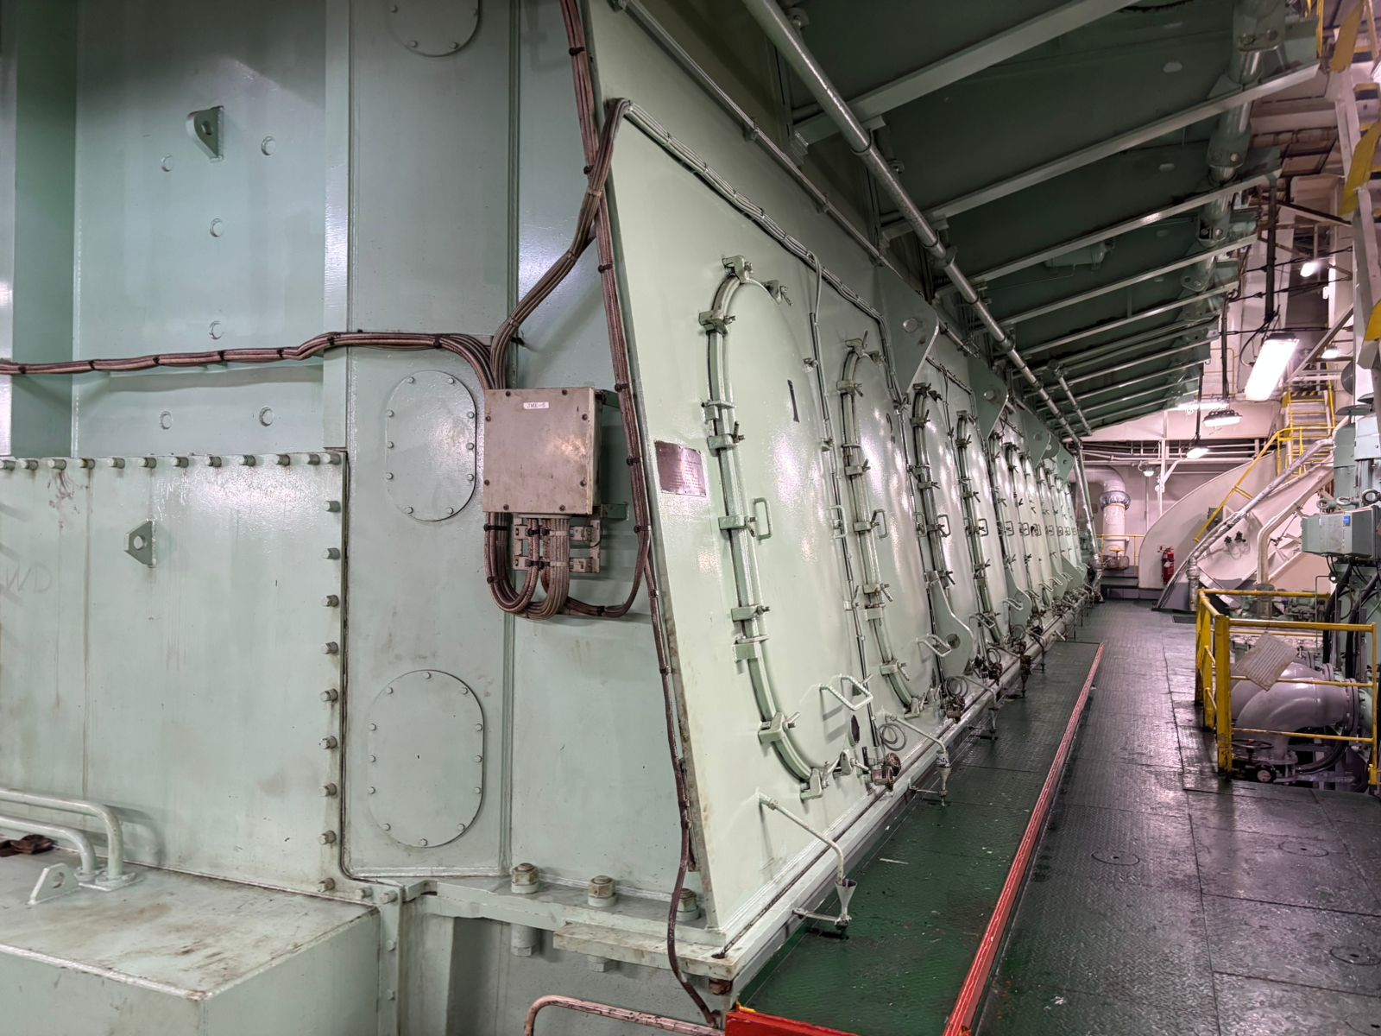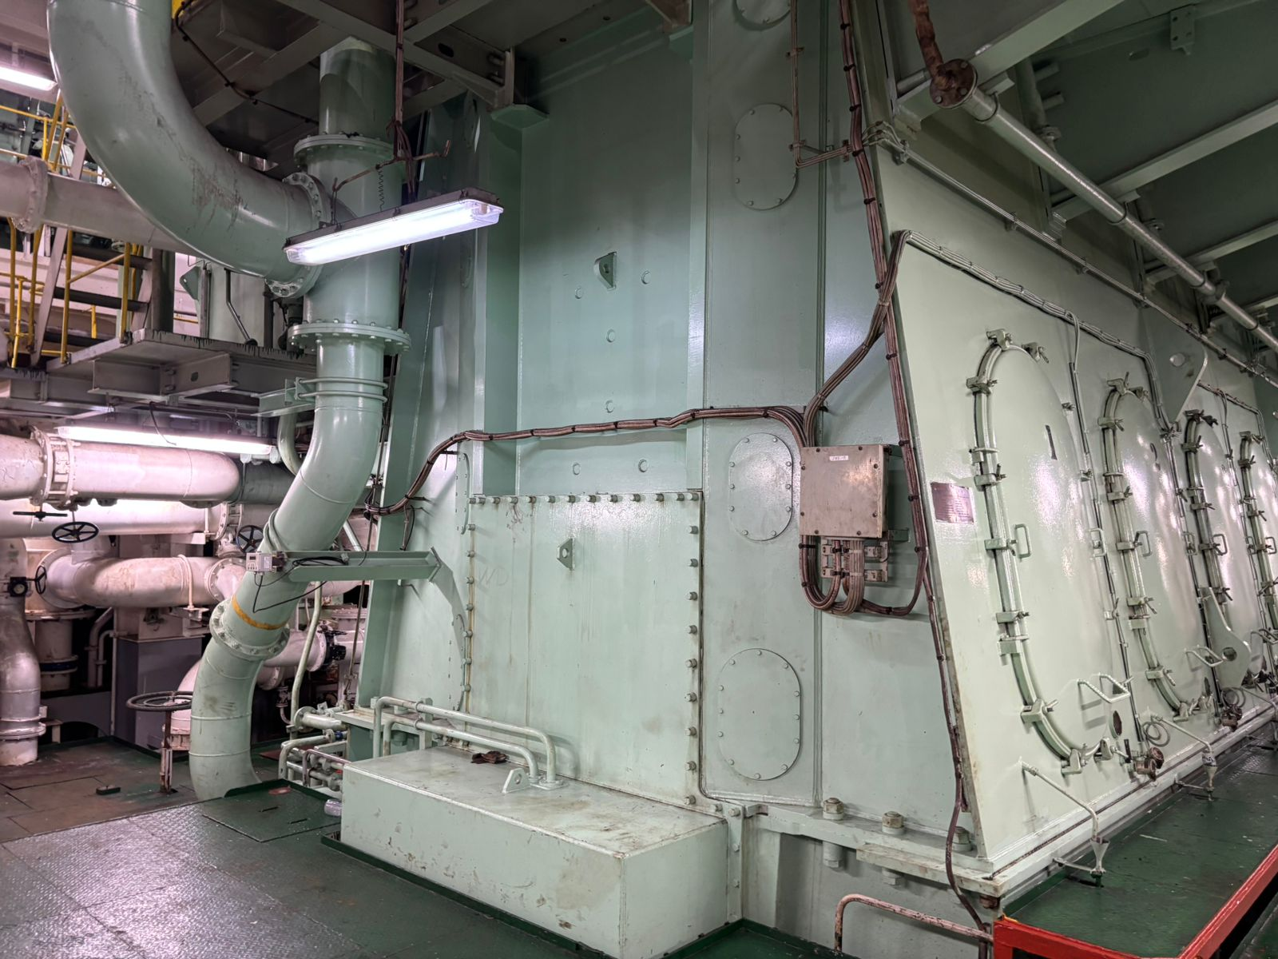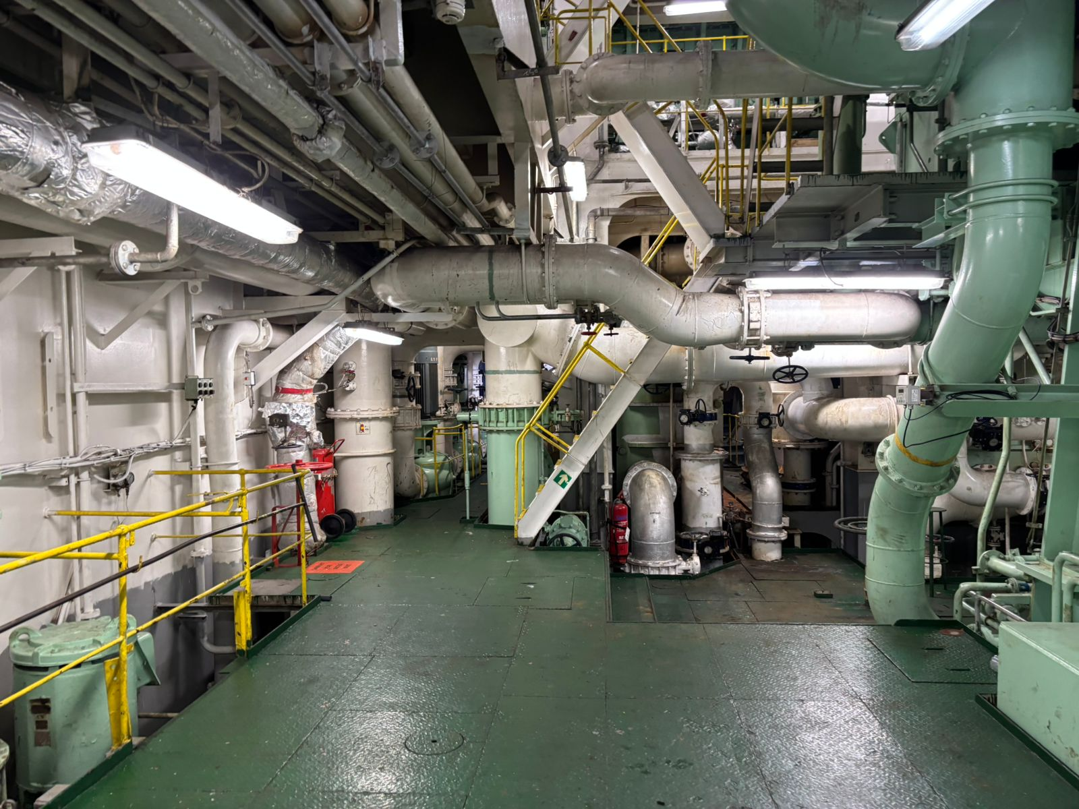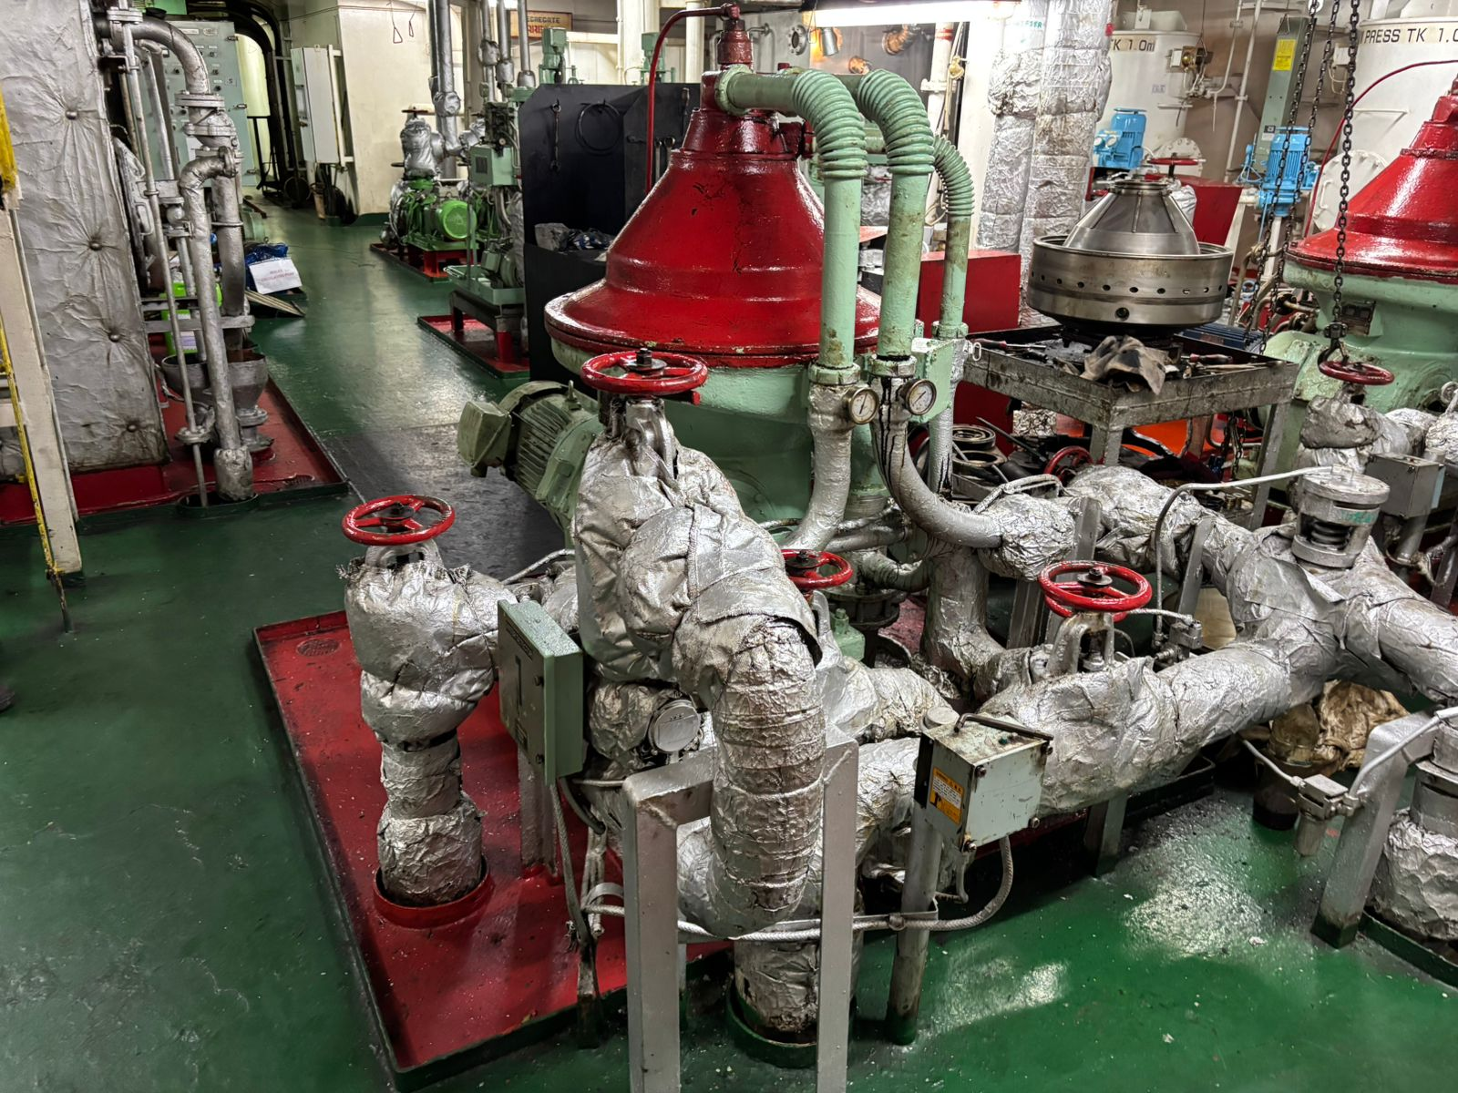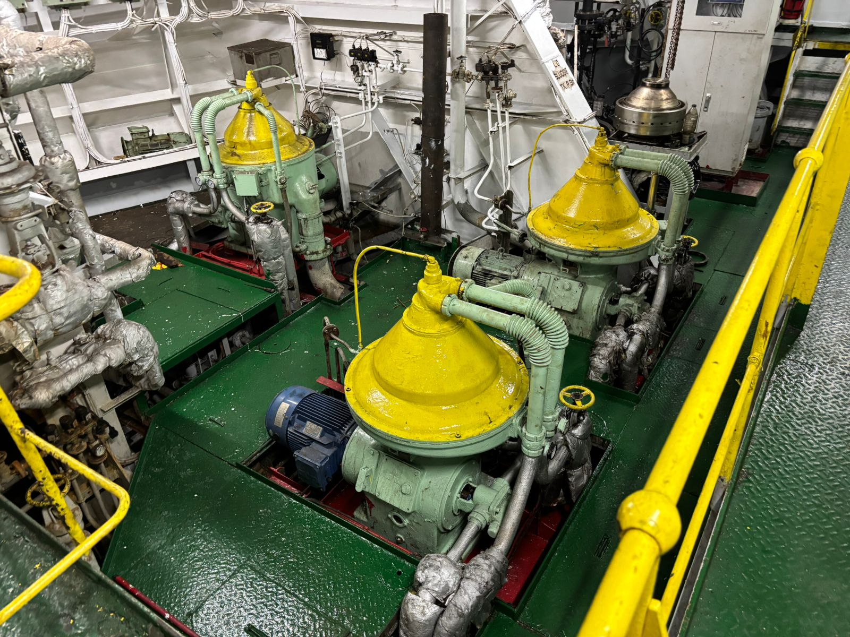
  - Survey attendance
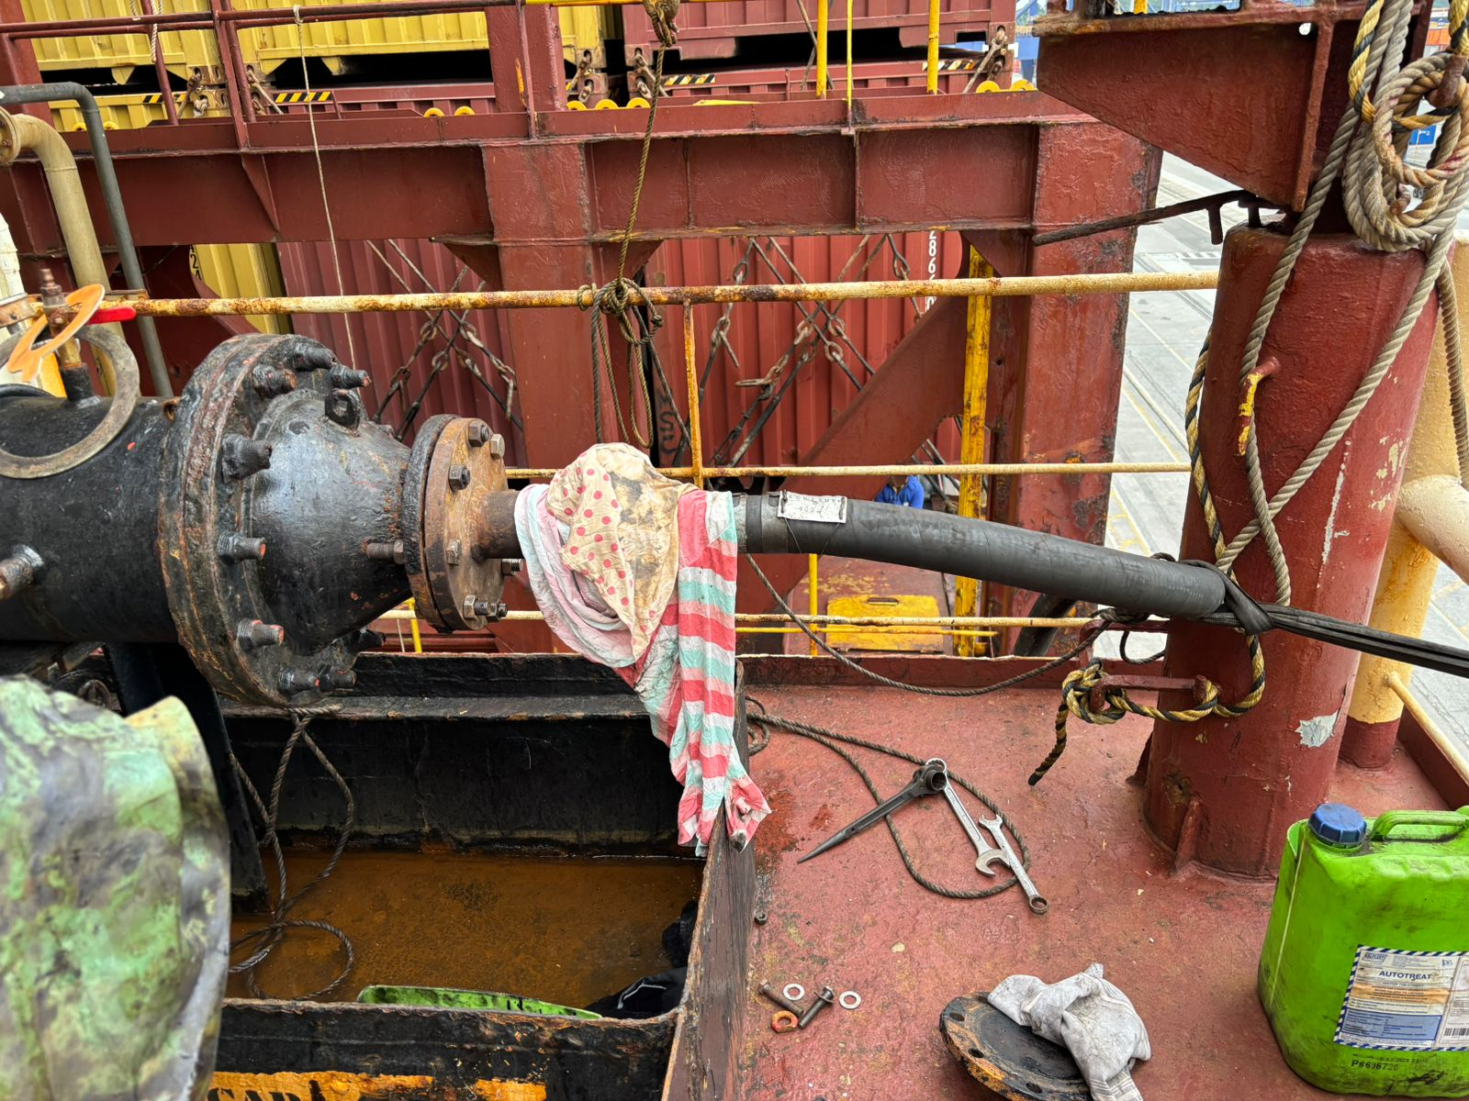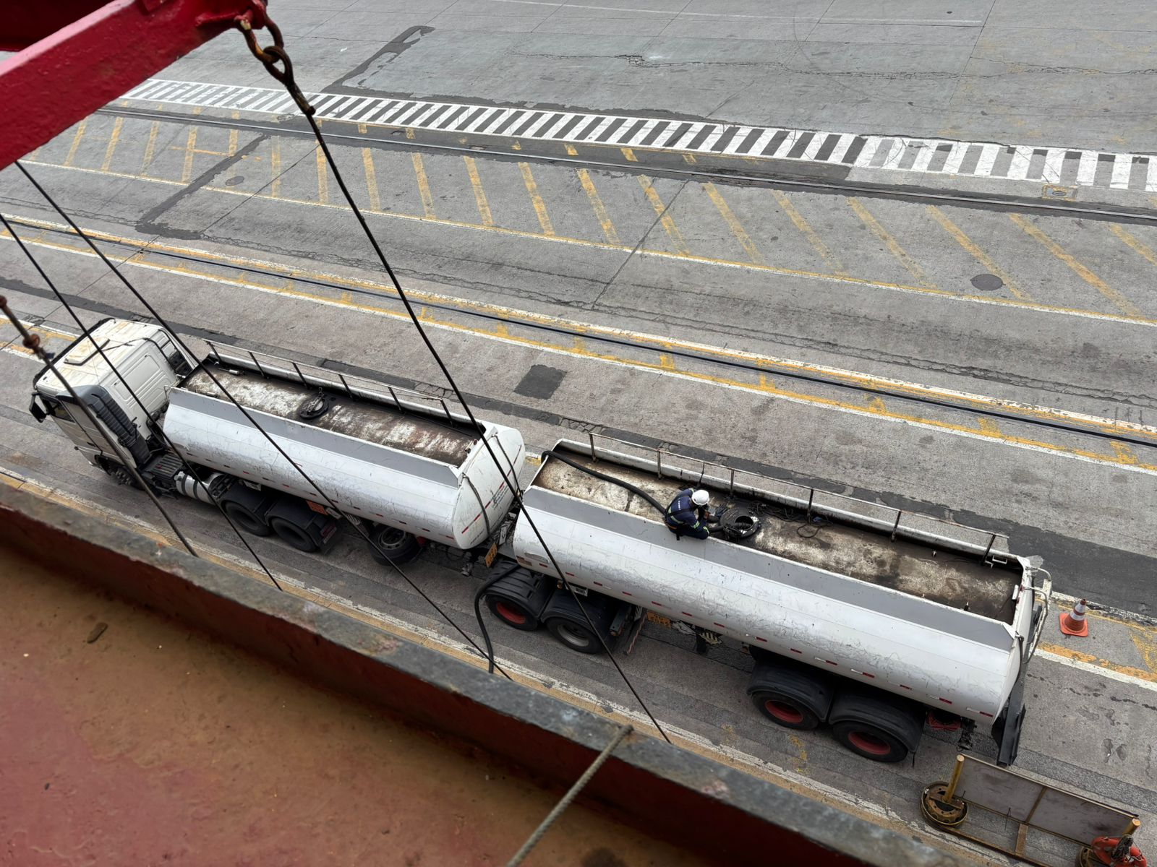
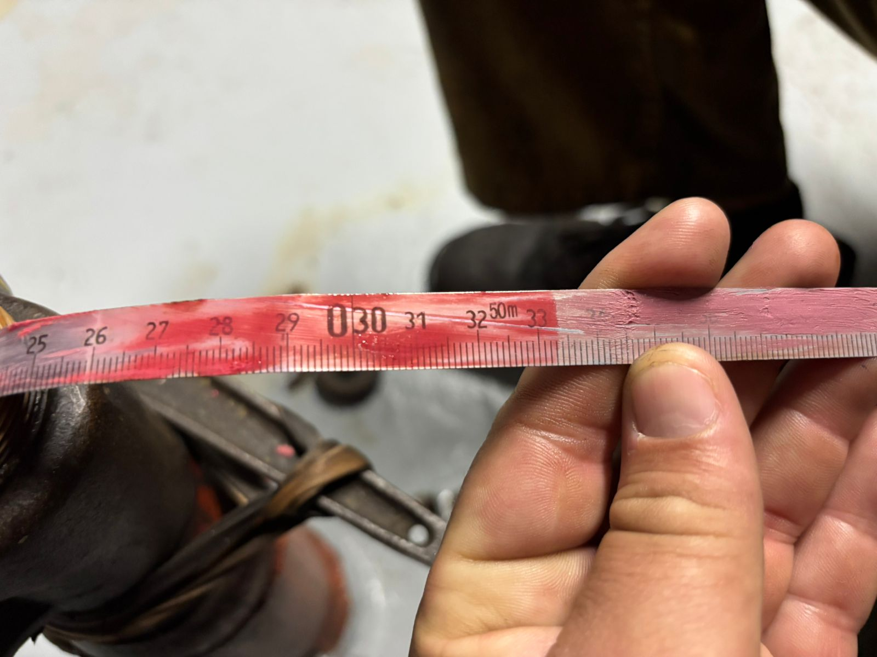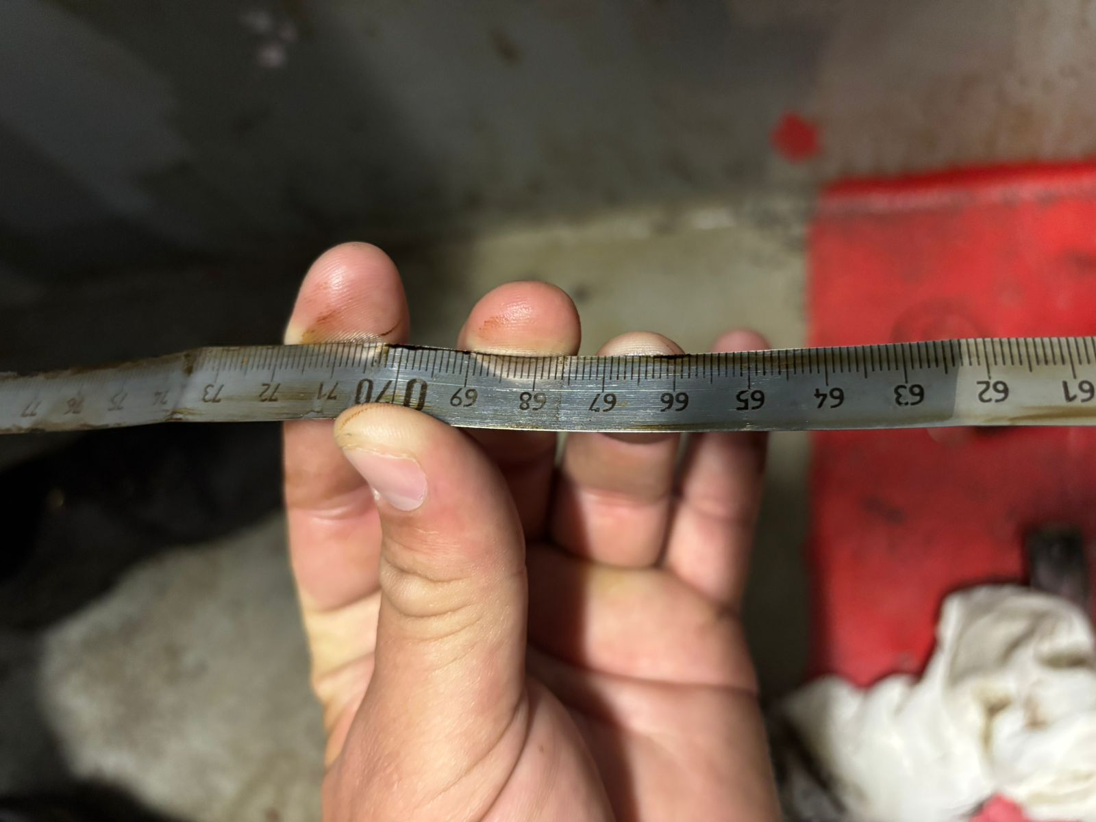
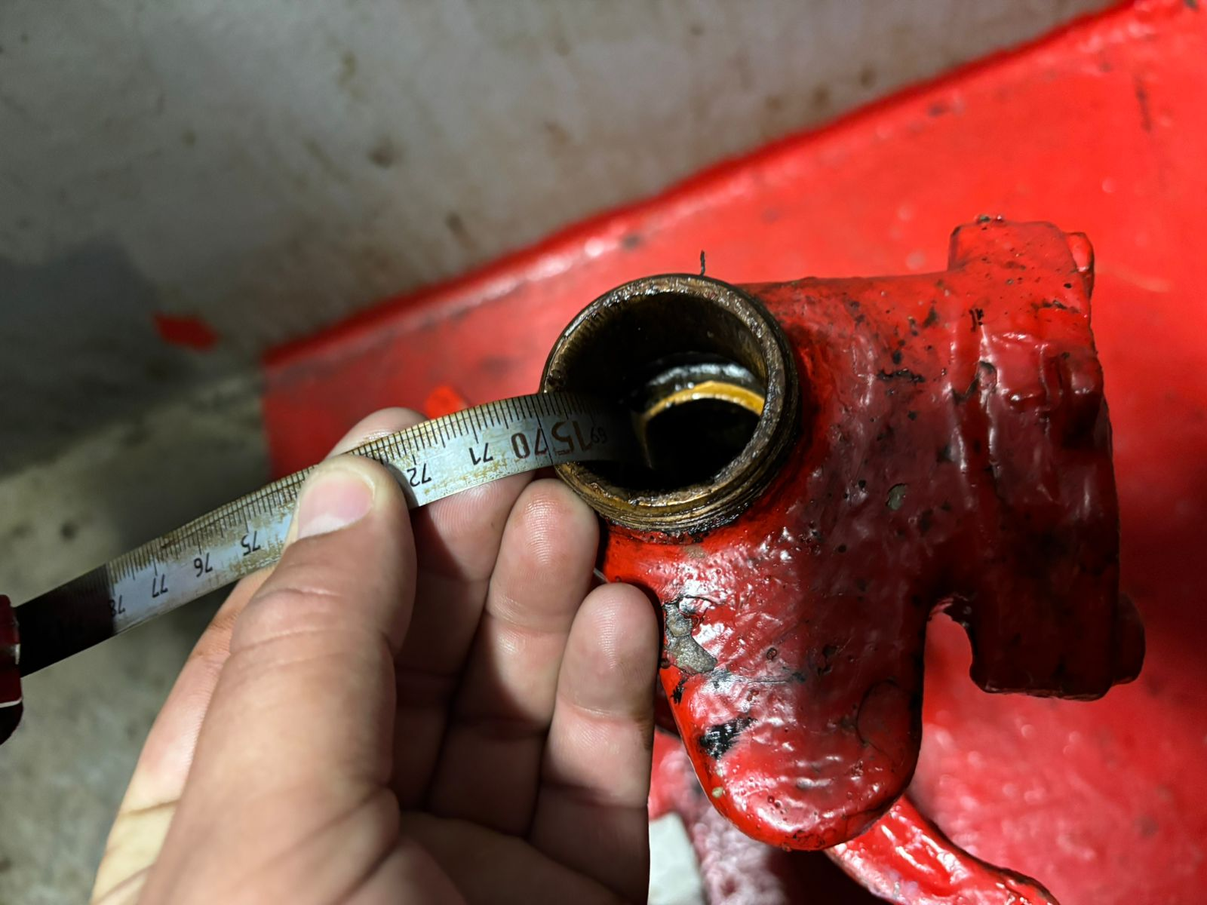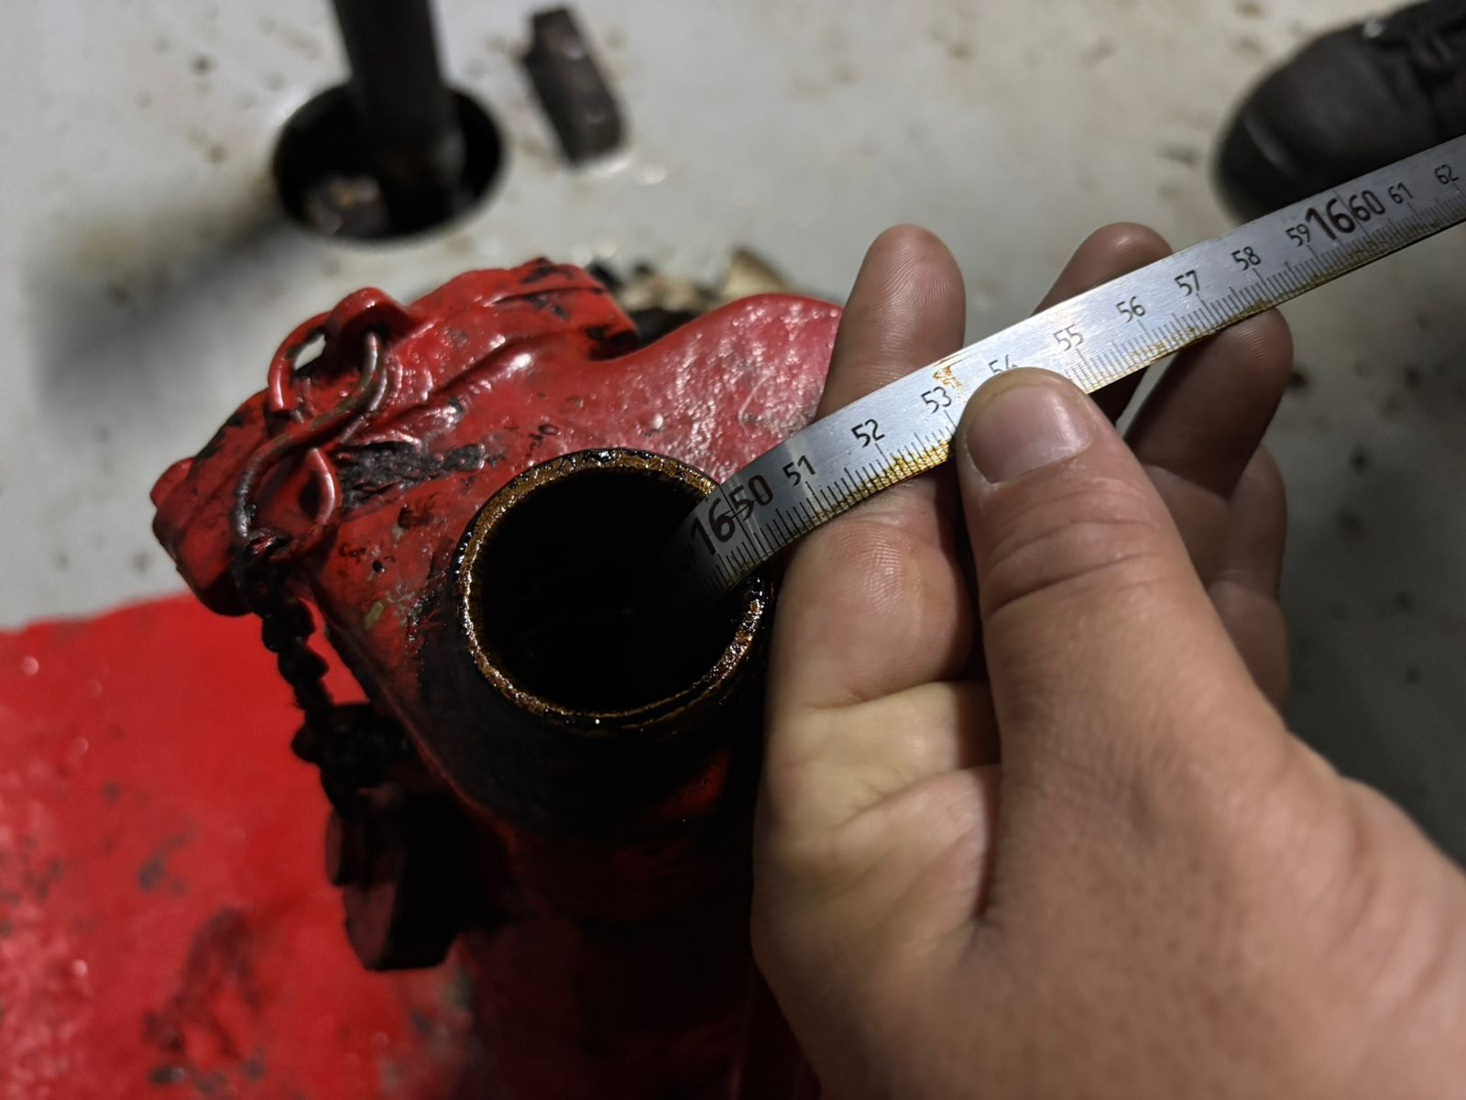
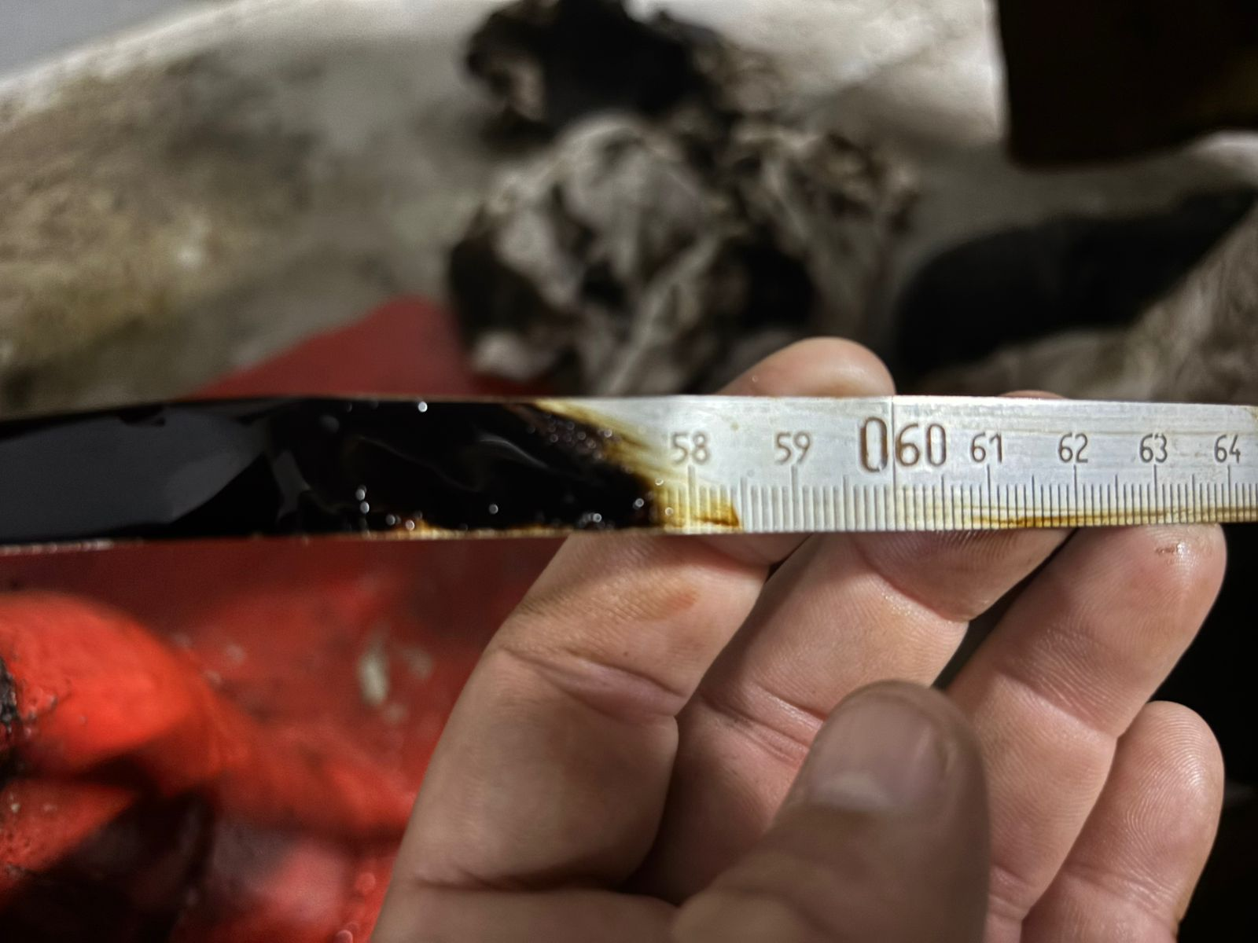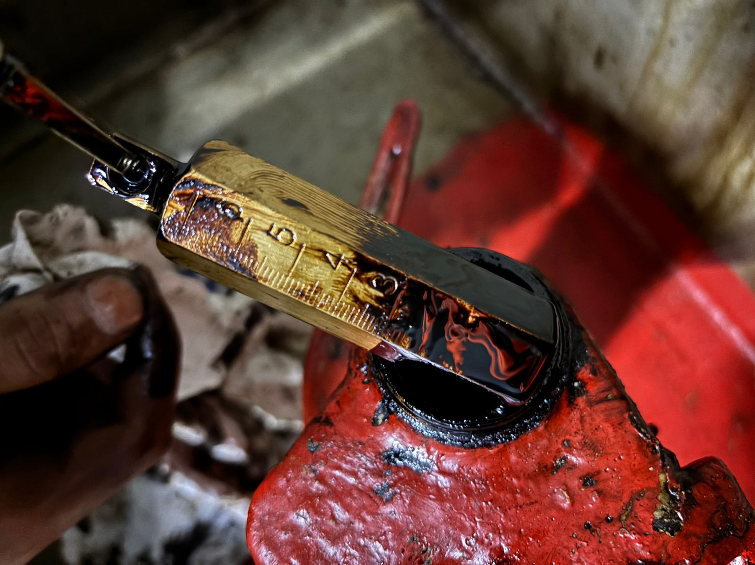
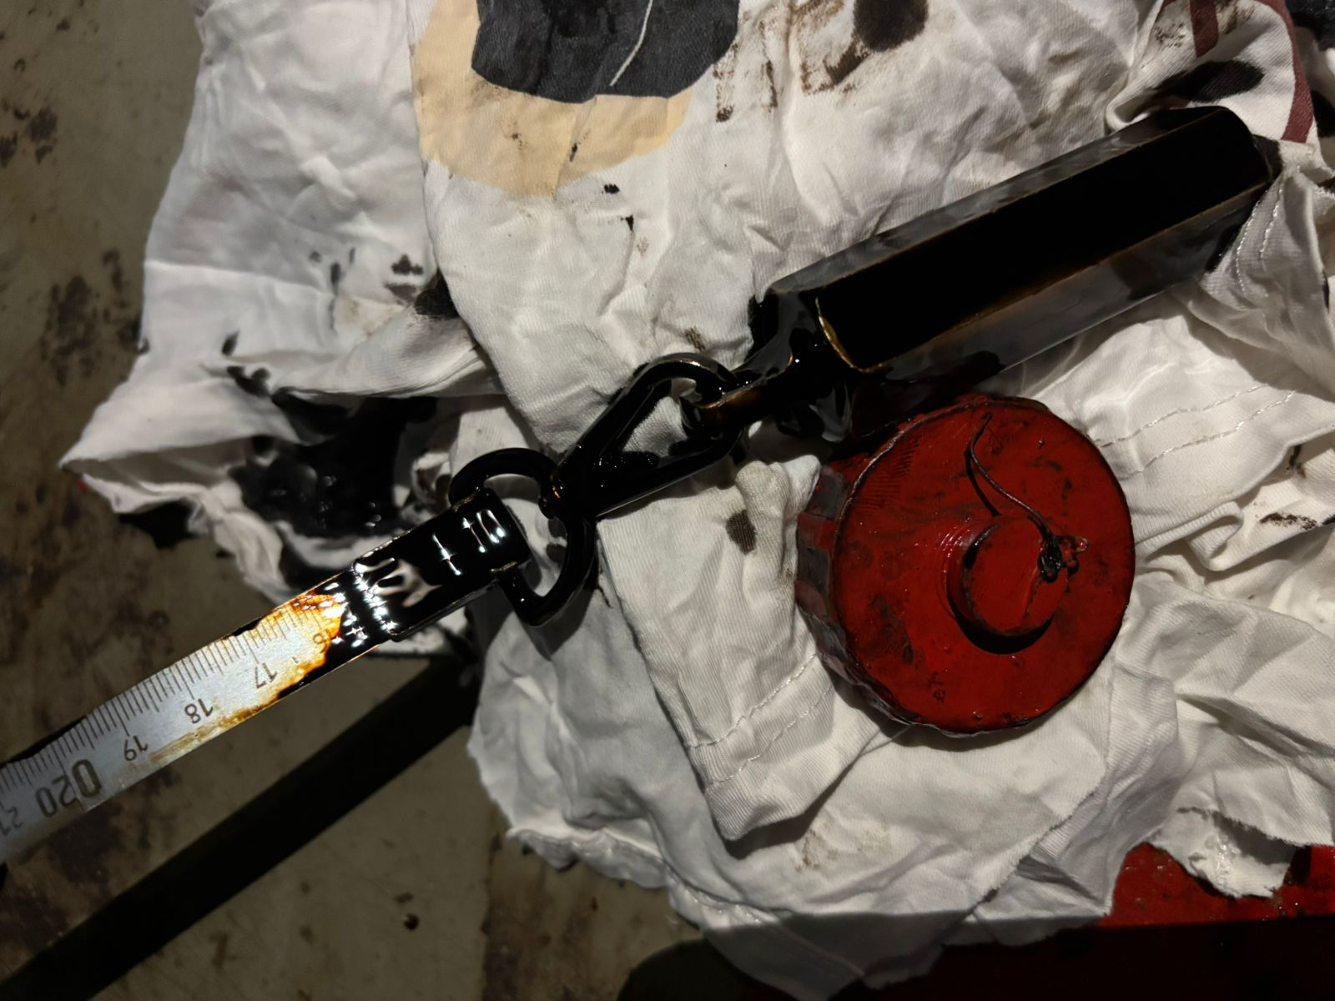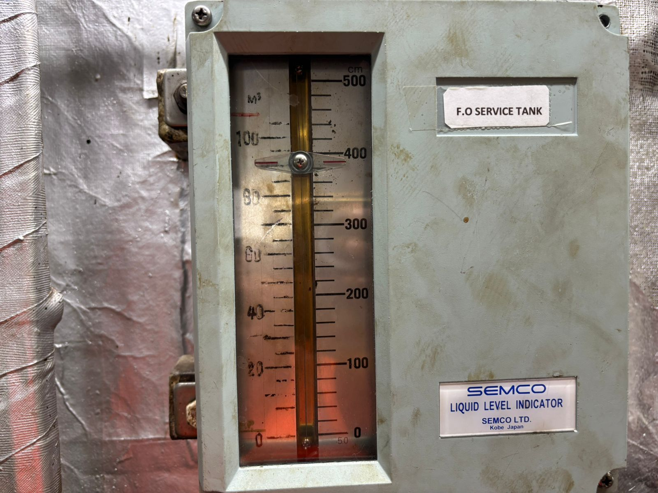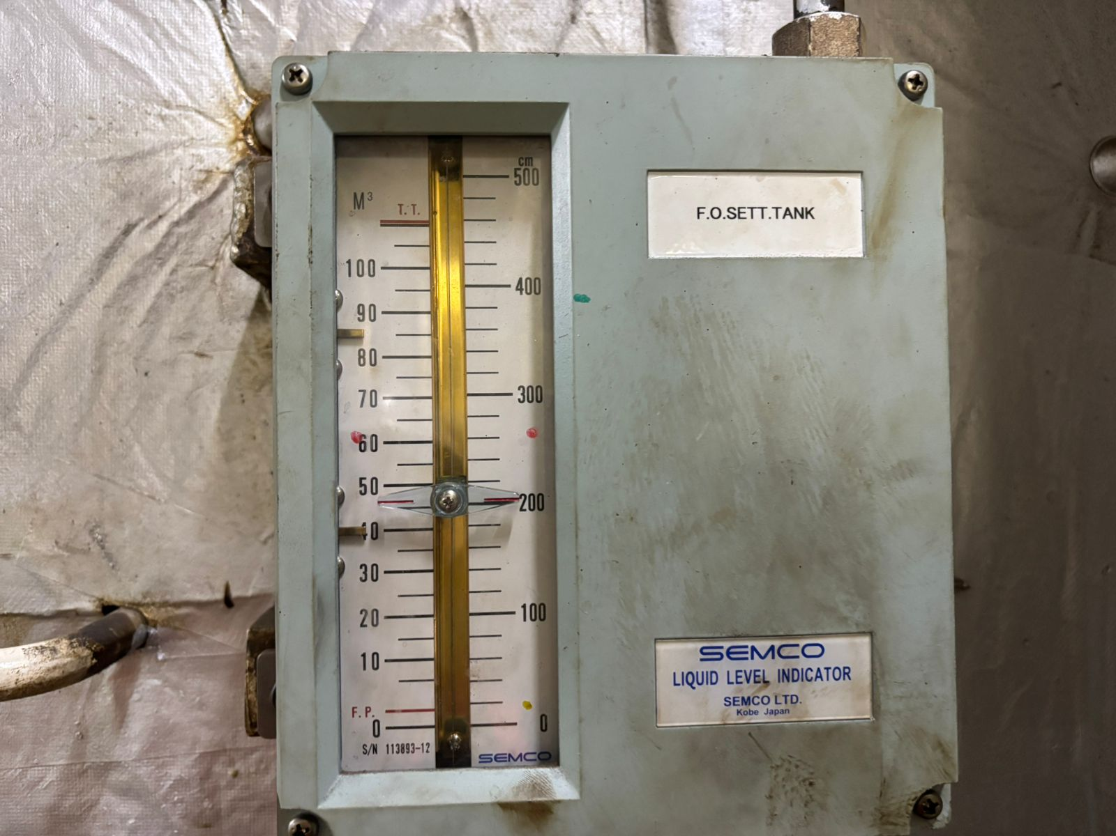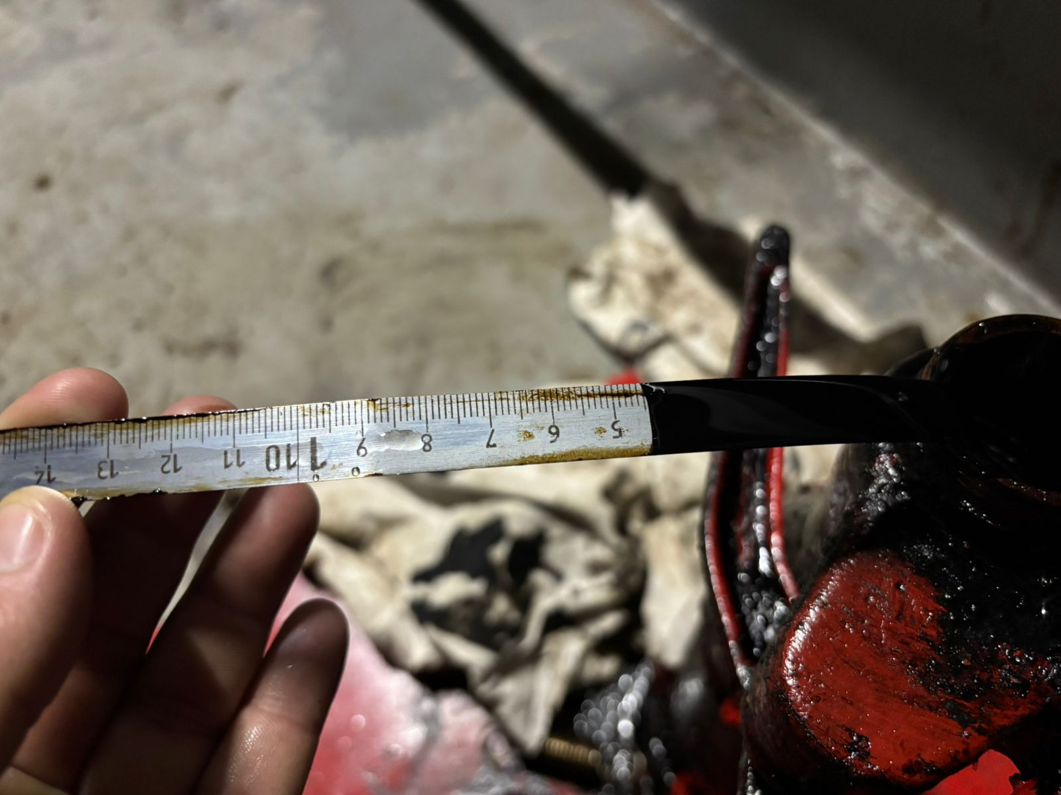

  - ECR
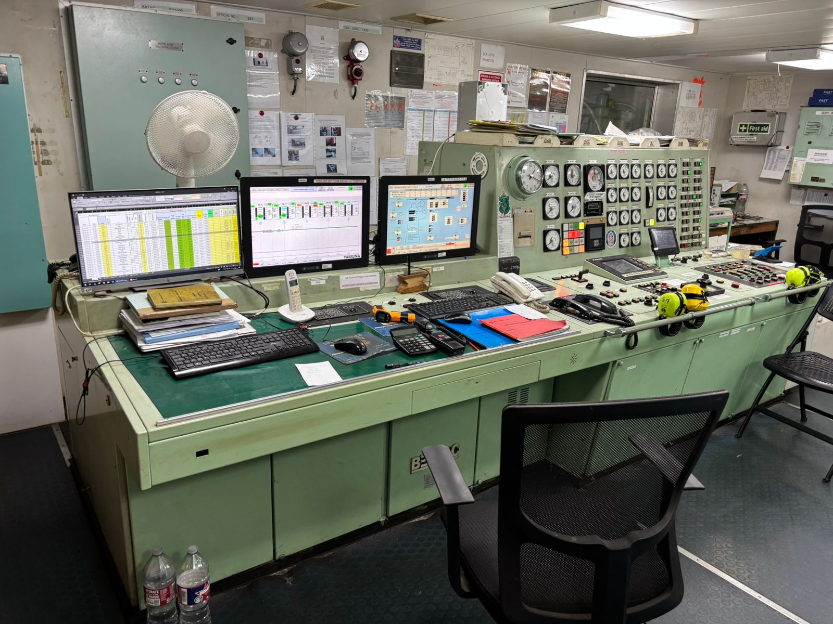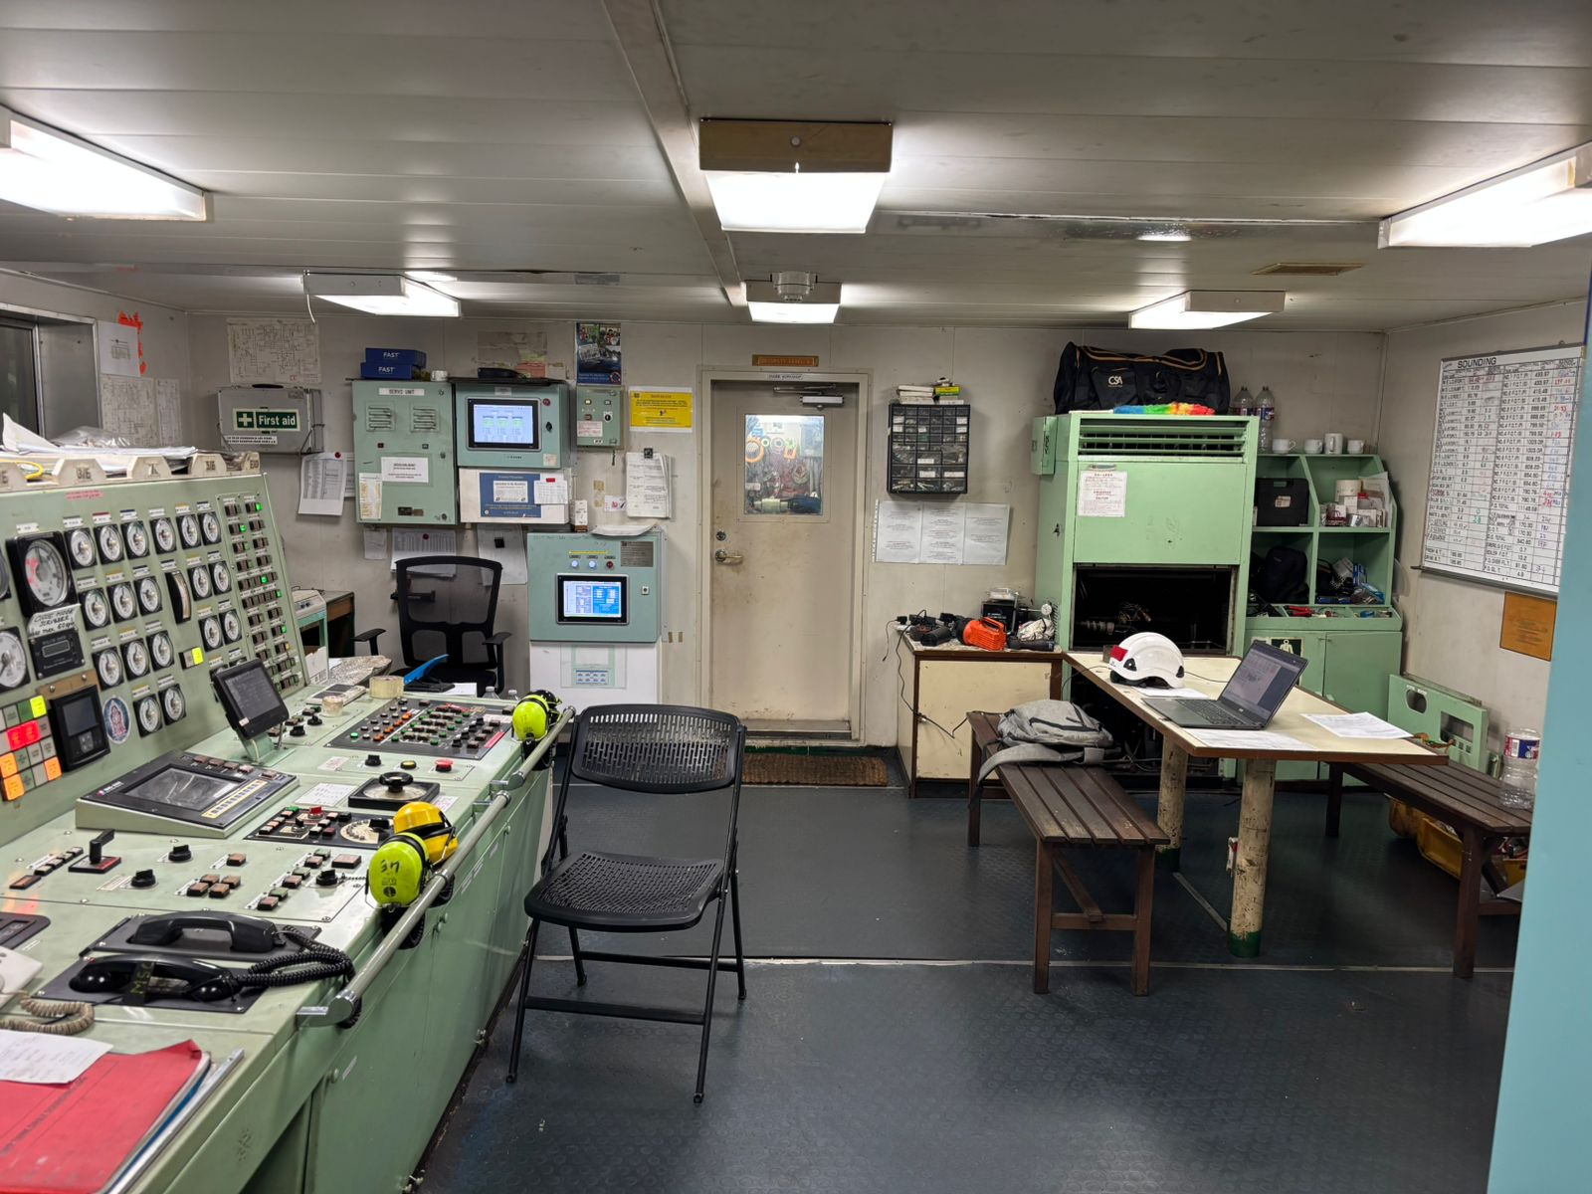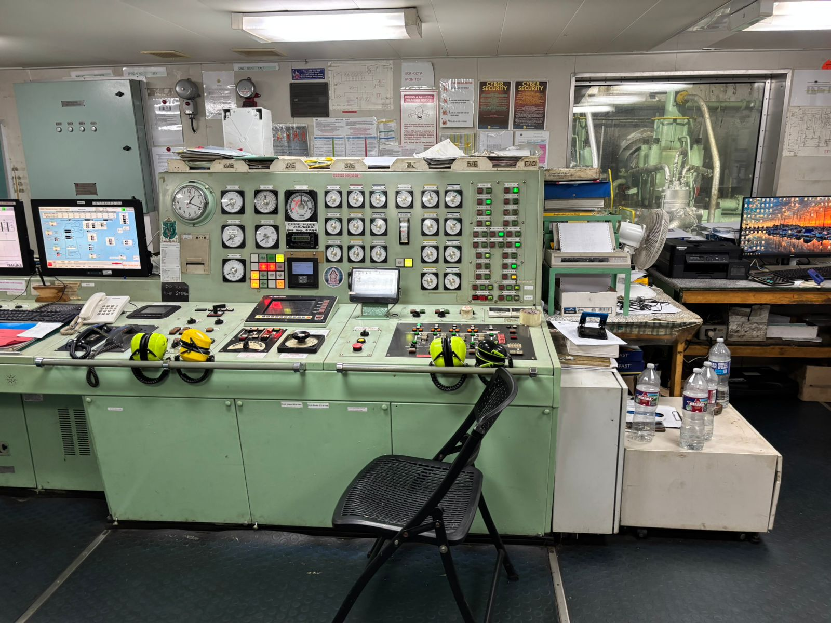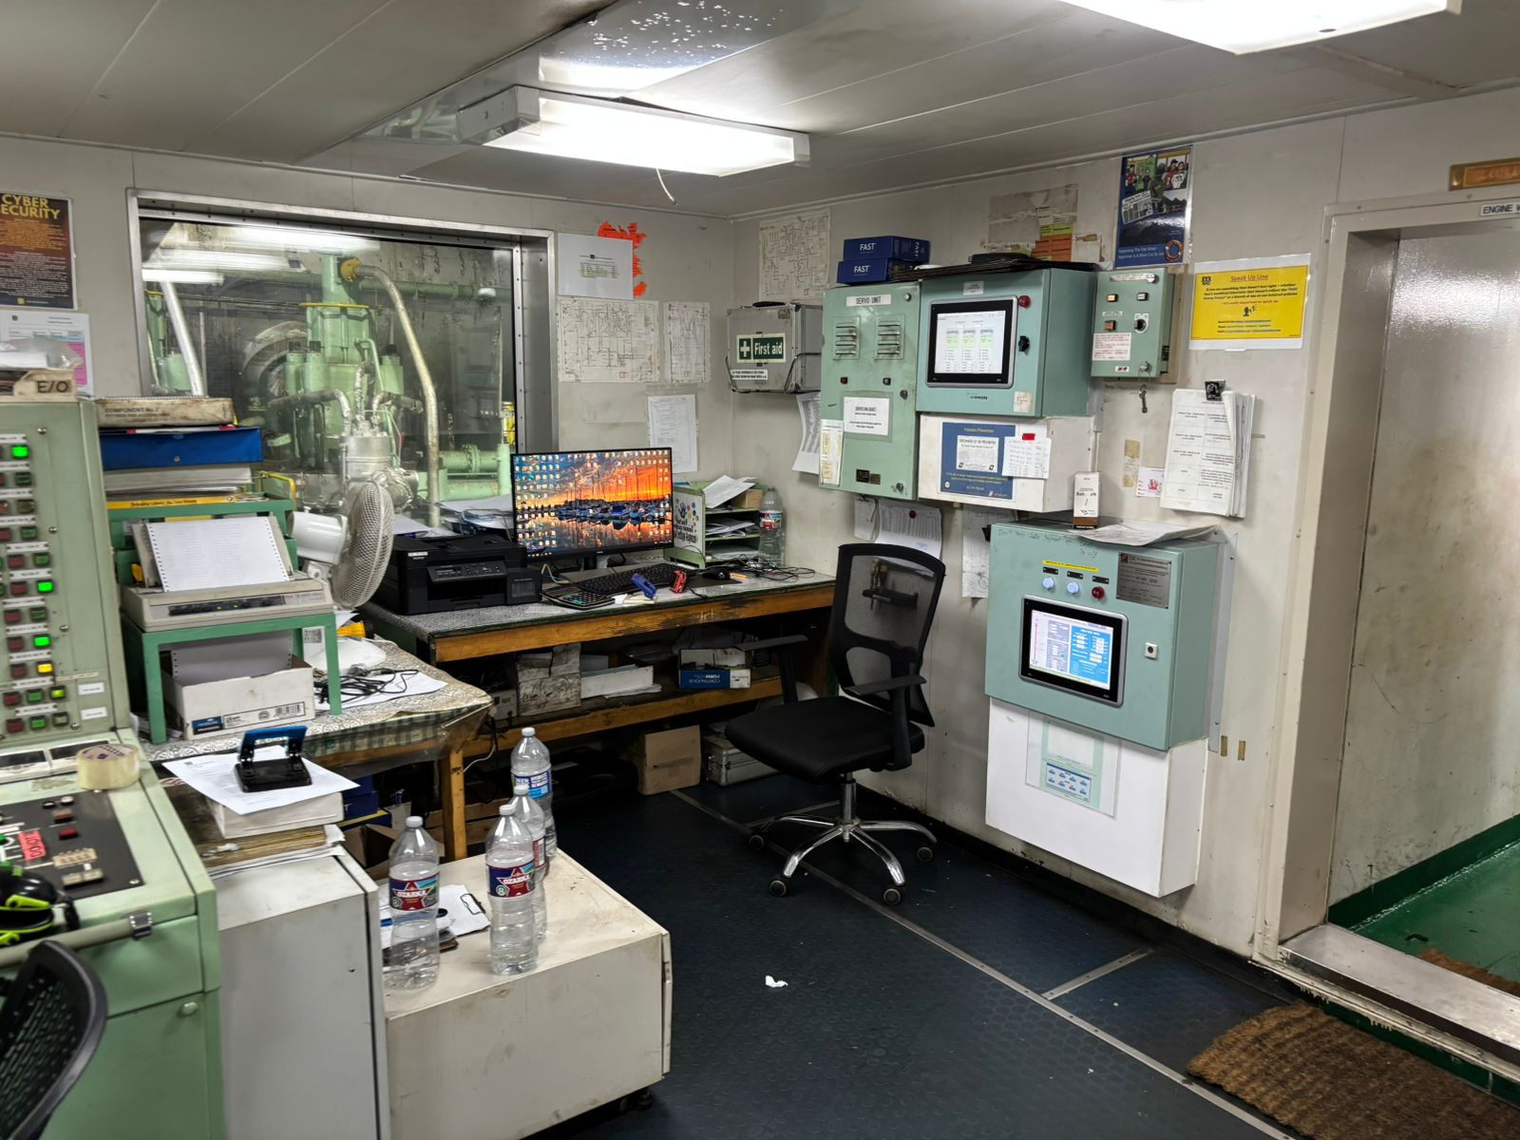
We certify that the content of these pictures has not been changed and/or altered and is just for illustration the survey conducted on board.

- Attachment

- Survey Report issued by undersigned surveyor
- Berthing message
- VRS updated
- Last manual sounding
- Logbook update
- Sludge removal certificates

