- IN GENERAL
- Remove language button. Language must be Italian. Make the appareance as a propertiy in the config file.

I will remove when finish the project, as I cannot understand without English

OK: AGREED. WE WAIT THE END

- We need a review of the captions in order to show only Italian names.
- Here the words to be changed:
Not give
See the txt document sent with this document

- Sometimes when tap or click on “SUMMARY” or “MANAGEMENT” it doesnt switch to the other tab but the tab is selected with a blu color and other tab with a gray color. Moreover the tabs summary and management must be blue when selected (now they are grey) In general please unify the style.
In figure below you can see that Summary is selected in blue and simultaneously Mangement is selected in grey. The caption says Summary but the content is related to Products
Done
OK

- “SUMMARY”:
- Request online must be at the top. Done KO
- …followed by Order history Done OK
- …and then Summary request Done KO

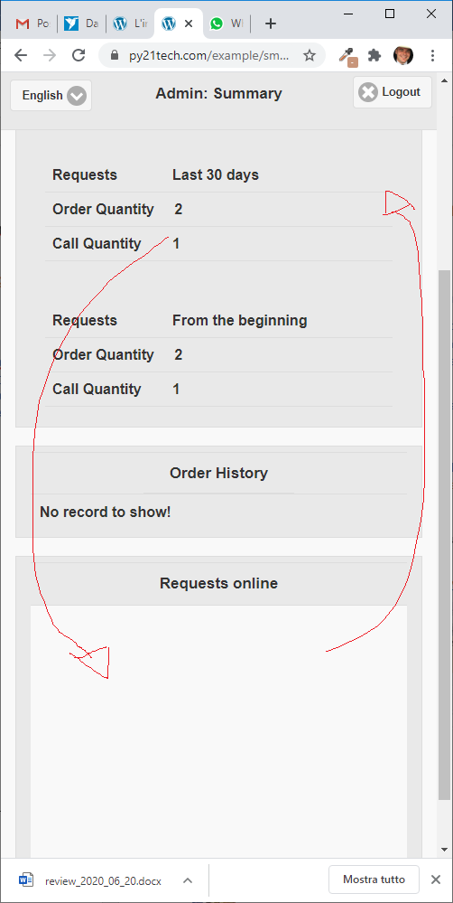
KO! WE SEE OBJECTS WITH THE FOLLOWING WRONG ORDER:
Summary
Order Hystory
Request Online
We

  - by default “today” filter must be selected Done
  - Selection must be permanent after the tap Done
- When you tap an item (i.e. Call waiter) Done
  - the caption name is wrong (Dettaglio ordine) Done
  - The action button to declare the item as done is missing. Done
- Reduce dimension of items in Request online Done

- “MANAGEMENT”
- TAB MANAGEMENT
  - must be in JQUERY MOBILE Done(already in jQuery mobile)

In tab edit, when you edit a tab in the right position the the position combo must show the right position, at the moment it shows always main menu

Also the number shown by default in sequence column must be the max sequence +1.

  - “Type” must be a combo in order to help the user to decide what to choose
    - We’ll give you a schema with the meaning of each code (not given)
See the txt document sent with this document

- PRODUCTS
  - We create a new tab, new category and new product and associate a “prova categoria luca” but the product is not visible. See figure below. Done KO

  - Also the new product is not visible also if i put it in an existing category. Done KO

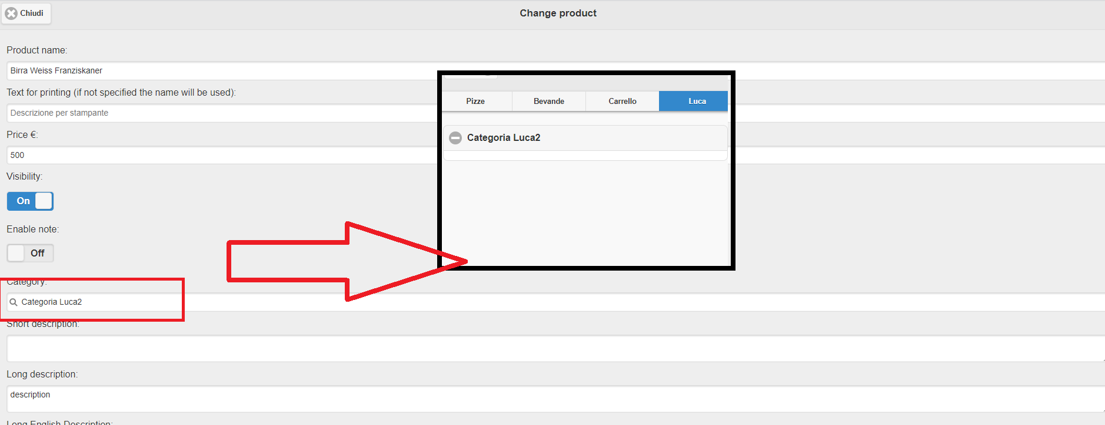
I TRIED IN DIFFERENT WAYS BUT I CANNOT ASSOCIATE A NEITHER A NEW PRODUCT NOR AN EXISTING TO A NEW CATEGORY
MOREOVER I CANNOT ASSOCIATE A NEW PRODUCT TO AN EXISTING CATEGORY

  - Sometimes after using product section if i try to enter in a product it does not work and i have to logout and login again to make it work. Done
  - Some product seems disabled but inside the product is enabled. See figures below
Done
sometimes you have to click the refresh button, after add or remove category and product.

- at the moment is not possible to delete products or category, please add this functionality
  - If the category has linked products show a confirmation message saying “Esistono prodotti associati alla categoria che stai cancellando. I prodotti rimarranno nel catalogo e potranno essere associati ad altre categorie. Confermi?” and then show the standard confirmation box Done
OK, BUT THE MESSAGE IS ALWAYS SHOWED, EVEN IF NO PRODUCT IS LINKED TO THE CATEGORY. IT HAS TO BE SHOWED ONLY IF THERE IS AT LEAST ONE LINKED PRODUCT TO THE CATEGORY
ALSO FOR DELETE PRODUCT ADD CONFIRMATION BOX: “Sei sicuro di voler eliminare il prodotto?”
  - Please note: when you delete a category you also delete the association with the products but not the products. (The Italian phrase at the previous point is a warning that inform the user of this fact) Done
4)on CID 1001 if I put a table it does not work and i can’t try the order from administrator, also after this i will redirect on a page without CID Done

- the language selection hides the menu button on the left, and also the login button doesn’t work, please do not modify the “customer site” (use the original code)
Here attached the original code and demo of servizismart.com, cannot find left menu
YOU MUST SET TO “1” THE FIELD USER_LOGIN_REQUIRED ON CLIENTS TABLE, OR YOU CAN SEE IT WITH CID=1002. SSE PICTURE BELOW. THERE IS A TINY PORTION OF THE BUTTON IN THE RED CIRCLE. IF YOU CLICK UN IT FROM THE PC YOU CAN OPEN THE LEFT MENU FOR THE LOGIN..

I ALSO ENEBLED ON THE FOLLOW LINK
http://www.servizismart.com/demos/smartorder/?cid=1001
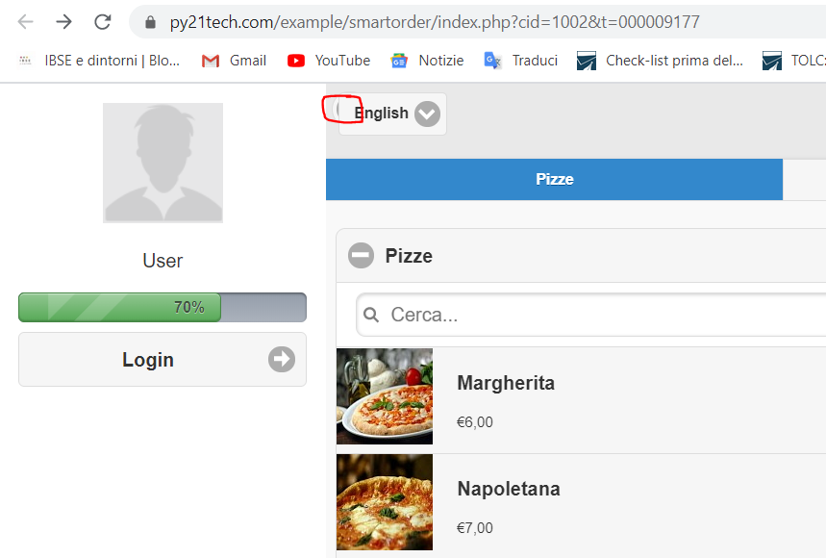
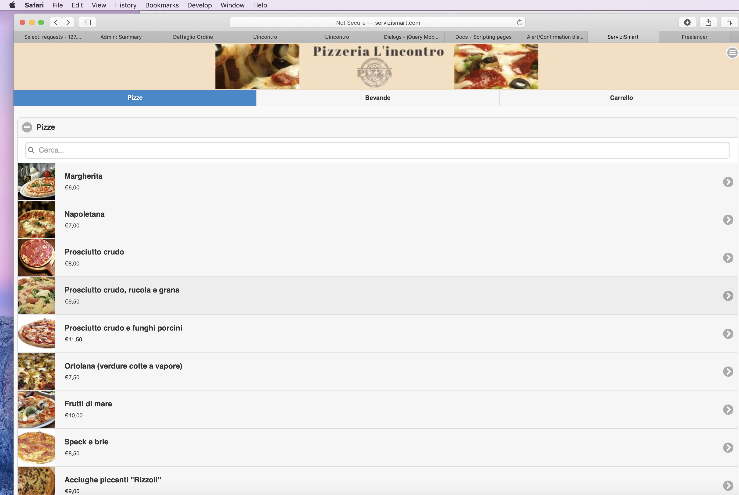
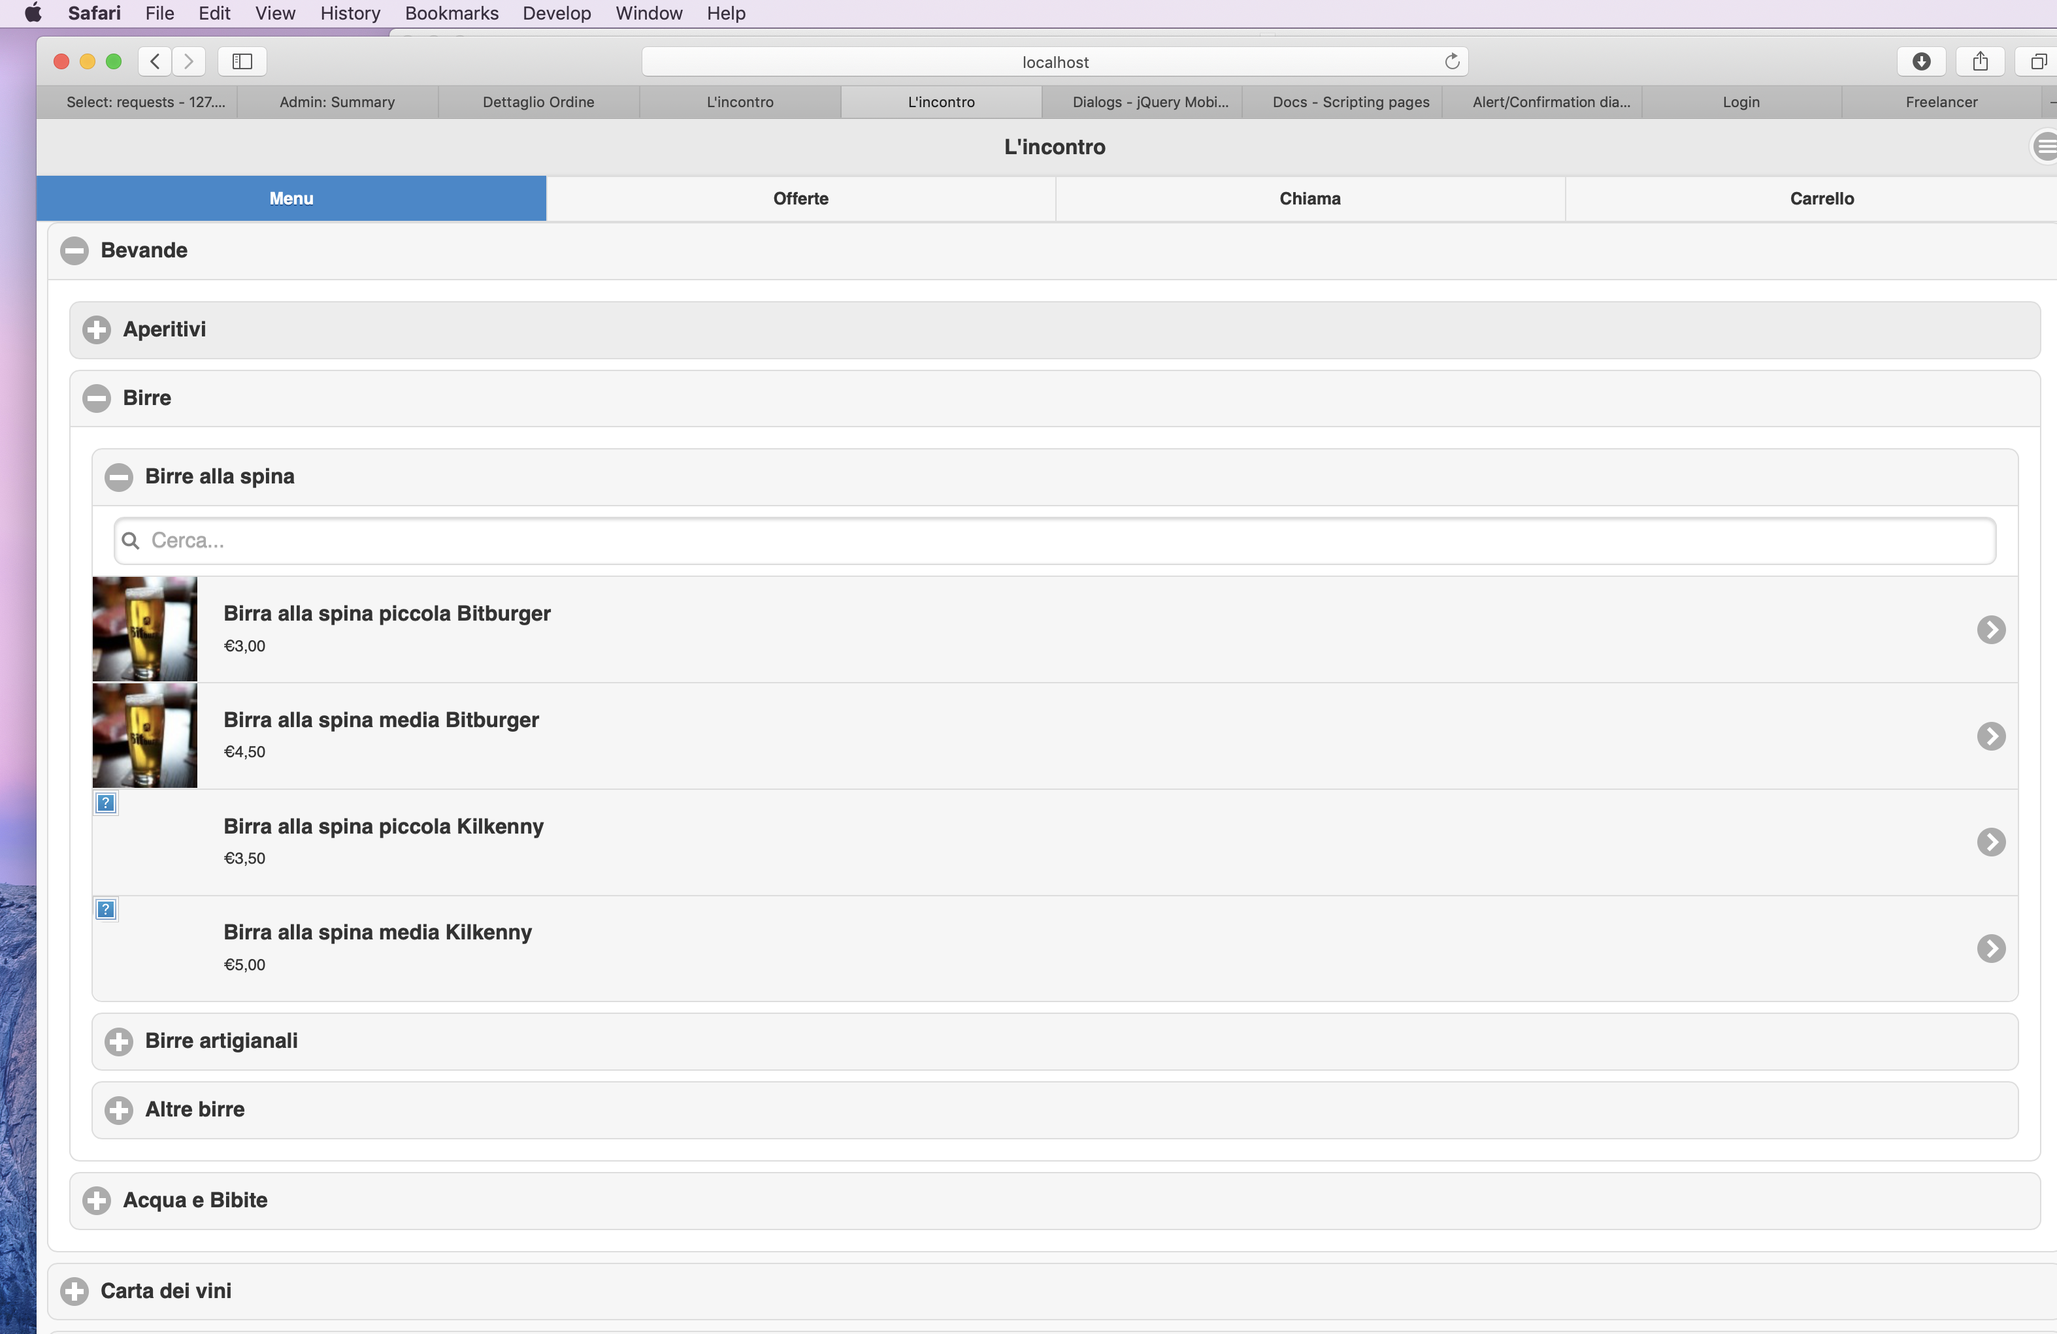

- The category combo inside the product management is non in JQUERY MOBILE. Done

IN GENERAL
Please Check consistency between the product attributes and links on the administrator site with the menu un the customer site Done KO
IT DOES NOT WORK, SEE EVIDENCES UP ON THE DOCUMENT.

