1. Dashboard

* Mobile view does not work, the view is not usable
* Call waiter and ask bill order is not manageble, I cannot close order (there is no button)
* Tab Riepilogo and Gestione is not selected (visible) the title is static and not change when i select a tab
* Link rapidi to manage section not working, please remove them
* Order history does not work

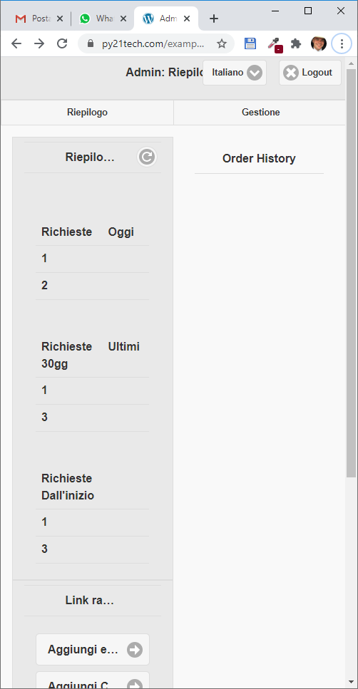

1. Manage cataloge section

* you use a different library not jquery mobile and do not working good with mobile devices, we need to use jquery mobile for the same user experience
* Tab gestione, categoria e prodotti is not selected (visible)

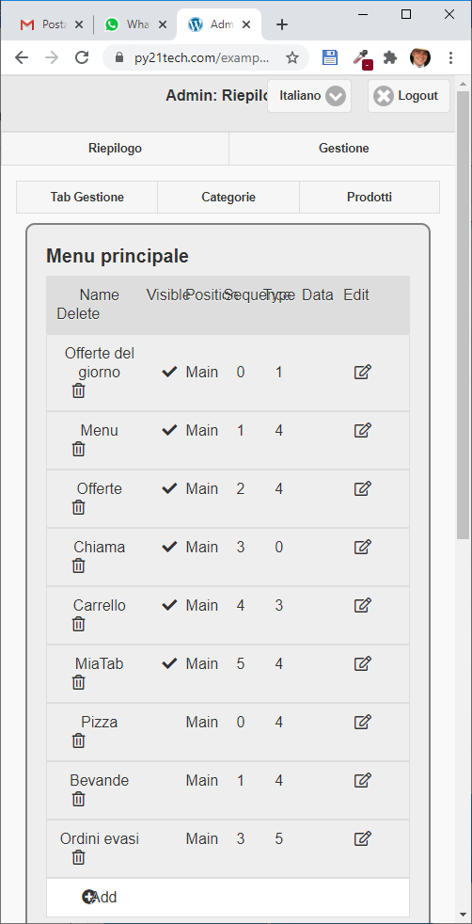

1. Product section

* Add the possibility to turn on and tur off the visibility directily from the list, see image below

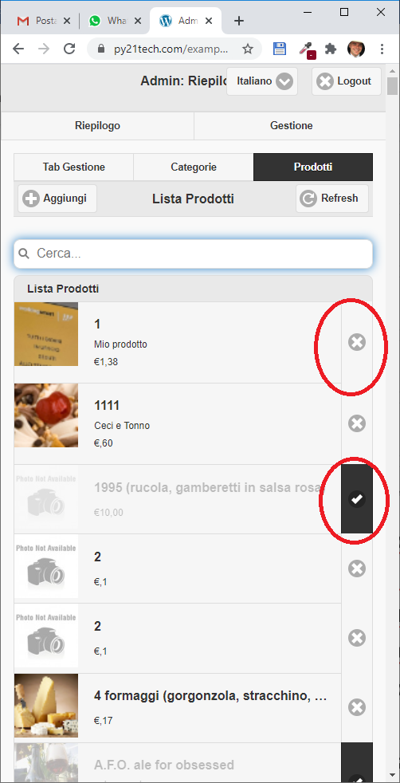

* Use jquery mobile library like before for better user experience insede the add and modify product function
* Make the category mandatory during the product management
* From smartphone the image into image crop div go outside the div, see image below

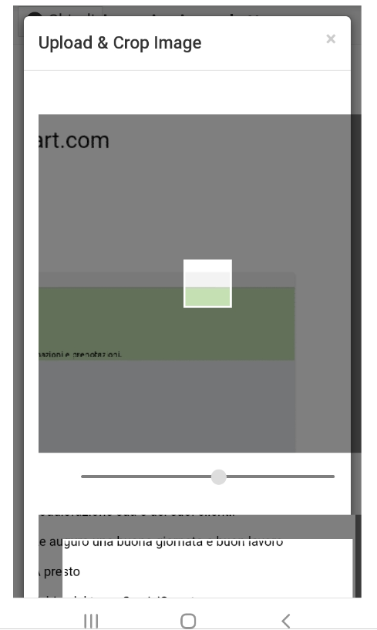

* Give the possibility to select a single image, as it dit before, and create the two same image (the difference is only the dimensions)
* Add a possibility to select images from library (load from certain folder on server i.e userimage/catalog)